SUBCOURSE EDITION
IT0432 B

US ARMY INTELLIGENCE CENTER
RC-MIOAC

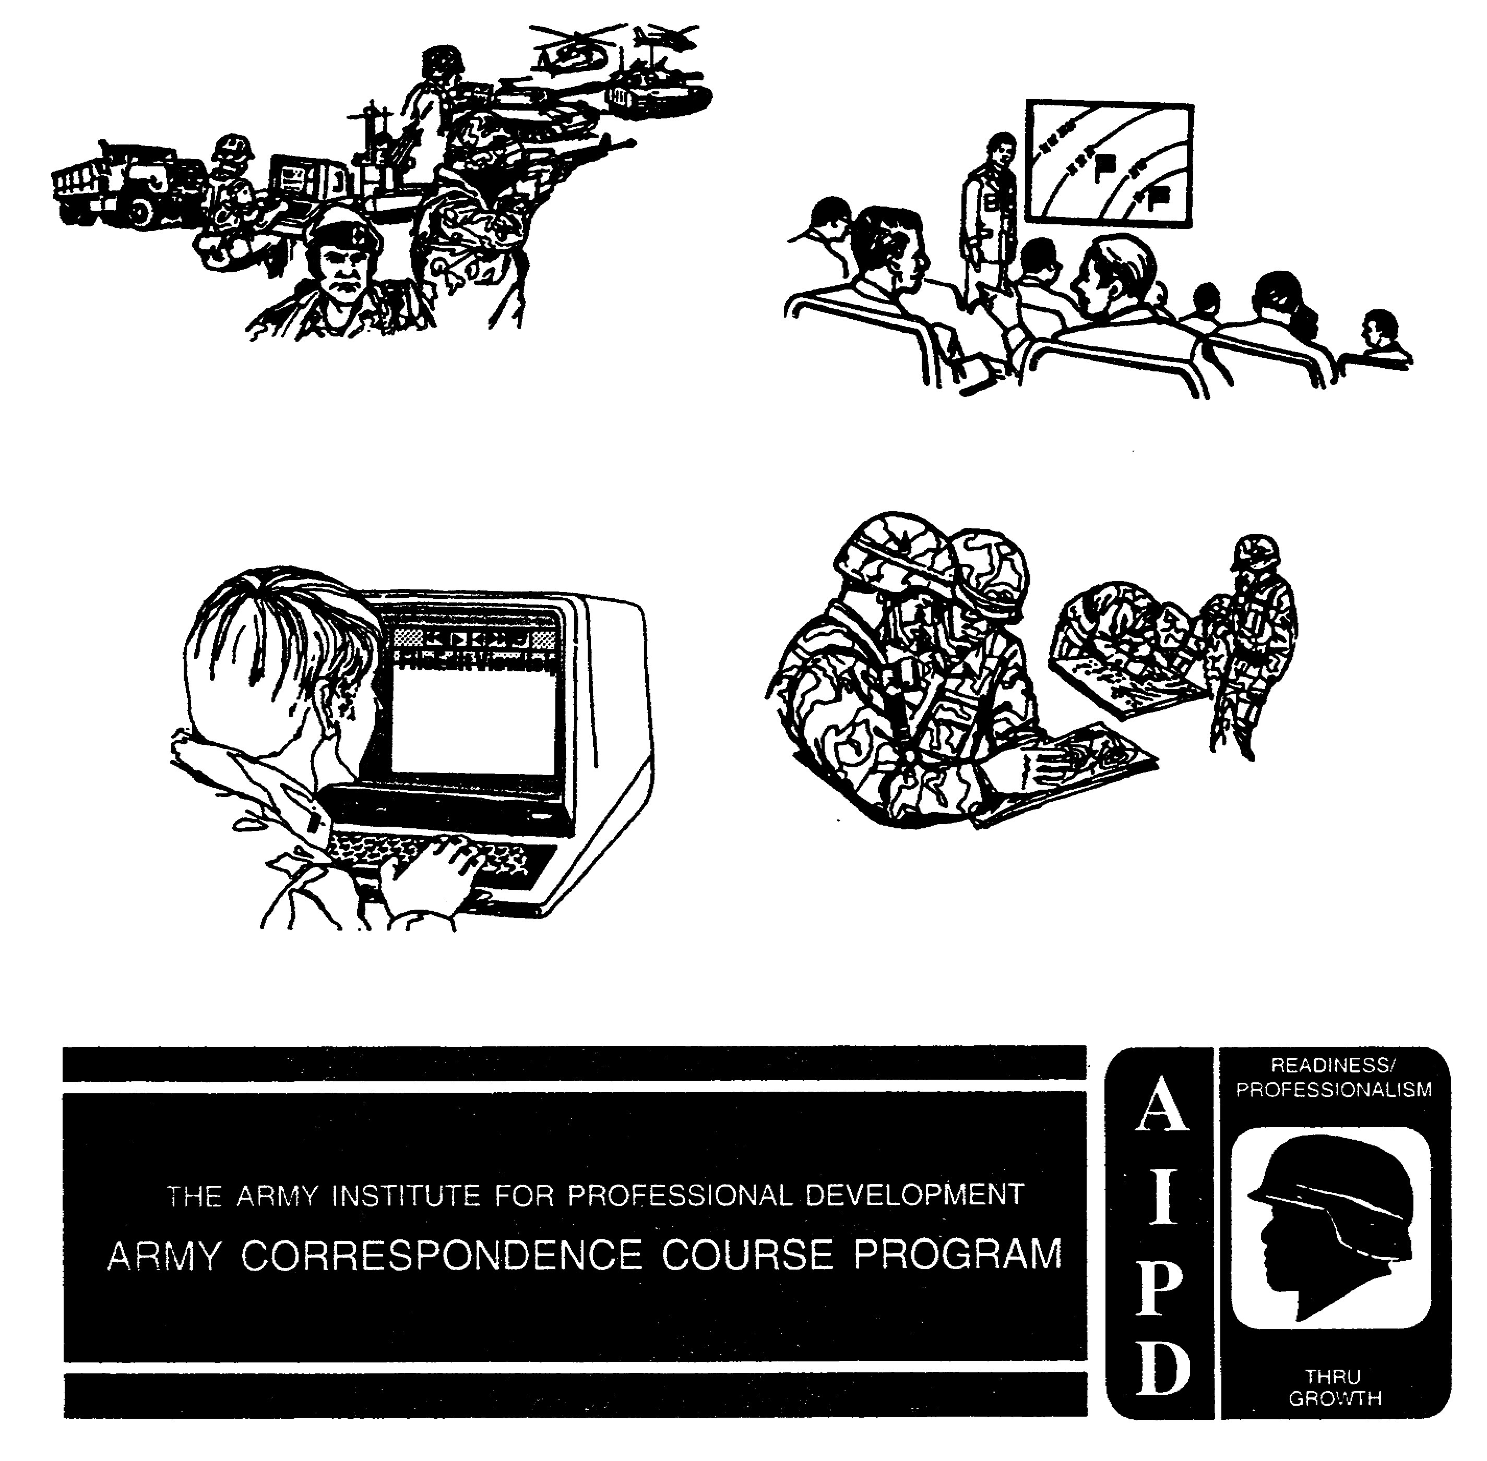

RC-MIOAC

Subcourse Number, IT0432

EDITION B

United States Army Intelligence Center
Fort Huachuca, Arizona 85613-6000

Edition Date: May 1997

CREDIT HOURS: 14

SUBCOURSE OVERVIEW

This subcourse presents the basic procedures involved in directing collection management and the intelligence preparation of the battlefield (IPB) process. It describes how the close combat-heavy (CCH) brigade fights, the intelligence support role, how intelligence facilitates the command estimate process, how to develop an intelligence and electronic warfare (IEW) scheme of maneuver, and the IEW structure at division level.

These lessons reflect doctrine which was current at the time it was prepared. In your own work situation, always refer to the latest official publications.

Unless this publication states otherwise, masculine nouns and pronouns do not refer exclusively to men.

TERMINAL LEARNING OBJECTIVE

ACTION: You will direct the development of intelligence requirements, the four steps of the IPB process, the decision support template, and a collection plan. Describe the organization, mission, capability, limitations, and operations of the CCH brigade. Describe the role of intelligence as one of the Battlefield Operating Systems (BOSs), and the IEW assets at division. Develop an IEW scheme of maneuver to support the commander's intent and concept of operations.

CONDITION: You will be given narrative information, illustrations, and sample formats from applicable field manuals. You will have access to extracts from FM 34-8.

STANDARD: To demonstrate competency of this task, you must achieve a minimum of 70% on the examination.

i IT0432

TABLE OF CONTENTS

SECTION Page

Subcourse Overview i

Lesson 1: DESCRIBE THE BRIGADE FIGHT 1-1

Part A: Brigade Mission 1-2
Part B: Brigade Organization 1-2
Part C: Brigade Combat Units 1-5
Part D: Brigade Combat Support Elements 1-10
Part E: Brigade Combat Service Support 1-17
Part F: Brigade Offensive Operations 1-19
Part G: Brigade Defensive Operations 1-39
Practical Exercise 1-52
Answer Key and Feedback 1-54

Lesson 2: DIRECT THE INTELLIGENCE PORTION OF THE INTELLIGENCE
PREPARATION OF THE BATTLEFIELD PROCESS 2-1

Part A: IPB Process 2-2
Part B: Define the Battlefield Environment 2-3
Part C: Describe the Battlefield Effects 2-5
Part D: Evaluate the Threat 2-10
Part E: Determine Threat Courses of Action 2-15
Part F: Intelligence Estimate 2-22
Part G: IPB Application 2-22
Practical Exercise 2-72
Answer Key and Feedback 2-74

Lesson 3: INTELLIGENCE SYNCHRONIZATION AND THE COMMAND
ESTIMATE PROCESS 3-1

Part A: Mission Analysis 3-2
Part B: Course of Action Development 3-3
Part C: Analyze and Compare Courses of Action 3-3
Part D: IPB Support - Wargaming 3-4
Part E: Decision and Execution 3-14
Part F: Prioritizing Intelligence Requirements 3-14
Part G: Mini-Wargaming Sessions 3-16
Part H: Example Application - IPB/Wargaming 3-17
Practical Exercise 3-24
Answer Key and Feedback 3-26

iii IT0432

Lesson 4: DIRECT COLLECTION MANAGEMENT OPERATIONS 4-1

Part A: Collection Management Functions 4-2
Part B: Collection Management and Intelligence Synchronization 4-3
Part C: Collection Management Process 4-4
Part D: Develop Requirements 4-6
Part E: Develop Collection Plan 4-9
Part F: Task or Request Tasking of Resources 4-25
Part G: Evaluate Reporting 4-26
Part H: Update Collection Plan 4-29
Practical Exercise 4-32
Answer Key and Feedback 4-34

Lesson 5: DEVELOP AN INTELLIGENCE AND ELECTRONIC
WARFARE SCHEME OF MANEUVER 5-1

Part A: MI Battalion Organization 5-2
Part B: IEW Equipment Data 5-8
Part C: IEW Tactical Mission 5-11
Part D: IEW Operations 5-12
Part E: IEW Company Teams 5-15
Part F: IEW Communications 5-17
Part G: IEW Scheme of Maneuver 5-19
Practical Exercise 5-21
Answer Key and Feedback 5-23

Appendix A: IEW Organizational Structure A-1

Appendix B: List of Common Acronyms B-1

Appendix C: Publication Extract C-1

FM 34-8 Combat Commander's Handbook on Intelligence, September 1992.

Use the above publication extracts to take this subcourse. At the time we wrote this subcourse, this was the current publication. In your own work situation, always refer to the latest official publications.

IT0432 iv

LESSON 1

DESCRIBE THE BRIGADE FIGHT

Critical Task: S1-9011-07-0001

OVERVIEW

LESSON DESCRIPTION:

In this lesson you will learn how the close combat-heavy (CCH) brigade is organized, its capabilities, limitations, and the conduct of brigade offensive and defensive operations.

TERMINAL LEARNING OBJECTIVE:

ACTIONS: Describe the brigade fight.

CONDITIONS: You will be given narrative information and illustrations from FM 34-3, FM 71-3, FM 71-100, and FM 100-5.

STANDARDS: Describe the organization, mission capability and limitations of the CCH brigade. Describe the conduct of offensive and defensive operations at brigade level. Describe the role of intelligence as one of the battlefield operating systems (BOSs).

REFERENCES: The material contained in this lesson was derived from the following publications:

FM 343
FM 71-3
FM 71-100
FM 100-5

INTRODUCTION

Army forces must meet worldwide strategic challenges against the full range of threats from terrorism through low- and mid-intensity operations to operations of high-intensity and nuclear weapons. The probability of global war or major conventional war is low, but the probability of regional conflict is high. Some mid-intensity conflict could occur, but conflict will most likely occur in low-intensity environments. The challenge is that low-intensity environments. The challenge is that low-intensity conflict is broadening and taking on more dimensions.

On the nonlinear battlefield described in the emerging doctrine the brigade will be a key player in tactical battle in the low-to mid-intensity environments. As an Army intelligence officer, you will be responsible for providing a clear intelligence picture to the brigade fight.

1-1 IT0432

PART A - BRIGADE MISSION

The close combat-heavy brigade is the maneuver element of the division.

NOTE: A number of specialized, separate, an contingency brigade-sized organizations have been designed to meet a variety of missions for the US Army. We will not address these during this lesson.

The division commander assigns varying numbers of tank and mechanized infantry battalions to the divisional brigade for a specific mission, based on his estimate of the situation. As a rule, each brigade can control two to five maneuver battalions (combat) and supporting combat support (CS) and combat service support (CSS) elements.

The mission of the brigade is to fight the battle. Its mission is to close with and destroy enemy forces using mobility, firepower, and shock effect. It defeats enemy assault by defensive fires, obstacles, and counterattacks. To do this it must destroy or disrupt enemy forces and seize and hold terrain.

PART B - BRIGADE ORGANIZATION

The close combat-heavy brigade is a combination of armored and mechanized infantry battalions grouped under the command of brigade headquarters (Figure 1-1). The distribution of battalions is based on the factors of mission, enemy, terrain, troops, and time available (METT-T) as determined by the division commander. Brigades are organized to accomplish specific missions. The brigade headquarters may be mechanized or armor, depending on the mix of combat battalions assigned for the mission. A headquarters with two mechanized (mech) battalions and one tank battalion is said to be mech heavy, likewise a brigade with two mech and two tank battalions is considered to be balanced. The brigade commander then organizes these battalions into task forces -a mix of capabilities designed to perform specific missions. The mix will include various combinations of armor and mechanized infantry companies. The only permanent unit assigned to the brigade is its headquarters and headquarters company (HHC).

The HHC directs and controls units assigned to, attached to, or supporting the brigade (Figure 1-2). The HHC has a brigade headquarters section, S1 section, S2 section, S3 section, S4 section, engineer section, communications section, maintenance section, company headquarters section, mess section, and unit ministry section.

IT0432 1-2

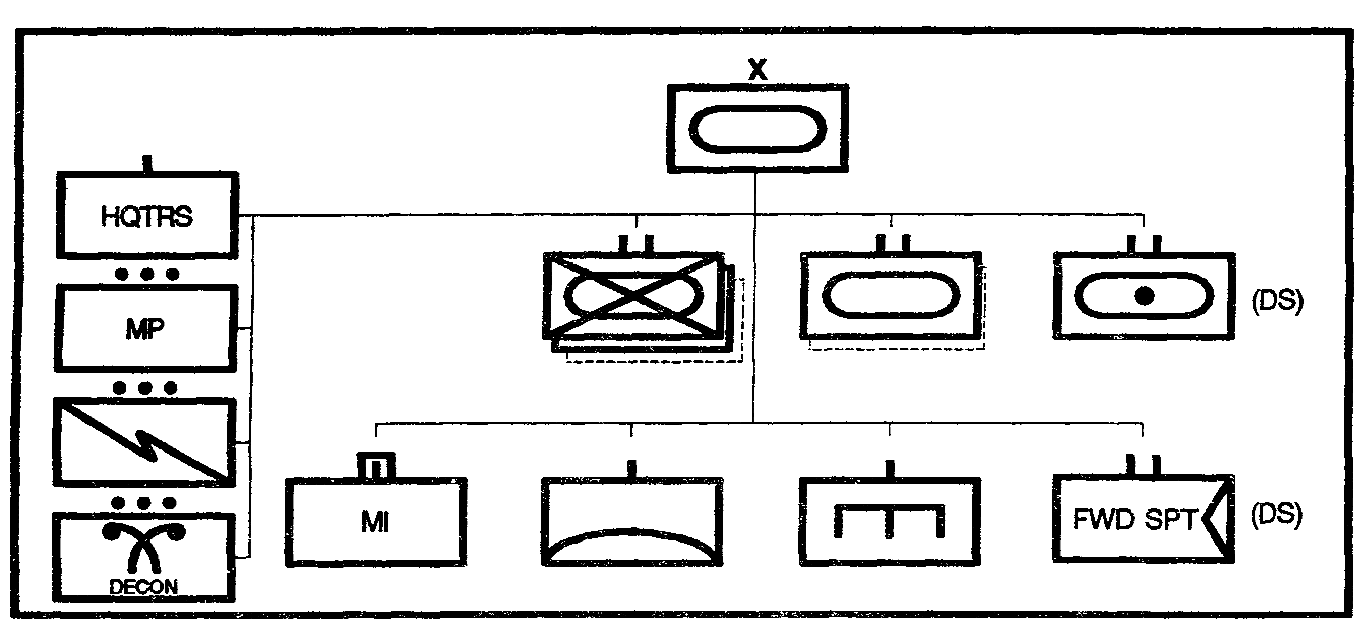

Figure 1-1. Brigade with supporting Units.

The brigade headquarters section consists of the brigade commander, executive officer, command sergeant major, and support personnel. This element provides guidance, leadership, and direction for the brigade.

The S1 section (personnel and administration) provides the administrative interface to higher and lower headquarters and manages the brigade personnel status. This section is responsible for the maintenance of unit strength, personnel management, and the maintenance of morale, discipline, law and order.

The S2 section (intelligence) provides information about the enemy situation for the conduct of combat operations. This section coordinates reconnaissance activities, updates the intelligence estimate, maintains the enemy situation map, provides current weather data, and evaluates and interprets enemy information. it is the driving force behind the Intelligence Preparation of the Battlefield (IPB) process. It prepares patrol, intelligence collection, reconnaissance, and surveillance plans, and supervises the activities of ground surveillance radars when they are attached.

The S3 section (operations) provides the execution planning for the conduct of combat operations. The S3 is the commanders principal assistant for matters pertaining to the organization, employment, training, and operations of the brigade and supporting elements.

1-3 IT0432

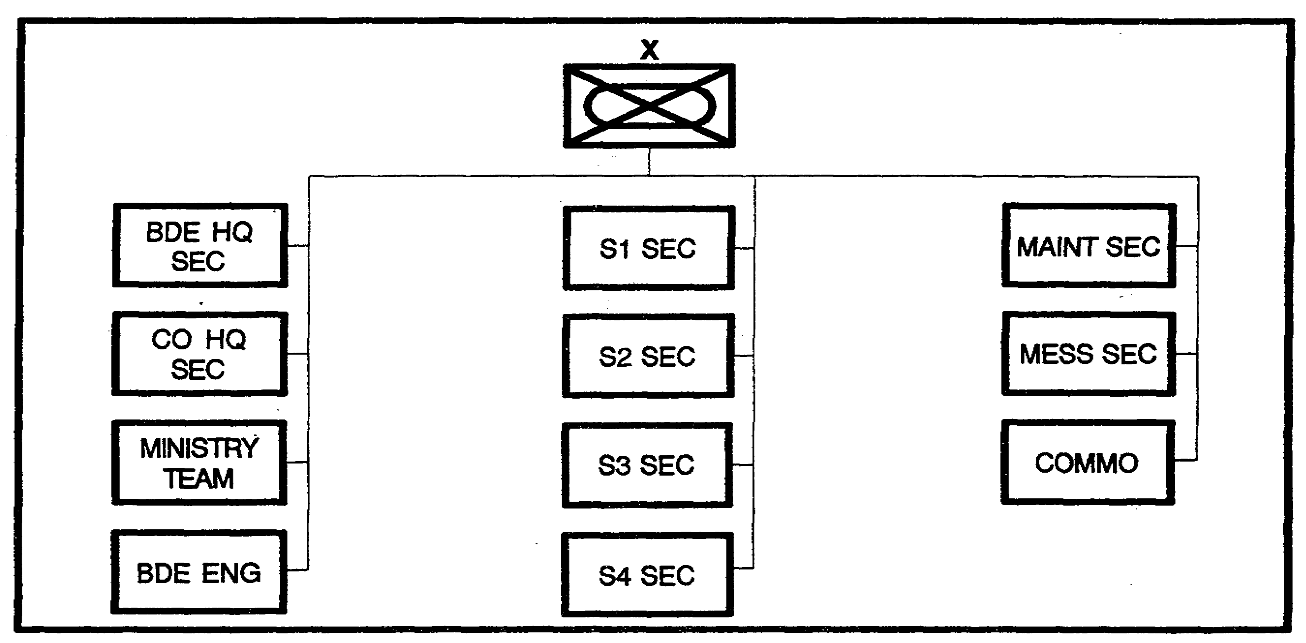

Figure 1-2. Brigade HHC organization.

The S4 section (logistics) provides the commander with information on all logistical matters. It coordinates with the battalion S4s about status of equipment and supplies and the capabilities of the battalion or task force (TF) field trains to support combat elements.

The brigade engineer section advises the brigade commander on engineer matters. He plans the use of engineers, prepares engineer portions of plans and orders, and exercises special staff responsibility for engineer operations.

The communications section provides the internal communications support to command and control the brigade. This section installs and maintains all signal facilities within the brigade headquarters.

The company headquarters is composed of the personnel and equipment required for support of the brigade headquarters.

o The mess section operates the dining facilities in the field environment and provides meal support to the personnel of the brigade headquarters (HQ).

o The unit ministry team provides morale and spiritual related support to the HQ.

o The maneuver brigade headquarters provides the command and control facilities necessary to employ attached and supporting units. The combat, CS, and CSS units necessary to accomplish the brigade missions are attached, placed under operational control (OPCON) of, or placed in direct support (DS) of the brigade.

IT0432 1-4

All units assigned or attached to the brigade will fall in one of these groupings:

o Combat units include infantry (IN), armor (AR), field artillery (FA), engineer (EN), aviation (AV), and air defense (AD).

o Combat support units include military police (MP), chemical corps, military intelligence (MI), psychological operations (PYSOP), signal corps (SC), and Air Force air liaison officers (ALO) from the U.S. Air Force (USAF).

o Combat service support units include personnel, logistics, medical, transportation, maintenance, and chaplain.

We will address each grouping and type of unit separately and discuss the normal size (slice) element that would be dedicated to the brigade. The slice will vary depending on need and mission.

The brigade focuses on fighting the tactical battle. Armored and mechanized infantry brigades are organized to fight successful battles on any part of the battlefield including conventional, nuclear, or chemical environments. The combined efforts of their battalions can accomplish major tactical tasks as part of division or corps operations. The brigade's key to success is its ability to synchronize its maneuver battalions and integrate CS and CSS combat multipliers in support of the brigade effort.

PART C - BRIGADE COMBAT UNITS

Maneuver Battalion Mission. The battalion is the lowest echelon at which firepower, maneuver, intelligence, and support are combined under a single commander. Mechanized infantry battalions and tank battalions are organized, equipped, and trained to accomplish compatible missions.

The mission of the mechanized infantry battalion is to close with the enemy by means of fire and maneuver to destroy or capture the enemy, or to repel assaults by fire, close combat, and counterattack.

The tank battalion mission is to close with and destroy enemy forces using fire, maneuver, and shock effect, or to repel assaults by fire and counterattack.

Battalion Organizations.

The mechanized infantry battalion is normally composed of a headquarters and headquarters company, four infantry companies (Figure 1-3). The major weapons systems associated with the infantry battalion are 58 infantry fighting vehicles, 10 scout vehicles, and 6-120mm mortars.

The tank battalion is normally composed of a headquarters and headquarters company and four tank companies (Figure 1-4). The major weapon systems associated with the tank battalion are 58 main battle tanks, 10 scout vehicles, and 6-120 mm mortars.

1-5 IT0432

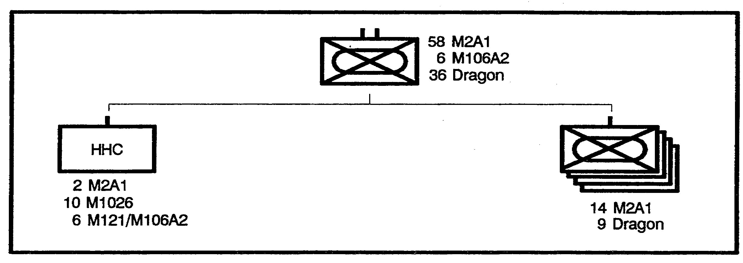

Figure 1-3. Mechanized Infantry Battalion.

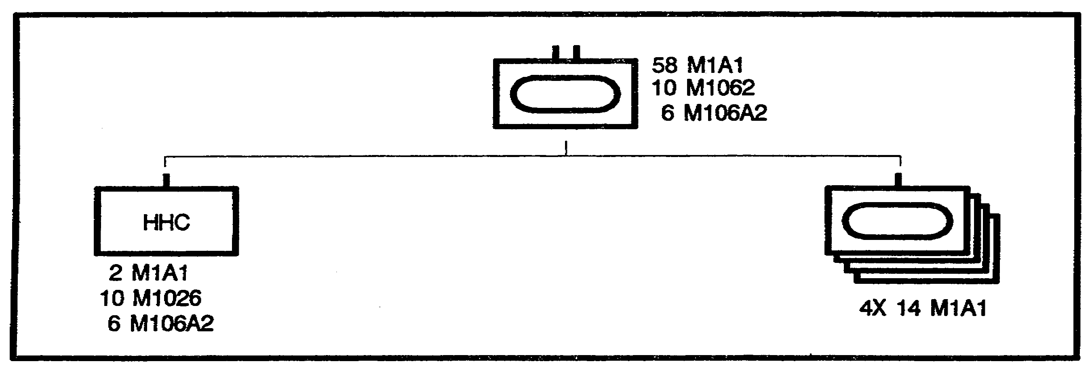

Figure 1-4. Armor Battalion.

Battalions, normally task organized as battalion task forces, fight as part of brigade. Battalions normally fight enemy forces they can see and shoot at; this defines an area of operations extending from less than 100 meters in forests, urban areas, or close terrain, out to about 5 kilometers from the battalion direct fire weapon systems.

The battalion task force is comprised of its organic headquarters and headquarters company, one or more of its organic companies, one or more tank or mechanized infantry companies, and additional CS and CSS assets necessary to accomplish the mission. It will normally have four maneuver companies under its command, but it may have as few as two or as many as five companies. A commander can generally command and control a maximum of five companies.

Task organization increases the capability of the tank and mechanized infantry battalions. Based on his estimate of the situation, the brigade commander task organizes tank and mechanized infantry battalions by cross attaching companies between these units. As a rule, cross attachment is done at battalion level because the battalion has the necessary command and control and support capabilities to employ combined arms formations. The brigade commander determines the mix of companies in a task force. The commander routinely augments the task force to improve engineer, fire support, air defense, intelligence, and CSS

IT0432 1-6

capabilities. The brigade commander usually provides the task force with the following combat support:

o At least an engineered platoon.
o A tactical air control party (TACP) from the USAF.
o A Stinger section or a Vulcan platoon.
o Ground surveillance radar (GSR) from the divisional Military Intelligence battalion.

Other combat organizations normally associated with the brigade are field artillery (FA), engineer, aviation, and air defense artillery. These elements, in varying sizes based on the mission and command relationships, provide the combat multipliers that the maneuver battalions need to complete their missions.

An FA battalion (Figure 1-5) is normally placed in direct support (DS) of a brigade. The brigade commander uses priorities and location to weight the combat power of the units at the proper time. Fire planning is conducted at the brigade main command post (CP) by the brigade fire support officer (FSO).

Under normal conditions, fire support teams (FISTs) and fire support planners remain with the combat units. If an artillery unit supports rear operations, it will not normally have forward observers available. This creates the need for the personnel in the rear area to provide their own observers and establish or identify the fire support communication channels in the rear area.

The division engineer battalion (Figure 1-6) normally provides engineer support to the brigade by providing a habitually associated company. Elements are further provided to the battalions, and they work in direct support or on an area basis depending on the command relationship. The company commander works for the brigade engineer who is a special staff officer.

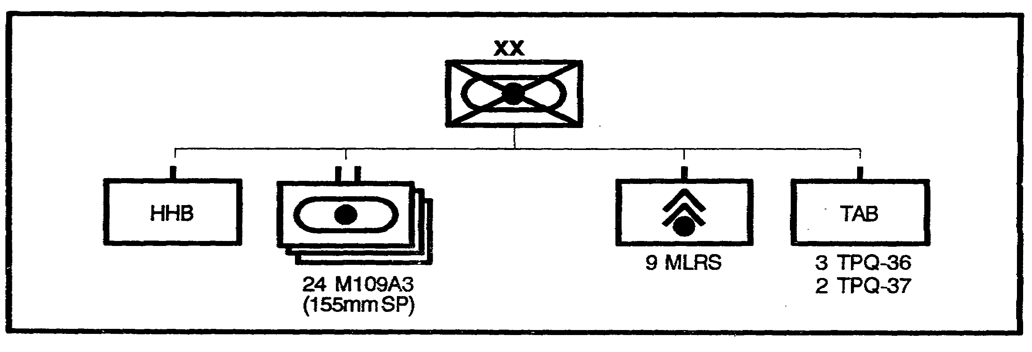

Figure 1-5. DIVARTY-AR/MECH Division.

1-7 IT0432

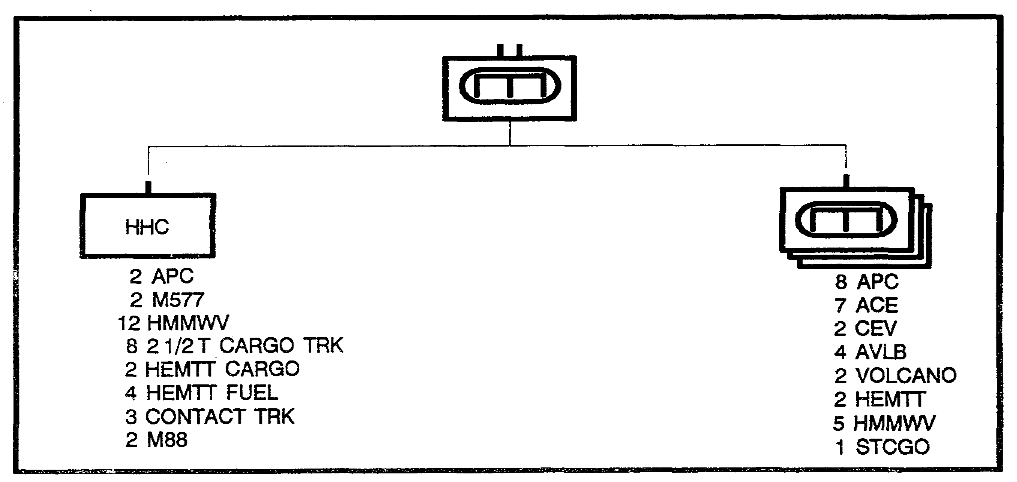

Figure 1-6. Combat Engineer Battalion-Heavy Division.

Engineer support in the rear area is normally provided on an area basis by either DS or general support (GS) engineer units. The use of habitually associated companies improves staff coordination and interaction. Habitual association simplifies coordination of mission and implementation of standing operating procedures (SOPs).

Aviation support for the brigade fight may be allocated in the form of attack helicopters (which may be part of a joint air attack team). While aviation is not normally assigned to the brigade, elements of a division combat aviation battalion (Figure 1-7) may operate in the brigade area under the control of the division. When the maneuver brigade controls the aviation assets, the aviation brigade will provide an Army aviation liaison officer. The Liaison officer's with the staff for positioning; helping prepare aviation portions of plans, estimates, and reports; and functioning as part of the brigade airspace management element.

While the use of the aviation assets of heavy maneuver forces must be discussed, normally the only assets discussed are attack helicopters. The CS capabilities of aviation are critical for success on the battlefield. Aviation's lift capabilities must be coordinated so that all assets are employed while preventing double tasking of the assets (the logistician and the tactician both wanting to employ the assets at the same time, or continuous tasking of the assets without allowing for proper maintenance).

IT0432 1-8

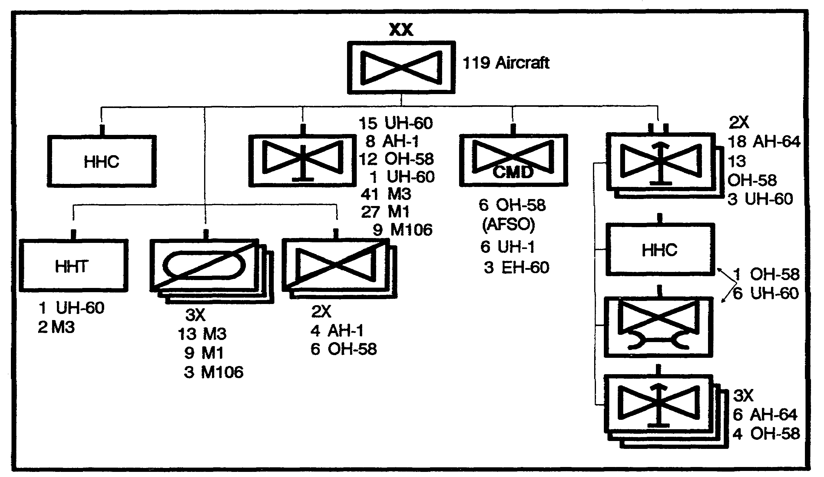

Figure 1-7. Combat Aviation Brigade-AR/MECH Division.

An air defense artillery (ADA) battery (Figure 1-8) normally provides ADA support. The battery commander provides liaison to the brigade HQ and acts as the brigade commander's special staff officer for planning and integrating air defense coverage.

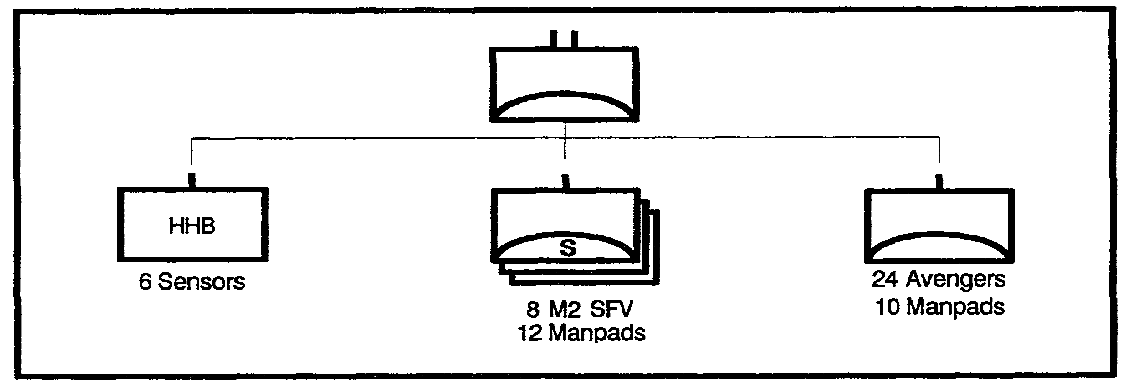

Figure 1-8. ADA Battalion-AR/MECH Division.

1-9 IT0432

PART D - BRIGADE COMBAT SUPPORT ELEMENTS

Military Police Company (Figure 1-9). MP support is normally provided by a platoon from the division MP company. The platoon leader acts as staff adviser (special staff) for military police combat, CS, and CSS operations.

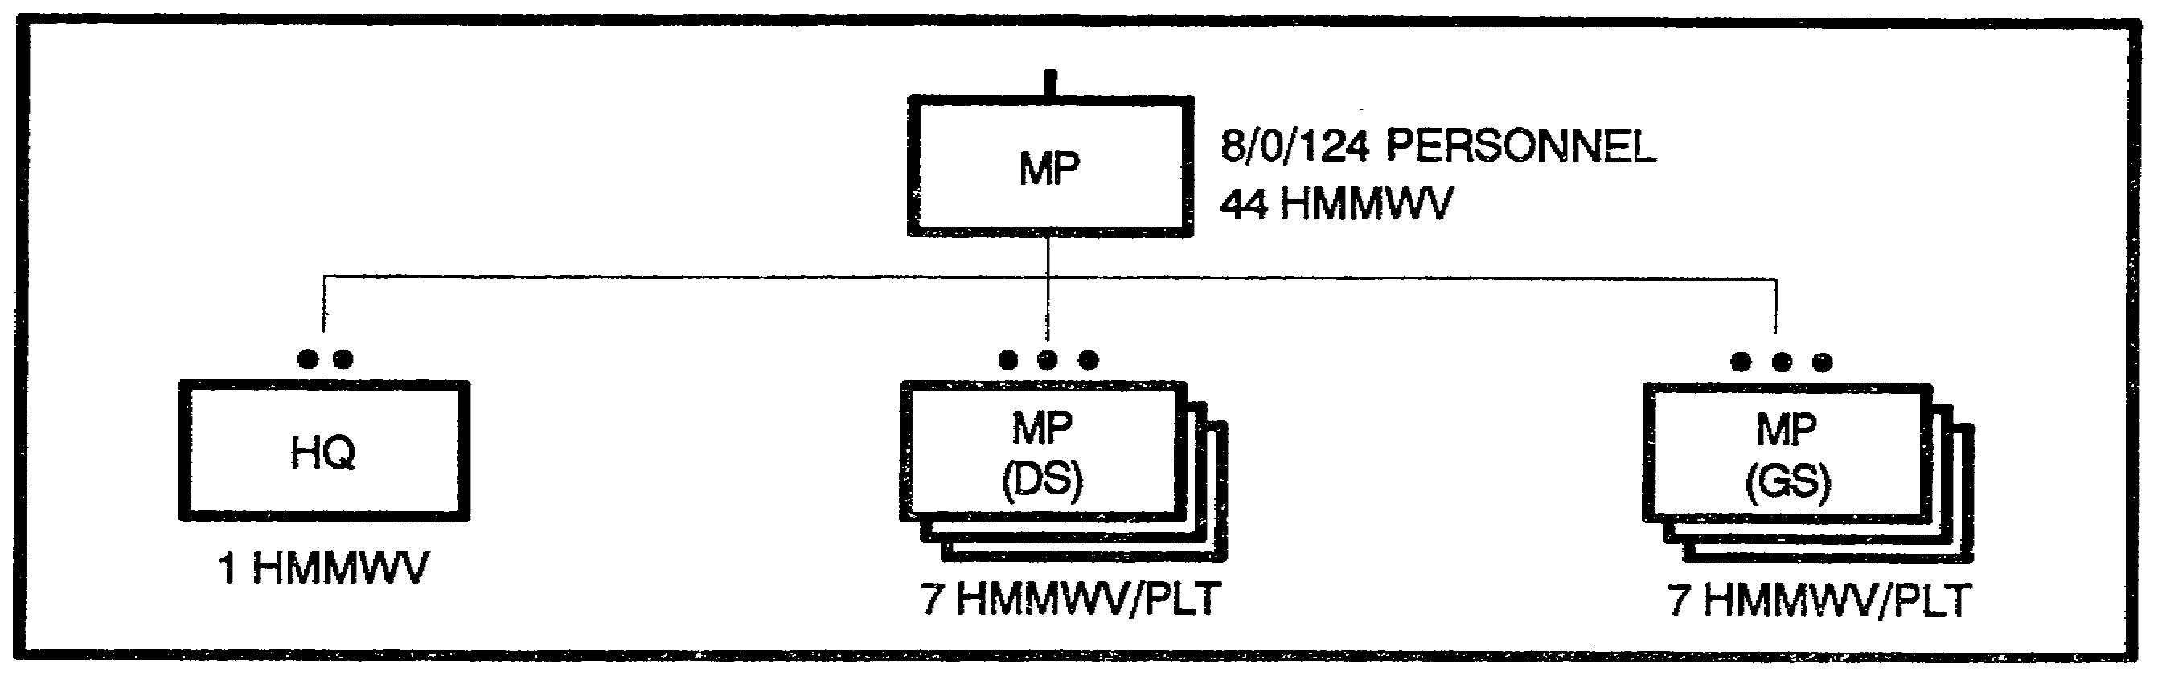

Figure 1-9. Military Police Company.

Chemical Company (Figure 1-10). One officer and a noncommissioned officer (NCO) supervise the chemical section and plan for chemical operations in the brigade area. Elements from the division chemical company support the section. The chemical officer:

o Advises the commander on matters of offensive and defensive operations.

o Operates the brigade nuclear, biological, and chemical (NBC) collection center.

o Helps plan the use of nuclear and chemical weapons.

o Prepares NBC estimates, plans, an SOPs.

o Recommends mission-oriented protective posture (MOPP) levels.

o Plans and coordinates decontamination (decon) operations.

o Maintains radiation exposure state of subordinate and attached units.

o Conducts nuclear vulnerability analysis.

IT0432 1-10

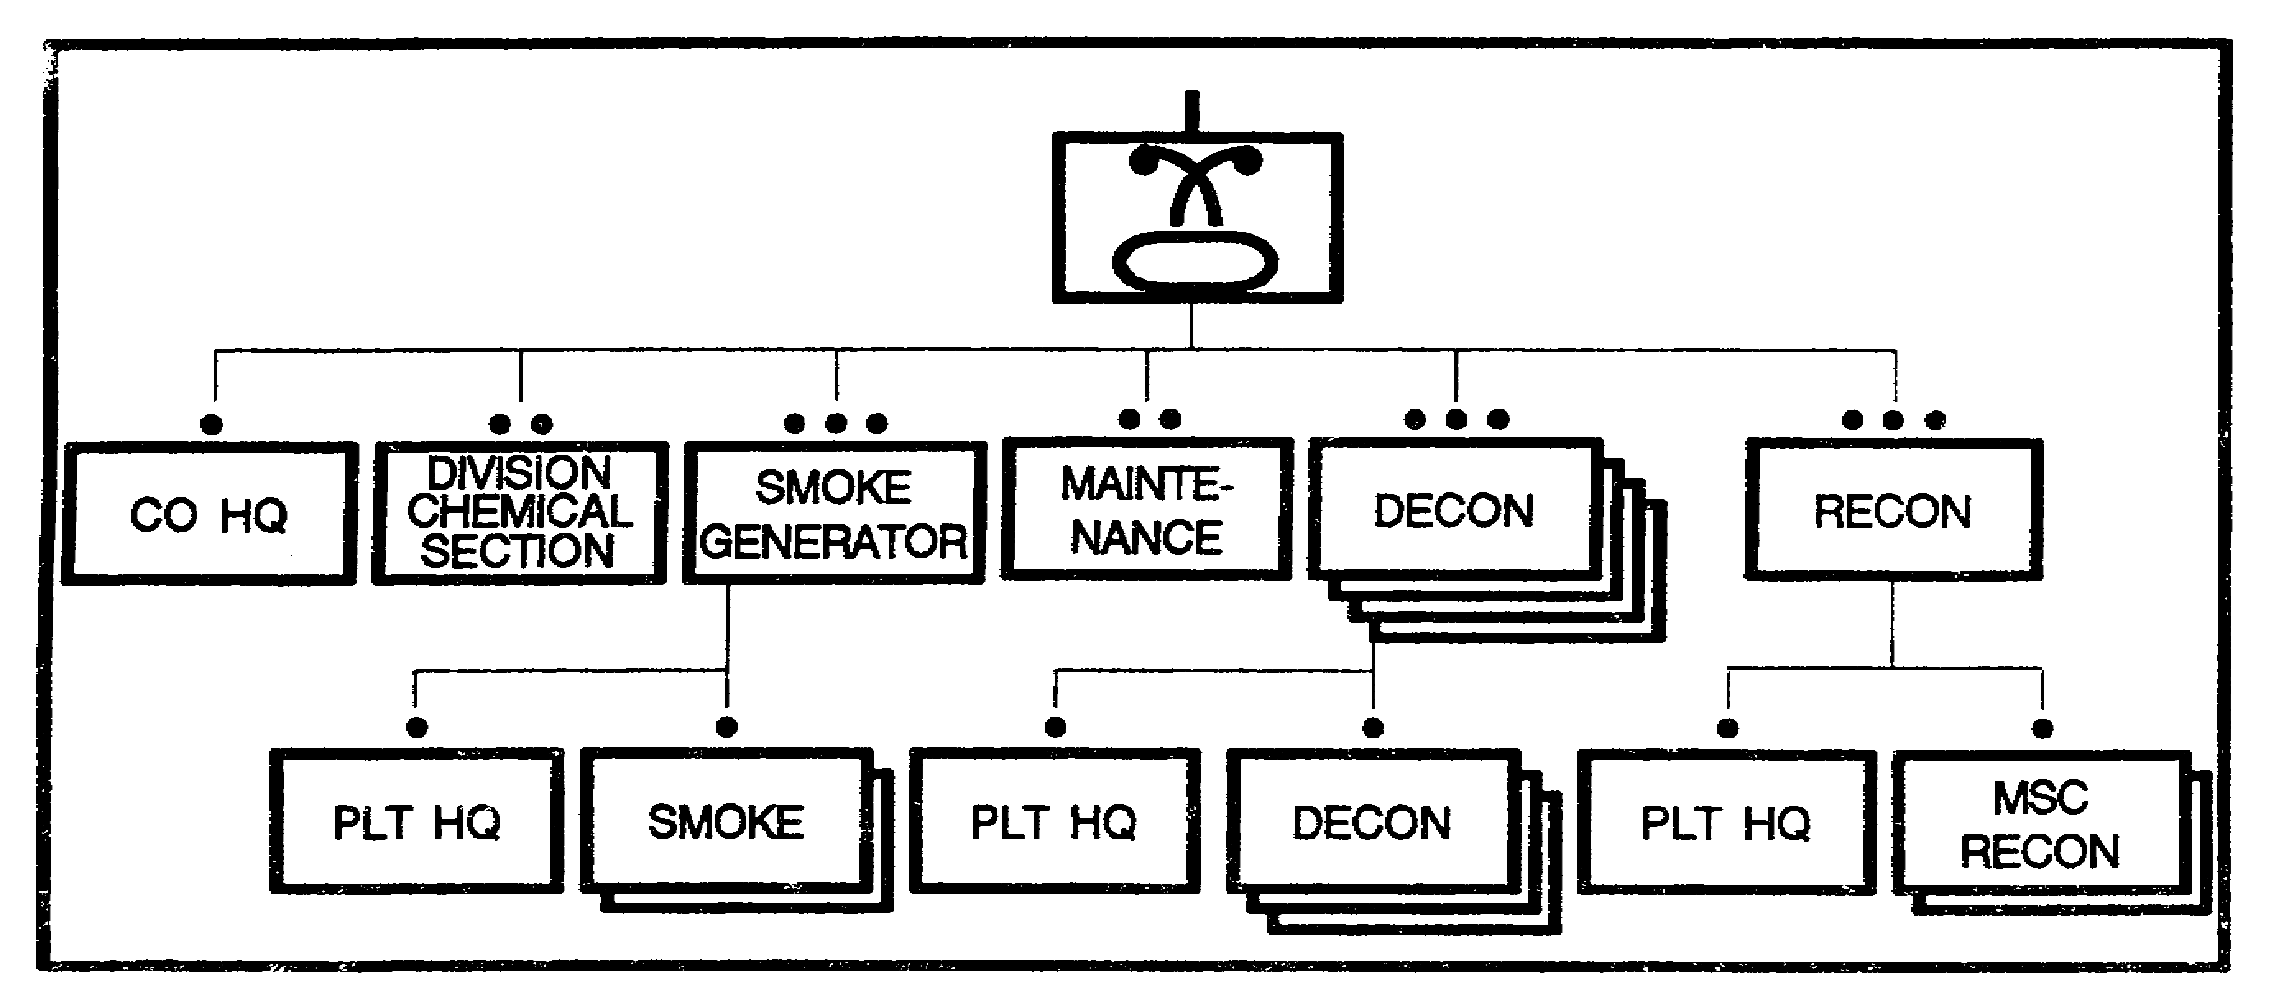

Figure 1-10. Chemical Company.

o Supervises NBC training throughout the command.

Military Intelligence Battalion (Figure 1-11). Ml assets of the division are organized to meet the intelligence gathering needs of the division G2. They are assigned locations in the brigade area. Coordination is conducted through the G3. Ml elements operating in the brigade area provide information as it is generated and can help the brigade conduct its missions without interfering if they have been properly coordinated.

Direct Support Psychological Operations Company (Figure 1-12). PSYOP companies are assigned to corps and provide DS to the division as required. Figures 1-13-1-16 are breakdowns of DS and GS companies as shown in Figure 1-12. PSYOP can help the following tactical activities:

o Interdiction of enemy personnel, equipment, and facilities.

o Close fire support.

o Reconnaissance and surveillance.

o Positioning and displacement of weapons systems.

o Logistics.

1-11 IT0432

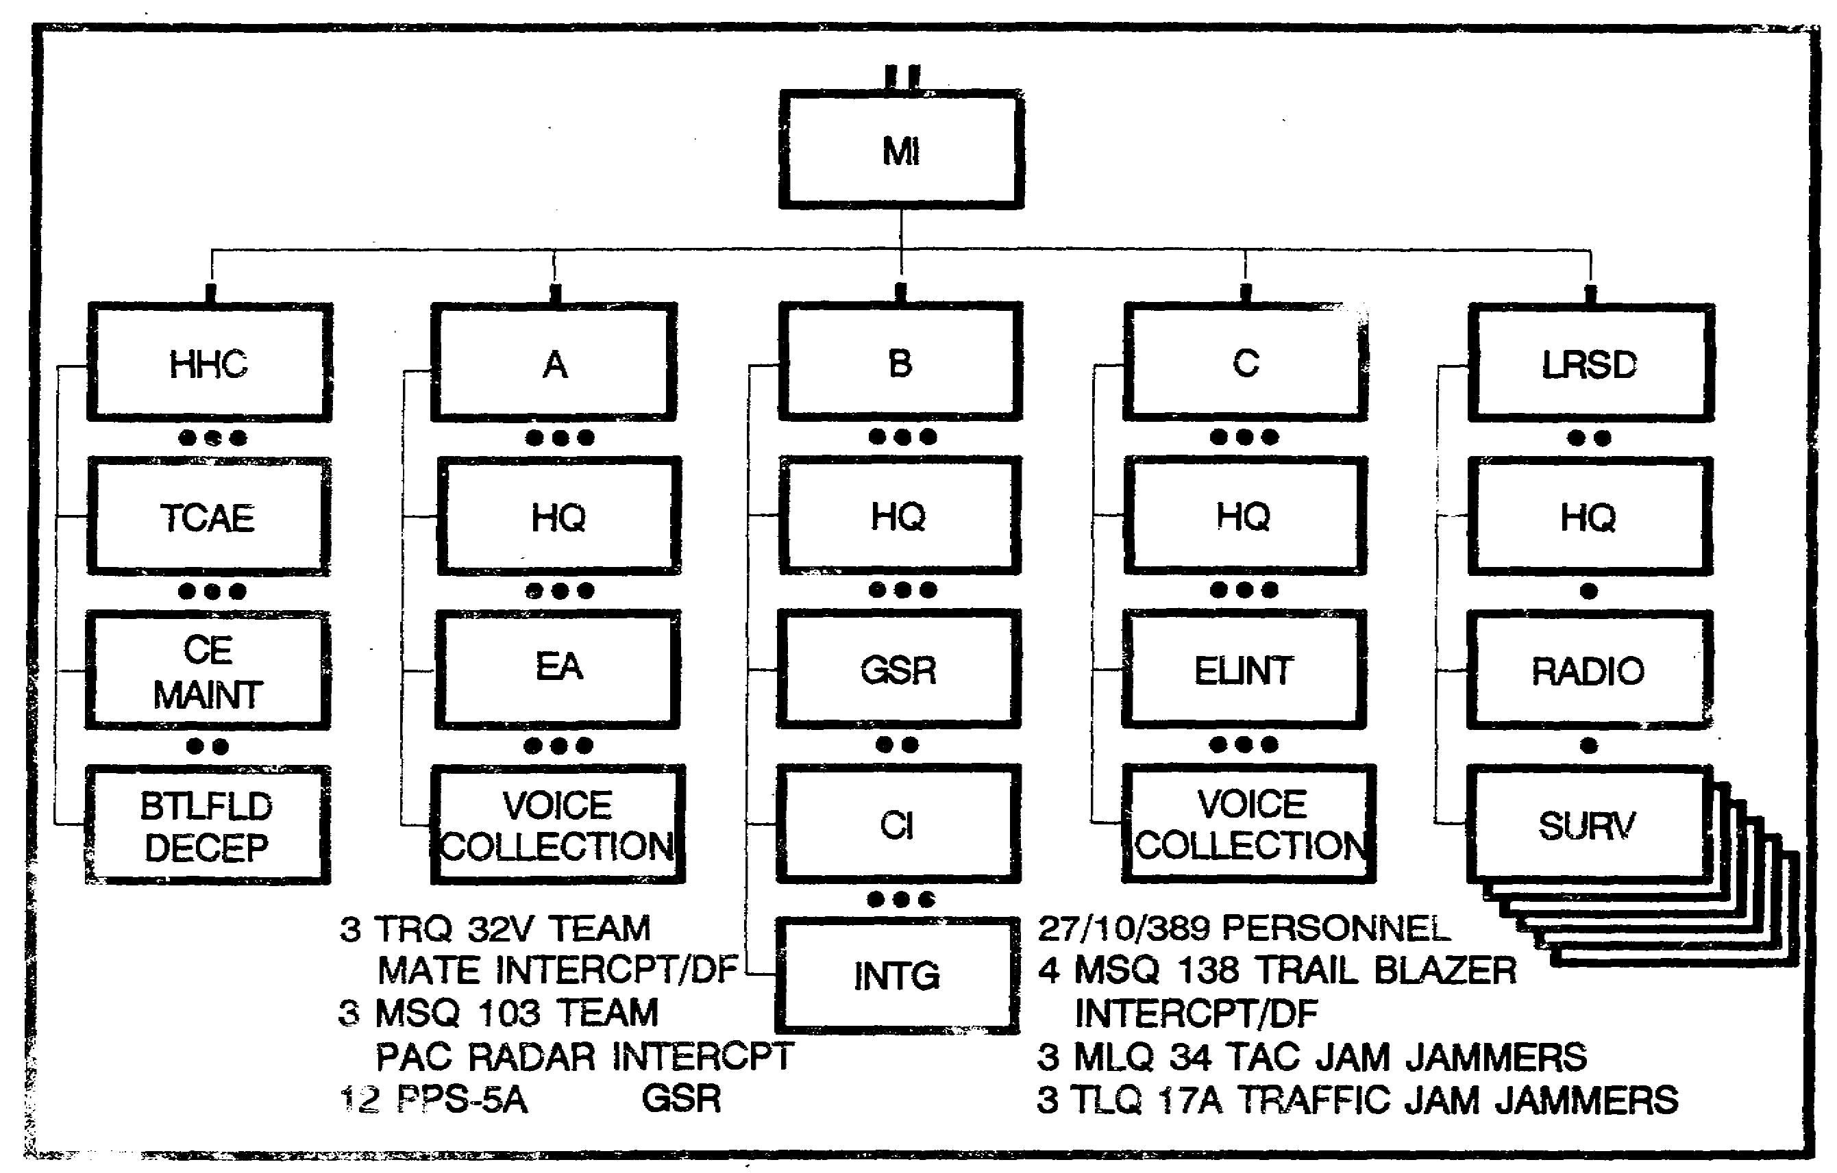

Figure 1-11. MI Battalion.

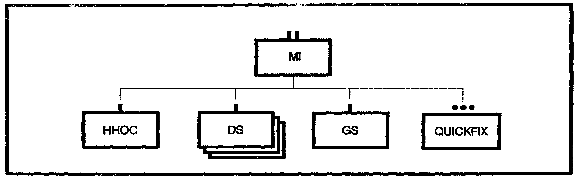

Figure 1-12. Ml Battalion (AR/MECH INF DIV)

IT0432 1-12

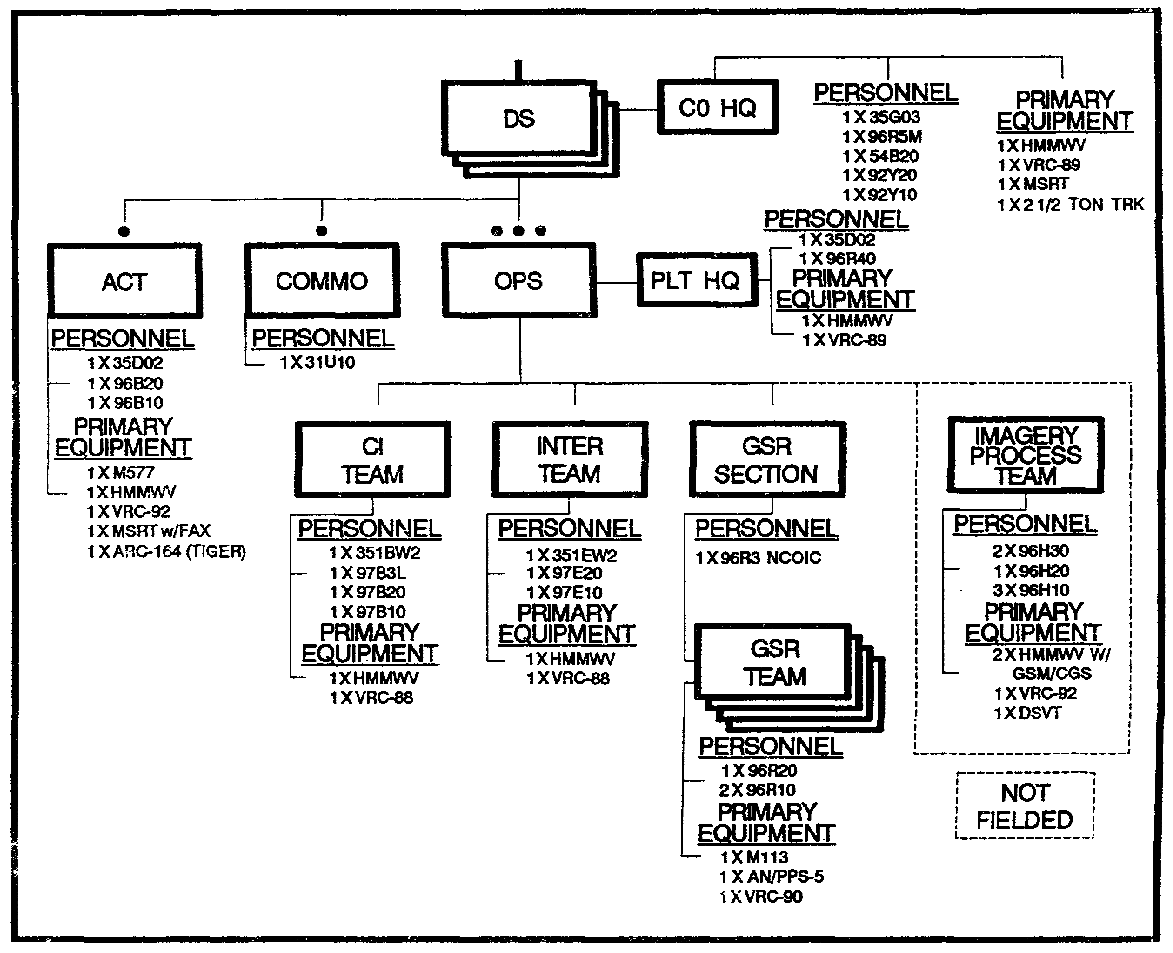

Figure 1-13. DS Company/AR and MECH INF DIV Interim Organization.

1-13 IT0432

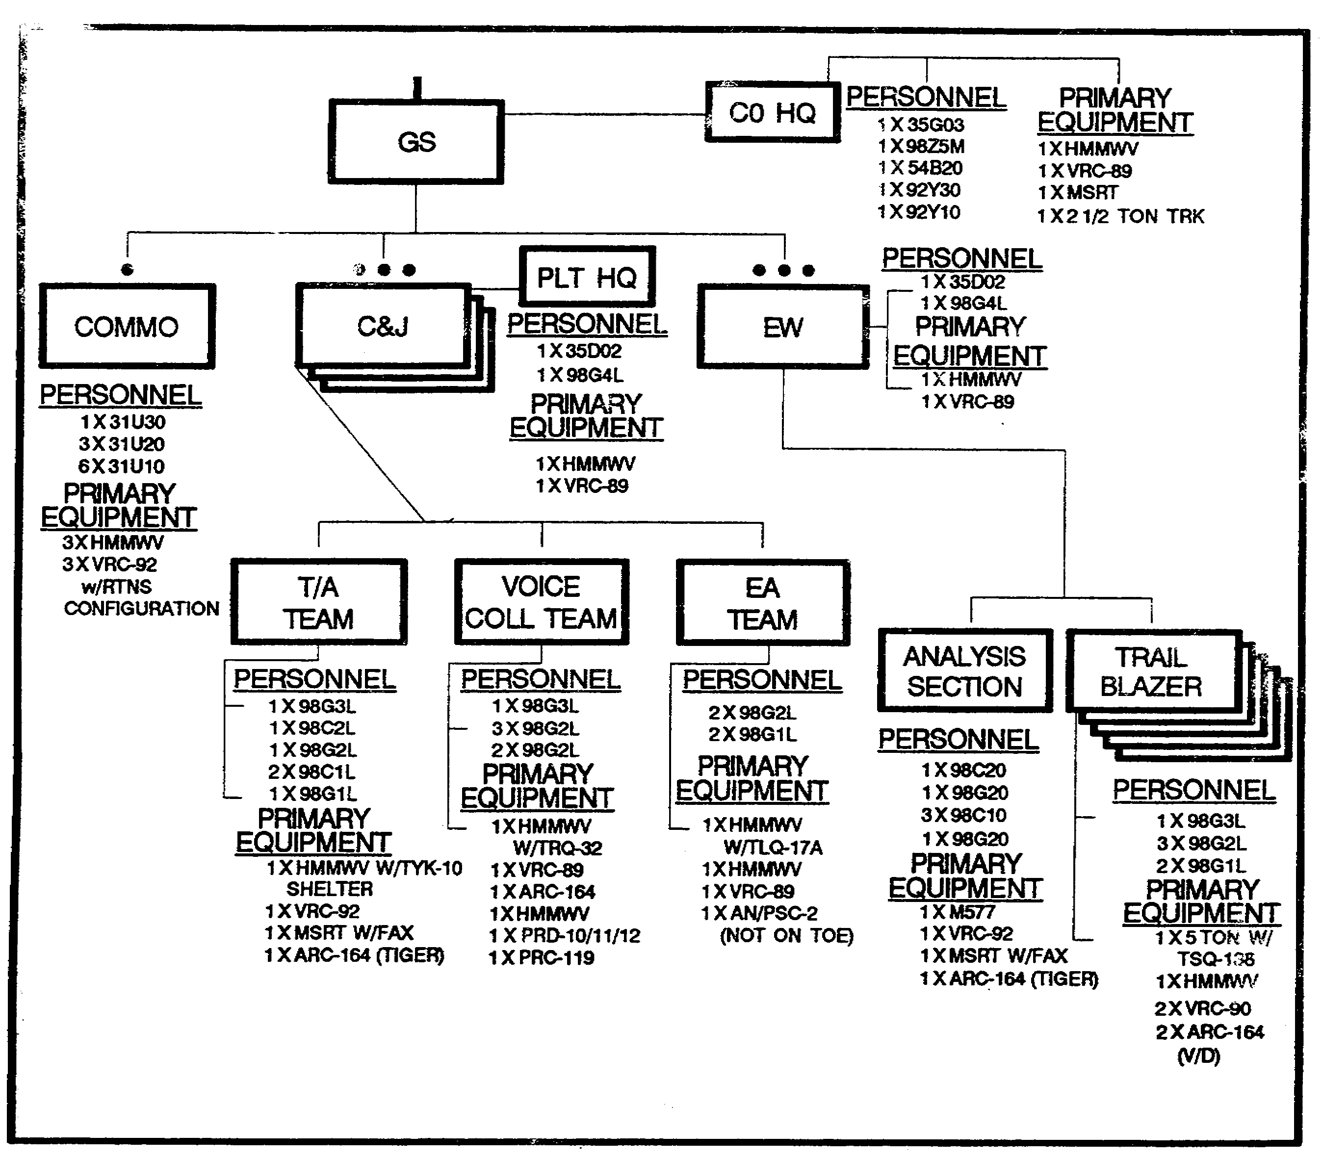

Figure 1-14. GS Company/AR and MECH INF DIV Interim Organization.

IT0432 1-14

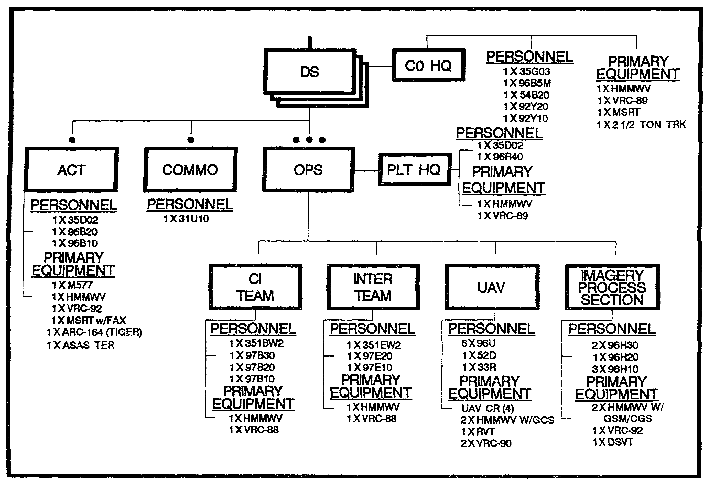

Figure 1-15. DS Company/AR and MECH INF DIV Organization.

1-15 IT0432

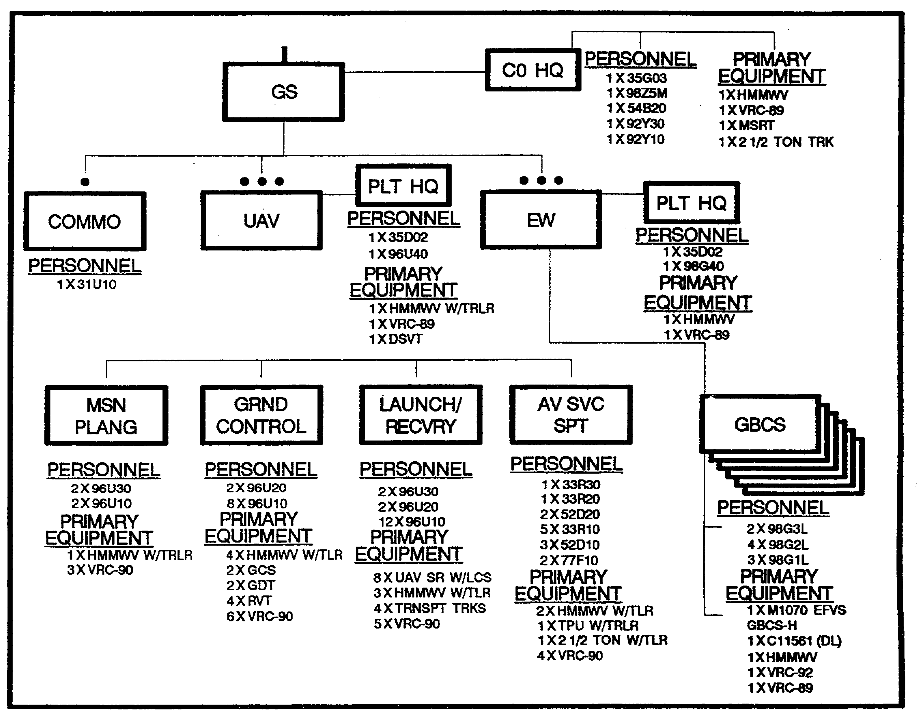

Figure 1-16. DS Company/AR and MECH INF DIV Organization.

Signal Battalion (Figure 1-17). The organic signal battalion controls and coordinates communications support within the division; operates its assigned portion of the division communications system; furnishes the signal section of the division special staff; and distributes crypto material to the organic and attached units of the division. The division signal battalion consists of a headquarters company, a command operations company, a forward communications company and a signal support company.

IT0432 1-16

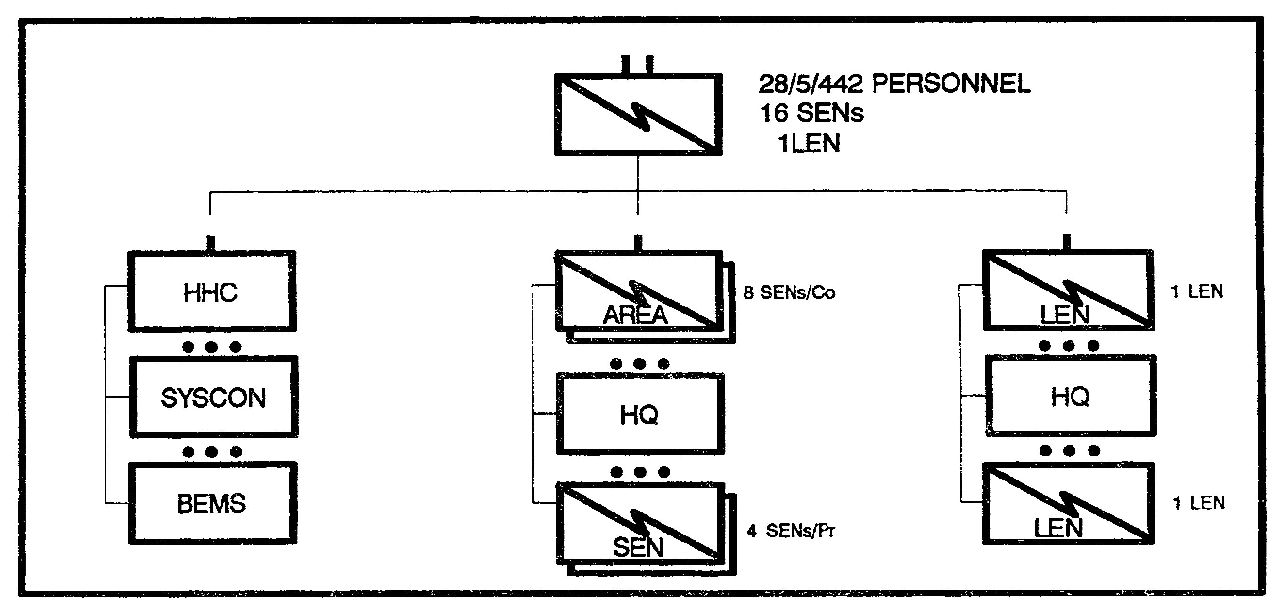

Figure 1-17. Mobile Subscriber Equipment (MSE) Signal Battalion.

The command operations company provides area common user (ACU) telephone extension nodes at the tactical, main, and rear command posts (CPs) and establishes communications nodal control elements at the division main CP and the Division Support Command (DISCOM).

The forward communications company provides ACU extension nodes to the three maneuver brigade CPs and their support areas. It also provides ACU switching support to division artillery, the aviation brigade, the ADA battalion, the Ml battalion, the engineer battalion, and one additional headquarters.

The area signal company provides additional ACU nodes and establishes combat net radio retransmission stations.

Division Tactical Air Control Party. The interface with the Air Force is provided by the ALO and his support personnel. The ALO advises the commander and staff on the employment of close air support (CAS), battlefield air interdiction (BAI), joint suppression of enemy air defenses (J-SEAD), reconnaissance, an airlift. Operating on the USAF air request net, the ALO transmits the brigade's requests for CAS and reconnaissance, coordinates CAS with the fire support element (FSE), supervises forward air controllers (FAC), and supervises the TACP.

PART E - BRIGADE COMBAT SERVICE SUPPORT

The forward support battalion (FSB) is the DISCOMs CSS operator in the brigade area. Each FSB provides dedicated division level logistic support for a specific brigade and to the units that directly support that brigade.

The FSB organization (Figure 1-18) depends on the type of brigade it supports. It has a headquarters and headquarters detachment, a supply company, a maintenance company with

1-17 IT0432

designated maintenance support teams (MSTs), and a medical company. The MSTs are tailored to support the combat arms battalion. This aligns FSB resources based on the number and type of maneuver battalions assigned or-attached to each brigade.

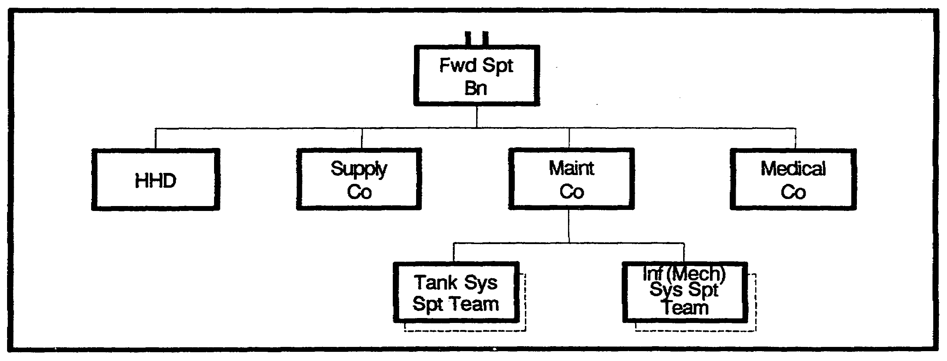

Figure 1-18. Forward Support Battalion.

Personnel support for the brigade is the CSS activity that does not fall under the direct control of the FSB. The brigade S1 supervises personnel activities and interfaces with the division staff for all matters that pertain to personnel assignment, replacement, promotions, and awards.

The FSB supply company provides supply support in the brigade area. The supply company consists mainly of the supply sections and an ammunition transfer point section.

The FSB supply company operates forward distribution points in the brigade support area (BSA). A supported unit usually picks up its supplies from those points.

Maintenance support in the brigade area is provided by the FSB maintenance company. It consists primarily of a base shop and mobile maintenance support teams (MSTs).

The mobile MSTs are structured to best support the weapons systems in the supported units. These MSTs repair vehicles, weapons systems, fire control systems, and radio systems -with primary emphasis on replacing components. Items that cannot be repaired on site are evacuated to the FSB maintenance company base shop in the brigade rear. If an item cannot be repaired there, it is evacuated to the appropriate maintenance company of the main support battalion in the division support area (DSA).

Transportation requirements in the BSA are coordinated by the FSB support operations officer and NCO. They transmit information on available transportation assets in the FSB and outstanding transportation requirements to the DISCOM movement control officer (MCO). The MCO forwards the brigade request for transportation to the main support battalion, which provides transportation support.

IT0432 1-18

Field service support in the brigade area is provided by the FSB supply company on an augmented basis. This service support includes graves registration, clothing exchange, and bath.

The medical platoon organic to the combat battalion operates the battalion aid station. The aid station is the first medical treatment site where sick and injured receive emergency treatment. This makes up the unit level health service support. Division level health service support in the brigade area is provided by the FSB medical company. The medical company treatment station provides emergency dental treatment and initial resuscitative medical and surgical treatment as well as evacuation from the BSA.

These CSS units and activities provide the continuous support that sustain the soldier and fuel, fix, arm, and move the elements of the brigade in support of the missions assigned by the higher headquarters.

PART F - BRIGADE OFFENSIVE OPERATIONS

The key to success in the brigade fight is its ability to synchronize subordinate maneuver battalions and integrate the Battlefield Operating Systems (BOS) in support of the brigade effort. The brigade in the offense has the following capabilities:

o T he armored or mechanized infantry brigade performs tactical tasks under the command of a division or corps headquarters. The heavy brigades receive varying numbers of tank and mechanized infantry battalions for a specific mission and additional combat, CS, and CSS units as necessary.

o The brigade accomplishes missions that conform to the higher commanders intent while meeting the intent while meeting the intent of the commander two levels up.

Brigades do not normally act independently but as part of a division or corps that conducts operations to attain tactical goals.

Heavy brigades have a high density of organic tracked vehicles that impose limitations the staff planner must consider. Some of these limitations include--

o Dense jungles and forests, steep and rugged terrain, and significant water obstacles restrict mobility.

o Substantial quantities of heavy equipment slow strategy mobility.

o The heavy brigade consumes large amounts of Classes ill, V, and IX.

The battlefield (Figure 1-19) is generally divided into three areas of operations (AO): deep, close, and rear. Deep and rear operations are essential to winning close operations. Deep, close, and rear operations are inseparable at the division level and higher. The brigade commander, due to the limitations of his organic weapons systems, does not normally conduct separate deep operations beyond nominating targets to his higher headquarters.

1-19 IT0432

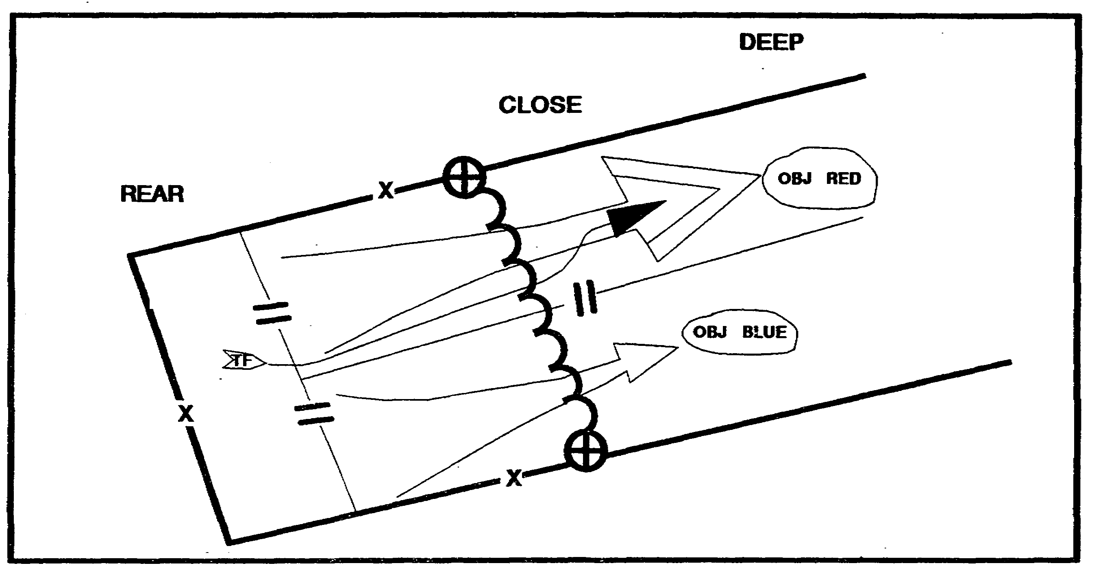

Figure 1-19. Battlefield Framework.

The brigade commander develops his intent and accepts risks to achieve decisive results. He must understand the intent of both the division and corps commanders to properly employ his forces.

Brigade tactics emphasize maneuver and firepower. Maneuver positions strength against weakness, throws the enemy off balance, and aggressively follows up to complete the enemy's defeat and destruction. This is done by synchronizing all organic and supporting assets to produce overwhelming combat power. Inherent in Battlefield Operations is the simultaneous attack of enemy forward forces, the defeat of enemy elements in our rear areas, and the deep attack of follow-on echelons. The brigade must conduct close operations to defeat the enemy while protecting its own CS, CSS, and C² facilities through effective rear operations. The brigade must be ready to exploit every opportunity by fighting in depth to disrupt the enemy timetable by combining fires, barriers, and maneuver forces during combat operations. Deep operations open opportunities for decisive action by slowing the enemy's closure rate and creating periods of friendly superiority to gain or retain the initiative. Deep intelligence preparation of the battlefield (IPB) and timely intelligence from organic and higher level sources are key to success.

Operations Tenets. The tenets of Operations are initiative, depth, agility, and synchronization.

Initiative is the ability to set the terms of the battle by action. It implies an offensive spirit when conducting an operations. To do this, the brigade commander trains subordinates to take risks and to be bold, innovative, and aggressive. By understanding the intent of the corps and division commanders, the brigade commander may operate confidently with the mission orders and boldly exploit success.

IT0432 1-20

Depth is measured in time, space, and resources. Brigade commanders use the entire depth of the battlefield to strike the enemy. They do this to prevent the enemy from concentrating firepower and disrupting friendly forces.

Agility requires flexible organizations and quick minded, flexible leaders who can act faster than the enemy.

Synchronization of operations is essential to obtain maximum combat power from the combined arms team. It requires a C² system that can mass and focus the combat power of the brigade at the decisive time and place.

Offensive Fundamentals. Brigades normally conduct offensive operations to support a division or corps operation. These operations include servicing as the division main attack, supporting attack, follow and support forces, or the reserve.

The offensive is the commander's primary means of gaining the initiative. Through constant offensive pressure on the enemy, the commander is best able to retain his own freedom of action and force the enemy to conform to his intent. Even in the defense, the commander seeks to regain the initiative through offensive action at the earliest opportunity.

The success of the attack depends on synchronizing combat power in time an space against enemy weaknesses. This is done by applying offensive characteristics of concentration, surprise, speed, flexibility, and audacity. One method of achieving concentration is narrowing the zone of the main attack, thereby producing an advantage of combat power at the point of attack. Brigade commanders must balance the requirement for concentration with that of presenting a lucrative target for enemy counterattacks by indirect conventional, chemical, or nuclear fires. Concentrated combat power is also achieved by allocating and shifting priorities of fire support at the point of the attack. This may require an economy of force elsewhere in a brigade area, using supporting attacks to fix the enemy in position, or pulling the enemy from the area of main attack and taking calculated risks.

Offensive Characteristics. Successful brigade offensive operations require surprise, speed, flexibility, audacity, and agility. Surprise is achieved by attacking in an unexpected manner or at unexpected locations and times. Speed and the flexibility to rapidly shift the main effort and take advantage of enemy vulnerabilities and weaknesses contributes to success. Brigade commanders must be audacious and able to take advantage of tactical situations as they develop.

Offensive Framework. The offensive framework has five complementary elements that cannot be viewed separately. They are woven into the overall plan so that, collectively, they contribute to successful offensive operations. These elements are--

o Operations in depth. Normally the brigade does not conduct separate deep or rear operation. In vital parts of the attack zone, deep operations contribute to the success of the brigade close fight. Deep operations limit the enemy's options and disrupt coordination and synchronization. Brigade deep operations depend on and are closely linked with the division close concept of the operation. Identifying division deep operations helps the brigade target units and set priorities for brigade operations in depth.

1-21 IT0432

o Reconnaissance and security operations. These are conducted forward and to the flanks and rear of the main and supporting attacks.

o A main attack and supporting attack. The brigade commander designates the main effort and allocates the requisite combat and CS assets to ensure it success.

o Reserve operations. The brigade commander clearly designates the reserve force and its potential missions and ensures the reserve's availability for commitment at a decisive time and place.

o Rear operations. Rear operations are necessary to maintain freedom of action and offensive momentum in the brigade's close fight. This may include fighting enemy airborne and air assault units within the BSA until augmented by the tactical combat force (TCF) as well as the necessary activities to sustain the brigade's offensive momentum.

Battlefield Operating Systems. Successful offensive operations require the total coordination, integration, and synchronization of all combat, CS, and CSS elements within the brigade AO. Synchronization of the operating systems occurs vertically from corps and division through brigade to battalion and separate companies. It also occurs horizontally among the staff sections. Let's look at some considerations for each of the battlefield operating systems.

Maneuver. The commander task organizes maneuver forces for the brigade mission. Each subordinate maneuver commander must fully understand the intent of the brigade commander when developing orders. Only when all of the subordinate unit commanders understand the entire scheme of the operation can the unit enjoy the flexibility and initiative necessary for successful offensive operations.

In the offense, maneuver commanders continuously look for ways to maintain the initiative and exploit enemy weaknesses. Rapid movement, shock action, and aggressive positioning characterize the offense. The scheme of maneuver is the keystone for coordinating all the other elements of combat power.

Intelligence. The brigade commander's guidance to the S2 contains the commanders Priority Intelligence Requirements (PIR). After coordinating with the S3, the staff may recommend additional intelligence requirements to the commander during the S2 and staffs IPB.

It is especially critical that the brigade S2 prepare an up-to-date enemy data base during the IPB process to support offensive operations and to answer the commander's PIR. The S2's threat estimate and data base help identify specific enemy vulnerabilities and weaknesses. This information helps the brigade commander properly concentrate available combat power.

The development of PIR and IPB is a continual process throughout the planning and execution of the offensive operation. The brigade intelligence section answers PIRs using a detailed reconnaissance and surveillance plan developed and coordinated by the brigade and TF S2s and S3s. The brigade S2 requests additional information and collection assets from division when brigade's organic assets cannot meet the commander’s PIR.

IT0432 1-22

During the operation, the brigade S2 continually briefs the commander on enemy activities and anticipated enemy courses of action. Sources of information include reporting from MI assets, eavesdropping on battalion operations and intelligence nets, analyzing reported sightings, and developing situation templates of the enemy.

Fire Support. Fire support can deliver a variety of munitions to support deep, close, and rear operations. Fire support assets available to the brigade are normally one DS FA battalion and organic battalion mortars. Additional fire support assets may include:

o Close air support (CAS).

o Naval gunfire (NGF).

o Army aviation.

o Reinforcing, general support, and general support reinforcing FA battalions.

The brigade FSE is the focal point for integrating all fire support for the brigade. The brigade fire support coordinator (FSCOORD) is the DS FA battalion commander. To effectively integrate fire support into the operation, the FSCOORD must understand the mission, the commander's intent, and the concept of the operation. The FSCOORD must be involved in the planning process from the outset. Using the products of the IPB and target value analysis (TVA) processes, the FSCOORD jointly war games courses of action with the brigade commander and his staff. Following the commander’s decision, the FSCOORD produces the fire support plan and the high-payoff target list. These tools fully integrate fire support for the operation by focusing attack and acquisition systems on enemy systems that must be eliminated or neutralized. The FSCOORD ensures fire support assets are properly employed and synchronized.

Specific considerations for employing fire support in offensive operations include--

o Employing weapons and target acquisition systems well forward to provide continuous in-depth support without untimely moves.

o Weighting the main attack by assigning priorities of fire support to the main effort.

o Using smoke to obscure portions of the battlefield.

o Isolating the point of attack.

o Destroying or softening enemy defenses by delivering effective preparatory fires.

o Screening enemy weapon systems to reduce the enemy stand-off capability.

o Interdicting enemy counterattack forces, isolating the defending force, and preventing its reinforcement and resupply.

1-23 IT0432

o Supporting rear operations.

Air Defense. The division commander's ADA priorities determine what ADA resources the brigade will receive. Normally, the brigade receives a battery of ADA attached, OPCON, or DS. The air defense officer must understand the commander's mission, intent, and concept of the operation. The ADA officer's continued integration in the planning process is critical to the successful integration of ADA support with the brigade concept. The brigade S3 also must consider terrain requirements to optimize ADA weapon systems and coverage of forward area alerting radar (FAAR).

Considerations for employing ADA in offensive operations should include--

o Mix guns and missiles.

o Concentrate ADA to achieve massive fires at decisive points.

o Integrate ADA weapon systems throughout the brigade.

o Weight the main effort with ADA protection.

o Identify potential choke points and plan their protection.

o Be sure the supporting ADA unit has the same mobility as the supported forces.

Mobile systems and man-portable air defenses systems (MANPADS) protect the maneuver force in the forward area. If MANPADS are used in the forward area, the commander must provide armor protection, C2, and early warning.

The ADA battery should be task organized to support the operation from the line of departure (LD) to the objective. In the offense, the following are normal AD priorities:

o Maneuver forces.

o Chokepoints.

o Command, control, communications, and intelligence (C3I).

o CSS assets.

The entire combined arms team has a role in counterair operations. All units practice air defense early warning and passive air defense measures. Also, tanks, crew-served weapons, indirect fires, IEW systems, and attack helicopters provide added all-around protection to the force and complicate the enemy air attack mission. During offensive operations beyond the range of FAAR coverage and voice communications, special provisions for early warning throughout the brigade must be planned, coordinated, and implemented.

Mobility, Countermobility, and Survivability. The brigade engineer plans and coordinates mobility, countermobility, and survivability tasks to support the offensive. The brigade engineer links engineer planning at division level and execution at battalion TF level.

IT0432 1-24

The unit can expect augmentation from elements of the corps engineer brigade. These additional assets can bring engineer strength supporting the brigade to battalion size or greater. Leads TFs are normally task organized with at least one company of combat engineers to provide adequate support in the offense, particularly to mobility operations.

In offensive operations, priority of engineer support is to mobility missions. This priority requires maneuver and engineer assets to breach obstacles, maintain forward momentum, and ensure routes are open to facilitate logistic support.

Countermobility planning in the offense requires the brigade engineer to coordinate use of the Family of Scatterable Mines (FASCAM) delivery assets to close potential flank avenues of approach, fix enemy counterattack forces, and close retreat routes for engaged enemy units. On consolidation to the objective, emplaced obstacles are defended against enemy counterattacks.

While survivability missions are of lower priority during offensive maneuvers, they become more important on consolidation of the objective and must be anticipated.

The brigade commander must give the brigade engineer clear guidance and priorities for engineer effort. The brigade engineer is an integral part of the development of the scheme of maneuver and he must coordinate with the S3, FSO, ALO, MPs, chemical officer, ADA officer, S2, and S4 to plan engineer support.

Combat Service Support. CSS operations in the offense are designed to maintain the momentum of the attack. The FSB commander prepares and executes a logistics plan to support the maneuver brigades tactical plan. The FSB commander commands and controls all elements inside the BSA.

The brigade S4 identifies and coordinates specific logistic needs of the maneuver brigade. Based on the brigade S4's estimate, the FSB commander and his staff tailor a mobile CSS forward support package to support the brigade. The FSB S3 and brigade S4 coordinate locations for ammunition transfer points (ATPs), unit maintenance collection points (UMCPs), and main supply routes (MSRs) outside of the BSA at the rear CP. The brigade S3 approves them. This coordination ensures the integration of the CSS plan and the tactical plan.

FSB logistic support must be continuous. The FSB moves priority supply classes by bounds to support the momentum of the offense. The movement of the FSB is coordinated among the FSB, rear CP, and main CP to ensure support is continuous and that it avoids impending maneuver elements.

Command and Control. The command group, augmented by members of the special staff as the commander desires, locate where they can see and sense the battle. By being well forward, the commander can feel the tempo of the battle, improve communications, and influence the main effort. The command group moves much of the time and relies on the brigade Tactical Operations Center (TOC) to maintain communications with higher and flanking units.

1-25 IT0432

The tactical (TAC) CP and the main CP move frequently during offensive operations. The TAC CP performs the C³I function for the main CP during these relocations. Therefore, the TAC CP may have additional people from the current operations, intelligence, operations support, and fire support sections of the main CP. The signal section leapfrogs multichannel and FM retransmission systems forward to maintain communications.

The main CP performs essential current battle coordination; however, it weights its effort toward future battle planning. This is possible because the disruption of frequent displacement has caused much of the C³I structuring for working the current battle to be pushed forward to the TAC CP and command group.

The rear CP and FSB commander are heavily committed to coordinating and facilitating the pushing of CSS forward through the cluttered battlefield to sustain the attack. The rear CP and FSB commander are initially concerned with sustaining forward units; providing rear area security; clearing MSRs; evacuating casualties, equipment, and Enemy Prisoners of War (EPW); and preparing to reestablish CSS base areas forward.

Other elements, while not directing parts of the battlefield maneuver operation systems, are necessary to the conduct of operations at the brigade level.

Brigade Maneuver. The five basic forms of maneuver are envelopment, turning movement, infiltration, penetration, and frontal attack. It can participate as one element of a turning movement conducted by corps. Subordinate infantry units can conduct an infiltration as part of the brigade's larger mission.

Envelopment. Envelopment (Figure 1-20) is the basic form of maneuver that seeks to apply strength against weakness. Envelopment avoids the enemy's front where forces are most protected, attention is focused, and fires are most easily concentrated. The attacker fixes the defender with supporting attacks. The attacker maneuvers the main attack around or over the enemy's defenses to strike at its flanks or rear. If there are no open flanks or gaps leading to a flank, gaps can be created by fires, fire and movement, and through deception operations.

IT0432 1-26

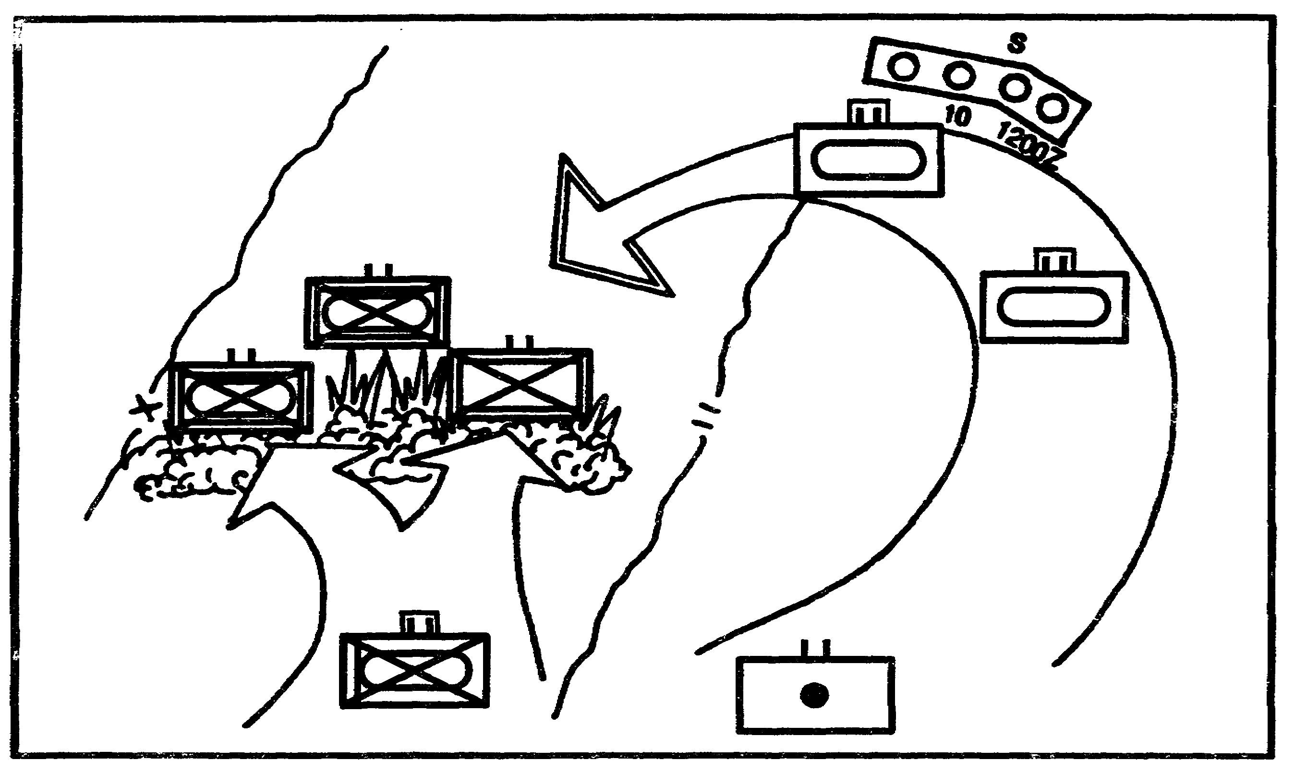

Figure 1-20. Envelopment.

Successful envelopment often depends on speed to prevent the enemy from reacting quickly and with enough force to slow the attack. Remaining battalions than maneuver past the enemy flank to rear positions. The enemy is then forced to fight in several directions or abandon positions.

Envelopment is the preferred form of maneuver. The double and aerial envelopment are variations of the envelopment.

Turning Movement. A turning movement (Figure 1-21) is a large scale envelopment in which the attacking force passes over and around the enemy defense to secure objectives deep in the enemy rear. Brigades participate in turning movements as part of a larger force.

Infiltration. Infiltration (Figure 1-22) is the covert movement of all or part of the attacking force through enemy lines to a favorable position in the enemy rear. A heavy brigade cannot expect to infiltrate all its combat elements through the enemy defense. The brigade attacks after infiltration or infiltrates to obtain intelligence and to harass the enemy.

1-27 IT0432

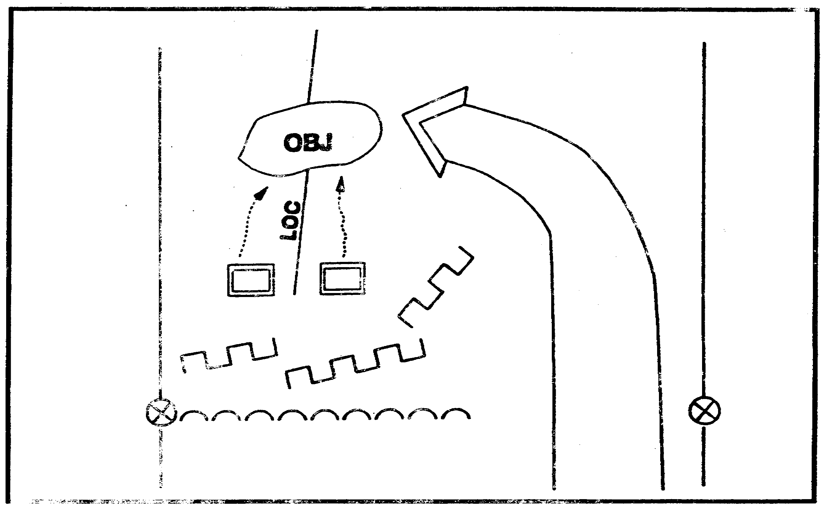

Figure 1-21. Turning Movement.

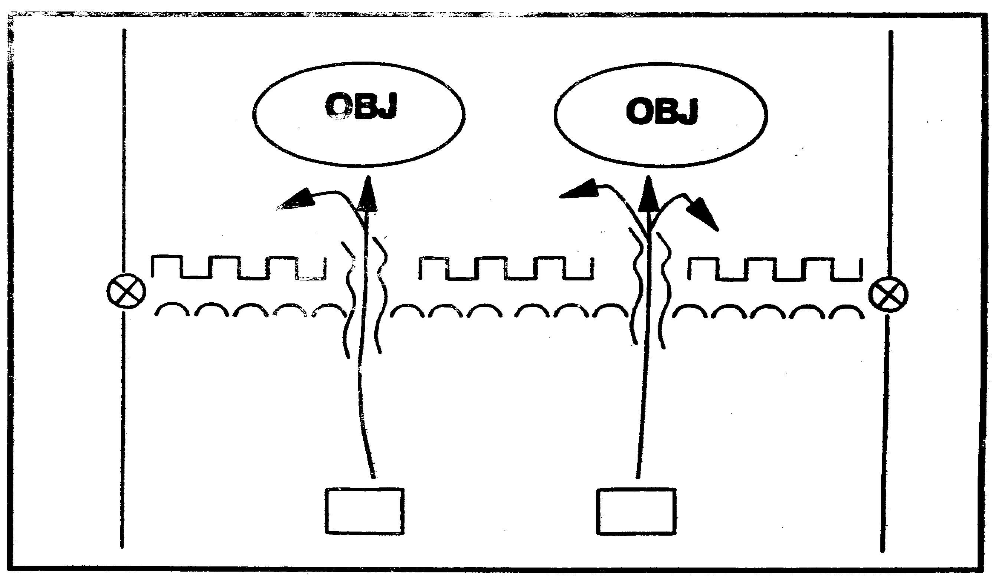

Figure 1-22. Infiltration.

IT0432 1-28

Penetration. The penetration (Figure 1-23) attempts to rupture enemy defense on a narrow front and create both assailable flanks and access to the enemy rear. Penetration is used when enemy flanks are not assailable, when enemy defense is overextended, or when time does not permit some other form of maneuver. Penetrations typically comprise three stages: initial rupture of enemy positions, roll-up of the flanks on either side of the gap, and exploitation to secure deep objectives.

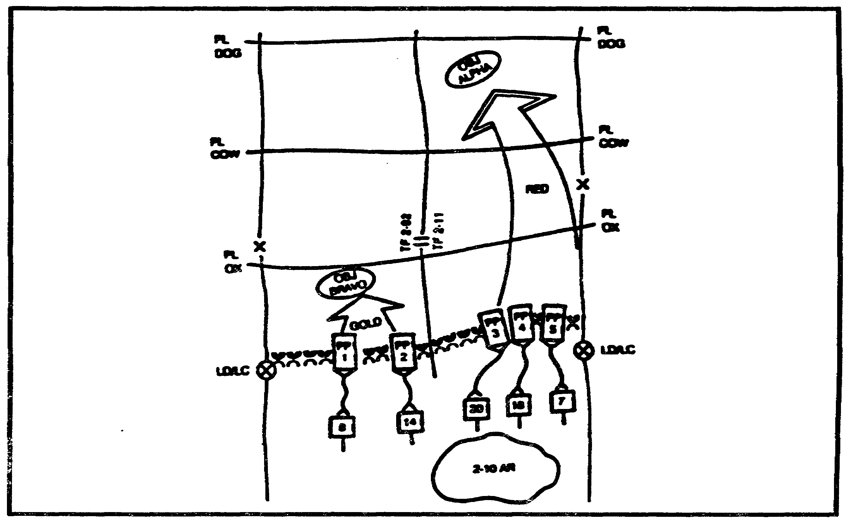

Figure 1-23. Penetration.

A successful penetration depends on the attacker's ability to suppress enemy weapons, mass forces and fires to overwhelm the defender at the point of attack, and quickly pass sufficient forces through the gap to rupture the defense. Once this is accomplished, the commander has two options. He can continue forward to rupture successive defense lines and ultimately enter enemy rear areas, or he can turn forces to roll-up enemy positions from the flanks. A successful penetration requires concentration of maneuver forces on a narrow front, synchronized fire support, and attack helicopters.

Two or more battalions can make the main effort to create and widen a gap in the enemy defense and hold the penetration open while an additional battalion is held ready to pass through the gap into the enemy rear. This type of attack is normally required when attacking strong, well-prepared enemy defenses.

Two or more battalions can make the main effort to punch through enemy defenses into the enemy rear while an additional battalion fixes enemy forces in position. A small reserve may be set up if there are sufficient forces. This type of operation is normally conducted against enemy defenses that extend over a wide area.

1-29 IT0432

One battalion can make the main attack while remaining battalions are held ready to pass through. Under these circumstances, it may be necessary to fix enemy forces elsewhere by indirect fire or by deception. This type of operation may be conducted when attacking a flank, when the enemy is weak and its forward defenses can easily be penetrated, or when there is only one weak point identified due to enemy defenses or terrain.

Frontal Attack. The frontal attack (Figure 1-24) is the least desirable form of maneuver. A frontal attack strikes the enemy across a wide front and over the most direct approaches. The purpose of the frontal attack is to overrun and destroy or capture a weakened enemy in position or to fix an enemy force in placed to support another friendly attack elsewhere. During a frontal attack, the commander seeks to create or take advantage of conditions that permit a penetration or envelopment of the enemy position.

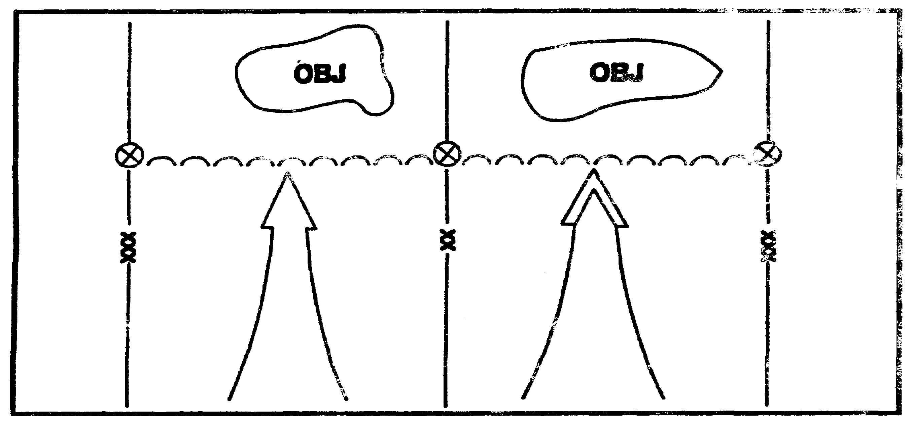

Figure 1-24. Frontal Attack.

Brigade Formations. The brigade may use any of several basic formations in offensive operations. It may attack with battalion TFs in column, in line, with or without reserves, or in variations thereof. These formations are not restrictive drills but general techniques to employ subordinate battalion TFs. After commitment to battle, the brigade can rapidly alter its formation and organization for combat to conform to the changing situation.

Brigade in Column. The brigade may form a column of battalion TFs for the initial attack when terrain or enemy defenses force it to attack on e narrow front or at night. This formation (Figure 1-25) makes it easier to retain the initiative and permits flexibility because the following battalion TFs can move through or around the leading elements to maintain the momentum of the attack. Leading companies react freely to developments at their immediate front; however, brigades in column can concentrate only a small part of their combat power to the front initially and are subject to piecemeal commitment and slow deployment to the front.

IT0432 1-30

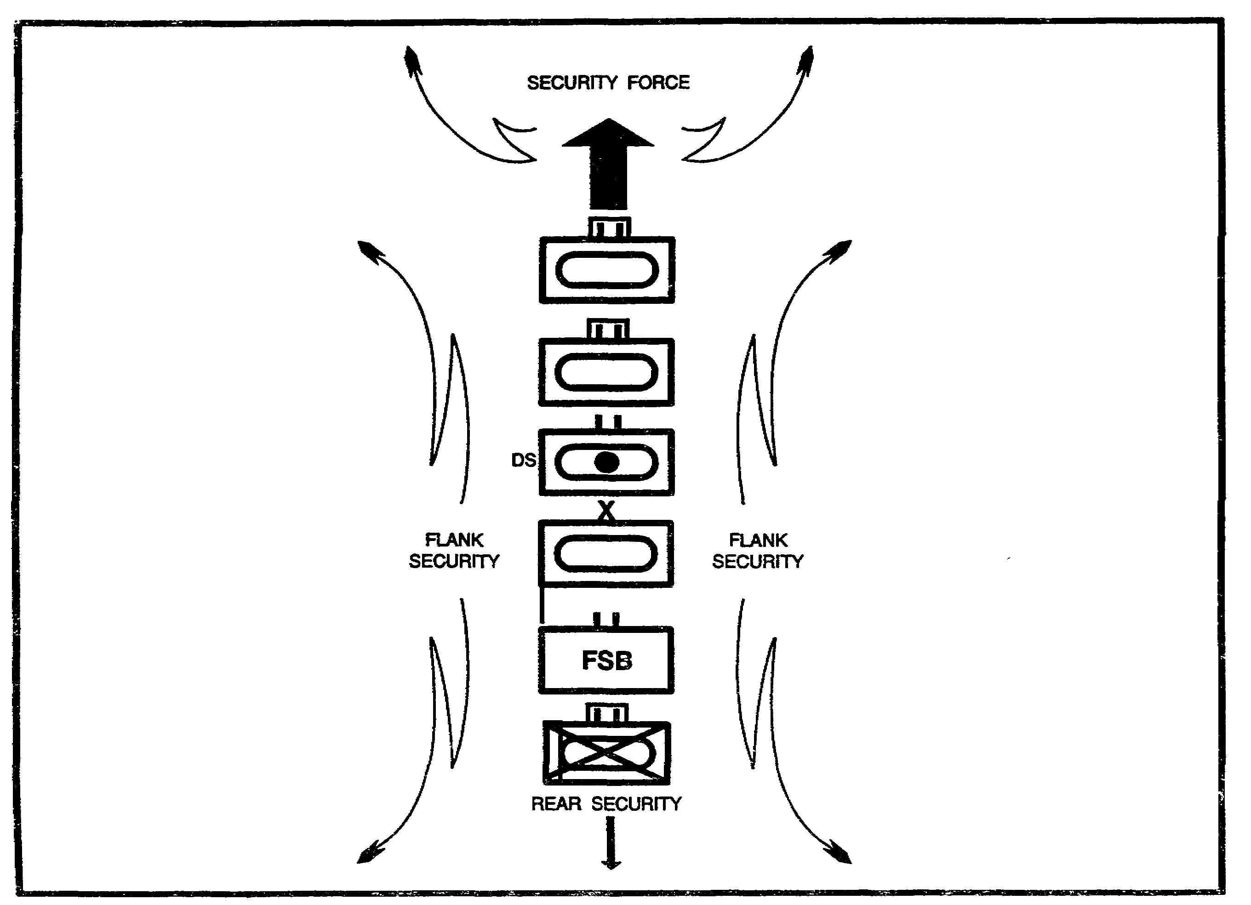

Figure 1-25. Brigade in Column.

Brigades in column are vulnerable to air attacks and counterfire. Air defense assets must be
interspersed throughout the column. Field artillery is positioned to provide counterfire during
this movement. Brigades require multiple routes in their zones if they are to attack effectively
from columns. Passage of the brigade through a given area using this formation usually
requires more time than when other formations are used.

Brigade Vee. When two or more battalion TFs of the brigade are on line, any remaining
battalion TFs may be the brigade reserve. The brigade vee (Figure 1-26) may be used when
the attack does not require great depth, such as in a limited objective attack. The brigade vee
may be used in the initial attack against a weak enemy that is vulnerable to defeat by an attack
on a relatively wide front. In the envelopment, the brigade can use this formation when it can
develop an assailable flank on a broad front. The lead TFs receive the priority of fire support.

1-31 IT0432

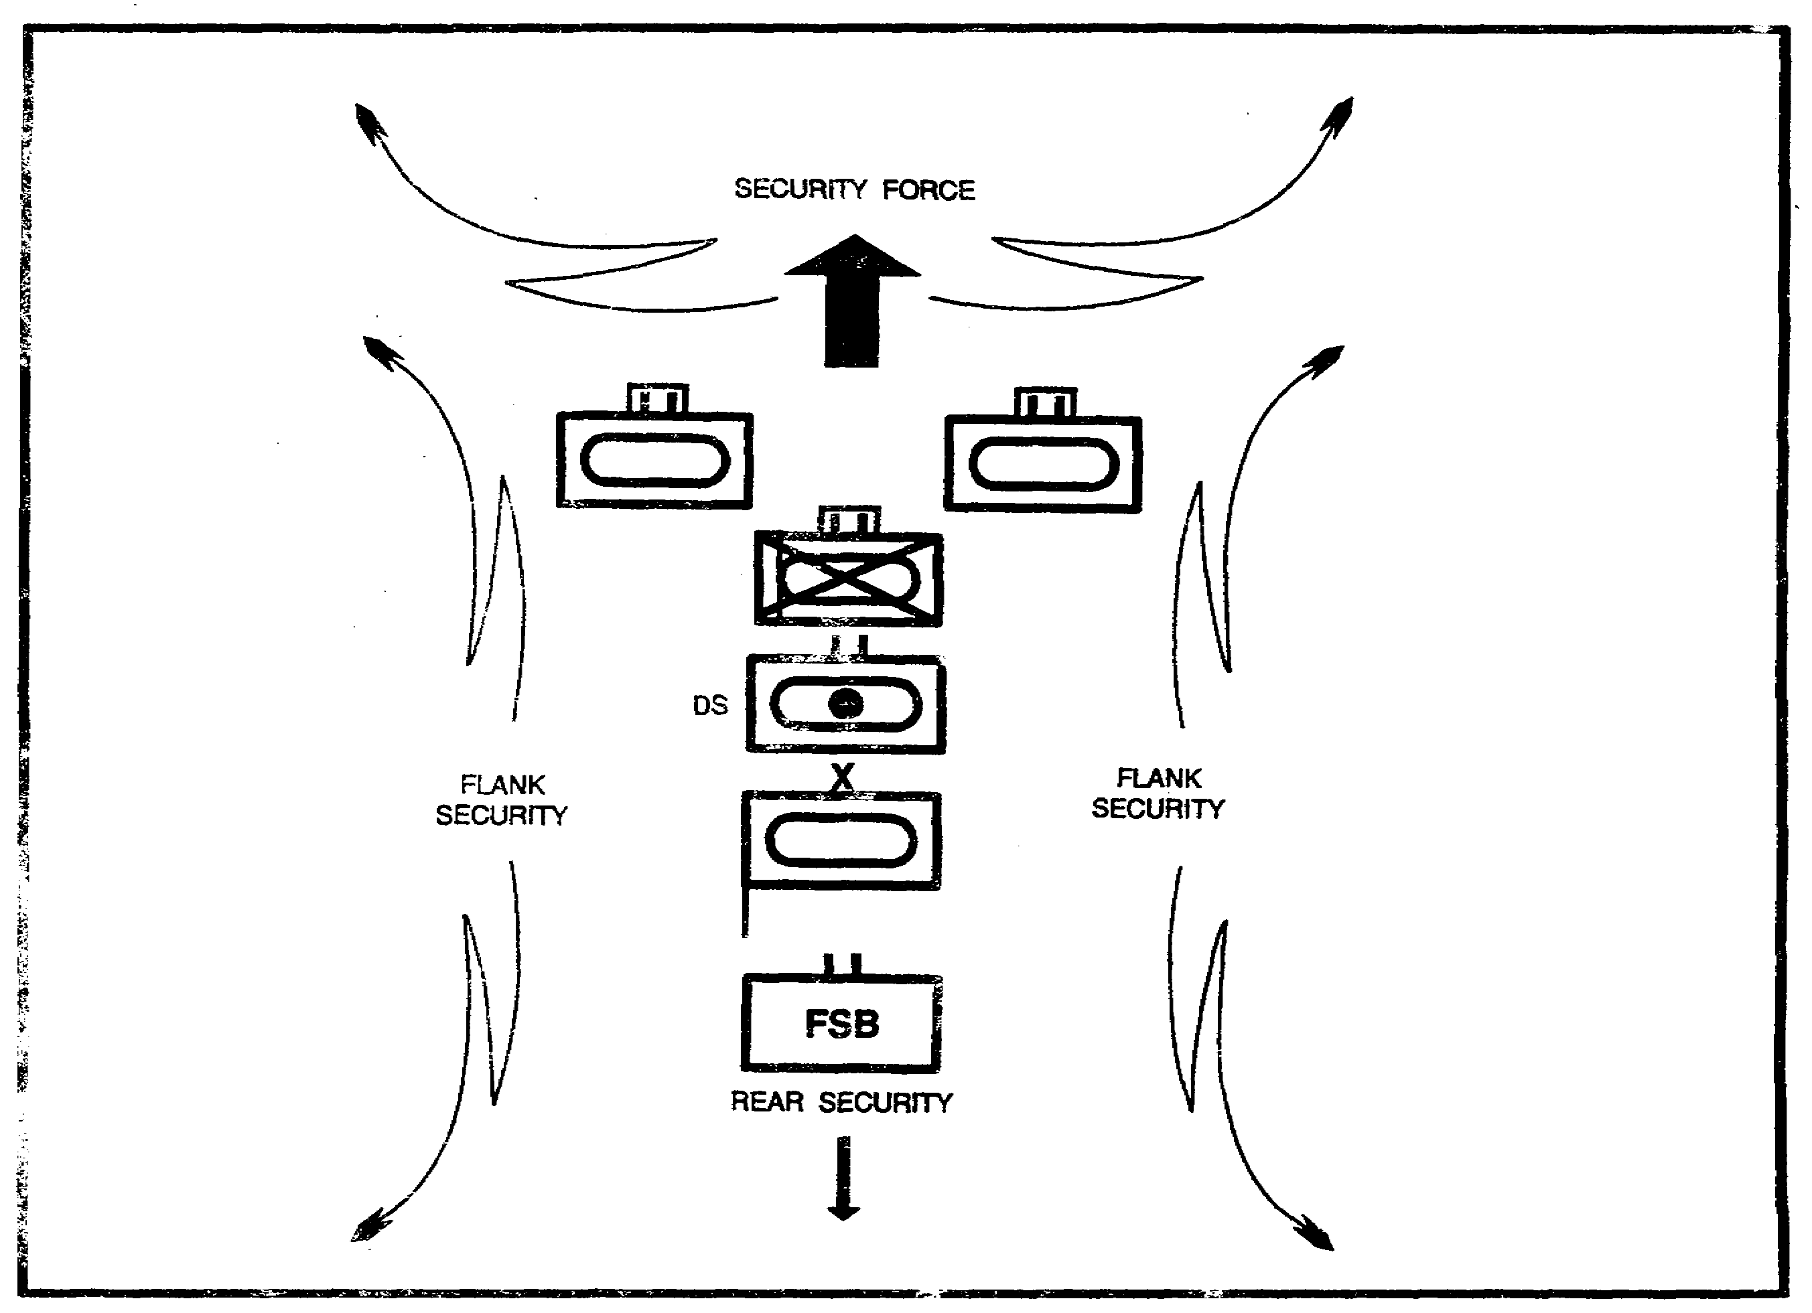

Figure 1-26. Brigade Vee.

Brigade Line Without a Reserve (Figure 1-27). Normally the brigade commander retains flexibility in his initial attack by holding part of his force in reserve; however, where METT-T warrants, a formation with two or more TFs abreast without a reserve may be successful. Inherently dangerous, it is considered when the enemy has been routed and is incapable of a large-scale counterattack. Fire support usually positions well forward to provide maximum continuous fires as the brigade attacks. The fundamental consideration in using this formation is whether the mission dictates a rapid advance on a broad front. Regardless of the initial formation for an attack, adhering to formations and fire support plans contradict the basic concepts of the attack. Subordinates freely exercise initiative to exploit enemy weakness within the context of the operation to achieve the commander’s intent.

IT0432 1-32

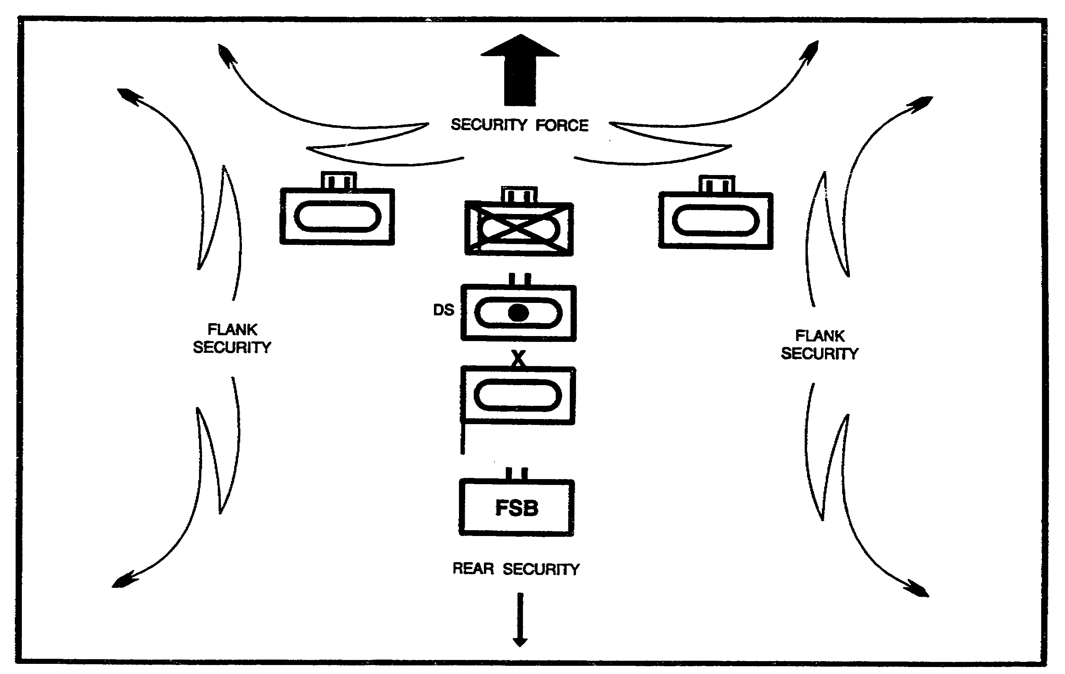

Figure 1-27. Brigade on Line Without A Reserve.

Brigade Offensive Operations. The types of brigade offensive operations are--

o Movement to contact.

o Hasty attack.

o Deliberate attack.

o Exploitation.

o Pursuit.

The brigade trains task organizes to pass from one operation to another without delay. The brigade may conduct all types of operations in sequence in a successful battle, beginning with a movement to contact to locate the enemy and ending with the destruction of the enemy through pursuit.

Movement to Contact. A unit conducts a movement to contact to gain or reestablish contact with the enemy. It develops the situation early to provide an advantage before decisive engagement. The brigade conducts a movement to contact as part of a larger formation. For instance, the brigade would conduct a movement to contact if it were the corps covering force. Decentralized control and rapid commitment of forces from the march characterize the movement to contact. It ends when the brigade occupies an assigned objective or when enemy resistance requires the brigade to deploy and conduct a coordinated attack to continue forward progress.

1-33 IT0432

During the movement to contact, the brigade can provide for its security by posting flank and rear security screens as appropriate. Forward security must be established by using a forward security force. The lead battalion TFs provide the forward security force. The forward security force conducts reconnaissance, develops the situation, destroys enemy reconnaissance elements, secures key terrain, reports and (if possible) breaches obstacles, and prevents necessary or premature deployment of the main body of the brigade.

Normally, movement is conducted in multiple columns. Subordinate battalions adopt the formations that best enable them to accomplish their mission.

To counter long-range surveillance capabilities, security for a moving force operate far enough from the main body to allow the commander adequate reaction time. Rapid movement, continuous ground and air surveillance of the brigade area of operations, and limited use of radio all enhance security.

The brigade integrates fire support into march columns and attack formations. Normally, this includes one FA battery immediately behind the lead TF with the remainder of the battalion behind the following TF. The brigade positions reinforcing FA battalions well forward, normally behind the second TF.

Brigade air defense protection is provided by all elements observing and providing fires with all available weapons. ADA occupies selected sites along the route of march and integrates into the moving column.

The decision to attack, bypass, or defend must be made rapidly at each echelon. Commanders should not hesitate to take appropriate action in the absence of orders. Main body elements may be committed to reduce pockets of resistance or bypass enemy forces. While efforts to retain the initiative remain decentralized, the decision to commit the entire force or to halt the attack remains with the senior commander.

Intelligence Support.

Intelligence on enemy movements and positions is quickly evaluated, interpreted, and integrated with information and intelligence from division or higher headquarters.

Timely intelligence supports command planning and execution.

Before, during, and after movement, the brigade intelligence system and assets provide current reports and intelligence. Brigade reconnaissance elements provide early warning on enemy activities and positions. IPB determines probable enemy dispositions and intentions. Intelligence and spot reports from maneuver and combat support units are integrated into the brigade intelligence planning and analysis.

Hasty Attack. The brigade conducts a hasty attack from a march formation without hesitation or major or detailed preparation. A hasty attack usually follows a movement to contact or occurs when unexpected enemy contact is made. The brigade conducts a hasty attack to maintain momentum with the resources immediately available. There are three phases to the hasty attack:

IT0432 1-34

o Advance of reconnaissance and security elements.

o Deployment and assault by security forces.

o Assault by the main body.

Attacking units may bypass local obstacles and stubborn pockets of resistance that do not threaten success according to the higher commander's intent. The directing maneuver headquarters retains some ability to reinforce fires and redirect maneuver with minimum instructions. An operations overlay gives each command echelon flexibility to mass forces and modify maneuver plans as the situation develops.

The most critical control measures are objectives, phase lines, checkpoint, axes of advance, and boundaries. Excessive use of intermediate objectives can reduce the momentum of the attack.

Fire support planning for the movement to contact and the hasty attack is a continuous process. The operation needs extremely responsive fire support to compensate for the relatively small amount of maneuver power initially echeloned forward. Displacement of artillery must be controlled so that fire support to committed units is not interrupted. The division continues to attack deep target, suppress enemy air defense, and provide counterfire.

The commander must visualize the critical points in the battle where deep fires will be most useful. In the movement to contact and hasty attack, tactical air support and deep fires interdict the movement of enemy counterattack forces, isolate the enemy at times and places critical to the brigade, and destroy the enemy artillery units, CPs and logistic units.

When the maneuver force attacks, the attacking maneuver battalions should receive priority of short-range air defense (SHORAD).

During movement to contact and hasty attack, engineers provide breaching support. protect the flanks with obstacles, and maintain routes.

Because preparation time is short, orders must be brief. If the hasty attacks are not succeeding, the commander may elect to establish a hasty defense on the best defensible terrain until greater combat power can be brought to bear.

Intelligence Support.

Brigade reconnaissance assets are employed well forward to provide early warning on enemy dispositions and activities. Corps and division intelligence assets assist in target and intelligence acquisition. Timely intelligence information is passed vertically and horizontally. Once enemy contact is gained, intelligence systems focus on identifying and locating enemy counterattack forces. Reconnaissance and intelligence information gathered about the enemy force allows the brigade commander to reach a sound and timely decision on the scheme of maneuver.

1-35 IT0432

Deliberate Attack. The brigade conducts a deliberate attack as part of a division or corps offensive operation. Detailed planning, coordination, integration, and synchronization of all organic and supporting assets allows the brigade to use all available combat power against well-prepared enemy defensive positions. A deliberate attack has detailed reconnaissance, thorough planning and rehearsal, rapid concentration of forces, surprise, attack on enemy weaknesses, violent execution, early shift to exploitation, and positive, aggressive leadership at all echelons of command. A deliberate attack is conducted when offensive operations are directed and--

o A hasty attack has failed.

o The enemy is well organized and cannot be turned or bypassed.

o Lead time is available for intelligence gathering and offensive preparation.

The factors of METT-T influence each situation in which a deliberate attack must be made and prevent development of a standard organization for combat. The brigade commander organizes forces to fix and maneuver against the enemy. Engineers are tasked organized to the force penetrating enemy defensive positions. An intelligence collection effort attempts to locate enemy reserves and second-echelon forces. Fire support planning fully integrates intelligence gathering sources into the targeting process.

An indirect fire preparation may be delivered immediately before the attack. Fire preparation is coordinated with the movement of attacking units depending on the amount of surprise desired or the necessity to soften the point of attack.

The brigade vigorously executes the attack plan and exploits all favorable developments. If the attack lags in one portion of the zone, the main effort shifts to another portion offering a greater opportunity for success. Follow and support units reduce isolated enemy resistance as necessary.

The attack may be a single, rapid advance and assault or it may be a series of rapid advances and assaults to obtain the same results. After the assault, attacking units disperse as rapidly as possible. This is done to avoid forming lucrative targets, continue the attack, or prepare for other operations.

The reserve is kept ready for immediate employment. The reserve moves within the overall formation of the brigade, positions to move rapidly to the point of probable employment, and provides security by its presence. When conditions dictate its use, it is committed without hesitation. The decision to commit the entire reserve or a portion thereof depends on the situation.

When the objective is secured, the brigade reorganizes rapidly and uses all means to continue the attack. The brigade makes maximum use of supporting fires during this critical period. Minimum forces normally retain control of objectives and remaining units disperse to defend themselves and the objective, prepare to continue the attack, and block enemy avenues of approach.

IT0432 1-36

Continuing the attack or exploitation must be an integral part of the attack plan. Immediate reorganization of the force is necessary to maintain momentum and prepare for the next phase.

Continuing the attack frequently depends on the ability to resupply attacking forces. The large quantities of ammunition, fuel, and equipment expended during the attack must be replenished.

During continuous day and night operations, leading elements of the brigade rotate to provide time for rearm and refit operations.

The commander anticipates halts and prepares orders to include the time and circumstances of the halt, missions and locations of subordinate units, and command and control measures.

Intelligence Support. The following are key to providing intelligence support to the deliberate attack:

o Timely intelligence is pertinent and helps the commander successfully plan and execute the deliberate attack.

o Intelligence on enemy positions, movements, undefended or weakly defended positions is evaluated and interpreted. It is integrated with other information and intelligence furnished by the parent division, other divisions, or echelons above division.

o Specific intelligence on enemy defensive positions, obstacles, and troop strengths is passed to battalion staffs and aids preparation for the attack.

o Reconnaissance by air, ground, and intelligence collection assets is continuous and aggressive prior to, during, and after the attack.

o Organic and supporting intelligence assets gather detailed information prior to the attack as part of an intelligence collection plan.

o Priority of targeting for intelligence assets is against those enemy units most likely to influence the brigade main effort.

o Locations of enemy battalion and regimental command posts, artillery, rocket, air defense control centers, and radio-electronic combat stations are ranked within the intelligence collection effort.

o Locations of units within or moving toward brigade AO that are significant to the division attack mission are identified and disseminated in a timely manner.

o Once a course of action is decide on, intelligence assets are massed to provide accurate and timely intelligence of the enemy and terrain supporting that course of action.

o The intelligence system, through the command and control process, is integrated and synchronized with the other battlefield operating systems.

1-37 IT0432

To support the deliberate attack, the brigade's intelligence system is employed to-

o Locate enemy units and determine weak areas or assailable flanks.

o Locate and determine the strength of enemy reserves and second-echelon units.

o Identify the location and strength of enemy reserves and counterattack forces.

o Determine location and disposition of enemy air defense weapons and command and control nodes.

Exploitation. Exploitation is an offensive operation that follows a successful attack to take advantage of weakened or collapsed enemy defenses. It prevents reconstitution of enemy defenses, prevents enemy withdrawal, secures deep objectives, and destroys C² facilities and enemy forces. During the exploitation, the brigade advances on a wide front (if the terrain permits) retaining only those reserves necessary to ensure flexibility, momentum, and security.

The exploitation begins when an enemy force is having recognizable difficulty maintaining its positions. Depending on the situation the brigade can exploit its own success, it can be used as an exploiting force for a higher echelon, or it can follow and support another exploiting force. The heavy brigade's inherent mobility, firepower, and shock effect make it an ideal exploiting force. Missions for the exploiting force include securing objectives deep in the enemy rear, cutting Lines of Communications (LOCs), surrounding and destroying enemy forces, and destroying enemy reserves.

The commander must be ready at all times to use every opportunity afforded by the enemy for exploitation. Exploitation opportunities are indicated by an increase in prisoners captured; an increase in abandoned materiel; and the overrunning of command posts, artillery, and supply dumps. The transition from the deliberate attack to exploitation may be so gradual as to be indistinguishable, or it may be abrupt. An abrupt transition is often the case when chemical or nuclear weapons are used in he attack. When transitioning to exploitation, every effort is made to continue the advance without halting. Enemy units are bypassed whenever possible.

Once exploitation begins, it is carried out to the final objective. The enemy should be given no relief from offensive pressure. The decision to bypass or engage enemy forces that are a threat to the brigade rests with the next higher commander. Commanders in the exploitation need freedom of action. The leading elements of the brigade habitually attack from march column to reduce roadblocks and small pockets of resistance.

Follow and support units clear bypassed areas and expand the zone of exploitation. As the exploitation brigade advances farther into the enemy rear areas, follow and support units secure LOCs, destroy enemy pockets of resistance, and expand the area of exploitation. Liaison must be maintained between lead units and follow and support units to facilitate coordination.

Decentralized execution characterizes the exploitation; however, the commander maintains enough control to keep the command from becoming overextended. Minimum control measures are used. Tactical air reconnaissance and Army aircraft maintain contact with enemy movements and advise the commander of enemy activities.

IT0432 1-38

Petroleum consumption rate are high; therefore, provision for rapid resupply is essential. Security of ground supply columns must be considered. Aerial resupply may be necessary. Exploiting forces take advantage of captured supplies whenever possible.

Pursuit. The pursuit normally follows a successful exploitation. Pursuit completes the destruction of the enemy force. As a successful exploitation develops and the enemy begins to lose ability to influence the situation, the brigade may be ordered to execute the pursuit. Unlike exploitation, in which the attacking force avoids enemy units to destroy their support system, in the pursuit the brigade may point its advance toward a physical objective; however, the mission is the destruction of the enemy main force.

Friendly forces in the exploitation should be alert to indicators of an enemy collapse that would permit a pursuit operation. Some of the indicators include--

o Continued advance without strong enemy reaction.

o An increased number of captured enemy prisoners, abandoned weapons, and unburied dead.

o A lessening of hostile artillery fire.

o A lack of enemy countermeasures.

The pursuit is ordered when the enemy can no longer maintain its position and tries to escape. The commander exerts unrelenting pressure to keep the enemy from reorganizing and preparing defensive positions. The brigade may conduct a pursuit functioning as either the direct-pressure or encircling force.

A direct-pressure force prevents enemy disengagement and subsequent reconstitution and inflicts maximum casualties on the enemy. At every opportunity, the direct-pressure force envelopes, cuts off, and destroys enemy elements. The enemy is not allowed to break contact.

The encircling force gets behind the enemy and blocks its escape so that it can be destroyed between the direct-pressure and encircling forces. When conditions permit, brigades attempt a double envelopment of retreating enemy main forces or their subordinate elements. Air assault, mechanized, and armored units supported by engineers are particularly effective as enveloping forces. If the enemy main force establishes itself on a position from which it cannot be easily dislodged, the pursuing commander launches a hasty attack promptly to restore fluidity.

Fire support performs two key tasks in the pursuit; slowing the retreat of enemy forces and preventing resupply and reinforcement of enemy forces.

Brigade CSS assets should follow the direct-pressure force to enhance their security.

PART G - BRIGADE DEFENSIVE OPERATIONS

The main purpose of a defensive operation is to cause an attack to fail by destroying enemy forces. Brigades perform a variety of missions to support a division or corps-level defense.

1-39 IT0432

They attack, defend, or delay across the full spectrum of the defensive framework as part of the security, main battle area (MBA), or reserve forces. Close combat-heavy brigades have the combat power to conduct an offensively oriented defense. This could be a mobile defense or a combination of a mobile and area defense.

Defensive Operations Characteristics. In the preparation phase, the defender arrives in the MBA before the attacker and takes advantage of this fact to plan the scheme of maneuver, supporting fire plan, deception plan, and other operations or tasks. During this phase, the defender prepares and conceals fighting positions, routes, obstacles, logistical support, and CPs. The brigade's battalion TFs use this time to train and rehearse their specific tasks. The brigade also prepares in areas such as reconnaissance, counterattack routes, protection of facilities, traffic control, and air defense planning.

The brigade tries to disrupt enemy synchronization. As you know, the fundamental objective of the defense is to regain the tactical initiative through offensive action. A brigade defense combines fires, obstacles, and maneuver to create and exploit the exposed flank and rear of the enemy. Locally, the brigade uses existing and reinforcing obstacles to disrupt, canalize, and structure an enemy attack. The defender tries to force the enemy into unfavorable terrain where strong battalion combined arms task forces mass frontal and flanking fires from mutually supporting battle positions (BP). Additional TFs attack the depth of the enemy. Electronic Warfare (EW) destroys the enemy's ability to command and control its forces and synchronize its artillery and air support. Indirect fires delay and weaken enemy forces, causing them to button up and change avenues of approach and limit their ability to resupply and reinforce committed forces. Smoke masks friendly positions, isolates enemy echelons, degrades the enemy's target acquisition, and further slows enemy maneuver.

Through concentration, the brigade attempts to mass its combat power at the decisive time and place. The brigade achieves concentration by economizing forces in some areas, maintaining a reserve, and maneuvering to gain local superiority at the decisive place. For example, as the enemy momentum slows, the brigade uses every opportunity to attack with lightly or uncommitted forces within the higher commander's intent. The defender regains tactical initiative through a combination of physical destruction and psychological shock as the enemy's will to fight erodes.

The brigade's offensive flexibility in defensive operations depends on the higher commander's intent. Flexibility means that the defender must be agile enough to counter or evade the attackers blow, then strike back effectively. At times, a brigade mission may be to retain key terrain. Higher headquarters may assign this mission if it creates or helps create the opportunity to shift to the offensive. Undoubtedly, the brigade defense must focus on regaining the tactical initiative or creating the opportunity for its higher headquarters to shift to the offensive. It does this by shifting its main effort quickly without losing synchronization and defeating any effort the enemy might take.

Mobile versus Area Defense. A mobile defense uses large reserves to counterattack and envelop enemy forces. It concentrates on destroying the enemy force by movement. Mobile defenses combine offensive, defensive, and delaying action to defeat an enemy attack. On the other hand, an area defense focuses on retaining terrain and destroying enemy forces by fire from mutually supporting positions. Simply put, an area defense is usually conducted to deny

IT0432 1-40

the enemy access to certain terrain for a specified time. Remember, both patterns combine static and dynamic elements to shape the battlefield.

The defense is organized into five complementary elements:

o Deep operations in the area forward of the Forward Line of Own Troops (FLOT).

o Security operations forward and to the flanks.

o MBA as part of the close operation.

o Reserve operations in support of the main defensive effort.

o Rear operations.

A brigade-controlled deep operation primarily consists of air, FA, and EW interdiction. A brigade may also attack across the FLOT to support the higher commander's scheme of maneuver. It is important to note here that often the brigade deep operation simply consists of nominating targets to the division since the brigade has no organic assets capable of conducting deep operations.

As part of the security force element, a brigade can act as the security force for the higher commander or provide its own security force although this is not desirable.

Normally a close combat-heavy brigade defends within the MBA or acts as the division commander's reserve.

During rear operations the brigade protects its own units and protects and maintains its LOCs. Within a brigade area of operations (AO), the brigade commander may designate a Tactical Combat Force to react to rear threats.

Regardless of where the brigade is defending, it defends, delays, attacks, and screens as part of the defensive battle. The brigade defensive plan synchronizes its operating systems throughout the defensive AO, and contributes to the overall division fight.

Defense Fundamentals. On today's nonlinear battlefield, brigade units may be bypassed, penetrated, or encircled without loss to the overall defensive integrity. But, a penetration by massive enemy forces in depth cannot be permitted. To prevent this type of penetration, the defense must be carefully organized.

Remember, the initial purpose of the defense for a brigade is to gain time. Gaining time, the brigade prevents the attacker from having success that could make the brigade's synchronized defense impossible. Keep in mind that the Threat's basic doctrine aims specifically at causing a rapid collapse of a defense.

When conducting a defensive operation, the brigade uses every available opportunity to seize the initiative. It uses fire support, EW, and maneuver in depth to isolate enemy leading

1-41 IT0432

formations while delaying, disrupting, and destroying enemy follow-on forces. This creates a window of opportunity for the brigade to execute offensive plans.

Thus, the brigade must consider deep, close, and rear operations. These three operations must support a coherent battle plan that will enable the defending brigade to defeat the enemy. This plan will include the possible use of deception.

The first step in preparing a defensive operation is conducting IPB. The defense is based on a careful IPB. The brigade commander uses IPB to plan selective attacks against deep, high-payoff targets to create opportunities for offensive action. This IPB, his own estimate of the situation, and the higher commander's concept tell the brigade commander where to concentrate his main defensive effort and where to economize forces., Once the brigade commander decides where to concentrate the majority of his combat power in the MBA, he allocates forces; assigns missions, fires, and other support; and sets priorities for the resources to fight a combined arms battle.

A brigade commander may elect to defend forward or in depth based on METT-T. A forward defense in sector requires early commitment of the main defensive effort. The brigade achieves this by initially deploying forces forward or by planning counterattacks well forward in the MBA or even forward of the MBA.

The brigade commander can choose a defense in depth when brigade missions are less restrictive, its defensive sectors are deep, or there is some key terrain deep within its sector. A defense in depth relies on the elements in the security force area and the forward elements in the MBA to identify, define, and control the depth of the enemy main effort. Normally in a defense in depth, the brigade counterattacks the flanks of the enemy main effort to isolate and destroy enemy forces in the MBA.

Defensive Control Measures. In both area and mobile defense, the overall scheme of maneuver makes the greatest possible use of maneuver and offensive tactics. The defenders chief advantage is the ability to seize the initiative and counterattack over familiar ground while being protected by defensive positions. Brigade commanders organize the battlefield by assigning sectors, battle positions (BPs), strongpoints, or a combination of all three control measures to its subordinate battalion TFs.

A sector is the least restrictive control measure. It is an area designated by boundaries within which a unit operates and for which it is responsible. When the brigade commander gives a battalion TF a sector he also gives that TF the freedom to maneuver and conduct its own fire planning. Having assigned sectors gives the TF commanders freedom to position or maneuver forces to prevent enemy penetration in the sector.

A BP is a defensive location oriented on the most likely enemy avenue of approach from which a unit may defend or attack. If the brigade commander assigns BPs to his TFs, the TF commander must locate forces within the general outline of the battle position. The unit security, CS, and CSS forces may operate outside its BP. The brigade commander uses BPs to retain greater control over the maneuvering and positioning of TFs.

IT0432 1-42

A strongpoint is a key fortified position in the defense. It is essentially an antiarmor next that enemy tanks cannot easily overrun or bypass. Enemy infantry can reduce the position only by expending much time and overwhelming forces. A strongpoint is located on a terrain feature critical to the defense or one that must be denied to the enemy. The brigade commander selects a strongpoint to shape, contain, or fix the attacker. Successfully establishing a viable strongpoint requires extensive engineer support, usually beyond that normally attached to a close combat-heavy brigade.

If you look at the sketch, Figure 1-28, of the major defensive control measures, you will see an Assembly Area (AA) for the reserve force. Depending on their missions, reserve forces are assigned Assembly Areas or BPs. Assembly areas are used when the plan is for the reserve to move to another area for employment i.e., a counterattack. The reserve is responsible for AA security. BPs for the reserve can be designated if the reserve must defend in depth as one of its major contingency missions.

Defensive Planning. The brigade commander must thoroughly understand the intent of the corps and division commanders and align brigade operations with the overall mission. The division commander's detailed intent, issued in writing or orally, depicts the brigade's role in the division battle. The brigade commander's complete understanding of this intent and its implied missions permits use of initiative and ensures mission accomplishment. If possible, the brigade commander should walk the critical portions of the defensive line with the battalion commanders or should receive backbriefs from subordinates. This ensures they understand the intent and will implement plans in concert with the brigade's overall defensive concept. As a minimum, the brigade commander and the staff must consider-

1-43 IT0432

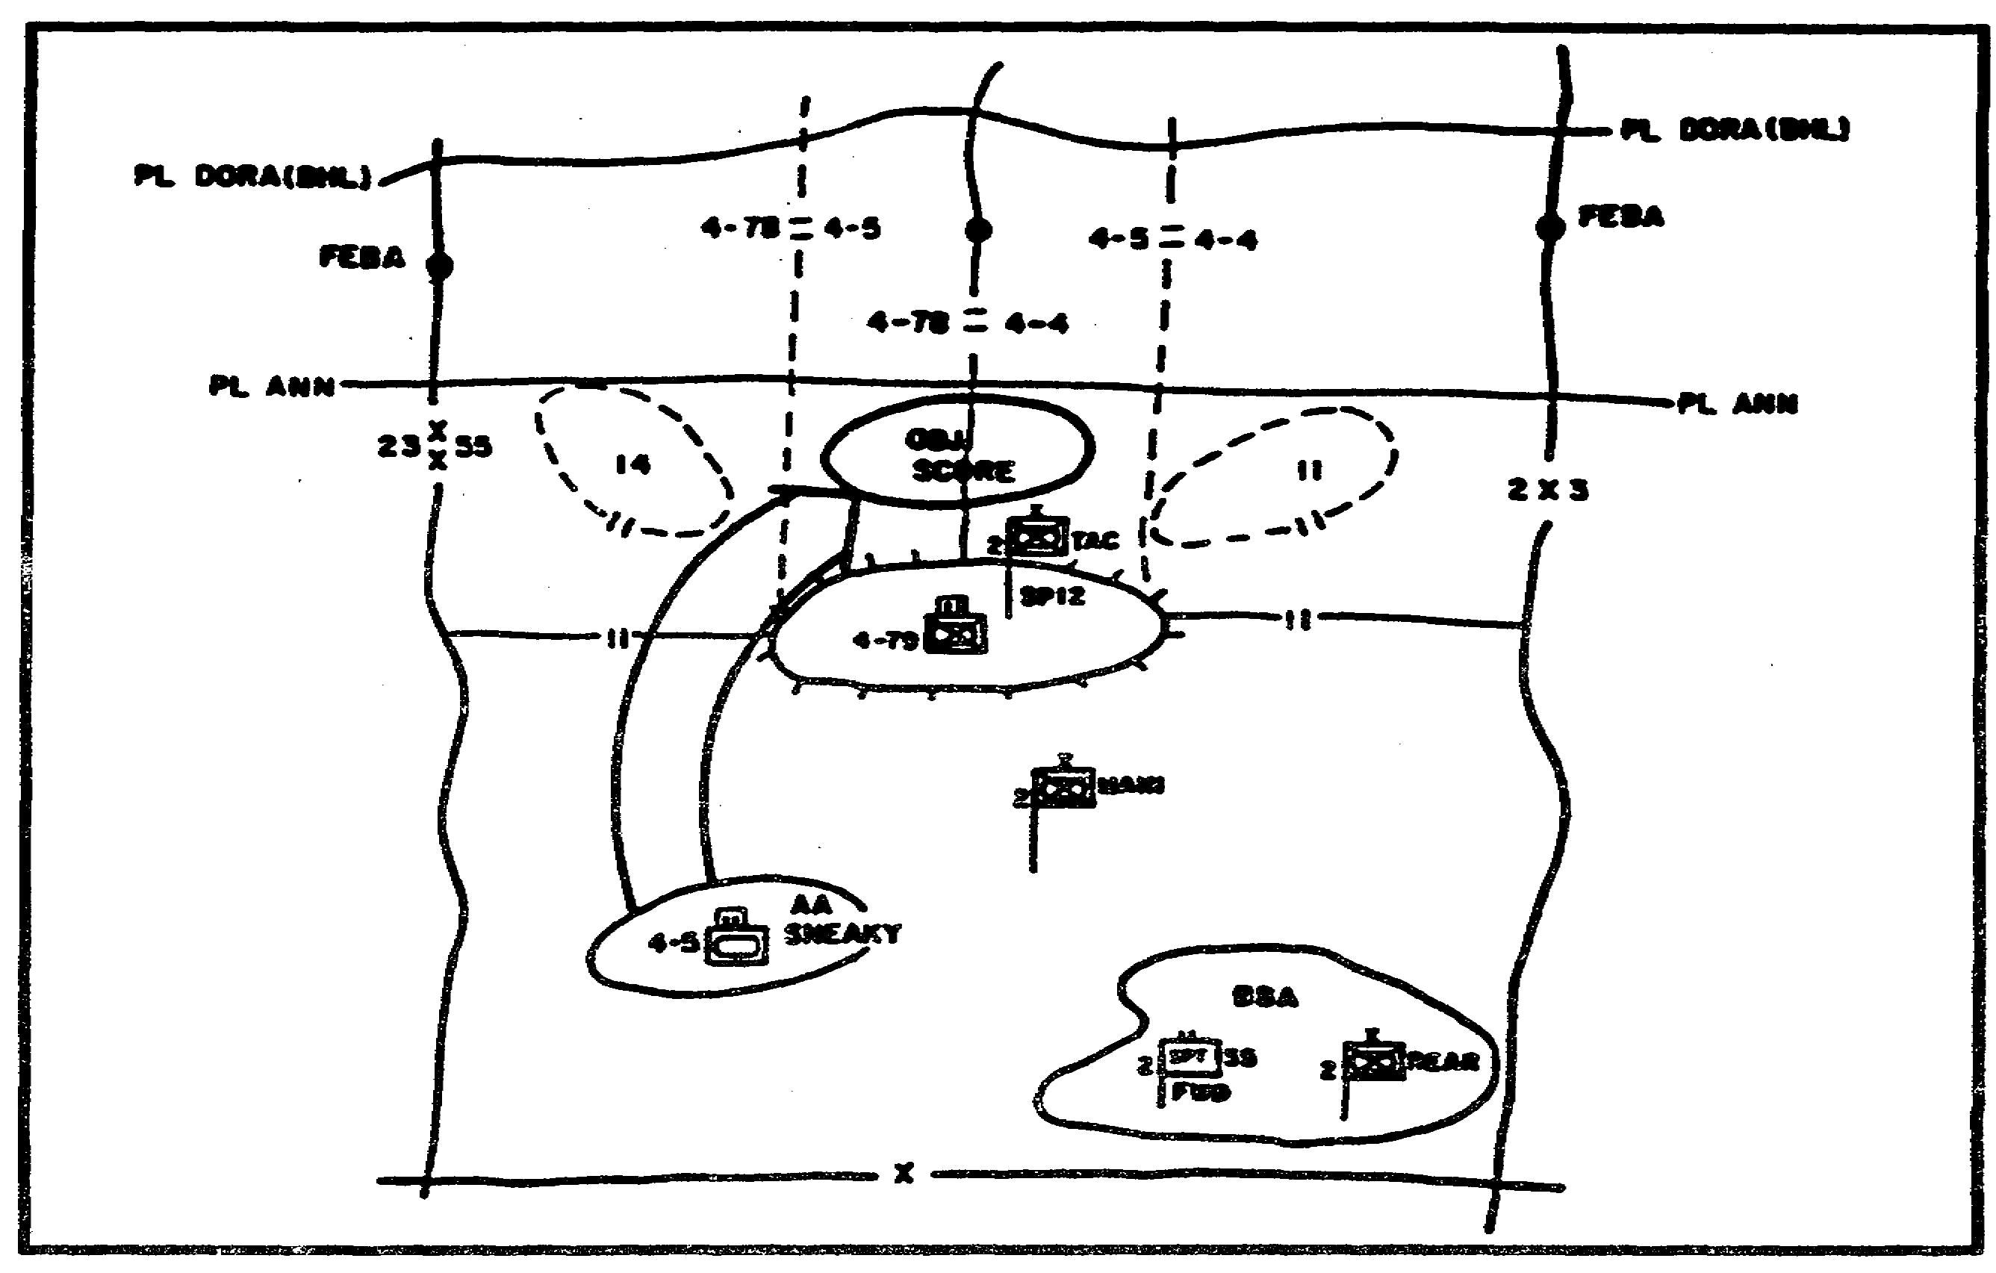

Figure 1-28. Defensive Control Measures.

o IPB.

o Friendly maneuver unit combat power.

o Friendly scheme of maneuver and reserve location.

o Vulnerability to enemy nuclear and chemical weapons.

o Impact of deep and rear operations.

o Use of combat multipliers-fires, obstacles, EW, aviation.

o Logistic supportability of each course of action.

o The human factor-training, morale, experience of subordinates.

Next, the brigade commander monitors the current friendly combat power of assigned subordinate maneuver and CS units. He must closely track the brigade's major killing systems and its personnel fill, especially dismounted infantry, to ensure the proper assignment of missions.

IT0432 1-44

Another area that the brigade commander must consider when planning a defense is the friendly scheme of maneuver. Within the scheme of maneuver is the use of the reserve. The brigade commander's most critical decision during the defense is the commitment of the reserve. The reserve is the most effective way the commander can influence the battle. Once committed, the reserve becomes the brigade main effort and claims priority of support.

The major purpose of the reserve is to regain the initiative through offensive action. Thus, early in the planning, the brigade commander, with assistance from the staff, decides the size, composition, and possible missions of the reserve. The brigade uses decision points developed through the IPB process to trigger the execution of the contingency plans for the reserve. Normal reserve missions are counterattacks, spoiling attacks, or raids against the enemy.
Some of the other missions of the reserve are to--

o Block penetrations.

o Contain enemy forces that have penetrated.

o React to rear area and flank threats.

o Relieve depleted units and provide continuous operations.

As a rule of thumb, the brigade commander should retain about one-third of his combat power in reserve. Of course, factors of METT-T might dictate either a larger or smaller force. In addition, the reserve must be in a secure area, hidden from the enemy until commitment.

Remember, the brigade must reconstitute a new reserve immediately after committing the original reserve. This restores the brigade commander's ability to influence the battle with maneuver forces. Even a small reserve can tip the balance of battle.

Defensive Synchronization. The brigade commander integrates and synchronizes all available assets to maximize combat power. To effectively focus combat power, the brigade commander designates a main effort. As the brigade commander develops his plan for employing maneuver forces, he visualizes synchronizing his support, air defense, IEW, NBC assets, engineer, Army aviation, and CAS assets at the decisive time and place on the battlefield. In short, he synchronizes the battlefield operating systems.

Intelligence Support. The brigade staff focuses on the IPB process when planning the defense and analyzing the close operation to predict and confirm enemy intentions. Before the battle, the brigade commander needs specific information about--

o The location, direction, and speed of enemy reconnaissance, first-echelon battalions, and subordinate companies.

o The locations and activities of enemy second- and follow-on echelons capable of reinforcing the first echelon.

o Enemy first- and second-echelon regimental command, control, and communications (C3) facilities.

1-45 IT0432

The brigade S2 and S3 prepare a detailed security plan, including reconnaissance, counterreconnaissance, and surveillance planning to keep the enemy from seeing and reporting the strength, composition, and location of the brigade. This plan is vital to detect and identify enemy reconnaissance early in the security area.

During close, deep, and rear operations, the brigade S2 and supporting intelligence assets aggressively develop current accurate intelligence assessments to expedite the commander's decision cycle.

Through the IPB process, the S2 analyzes terrain from both friendly and enemy perspectives. IPB helps define enemy avenues of approach and determine air avenues of approach into and through the defensive sector. The S2 then develops various situation templates indicating how the enemy can use the terrain and how it may deploy along avenues of approach. The S2 develops named areas of interest (NAls) identifying critical points or areas where enemy action will indicate intent and trigger brigade actions. The S2 and S3 then develop decision support templates to aid critical maneuver or fire support decisions.

The IPB process analyzes terrain to provide information the commander and staff use to plan the brigade scheme of maneuver. All organic and supporting intelligence assets are task organized, positioned, and coordinated into an intelligence collection plan to gather detailed information before contact begins, if possible.

The commander and staff receive timely and pertinent intelligence that helps them successfully plan and execute the defense and make the transition to subsequent missions. Once a concept of operations is decided upon, intelligence assets mass to provide accurate and timely intelligence on the enemy and terrain. Locations of enemy battalion and regimental CPs, artillery, rocket, air defense control centers, and radio electronic combat stations are put in priority within the intelligence collection effort. Intelligence on enemy positions and movements are correctly identified, evaluated, and interpreted.

Intelligence collected is integrated with information and intelligence from adjacent brigades, subordinate commands, division, and/or echelons above division. The user can often obtain information about activities in the AO in real time and information about activities in an area of interest beyond the AO in time to plan for future operations. Once information is obtained it is disseminated quickly to those who need it.

Intelligence assets can find, target, follow, and report on enemy forces within the AO. These assets tell the commander where enemy units are within their AO, what they are doing, what they might do and when they might do it.

Security forces forward in a counterreconnaissance role keep the enemy from seeing obstacles being built or penetrated and keep the enemy from performing reconnaissance of obstacle plans. Organic and supporting intelligence collection assets placed well forward identify enemy reconnaissance units and confirm movement within NAls and target areas of interest (TAls).

EW assets focus on enemy command and control and fire support assets in support of the close operation.

IT0432 1-46

Brigade Defensive Battle. The defensive framework looks like Figure 1-29 in graphic form. Note the five elements of the defensive framework-the deep operations area, security areas, MBA (close operations), reserve operations, and the rear operations area.

Counterreconnaissance Battle. Within the security area the first potion of the brigade defensive battle begins-the counterreconnaissance battle. Counterreconnaissance is an integral part of the brigade security mission. Remember the purpose of the Threat's reconnaissance is to confirm or deny the intentions and dispositions of the forces it is attacking.

Counterreconnaissance can be active or passive. Active measures are those designed to detect, fix, and destroy enemy reconnaissance forces. Passive measures attempt to conceal, deceive, and confuse enemy reconnaissance units. The brigade integrates both active and passive measures into a detailed reconnaissance and surveillance plan. This plan prevents the threat from seeing and reporting the strength, composition, and location of the brigade and its obstacles. The brigade focuses on providing and coordinating intelligence and fire support to help the TFs identify, fix, and destroy the enemy reconnaissance forces in the counterreconnaissance battle.

During the preparation phase, the brigade S2 and the Deployable Intelligence Support Element (DISE) monitor and track the covering force battle updating the actual Threat reconnaissance situation to the commander and TFs. They develop, with the commander, specific PIRs and modify them to help confirm, identify, or deny the expected threat.

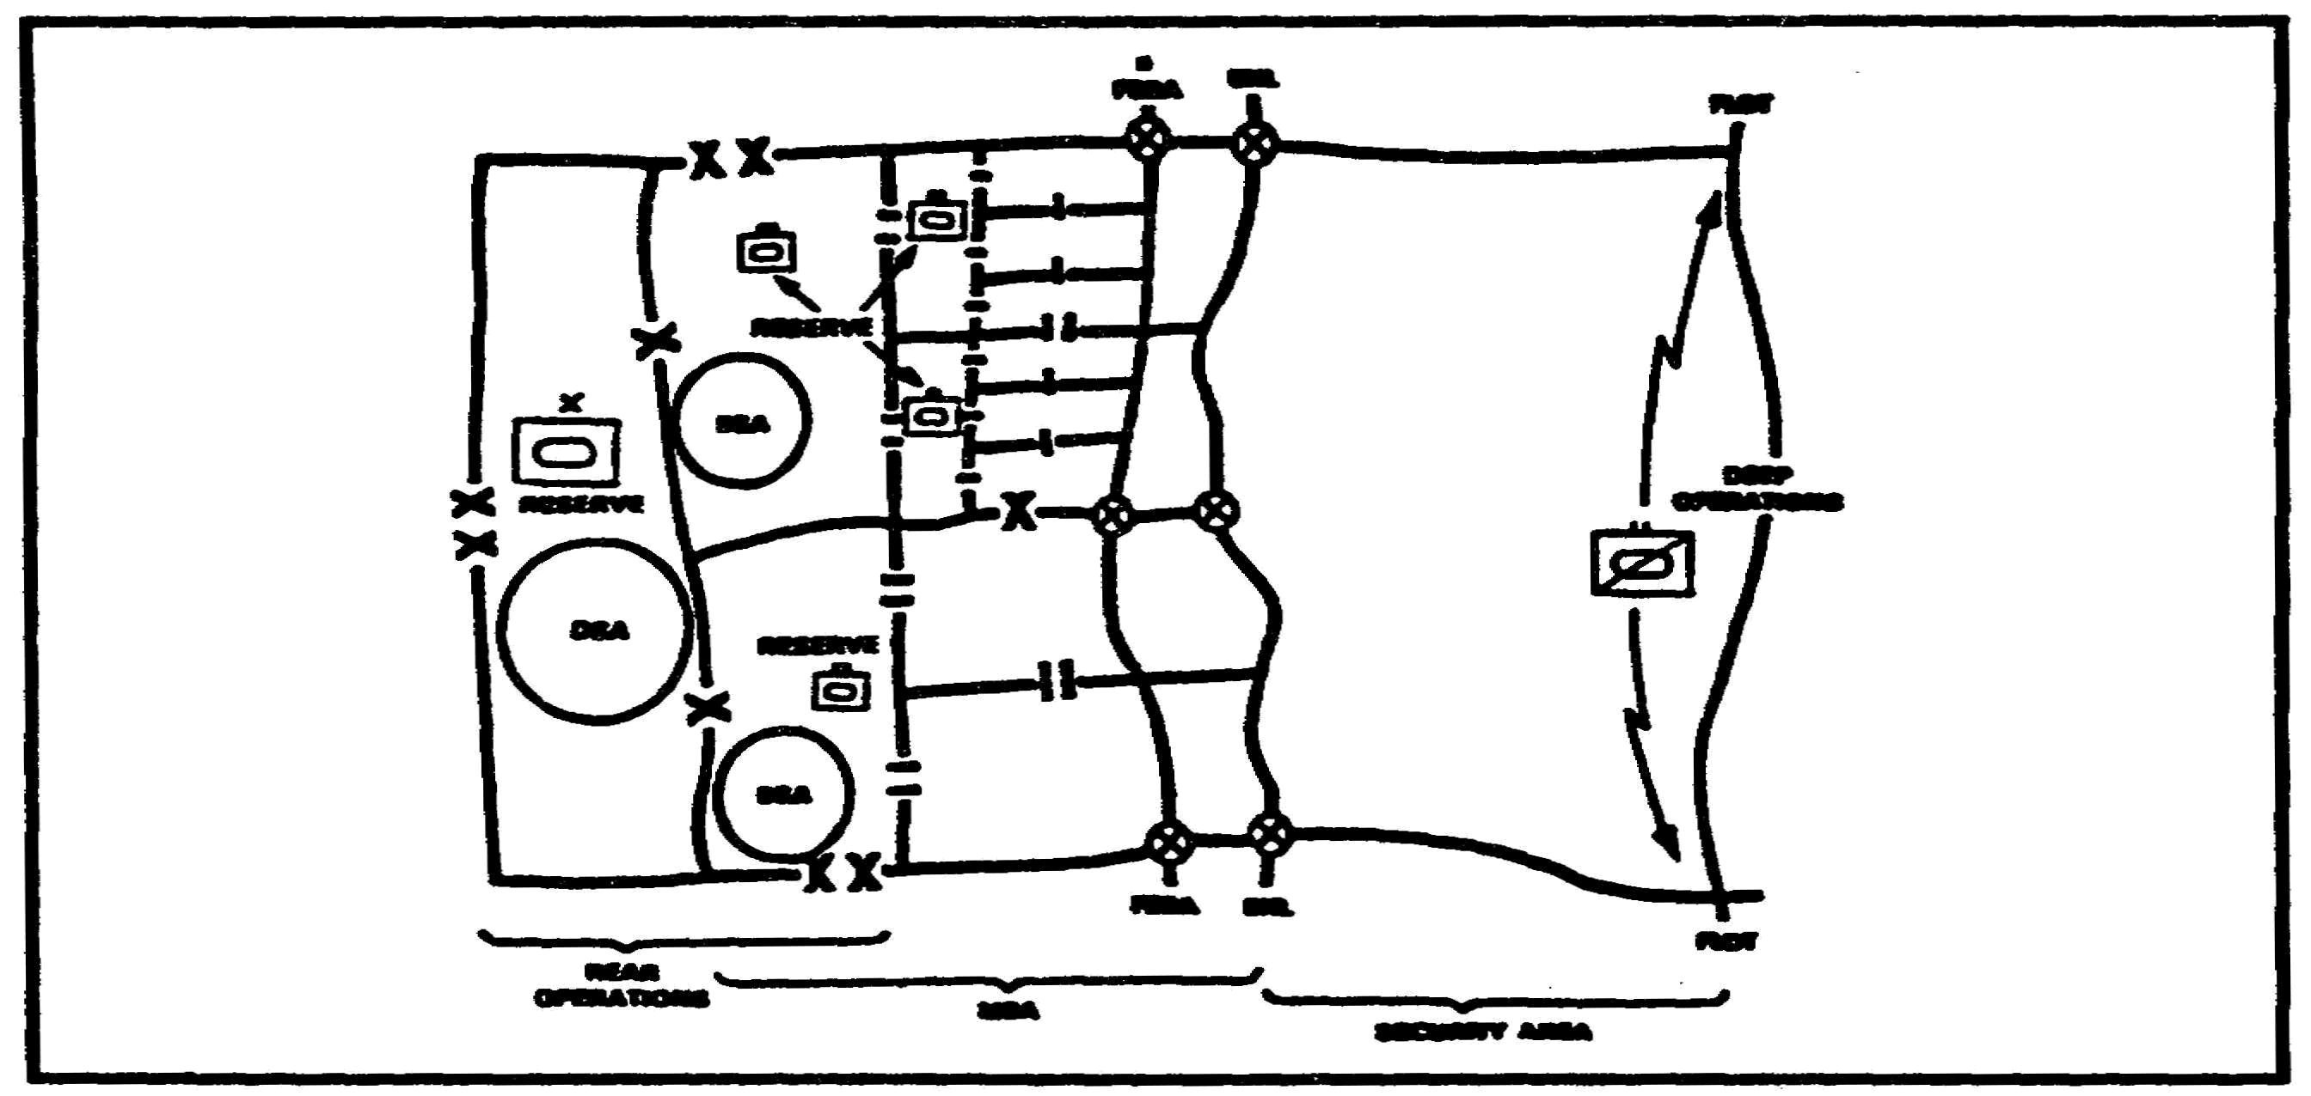

Figure 1-29. Defensive Framework.

The brigade S2 recommends changes to the task organization to reflect actions he deems necessary to accomplish the reconnaissance, surveillance, and counterreconnaissance plan. He also coordinates support from attached, DS, and GS assets, such as ground surveillance radars (GSRs), Communications and Jamming (C&J) platoons, FSBs, and FA.

1-47 IT0432

The brigade S3 coordinates the counterreconnaissance effort by issuing specific directions to the TFs to observe specific NAls. He also lists required patrols, ambush requirements, specific observation post locations, GSR sites, and reporting and engagement criteria. This synchronizes the brigade counterreconnaissance battle.

Deep Operations. In the defense, deep operations try to keep the enemy from concentrating overwhelming combat power. This is accomplished by disrupting the enemy's momentum and destroying the coherence of the attack. The brigade's ability to conduct deep operations is limited. It depends on what assets the division provides; i.e., FA, IEW, Close Air Support (CAS). Effective employment of these fire support and EW deep attack assets depends on careful and continuous planning and IPB. To be successful in deep operations, the FSO, S3, and S2 must coordinate fully and address deep operations during all phases of the defense.

Security Operations. A brigade conducts security operations forward, to the rear, and to its flanks. The brigade protects its freedom of action by making itself less vulnerable to hostile acts, influence, or surprise. A brigade can also act as the division covering force, serving as its forward security echelon. The covering force protects MBA units from surprise, allows MBA forces time to deploy and meet enemy attacks, prevents the delivery of enemy medium-range artillery fire against MBA units, and deceives the enemy as to the location of the main defensive positions. When a division conducts its own covering force operations, normally a close combat-heavy brigade will receive the mission.

Remember, security force operations include cover, guard, and screen as well as counterattack or defend missions. The most comprehensive mission is the covering force.

The fundamental purposes of the covering force in the defense are to--

o Defeat and destroy enemy reconnaissance forces.

o Force the enemy to deploy.

o Confirm the direction and strength of the enemy attack.

o Provide time for MBA forces.

o Shape the battlefield.

o Destroy enemy forces within their capabilities.

To accomplish these, brigades defend or delay -stripping away enemy reconnaissance units, defeating the advance guard, forcing enemy deployment, and causing the enemy to bring up its artillery and possibly its second-echelon forces. The brigade also seeks to deceive the enemy as to the actual location of the MBA. To do this, the brigade fights forward of the MBA in the security area.

The size and composition of the security force depends on the commander's estimate of the situation as influenced by the factors of METT-T. A brigade acting as a division security force may consist of up to four armor-heavy battalion TFs with their attached, DS, and OPCON units.

IT0432 1-48

Normally a security force is armor-heavy.

When a brigade has a security force mission, subordinate units accomplish their missions as the brigade commander determines. Because giving the MBA forces time to react and room to maneuver provides security, the depth of the security force area influences what missions are assigned.

As commanders compare time and distance requirements, they may allocate more forces to the security force or provide more distance in the security force area. As a rule, the minimum defensive security force area should be at least 20 kilometers deep to force the enemy to commit combat forces before it attacks into the MBA. Enemy repositioning of artillery and air defense provides the essential indicators of the main effort.

Combat power brought against enemy forces within the security area defends the MBA because it destroys the enemy force's combined arms integrity and damages its ability to react once it arrives in the MBA. Fire support tasks in the security area are to deceive the enemy about the location of the MBA and disrupt the enemy center of gravity before it enters the MBA. Remember, fire support helps defeat the enemy by forcing it to commit forces piecemeal and without key elements.

Fire support missions in the security area are--

o To isolate attacking units.

o To isolate attacking units with offensive EW.

o To destroy accompanying air defense systems and radars.

o To destroy enemy engineer assets.

o To destroy by artillery or hinder by EW assets enemy communications systems or facilities.

Battle Handover. An MBA brigade assumes responsibility for the battle as security forces begin to withdraw their combat elements across the battle handover line (BHL). The higher commander establishes the BHL. The security force and the MBA brigade commanders coordinate the exact location of the BHL and recommend changes to the higher commander. Graphically, the BHL is a phase line identified in the appropriate operation plan (OPLAN), operation order (OPORD), or fragmentary order (FRAGO).

The BHL establishes a boundary between the ground owned-by the security force commander and the ground owned by the MBA commander. Most MBA forces are between the brigade rear boundary and the forward edge of the battle area (FEBA). However, the MBA brigade commander controls the ground forward of the FEBA out to the BHL. He places security forces, obstacles, and fires in this area to canalize the enemy or to facilitate the withdrawal of security force elements.

1-49 IT0432

The BHL also marks where control of the battle shifts from the security force to the MBA brigade. Typically, the BHL is 2 to 4 kilometers forward of the FEBA. This allows the brigade to bring direct and observed indirect fires to bear on the enemy.

If possible, the boundaries of the security force and the MBA brigade should coincide whether the brigade is performing its own security mission or that of a higher headquarters.

The MBA brigade and the security force coordinate to ensure the battle handover goes well. The key areas are monitoring the security force radio nets to obtain a picture of the battle, establishing and maintaining liaison with the security force units forward of the MBA brigade's positions, and collocating TAC CPs during the passage of security force units. Covering force units will withdraw at different times in different areas across the battlefield. This makes coordination and hand over extremely difficult processes.

Main Battle Area. The battle is almost always decided in the MBA. Brigades adjust their defensive main effort to defeat the attack based on information received during security force operations. The defending brigade concentrates the strongest possible force for decisive action against the enemy main effort and commits them with the greatest possible violence when the enemy acts.

In the MBA, brigades direct and control their fight using direct and indirect fires and maneuver against an assaulting enemy. Air support, EW, attack helicopters, combat engineers, AD weapons, naval gunfire, and DS and reinforcing artillery units assist maneuver battalions in the destruction of the assaulting regiments.

The division also supports the brigade fight by providing combat, CS, and CSS; by directing operations involving forward brigades; and by committing the division reserve when necessary. Concurrently, the division conducts operations against the follow-on echelons, directs the engineer obstacle effort, and conducts counterfire operations.

Brigade operations emphasize execution of battalion plans within the context of the overall brigade concept and use of individual initiative in accordance with mission orders. When a brigade main effort is identified, CS assets and other battalion plans are tailored to support this effort.

Brigade and battalion commanders plan and reconnoiter the sectors, counterattack objectives, determine attack routes, and determine BPs in depth throughout their operational areas. Commanders direct the fight by specifying which BPs or sectors their units will occupy, what units will do when they get there (defend, delay, attack, or overwatch), and determine how fire support will be integrated into the fight at each location.

The brigade defends by confronting the enemy with strong combined arms TFs and battalions in the brigade sector. As the enemy attack moves into the defended area, the brigade's battalion TFs delay, contain, separate, and attack those forces.

Obstacles incorporated into the brigade's defensive plan slow, canalize, and disrupt the enemy's timetables. Obstacles and fires are critical to fragment enemy mass, degrade

IT0432 1-50

trafficability, and confuse enemy command and control by causing the enemy to fight in multiple directions.

The brigade commanders plan combines the defense of open spaces and chokepoints. Counterattacks exploit the separation of enemy forces that occurs naturally because of the terrain.

Commanders and staff planners recognize the likelihood of penetrations in the MBA. When fighting large, mobile forces, the commander may permit a partial penetration of the MBA. If separation from adjacent units occurs, MBA forces continue to fight within the commander's intent; they protect their own flanks while striking at the enemy's and, when possible, reestablish contact across areas of penetration. The commander rapidly shifts fire support to limit the ability of the enemy commander to capitalize on a penetration. Preparation of counterattack plans are integral to the MBA fight.

The defense cannot be strong everywhere and should not attempt to be. The defender must take some risks. This is particularly true when forces are moved to join the reserve in a decisive counterattack. Less threatened areas are screened by scouts, Ml assets, aviation assets if available, or designated TFs. GSRs, remote sensors and obstacles aid in this effort. Contingency plans are developed to counter enemy efforts in these risk areas.

Rear Operations. The brigade rear area extends from the forward battalion rear boundary. Units in the brigade rear area are responsible for planning defense against Levels I, II, and III enemy threats. Operations against a Level III rear area threat force a major change in the brigade mission. The brigade's higher headquarters provides the flexibility to deal with a Level III threat or accept the responsibility for brigade rear area defense. Rapid response to a rear area threat, particularly Levels II and III, is integral to the commanders ability to sustain a viable defense. Fire support, with its ability to shift on the battlefield faster than other forms of combat power, is key to rear operations.

1-51 IT0432

LESSON 1

PRACTICE EXERCISE

The following items will test your grasp of the material covered in this lesson. There is only one correct answer for each item. When you complete the exercise, check your answer with the answer key that follows. If you answer any item incorrectly, study that part of the lesson which contains the portion involved.

1. What is the only permanent unit assigned to a brigade?

A. Military Intelligence Battalion.

B. Air Defense Company.

C. Armor Battalion.

D. Headquarters and Headquarters Company.

2. What type of brigade maneuver is designed to avoid the enemy's front defensive positions?

A. Envelopment.

B. Turning movement.

C. Infiltration.

D. Penetration.

3. Which of the following prevents an enemy from seeing and reporting the strength, composition, and location of the brigade and its obstacles?

A. Reconnaissance.

B. Security Operation.

C. Counterreconnaissance.

D. Retrograde Operations.

IT0432 1-52

LESSON 1

PRACTICE EXERCISE

ANSWER KEY AND FEEDBACK

Item Correct Answer and Feedback

1. D. Headquarters and Headquarters Company. Page 1-2.

2. A. Envelopment. Page 1-26.

3. C. Counterreconnaissance. Page 1-47.

IT0432 1-54

LESSON 2

DIRECT THE INTELLIGENCE PORTION
OF THE INTELLIGENCE PREPARATION
OF THE BATTLEFIELD PROCESS

Critical Tasks: 301-372-2051
301-372-2052
301-372-2054
301-372-2055
301-372-2056
301-372-2058
301-372-3052
301-372-3053
301-372-3054
301-372-3055
301-372-3056

OVERVIEW

LESSON DESCRIPTION:

In this lesson you will learn how to direct the intelligence portion of the intelligence preparation of the battlefield (IPB) process.

TERMINAL LEARNING OBJECTIVE:

ACTIONS: Direct the development of the four steps of the IPB process. Ensure that IPB products are used as the basis for the preparation of the intelligence estimate. Ensure that Threat studies and order of battle (OB) files are maintained to support the development of Threat models for step three (Evaluate the Threat) of the IPB process.

CONDITIONS: You will be given narrative information and illustrations from FM 34-3 and FM 34-130.

STANDARDS: Direct the IPB process in accordance with FM 34-3 and FM 34-130.

REFERENCES: The material contained in this lesson was derived from the following publications:

FM 34-3
FM 34-130

2-1 IT0432

INTRODUCTION

Intelligence preparation of the battlefield is the key for preparing for the next battlefield environment. It is the best process we have for understanding the battlefield and the options it presents to friendly and Threat forces. It is a systematic, continuous process that--

o Describes the environment a friendly unit is operating within and the effects of that environment upon the unit.

o Determines what the Threat can accomplish within that environment.

Everyone in the US Army conducts some form of IPB, from a rifleman in an infantry squad to a division/corps staff. As the size of the unit increases, the level of detail required in the IPB effort increases significantly. The rifleman conducts informal IPB while a division/corps staff produces detailed IPB products addressing the environment and Threat.

The G2 or S2 is responsible for the command's IPB -that IPB which directly supports the command estimate process. The G2 or S2, however, is not the only one who conducts or needs to understand IPB. Every commander and every member of the battle staff needs to understand and apply IPB during the staff planning process. The commander leads the IPB effort. The entire staff executes the IPB process. IPB identifies the facts and assumptions about the battlefield and the Threat that allows effective staff planning. IPB forms the basis for defining courses of action (COAs) available to the friendly command and drives the wargaming process that selects and refines them.

The G2 or S2 is responsible for facilitating the unit IPB effort, but he and his staff cannot provide all the IPB the unit requires. Every commander and staff officer needs to think through the effects the environment has on both Threat and friendly operations. The bottom line is that every soldier conducts IPB. Every soldier thinks through an informal IPB procedure, but commanders and staff officers undertake a more formal process. This lesson is designed to explain the fundamentals an applications of the IPB process. It will provide you with the information necessary to direct the intelligence staff in conducting IPB.

PART A - IPB PROCESS

As stated earlier, IPB accomplishes the following:

o Describes the environment a friendly unit is operating within and the effects of that environment upon the unit.

o Determines what the Threat can accomplish within that environment.

IPB identifies facts and assumptions about the battlefield environment and the Threat. This provides focus for the intelligence effort and enables staff planning and development of friendly COAs. It provides a crucial structure to the successful accomplishment of the intelligence cycle. The intelligence cycle is the fundamental procedure that the G2 or S2 uses to accomplish the IEW functions. IPB, as the first IEW function, forms the foundation for the successful accomplishment of the remaining five IEW functions. These IEW functions include; situation

IT0432 2-2

development, indications and warnings (I&W), target development and target acquisition, battle damage assessment (BDA), and force protection.

The IPB process consists of four steps:

o Step 1 - Define the battlefield environment.

o Step 2 - Describe the battlefield effects.

o Step 3 - Evaluate the Threat.

o Step 4 - Determining Threat courses of action.

PART B - DEFINE THE BATTLEFIELD ENVIRONMENT

Step 1 sets the parameters in time, boundaries in space, and those characteristics of the battlefield environment that may be significant in accomplishing the command's mission. During this step, the G2 or S2 establishes the limits of the battlefield by identifying the area of operations (AO) and area of interest (Al). To focus the remainder of the process, he identifies those characteristics of the battlefield which require in-depth evaluation, such as terrain, weather, logistical infrastructure, and demographics.

In addition to focusing the IPB effort, this definition of the battlefield environment aids in identifying gaps in current intelligence holdings and the specific intelligence required to fill them.

During this step the following substeps are performed:

o Identify significant characteristics of the environment.

o Identify the limits of the area of operations.

o Establish the limits of the area of interest.

o Identify gaps in current intelligence holdings.

o Identify the amount of detail required and feasible within the time available for IPB.

o Collect the material and intelligence required to conduct the remainder of IPB.

Identify Significant Characteristics.

Significant characteristics are those that will influence your commander's decisions or affects the courses of action available to your own force or the Threat.

Identifying the significant characteristics of the battlefield environment helps establish the geographical limits of the area of interest and directs analytical efforts in steps two and three of

2-3 IT0432

the IPB process. It also identifies gaps in the common understanding of the battlefield (Figure 2-1), serving as a guide to the type of intelligence and information required to complete the IPB process. Initially, these characteristics are examined only in general terms to identify those of significance to the command and its mission. Evaluation of their effects takes place during step two of the IPB process.

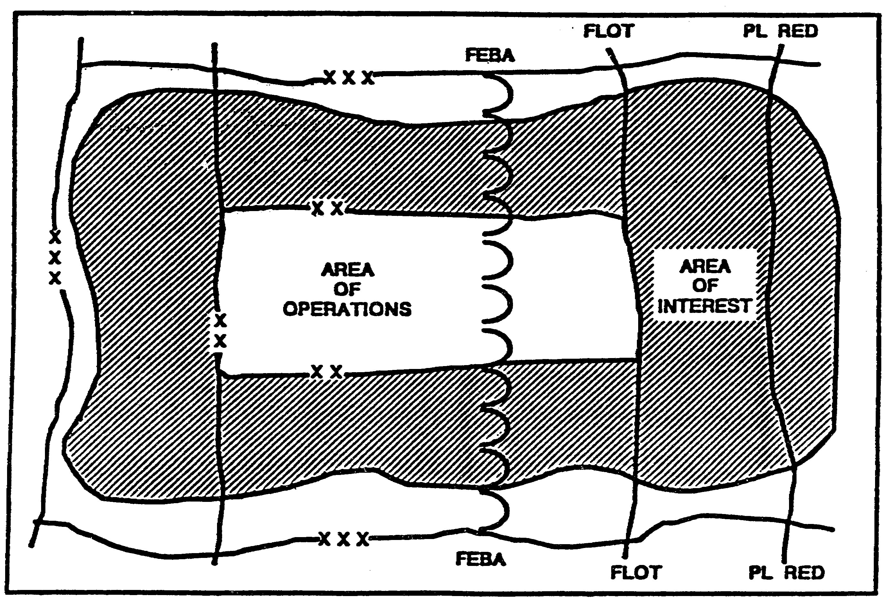

Figure 2-1. Define the Battlefield Areas.

Identify the Limits of the Area of Operations.

The area of operations (AO) is the geographical area where the commander is assigned the responsibility and authority to conduct military operations. A thorough knowledge of the characteristics of this area leads to its effective use. Identify the limits of the area of operations in order to focus your efforts in step two of the IPB process. The limits of the area of operations are normally the boundaries specified in the operations order or contingency plan from the higher headquarters that define the command's mission.

Establish the Limits of the Area of Interest

IT0432 2-4

The area of interest is that area from which information and intelligence are required to permit planning or successful conduct of the command's operation. The area of interest (Al) extends beyond the boundaries imposed by the AO. Its limits include each of the characteristics of the battlefield environment identified as exerting an influence on available courses of action or command decisions.

The limits of the Al are based on the ability of the Threat to project power or move forces into the area of operations. Also considered are the geographical locations of other activities or characteristics of the environment which might influence courses of action or your commander's decisions.

Identify Gaps in Current Intelligence Holdings

Identify and prioritize the gaps in your current holdings, using your commander's PIR and intent to set the priorities. You should also identify those gaps which cannot be filled within the time allowed for IPB.

Identify the Detail Required and Time Available

Identify the amount of detail required to support planning by consulting with the commander and the remainder of the staff. Prioritize your efforts to produce the amount of detail required within the available time.

Collect the Required Intelligence And Material

Initiate requests for intelligence or collection to fill your intelligence gaps to the level of detail required. Include collection against all identified significant characteristics of the battlefield, in priority order.

PART C - DESCRIBE THE BATTLEFIELD EFFECTS

Step 2 evaluates the environment with which both sides must contend. The G2 or S2 fully explores what the environment encourages or discourages in the way of friendly and Threat Courses of Action (COA). This is accomplished by an analysis of all characteristics of the battlefield environment that may affect operations. This assessment of the environment always includes an examination of terrain and weather. It may also include discussions of the effects of politics, civilian press, local population, and other factors affecting the mission. Products developed in this step might include, but are not limited to--

o Population status overlay.

o Overlays that depict the military aspects and effects of terrain.

o Weather analysis matrix.

o Other Products. Regardless of the subject or means of presentation, the G2 or S2 ensures that these products focus on the effects of the battlefield environment

2-5 IT0432

This step includes the following:

o For friendly courses of action, evaluate the effects of:
- terrain.
- weather.
- other characteristics of the battlefield.

o Judge the combined effects of the battlefield environment on friendly courses of action

o For Threat courses of action, evaluate the effects of:
- terrain
- weather.
- other characteristics of the battlefield.

o Judge the Combined Effects of the Battlefield Environment on Threat COAs.

Evaluate the Effects of Terrain on Friendly COAs

Express your evaluation of the terrain's effects by identifying which courses of action the terrain favors. Examples of terrain conclusions that structure COAs would be the identification of those places best suited for use as (Figure 2-2):

o engagement areas.

o battle positions.

o avenues of approach.

o specific system or asset locations.

These conclusions are reached through a series of substeps:

o Decide to what level of detail you will analyze each area within the Al.

o Collect available materials for terrain analysis.

o Evaluate the military aspects of terrain in terms of their effects on courses of action.

o Integrate the separate evaluations into a combined product showing the effects of terrain on friendly COAs.

Evaluate the Effects of Weather on Friendly COAs

Express your evaluation of the weather's effects by identifying which courses of action the weather favors. These conclusions are reached through a series of substeps (Figure 2-3):

IT0432 2-6

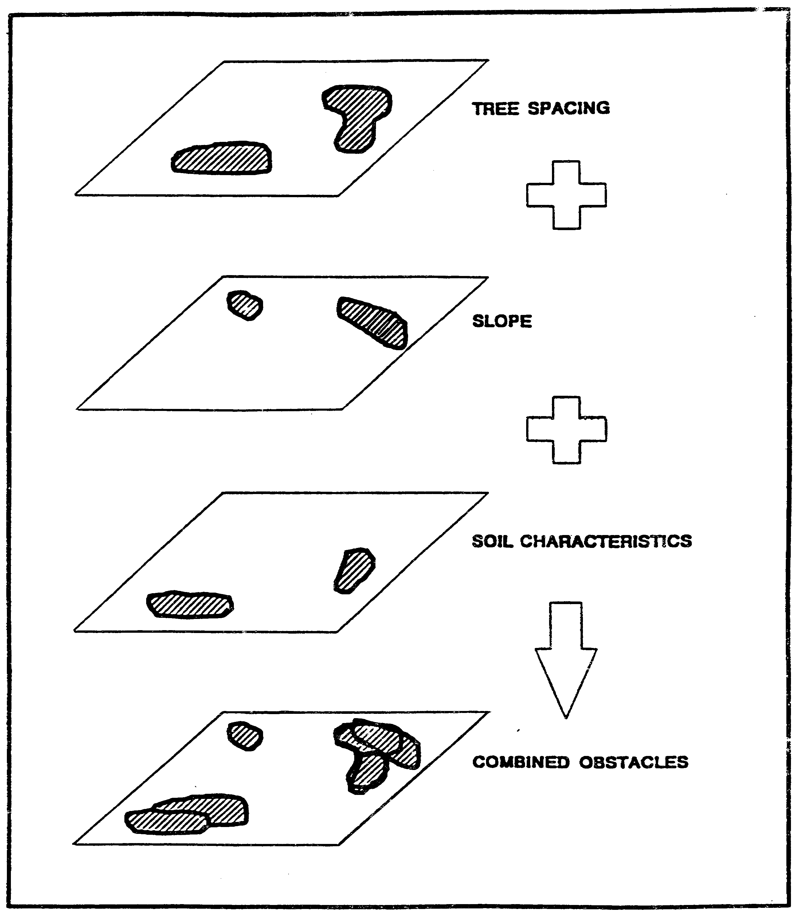

Figure 2-2. Combined Terrain Factors Overlay.

2-7 IT0432

o Assess the military aspects of weather.

o Incorporate the effects of weather into an integrated terrain/weather product.

o Determine the direct effects of weather on personnel, equipment, and operations.

o Integrate the separate evaluations into a combined product showing the effects of weather upon friendly COAs.

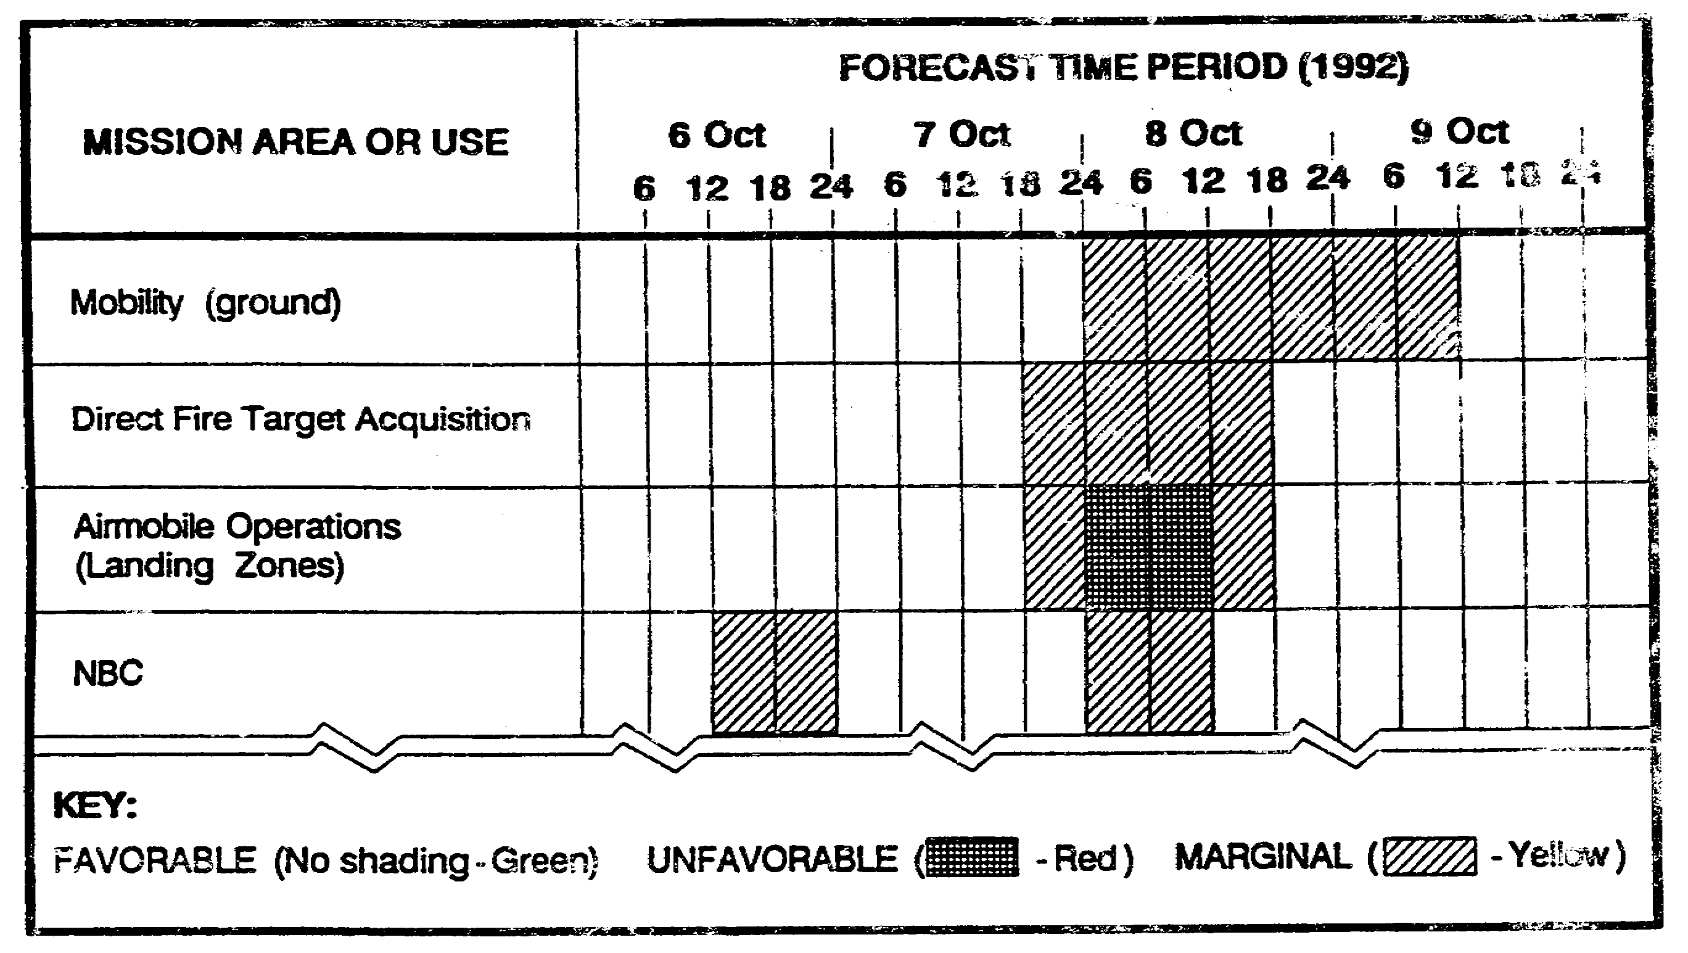

Figure 2-3. Effects of Weather on Operations.

Evaluate the Effects of Other Considerations on Friendly COAs

"Other Characteristics" include all aspects of the battlefield environment that affect friendly or Threat COAs not already incorporated into the terrain and weather analysis. This step determines how those aspects affect friendly COAs. Because these aspects vary greatly with each circumstance a comprehensive list cannot be provided here. However, depending on the situation, these characteristics might include:

o Logistics infrastructure.

o Population demographics.

o Economics.

o Politics: local, regional and international (government systems, treaties, agreements, and legal restrictions; includes unofficial systems such as gangs, etc.).

IT0432 2-8

Judge the Combined Effects of the Battlefield Environment on Friendly Courses of Action.

Combine the evaluation of the effects of terrain, weather, and the other characteristics of the battlefield into one integrated product. Do not focus on the factors that lead to your conclusions. Instead, focus on the total environment's effects on courses of action available to both friendly and Threat forces. Some good techniques for accomplishing this are:

o Prior to the development of friendly COAs:

- Provide the evaluated and prioritized set of Avenues of Approach (AAs) to the S3 so he can develop COAs by designating an axis of advance, direction of attack, or zone of attack for each subordinate unit (offense).

- Provide the sets of defensible terrain along Threat AAs to the S3 so he can develop strong points, battle positions, or sectors for each subordinate unit (defense and retrograde).

o After the development of friendly COAs emphasize concluding sentences such as "...of the courses of action available, COA 2 exploits the battlefield environment second best for the following reasons..."

In addition to distribution of graphic products, communicate your description of the battlefield environment in written reports such as the analysis of the area of operations or paragraph 2 of the intelligence estimate.

Evaluate the Effects of Terrain on Threat COAs.

In this step the same procedures and techniques used for evaluating the effects of terrain on friendly COAs are used on Threat COAs. A good technique for accomplishing this critical e function is to completely place yourself in the perspective of the Threat's S2 and S3 who must recommend a set of courses of action to their commander.

A critical difference in evaluating terrain from the Threats perspective is that:

o The friendly commander chooses one friendly course of action over the others during staff planning. This enables the S2 to ignore the other available friendly courses of action during the execution of the mission.

o However, during planning the S2 is unaware of which course of action the Threat commander has chosen. Therefore, the friendly staff must plan for all the reasonable options that the battlefield environment provides the Threat. Appendix A shows how the staff accomplishes this through wargaming.

o The bottom line is that the S2 cannot disregard any COA available to the Threat until collection and analysis reveal that the Threat has not chosen that COA.

2-9 IT0432

Evaluate the Effects of Weather on Threat COAs.

Once again, use the same procedures in this step that you used for evaluating the effects of weather on friendly COAs. Bear in mind that weather will affect Threat equipment differently than U.S. equipment. An AK 47 is more resistant to moisture than an M-16, for example. Likewise, fog will affect U.S. thermal sights less than it will affect vehicles with optical sights only.

Just as in terrain analysis, you will best accomplish this step by completely immersing yourself in the perspective of the Threat S2. Don't forget to conclude this analysis with the integrated evaluation of how weather affects Threat COAs.

Evaluate the Effects of Other Characteristics on Threat COAs.

Use the same procedures as discussed above. Remember to account for the cultural bias that the Threat operates within. They will evaluate the same legal, political, economic, and demographic aspects in a completely different manner than U.S. personnel would.

Judge the Combined Effects of the Battlefield Environment on Threat Courses of Action.

Use the same procedures as discussed above. Remember that "other characteristics" may sometimes influence Threat actions much more than terrain or weather considerations.

PART D - EVALUATE THE THREAT

Step 3 begins with an examination of the common understanding of the battlefield to identify what is known and unknown about the Threat situation. The G2 or S2 and his staff analyze the command's intelligence holdings to determine how the Threat normally organizes for combat and conducts operations under similar circumstances. As the G2 or S2 identifies intelligence gaps concerning the Threat, the commander prioritizes those uncertainties he wants to reduce with intelligence.

When facing a well-known Threat, the G2 or S2 can rely on his historical database and well developed Threat models. When operating against a new or less well-known Threat, he may be required to develop his intelligence databases and Threat models concurrently.

In any event, the G2 or S2s evaluation is portrayed in a Threat model that includes doctrinal templates, which may take various forms. Often graphic, doctrinal templates take the form of a matrix or simple narrative (Figure 2-4).

During this step the following substeps are performed:

o Identify Gaps in Knowledge of the Threat and Initiate Action to Fill Them.

o Acquire Relevant Intelligence.

o Update Threat Models.

IT0432 2-10

Identify Gaps in Knowledge of the Threat and Initiate Action to Fill Them.

In this substep you identify all the gaps, or uncertainties, that your staff needs resolved for planning and execution.

Ideally, intelligence operations enable you to develop your perception of the battlefield and the Threat to completely match the actual situation on the battlefield. In reality intelligence will never eliminate all of the unknown aspects or uncertainties which concern a commander and his staff.

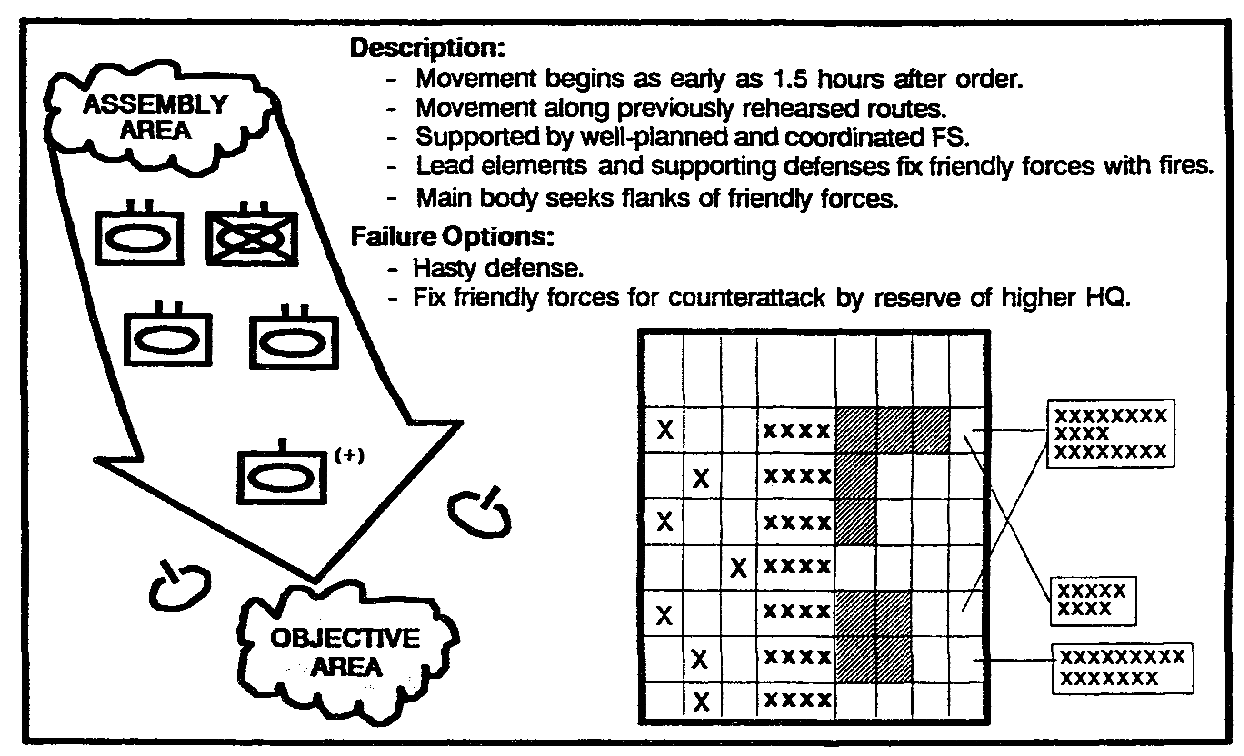

Figure 2-4. Threat Model Example.

Therefore, you must continually work to resolve these uncertainties through the IPB process. To identify gaps in your knowledge of the Threat:

o Use the products already developed in step one of IPB, Define the Battlefield Environment. These provide a good start point for this process.

o From the broad areas identified in the first step of IPB, identify those specific unknowns which you plan to solve using the IPB methodology.

o Translate these unknowns into a specific list of Threat models required for the remainder of IPB.

o Establish priorities of work and collection to fill these intelligence gaps.

2-11 IT0432

Acquire Relevant Intelligence.

After you establish the prioritized list of Threat models you require, acquire as much relevant intelligence as time permits in order to construct or update the models. You accomplish this through the following steps:

o Pull intelligence from the OB Files.

o Acquire additional information from the intelligence database.

o Request additional intelligence support from other agencies.

o Conduct new collection operations.

Order of Rattle Files.

Order of Baffle files contain evaluations of the Threats capabilities and weaknesses. The nine OB factors that structure the OB files are:

- Composition
- Disposition
- Strength
- Tactics or modus operandi
- Training status
- Logistics
- Effectiveness
- Electronic technical data
- Miscellaneous data, such as personalities, etc.

Create an order of battle file for each Threat unit you're concerned with. As time permits, continuously update the OB files as you develop intelligence during the processing phase of the intelligence cycle. Do not wait until staff planning begins to conduct this analysis.

A common technique is to maintain a set of Threat models under the "tactics" or "modus operandi" tab of each OB file. In any case, pull specific information from OB files that will enable you to construct, maintain set of original or update required Threat models.

The OB factors are not independent of each other; they are closely related -consider them as a whole. For example, training status, command personality, strength, or any other of the OB factors will affect the tactics of a unit at a given time.

These same factors form a framework for evaluation of any force, not just those that are strictly military. In evaluating an insurgent force, you would include an analysis of the insurgent political structure and its relationship to the military elements.

Tailor your evaluation of the OB factors to your unit needs. For example, an aviation unit's evaluation of composition would focus on those units that contain air defense assets. Its evaluation of equipment would focus on the vulnerabilities of likely Threat targets as well as the

IT0432 2-12

technical characteristics of the Threat's air defense systems.
Consider not only the Threat's physical capability, based on organization and equipment strength, but also his normal modus operandi or tactical doctrine. This requires an understanding of the art and science of war as well as knowledge of the Threat.

A useful technique for this evaluation is to first gain an understanding for how your own force conducts operations. Then compare and contrast the Threat's normal approach to the same operations. The OB factors form the framework for this evaluation. The ultimate goal of evaluating these factors is to produce an integrated description of the Threat and his capability to influence friendly courses of action.

Intelligence Database

Either through automation or manual means, intelligence sections maintain a database of raw information stored in intelligence files. Derive pertinent information from these files to develop conclusions for your OB files. Focus on select sets of information from the database with which to conduct analysis:

o In a manual system, maintain a set of indexes that allows; you to cross-reference the intelligence files according to time, physical location, or subject. Some standard index devices are:

- intelligence journal
- time event charts
- situation map and coordinates register
- intelligence workbook
- activities and association matrices
- link diagrams
- radio net diagrams

Once you have determined the parameters of the information for which you need to conduct analysis (ie, "all reports of helicopters in 3rd Combined Arms Army's (CAA's) sector between the 3rd and 15th of this month"), use the index devices to identify the messages to pull from the files.

o In an automated system each message is recorded into a relational database indexed by time, location, and subject. Once you have determined the parameters for your search, simply direct the database program to develop a report of the appropriate messages. Obviously, the automated system is quicker than the manual system.

Chances are, the database contains recent pertinent information that is not reflected in the Threat model you pulled from the OB files. Use the information from the database to update and modify your Threat models as needed.

2-13 IT0432

Intelligence Support

After you have searched your OB files and intelligence database check with other available agencies for more information and intelligence. Consider requesting support from:

o Higher headquarters.

o Adjacent units.

o Intelligence units operating in the local area (ie, echelons above corp (EAC) units, joint agencies, interagency staffs, etc.)

o Host nation agencies.

Collection Operations

Time permitting, conduct collection operations to complement or complete the intelligence and information you've already collected.

Update Threat Models

After you have collected relevant intelligence and information:

o Update the Threat model pulled from the OB files with the new information, or

o Construct a new Threat model if the OB files did not contain an original Threat model.

A useful technique for updating or constructing Threat models is pattern or trend analysis. Regardless of the techniques used to create your Threat models, ensure they communicate the results of your evaluation rather than the specific factors that formed that Threat model. Threat models consist of three parts:

o doctrinal templates - graphic portrayal of the employment of enemy units throughout the
tactical procedure.

o doctrinal narrative - description of the tasks that each subordinate unit will accomplish
throughout the tactical procedure. Expressed as either a written narrative or synchronization
matrix.

o high value targets - tactical systems that the enemy depends upon for successful
accomplishment of the procedure.

IT0432 2-14

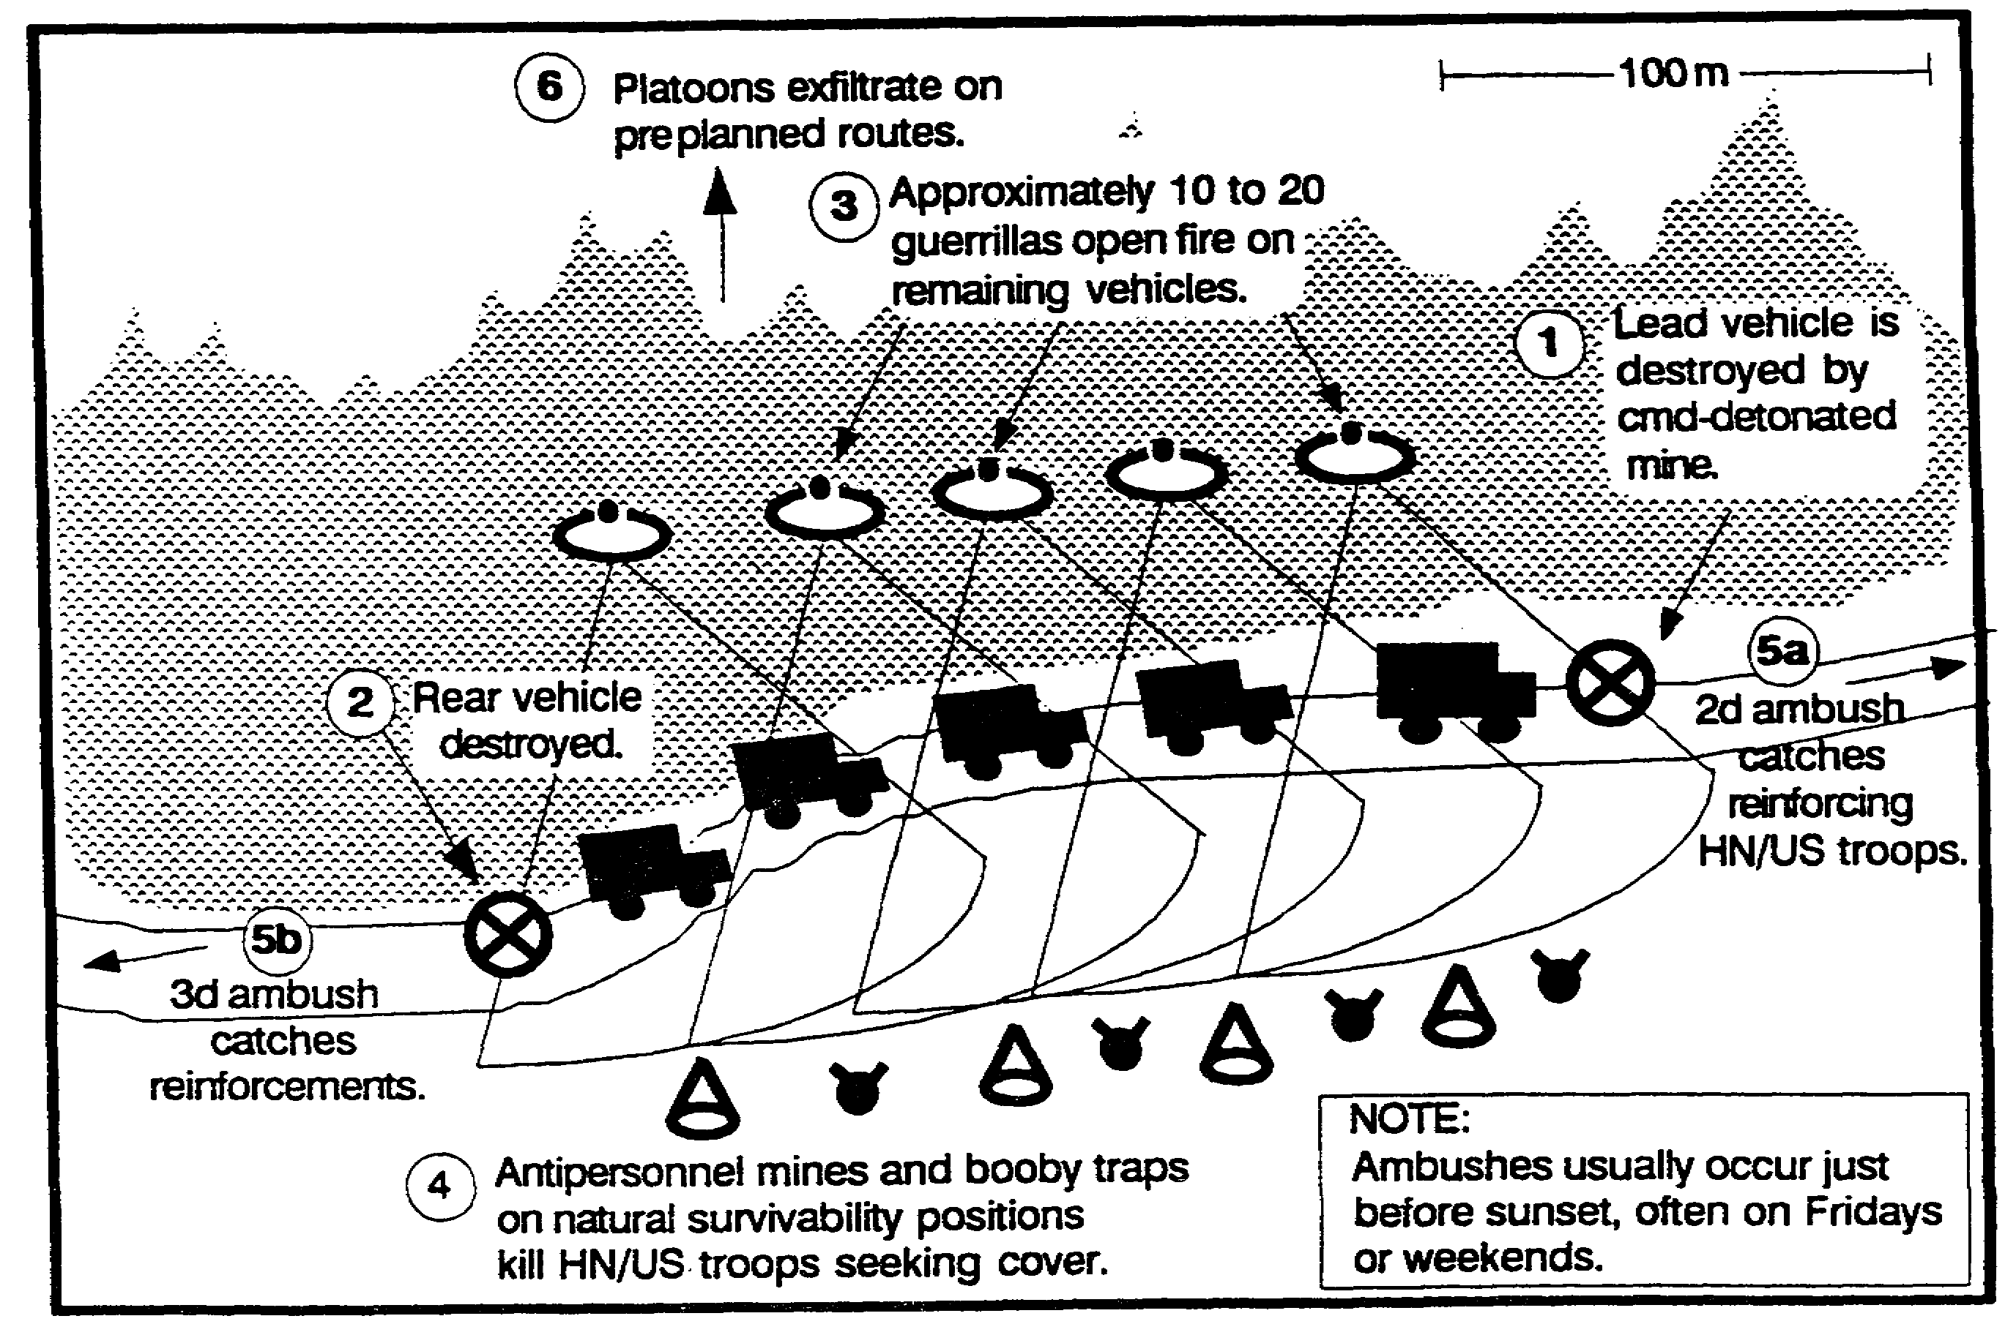

Figure 2-5. Doctrinal Template depicts the enemy's normal or preferred tactics.

PART E -- DETERMINE THREAT COURSES OF ACTION

Finally, step 4 integrates the previous steps into a meaningful conclusion. Given what the Threat normally prefers to do, and the specific environment in which he is operating now, what are the COA options available to him? In step 4, the G2 or S2 develops situation templates, event templates, and event matrices.

The situation templates developed in step 4 are the products that the staff will use to portray the Threat in the command estimate and targeting process. However, the G2 or S2 cannot produce these templates, effectively predicting the Threat COAs, unless he has:

o Adequately analyzed the friendly mission throughout the time-duration of the operation; the physical limits of the AO and Al; and every characteristics of the battlefield that might affect the operation. (Step 1).

o Fully explored what the METT-T situation (environment) encourages and discourages. (Step 2).

o Thoroughly considered what the Threat is capable of and what he prefers to do in like situations. (Step 3).

In summary, the situation templates which drive the command estimate process are valid only if the G2 or S2 establishes a good foundation during the first three steps of the IPB process (see Figure 2-6).

2-15 IT0432

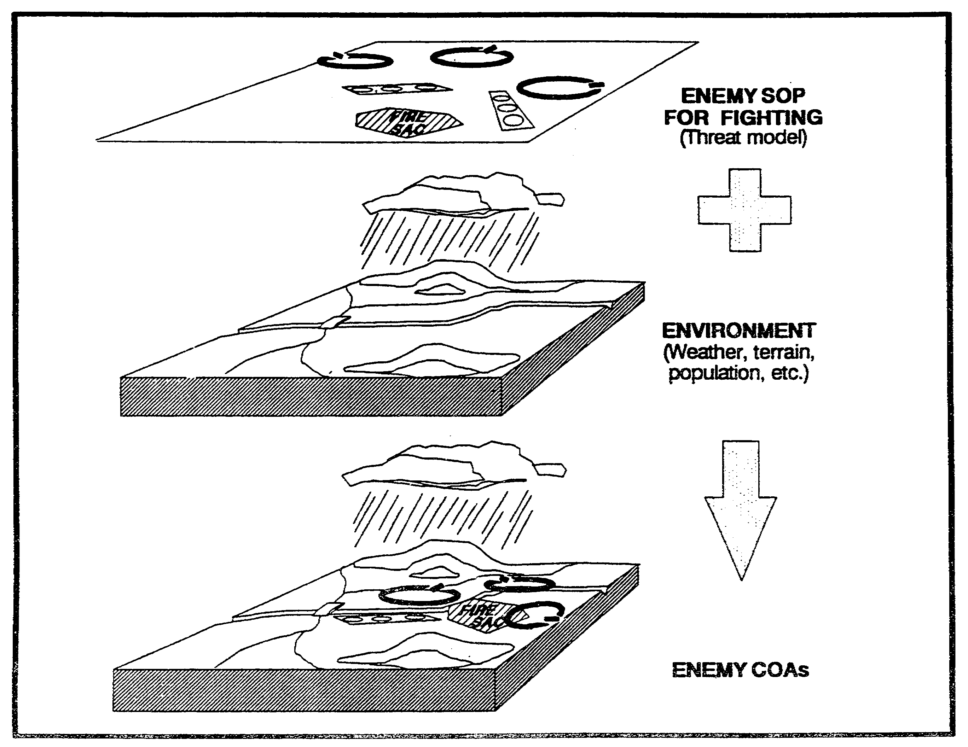

Figure 2-6. From Doctrinal Templates to Situation Templates.

During this step the following substeps are performed:

o Identify the full set of rational courses of action available to the Threat.

o Consider wild card courses of action.

o Evaluate and prioritize each course of action.

o Develop each course of action in the amount of detail time allows.

o Identify initial collection requirements.

Identify the Full Set of Rational Courses of Action Available to the Threat.

Begin by identifying the Threat's likely objective and intent. Then select Threat models, from step three of the IPB process, that will accomplish these objectives. Examine how the effects of the battlefield, from step two of the IPB process, influence their application as courses of action.

IT0432 2-16

You will find that terrain, weather, and other characteristics "offer" a limited set of COAs, encouraging some while discouraging others. Threat characteristics will further limit this set of COAs. When identifying Threat courses of action consider the forces and options available to the Threat at one level of command above and two levels below your own. This allows you to consider the options available to the forces opposing your command within the context of their parent command.

Identify likely objectives and desired end states for each Threat force you're dealing with. Compare the likely objectives and intended end state with Threat capabilities and Threat models identified in step 3 of IPB.

Identify the general courses of action open to the Threat, such as deliberate attack. hasty attack, defend, and delay. Further define each general COA into a set of specific courses of action. For example, a general course of action such as "hasty attack" might be further defined as a set of specific courses of action such as "with main effort in the east....in the west....against the adjacent unit."

Account for the effect of friendly dispositions, or the Threat's perception of friendly dispositions, when replicating the COAs available to the Threat. A technique for accomplishing this is too conduct "reverse IPB." In other words, replicate the process that the Threat is employing to discern friendly COAs.

Consider Wild Card Course of Action.

The Threat does not always choose a rational course of action that can be logically predicted using the techniques described thus far. In fact, in his book, Strategy, B.H. Liddelt Hart demonstrates through a study of history that most brilliant military victories have occurred when a commander chooses an indirect approach.

To avoid this surprise, identify alternative methods by which the Threat can achieve its objective or desired end-state in addition to the standard, rational COAs already identified.

Evaluate and Prioritize Each Course of Action.

The resulting set of courses of action depicts options available to the Threat, both rational and wild card Remember that these COAs are assumptions about the Threat -not facts. Because of this you cannot predict with complete accuracy which of the COAs the Threat will employ until you have acquired confirming intelligence.

However, the commander and his staff still need to develop a plan that is optimized to one of the courses of action, while still allowing for contingency options if the Threat chooses another COA. Therefore, you must evaluate each COA and prioritize it according to how likely you estimate the Threat will adopt that option. Refine this initial list after the friendly command has developed friendly courses of action.

2-17 IT0432

To prioritize each course of action --

o Further refine the set of COAs available to the Threat, analyze each COA to identify its individual strengths and weaknesses, centers of gravity, and decisive points.

o Compare each COA to the others and determine if the Threat is more likely to prefer one over the others.

o Analyze the Threat's recent activity to determine if there are indications that one COA is already being adopted. Based on these evaluations, rank the Threat's courses of action in their likely order of adoption.

Develop Each-Course of Action in the Amount of Detail Time Allows.

Once the complete set(s) of Threat COAs are identified, develop each course of action into as much detail as the situation requires and time available allows. To ensure completeness, each course of action must answer five questions:

o What -the type of operation, such as attack, defend, etc.

o When -the time the action will begin. You usually state this in terms of the earliest time that the Threat can adopt the course of action under consideration.

o Where -the sectors, zones, axis of attack, avenues of approach and objectives that make up the course of action.

o How -the method by which the Threat will employ his assets, such as dispositions, location of main effort and the scheme of maneuver.

o Why -the objective or end state the Threat intends to accomplish.

Consider threat forces available to at least one level of command above your own when developing each COA. For example, a battalion S2 would consider the COAs available to threat regiments and brigades. This helps to ensure that you account for possible reinforcing forces and the higher command's own objectives and intent (see Figure 2-7).

Time permitting, your final product should consist of a comprehensive, detailed set of Threat courses of action. Each developed Threat course of action has three parts:

o a situation template.
o a description of the course of action.
o a listing of high value targets.

Identify Initial Collection Requirements.

The art of identifying initial collection requirements revolves around predicting specific areas and activities, which when observed, will reveal which course of action the Threat has chosen.

IT0432 2-18

These areas are called named areas of interest, or NAls. The activities which reveal the selected course of action are called indicators.

Evaluate each course of action to identify its associated NAIs. Consolidate the NAls from each course of action onto one event template.

Record the indicators associated with each NAI onto the event matrix (see figure 2-8). The event matrix shows the relationship between indicators, NAls, and the courses of action they confirm or deny.

Your event template and matrix, once complete, form the basis for planning your collection strategy, synchronizing intelligence with friendly operations, and preparing the collection plan. In some cases, you might disseminate the event template in the form of a collection graphic to support intelligence planning and collection by other units.

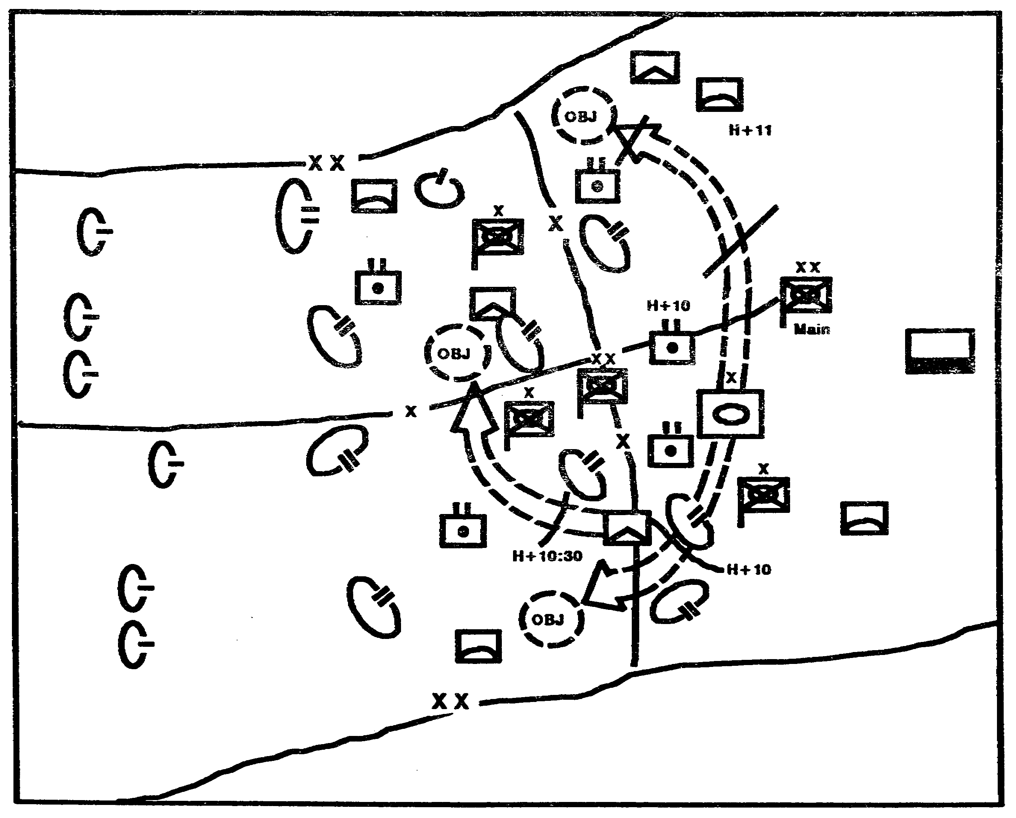

Figure 2-7. Situation Templates depict enemy COA.

2-19 IT0432

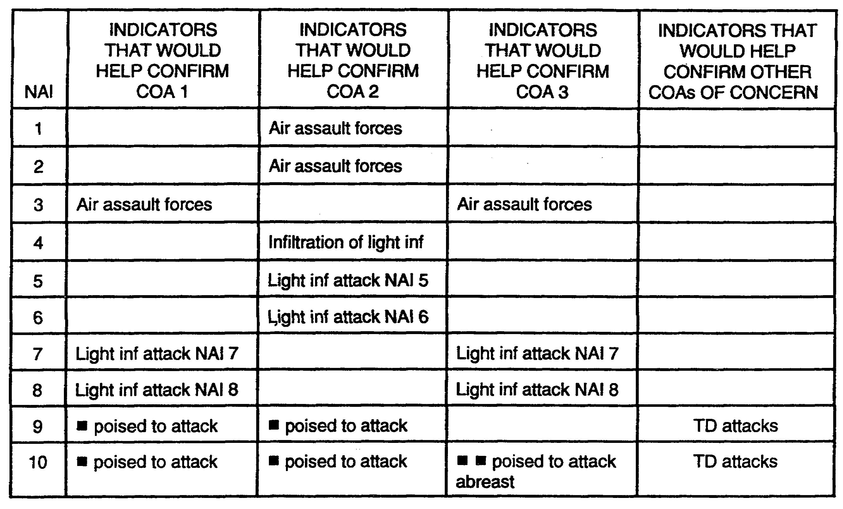

Figure 2-8. The Event matrix.

IT0432 2-20

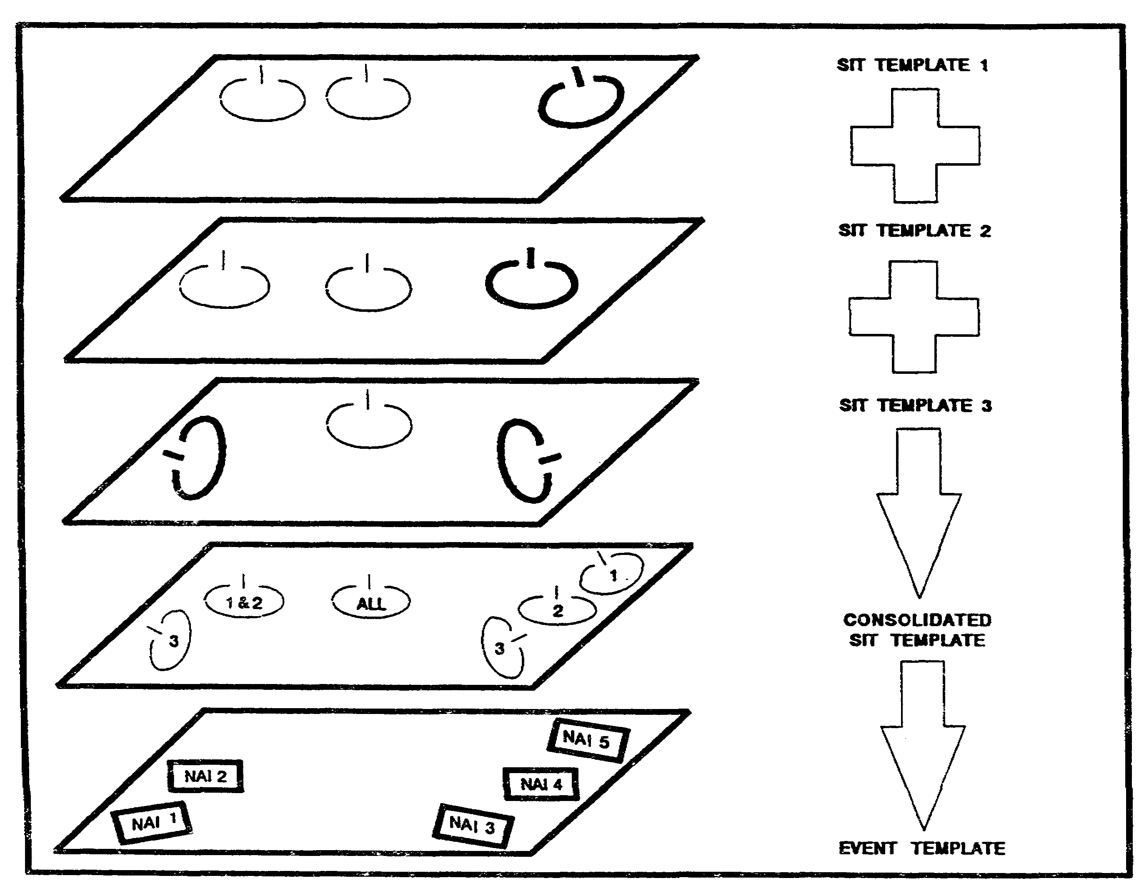

Figure 2-9. Compare enemy COAs to produce the event template.

2-21 IT0432

PART F -- INTELLIGENCE ESTIMATE

In order to facilitate staff planning, the G2 or S2 prepares the intelligence estimate before the remainder of the staff completes their own estimates. The intelligence estimate forms the basis for the facts and assumptions of the command estimate process, driving and remaining staff estimates and steps in the command estimate process. The set of templates, overlays and matrices produced during IPB constitute the basis of the intelligence estimate.

Paragraph 2 of the estimate, the Al, is derived from step 2 of the IPB process, describe the battlefield effects. The most important subparagraphs of paragraph 2 are the "effects on enemy COAs" and "effects on own COAs." These sections describe the battlefield's impact on operations.

Paragraph 3 of the estimate, enemy situation, is derived from step 3 of the IPB process, evaluate the Threat. This is primarily a discussion of what is known about the Threat (facts) and the results of analysis of those facts (assumptions).

Paragraph 4 of the estimate, enemy capabilities, is derived from step 4 of the IPB process, determine Threat COAs. This is a list and discussion of the COAs available to the Threat. These COAs should correspond with the situation templates.

Paragraph 5 of the estimate, conclusions, simply states the bottom line from the analysis reflected in the previous paragraphs.

PART G -- IPB APPLICATION

Basic IPB doctrine can be applied to support planning in any situation. However, the application of that doctrine will vary according to the circumstances. This portion of the lesson illustrates the application of IPB in two different situations. The basic IPB process is used for each situation, but each one emphasizes different techniques. The two situations depict the four steps of the IPB process and illustrate some of the graphics applicable to each step. The number and degree of IPB graphic products produced will be dependent on METT-T with time being the most critical. many of the steps involved in the IPB process are time intensive. Consequently the IPB process may have to be abbreviated.

The first situation portrays a heavy division attacking an under strength enemy division. The second situation portrays a heavy brigade defending against a heavy division. The second situation provides an example of abbreviated IPB.

Situation 1 - Offensive Operations.

As the attacking enemy reaches his culminating point, the corps prepares to launch a counteroffensive. The corps will attack with its main effort in the north. Our division will conduct a supporting attack in the south, crossing the Kald River and establishing a hasty defense once we reach the corps limit of advance (LOA).

IT0432 2-22

Our division is composed of one armored brigade, two mechanized infantry brigades, one light infantry brigade, and the normal complement of aviation, artillery, and combat support (CS) and combat service support (CSS) units.

The enemy in our division's sector is on under strength mechanized infantry division. Beyond our limit of advance is the enemy's second echelon, two armored divisions, also under strength. An air assault brigade and surface-to-surface missile (SSM) units are located in the enemy's depth (Figure 2-10).

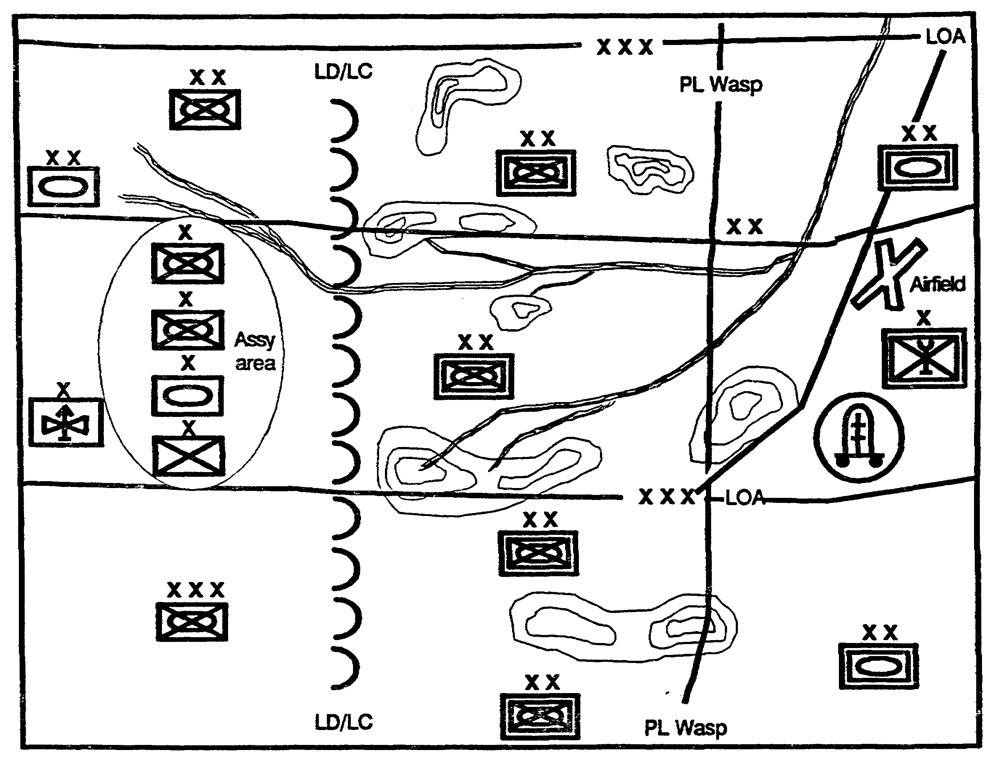

Figure 2-10. General Situation.

2-23 IT0432

DEFINE THE BATTLEFIELD ENVIRONMENT

The operations graphics from corps specify our division's AO. It lies within our current boundaries and extends out to our LOA (Figure 2-11).

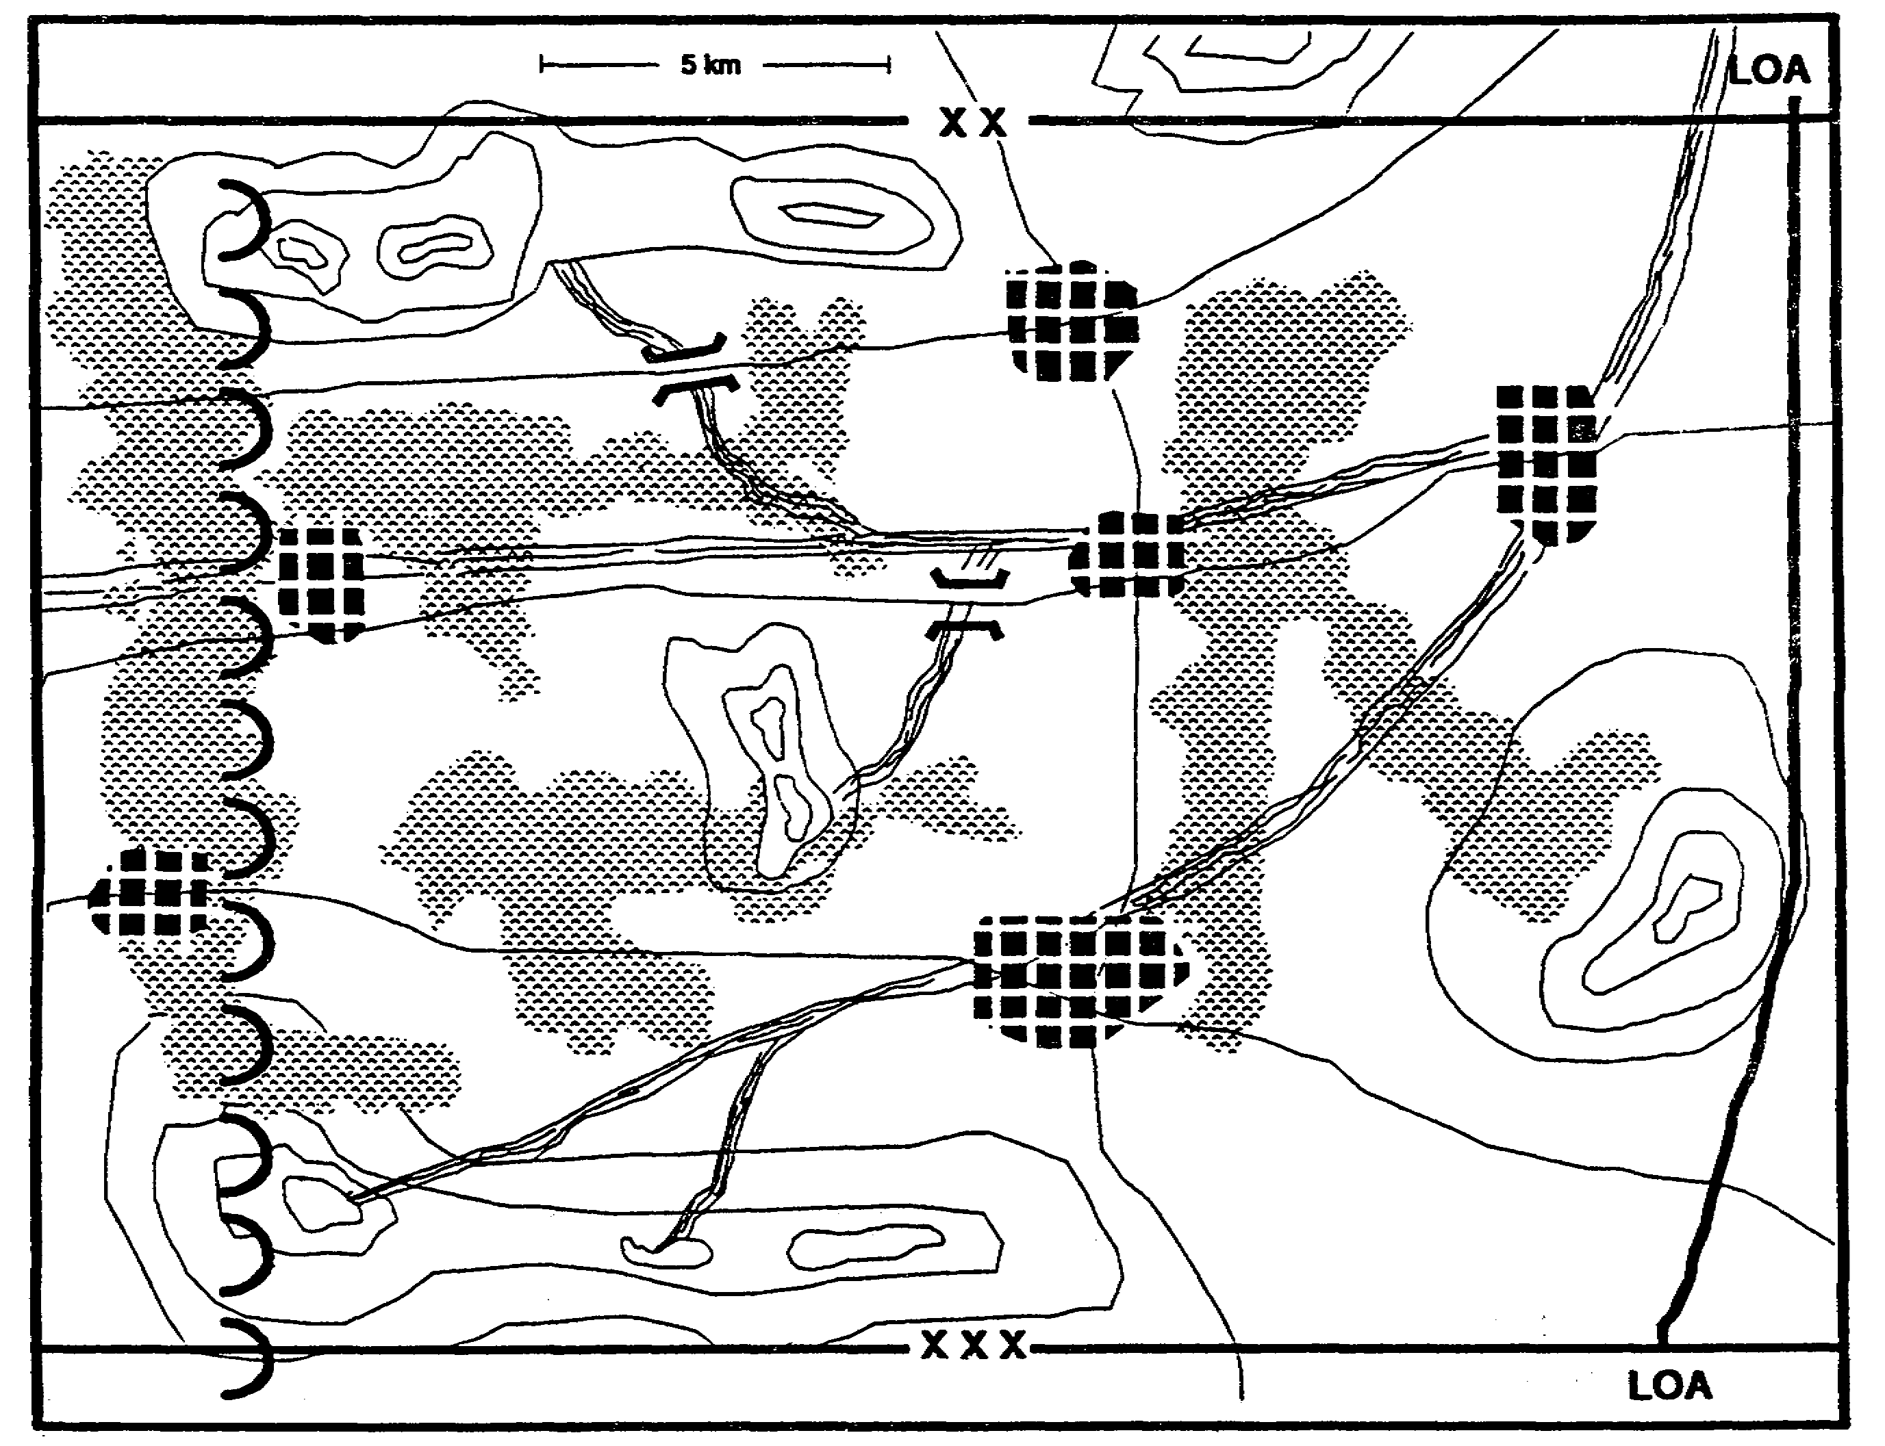

Figure 2-11. Operations Graphics.

We establish our Al to include all likely Threats to our mission. We know from our previous operations in the sector now controlled by the enemy that the populace's sympathies are mixed. We define the battlefield environment as including the civilians within our sector and establish the limits of our Al (Figure 2-12).

IT0432 2-24

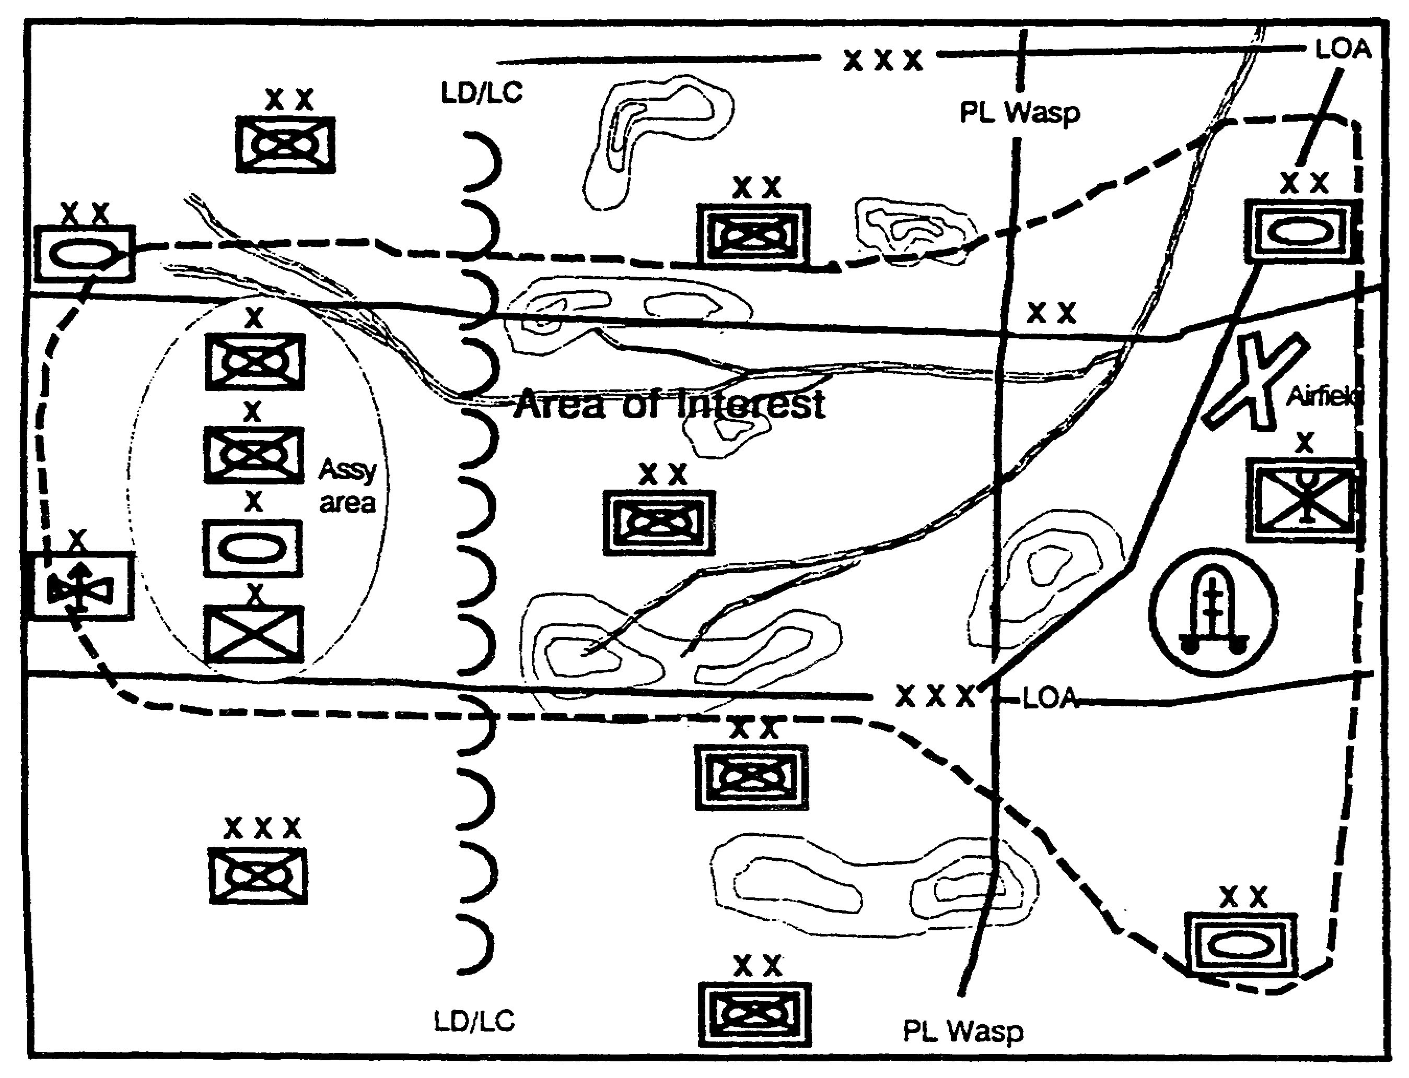

Figure 2-12. Expanded Al.

DESCRIBE THE BATTLEFIELD EFFECT

Since our division contains a mix of heavy and light forces, we must evaluate the effects of the battlefield environment on both types of forces. We start with the environment's effects on the mobility of our heavy forces (Figure 2-13).

2-25 IT0432

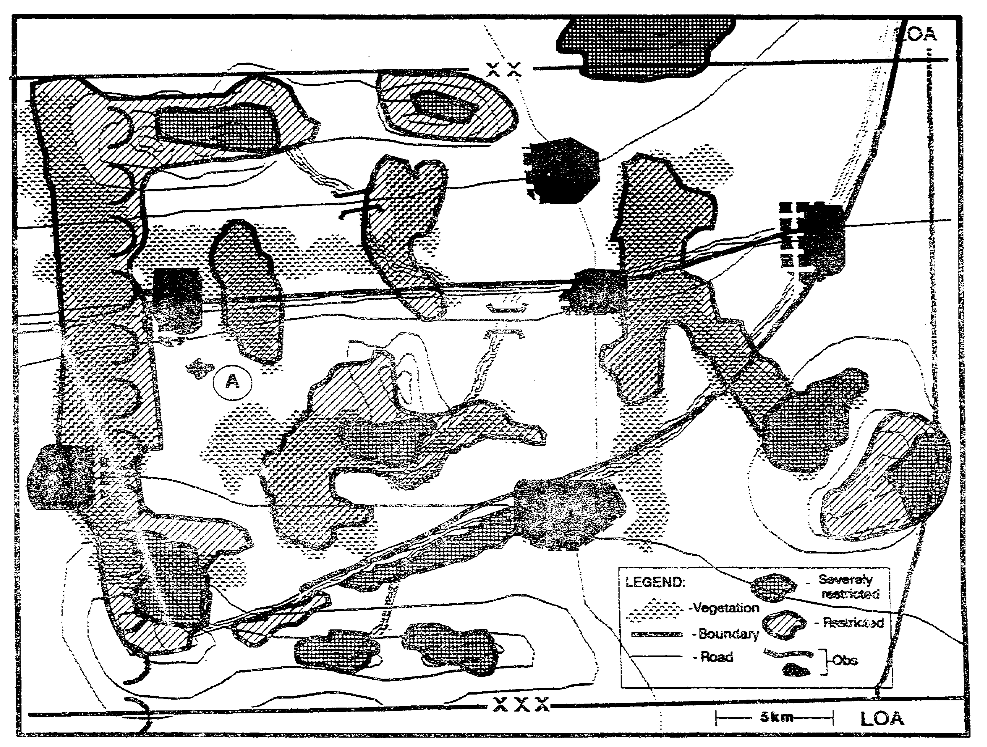

Figure 2-13. Combined Obstacle Overlay.

The engineer (terrain) detachment conducts an analysis of the various terrain factors that constitute obstacles to movement to produce a base graphic depicting the environment's effects on mobility. Because of the availability of logging roads and the lack of dense undergrowth, the woods are passable. Some branches of the river system are fordable and pose no real obstacle to maneuver. The Kald River, however, is a major obstacle that will require our division to conduct river crossing operations if the bridges cannot be taken intact.

To the engineer detachment's base graphic we add any other characteristics of the battlefield that will affect our mobility. In this case, it consists of the apparently unrestricted terrain at (A); which is severely restricted due to the presence of an historic and religious landmark, a 10th century abbey, protected by international laws and treaties.

Using the combined obstacle overlay as a base, we identify mobility corridors between areas of restrictive terrain and determine the size force they will accommodate. Areas which are not restricted are not marked (Figure 2-14).

IT0432 2-26

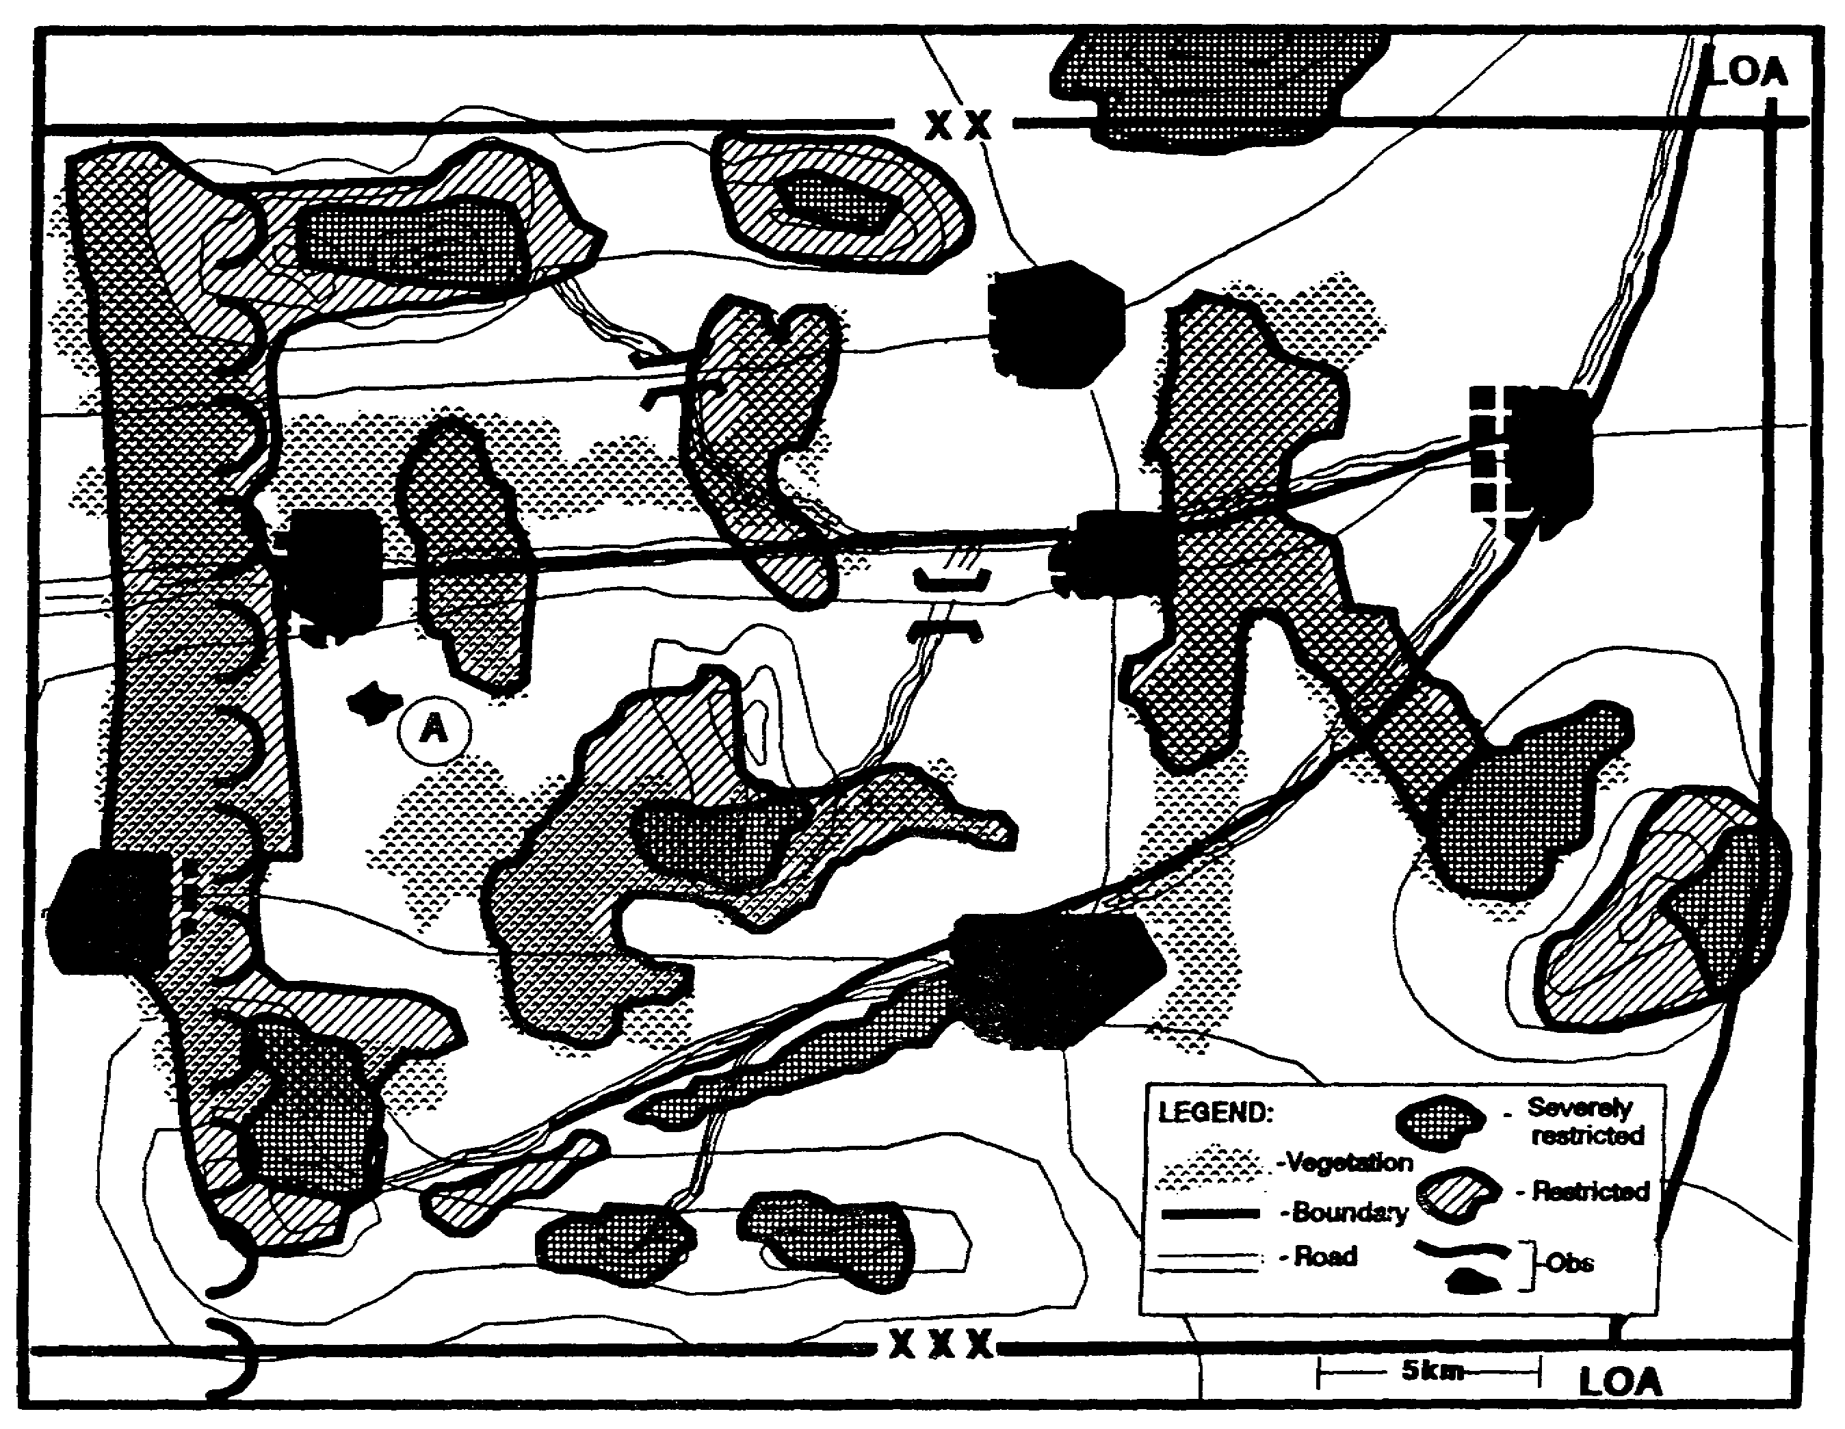

Figure 2-14. Mobility Corridors.

2-27 IT0432

We group mobility corridors together to identify heavy force avenues of approach (Figure 2-15).

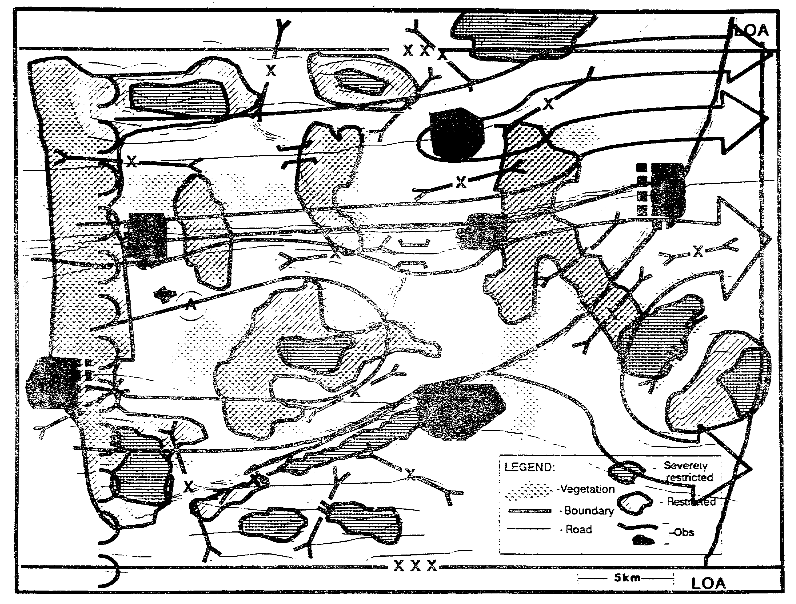

Figure 2-15. Avenues of Approach.

Although they have already included the effects of current and expected weather into their analysis, we ask the engineer (terrain) detachment to evaluate the effects of the worst possible weather expected during the operation's duration.

Based on climatic studies provided by the supporting USAF weather team, the engineers predict that the worst expected weather would restrict mobility corridors along the river valleys due to the effect of rain on the soil types in the area (Figure 2-16). By comparing the new evaluation with previous ones (see Figure 2-13), we note that these weather conditions would cause some water features to go from a fordable to an unfordable condition; requiring a greater need for tactical bridging assets.

IT0432 2-28

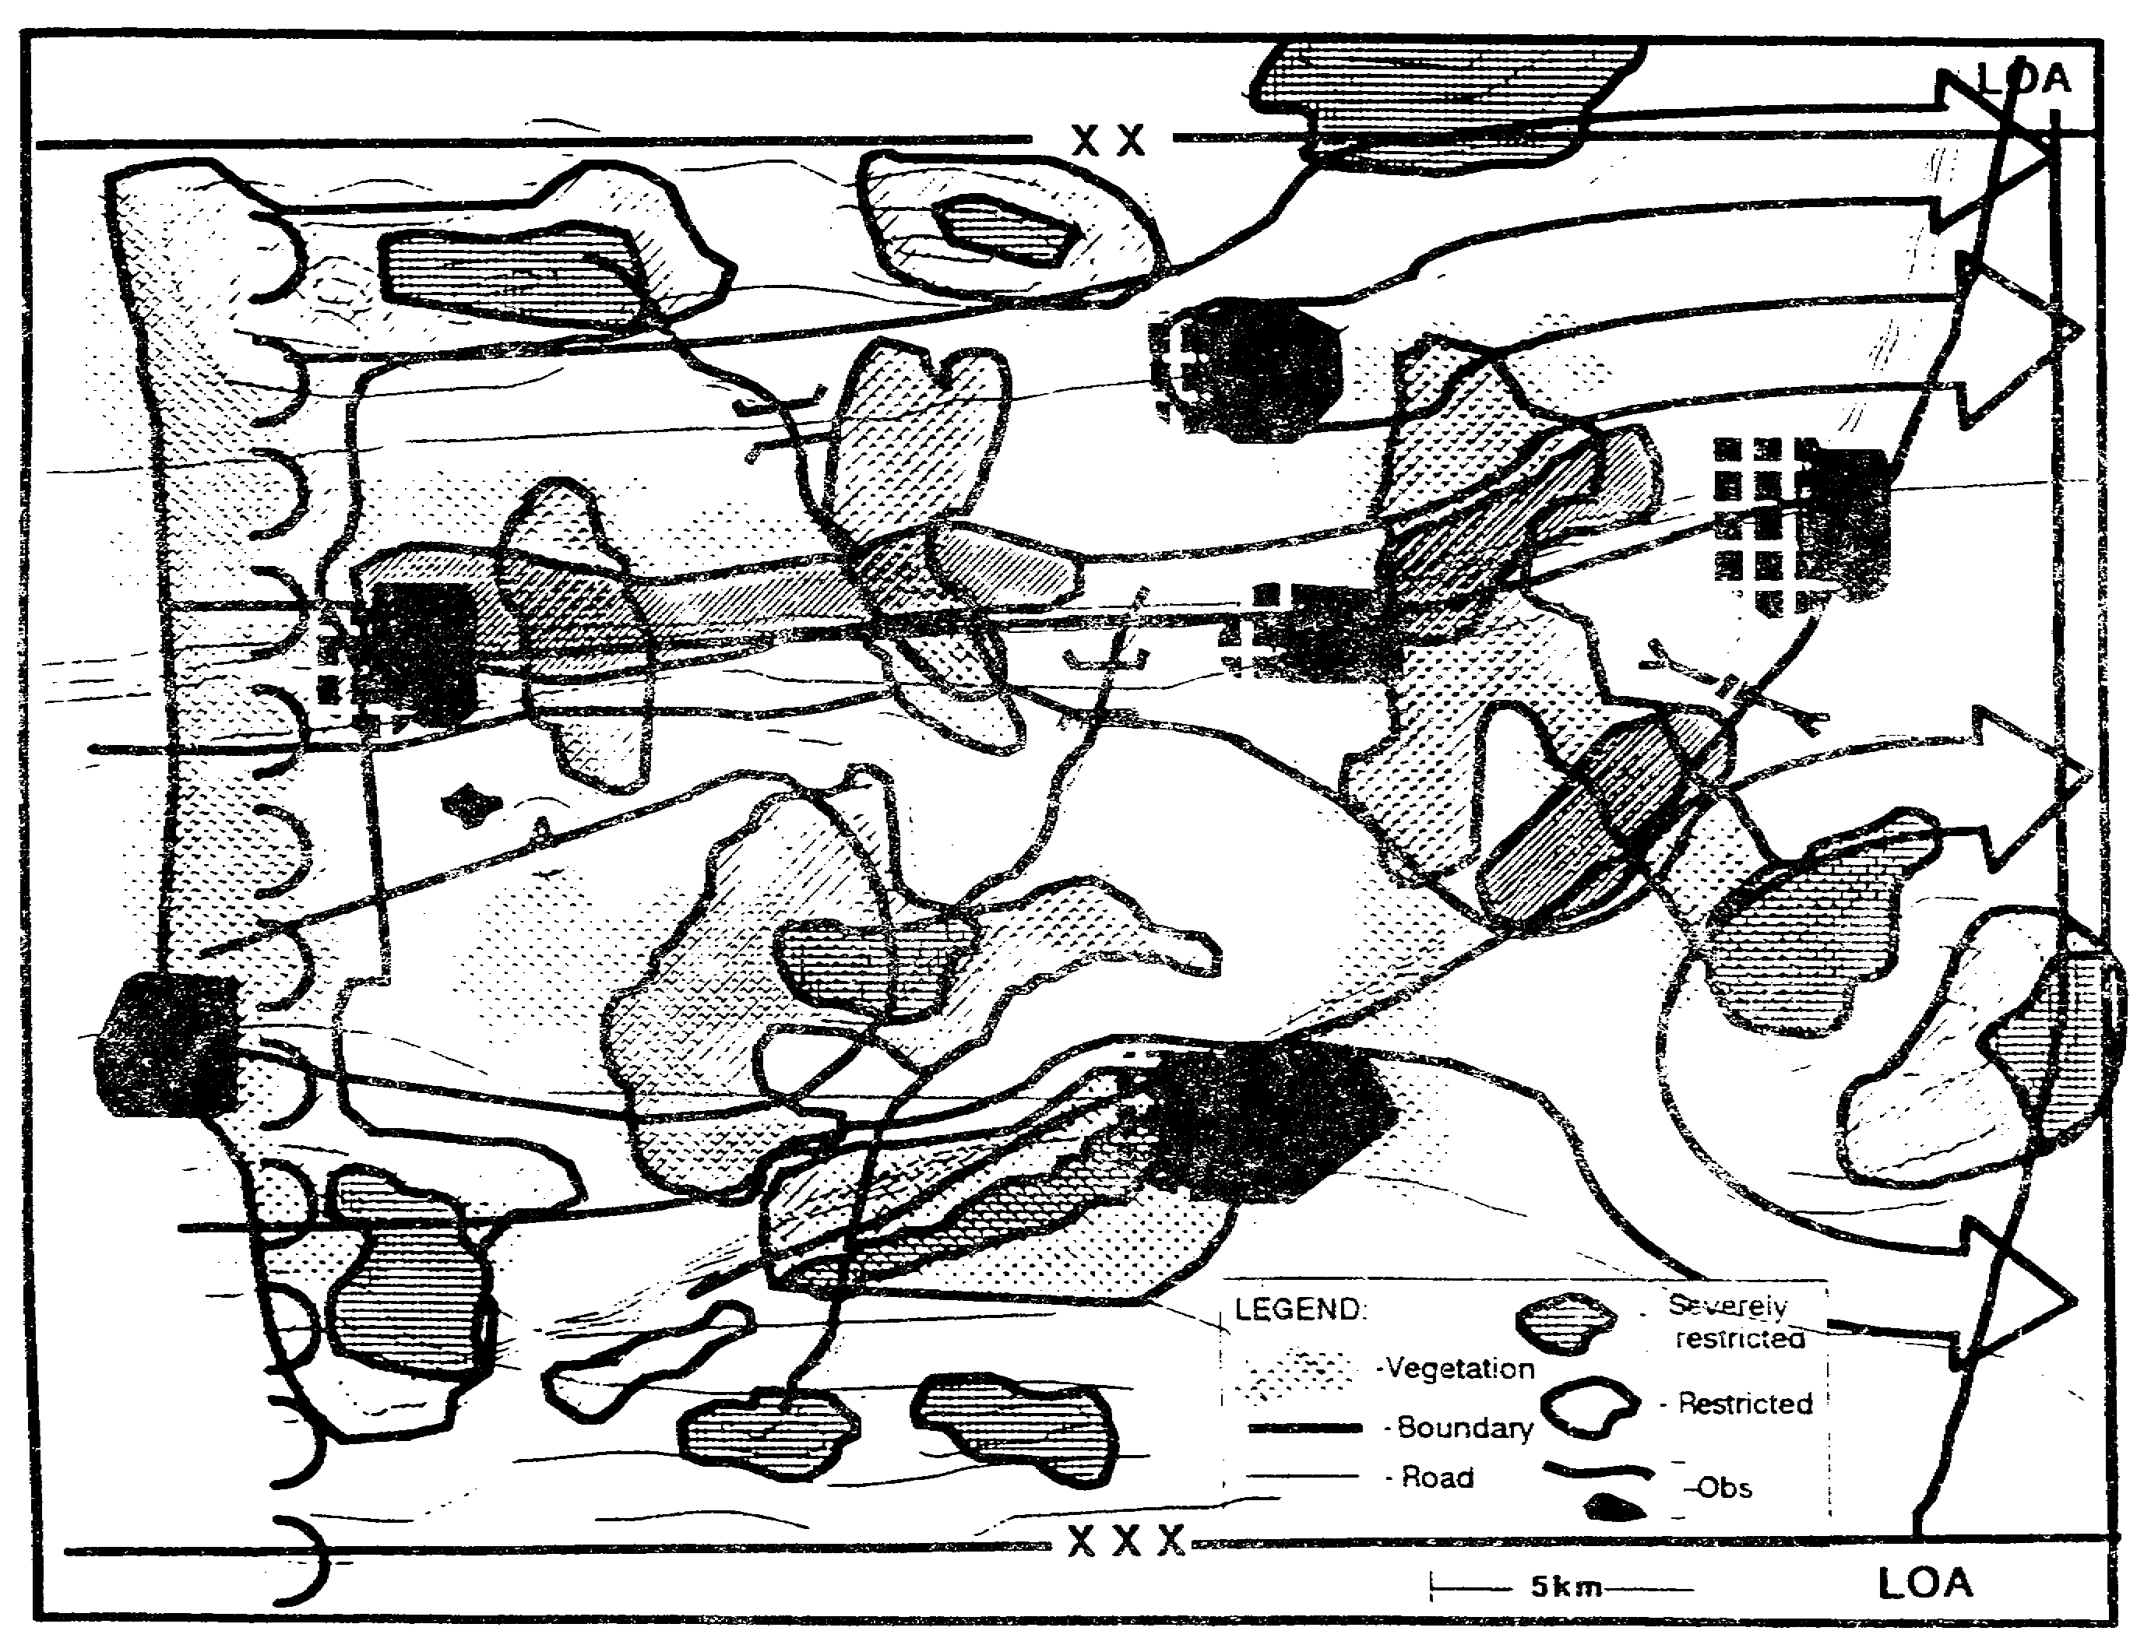

Figure 2-16. Weather Effects.

More significantly, we note that some mobility corridors become infeasible, causing one avenue of approach to detour around terrain now classified as severely restricted. The avenue of approach, now less direct than the others, is still viable although less likely to be used. We reserve this overlay for use in the event of poor weather during our operation.

We next identify defensible terrain along the avenues of approach identified in our initial analysis (see Figure 2-15). We evaluate observation, fields of fire, concealment and cover and obstacles to identify those areas that offer potential defensive positions against forces using these identified avenues of approach (Figure 2-17).

2-29 IT0432

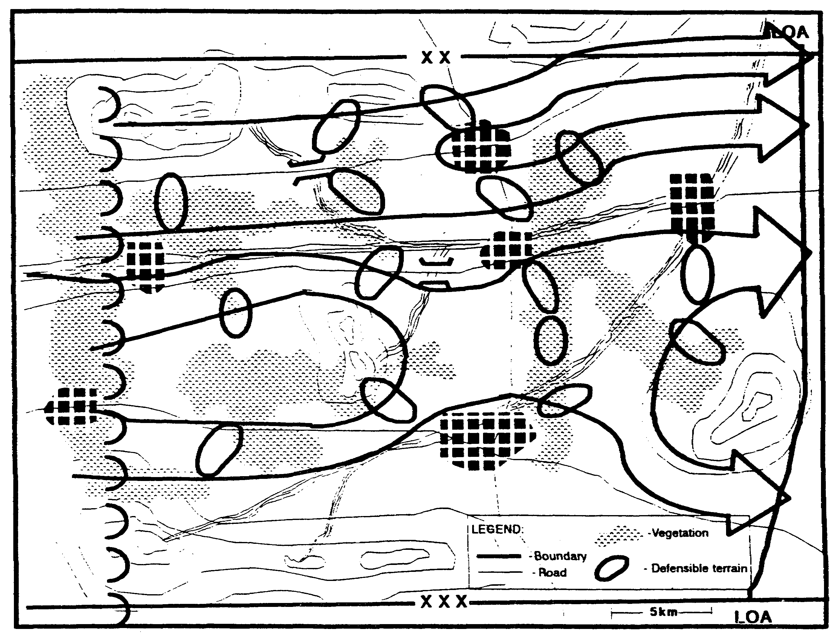

Figure 2-17. Defensible Terrain.

Using the defensible terrain as likely objectives for our light forces, we evaluate available infiltration lanes. We look for areas that offer concealment and cover to dismounted forces as they approach their likely objectives. Only the streams offer any obstacles to light forces, and these are only minor obstacles (Figure 2-18).

IT0432 2-30

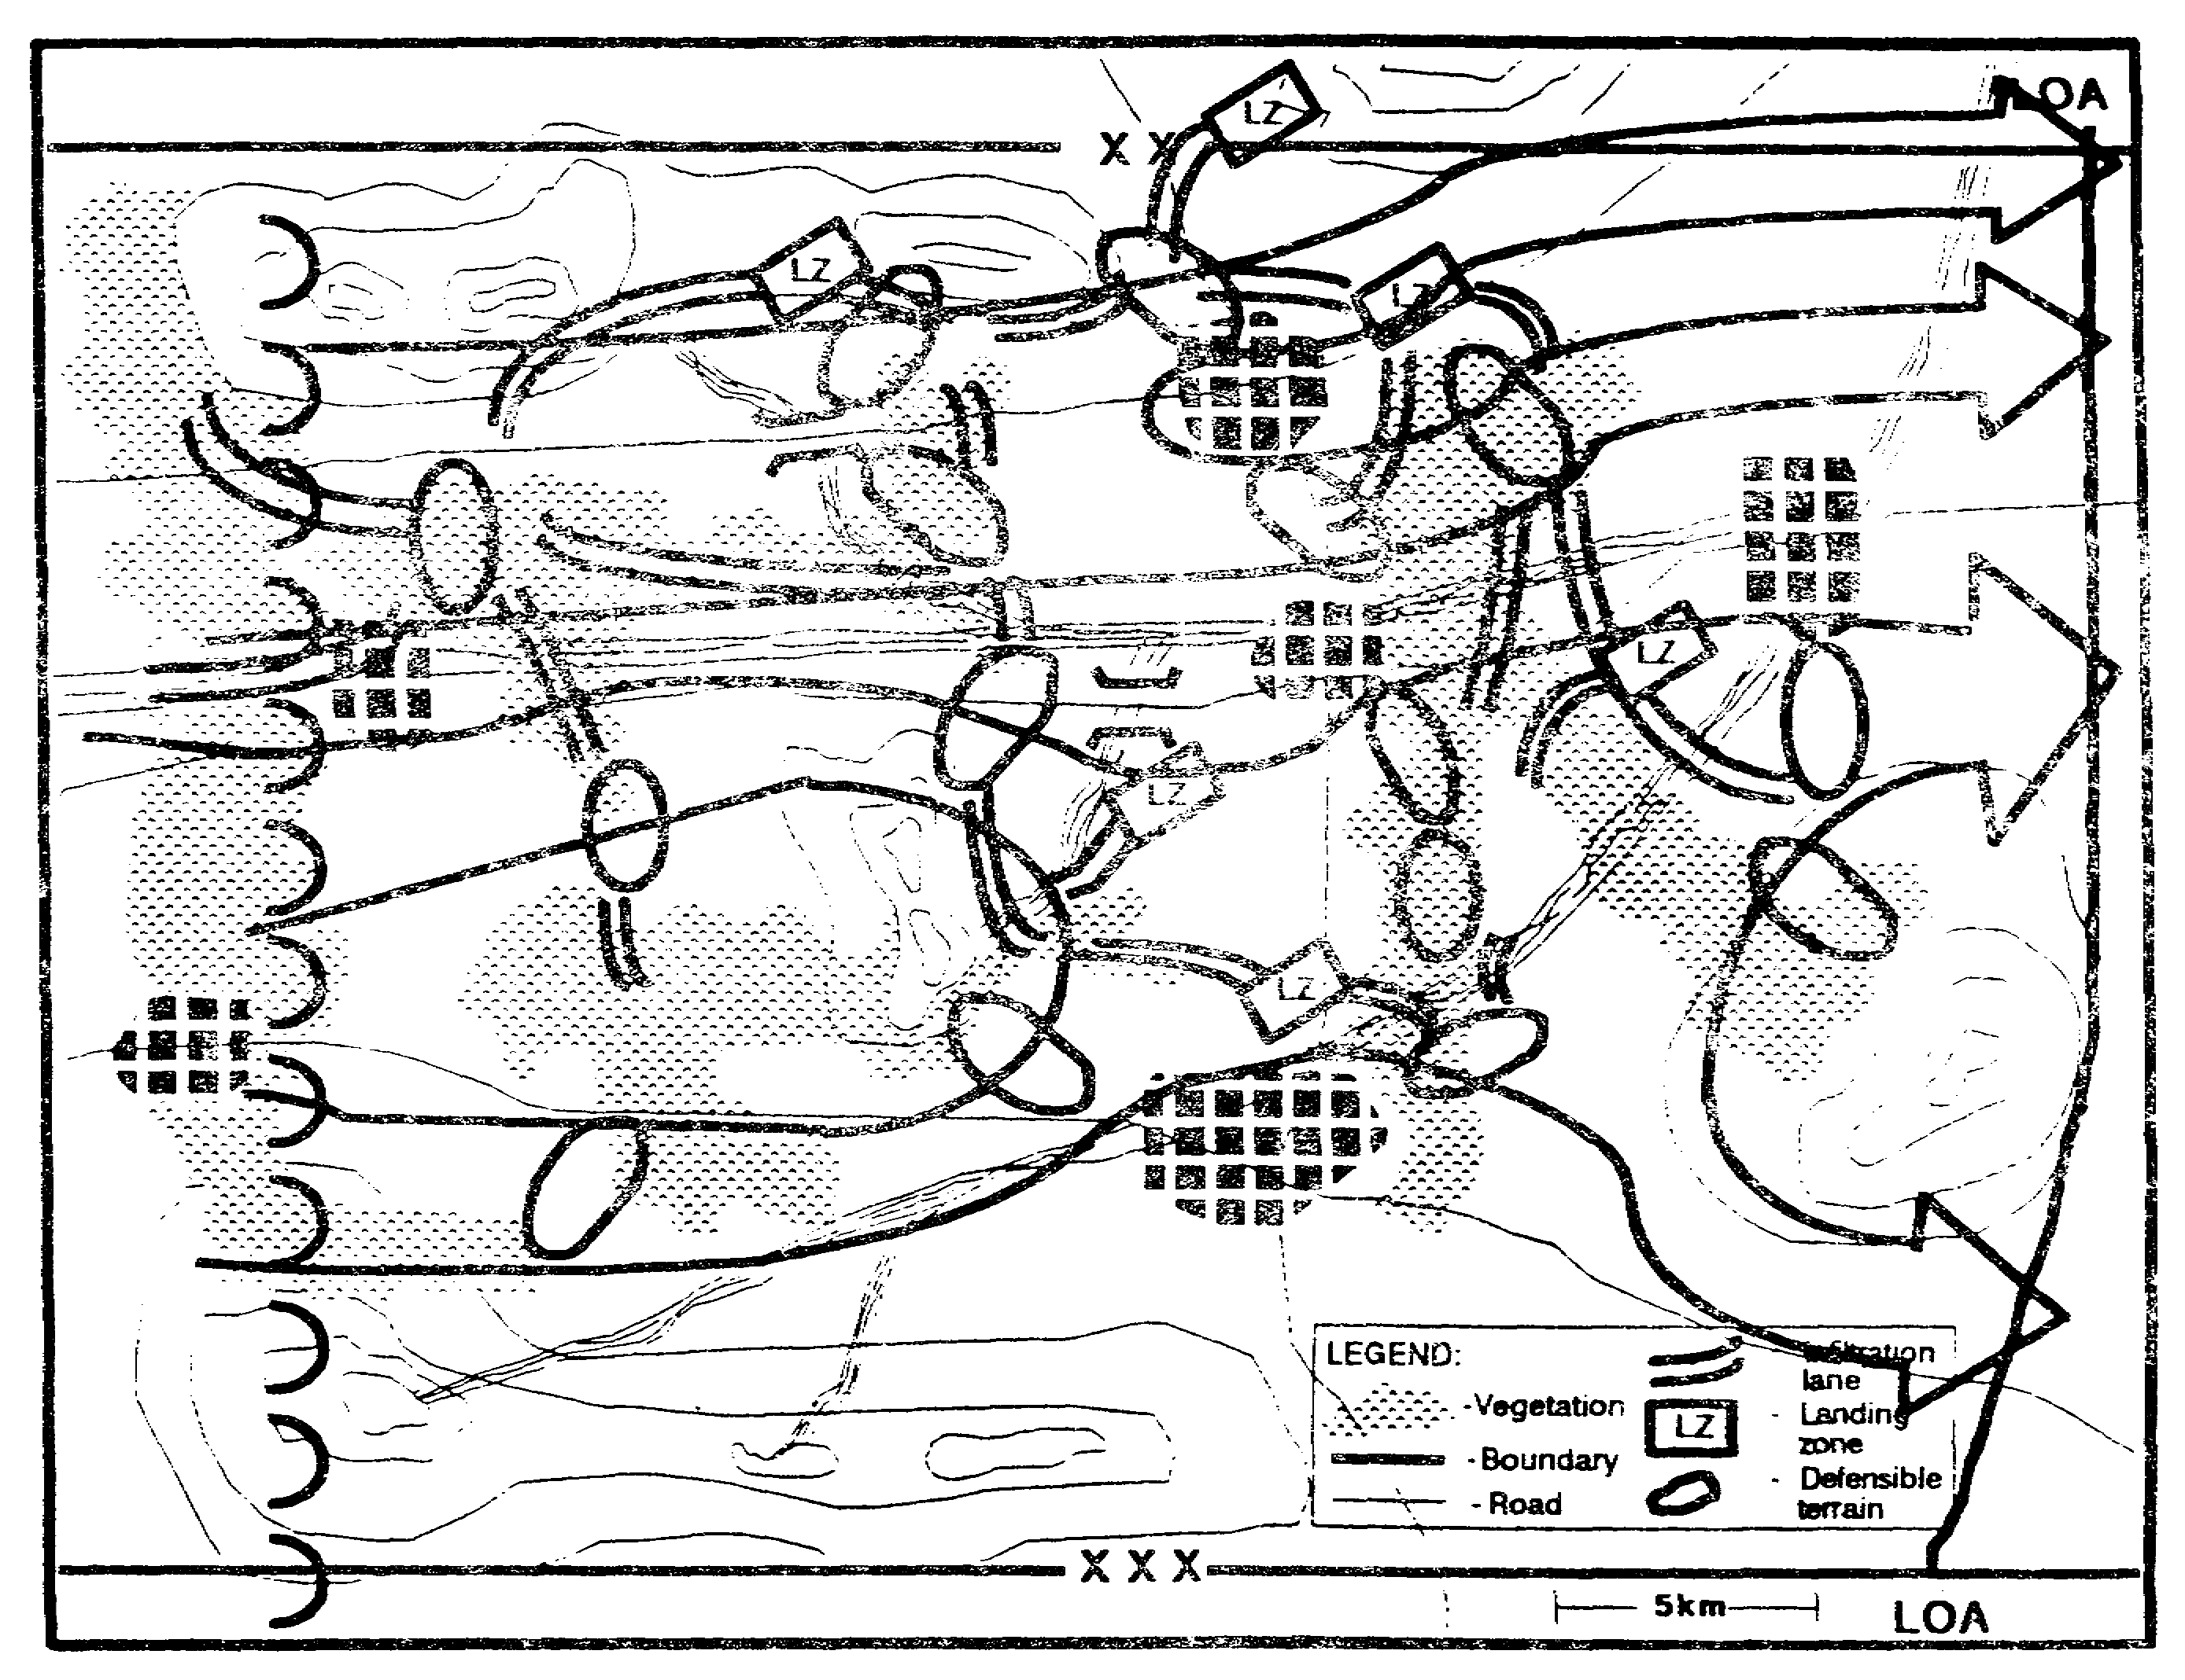

Figure 2-18. Friendly Approach Routes.

2-31 IT0432

We include an evaluation of suitable zones of entry. In this case, we identify potential helicopter landing zones (LZs) that support the approaches to the likely objectives. We identify friendly air avenues of approach to the LZs and into the enemy's depth for deep battle attacks (Figure 2-19).

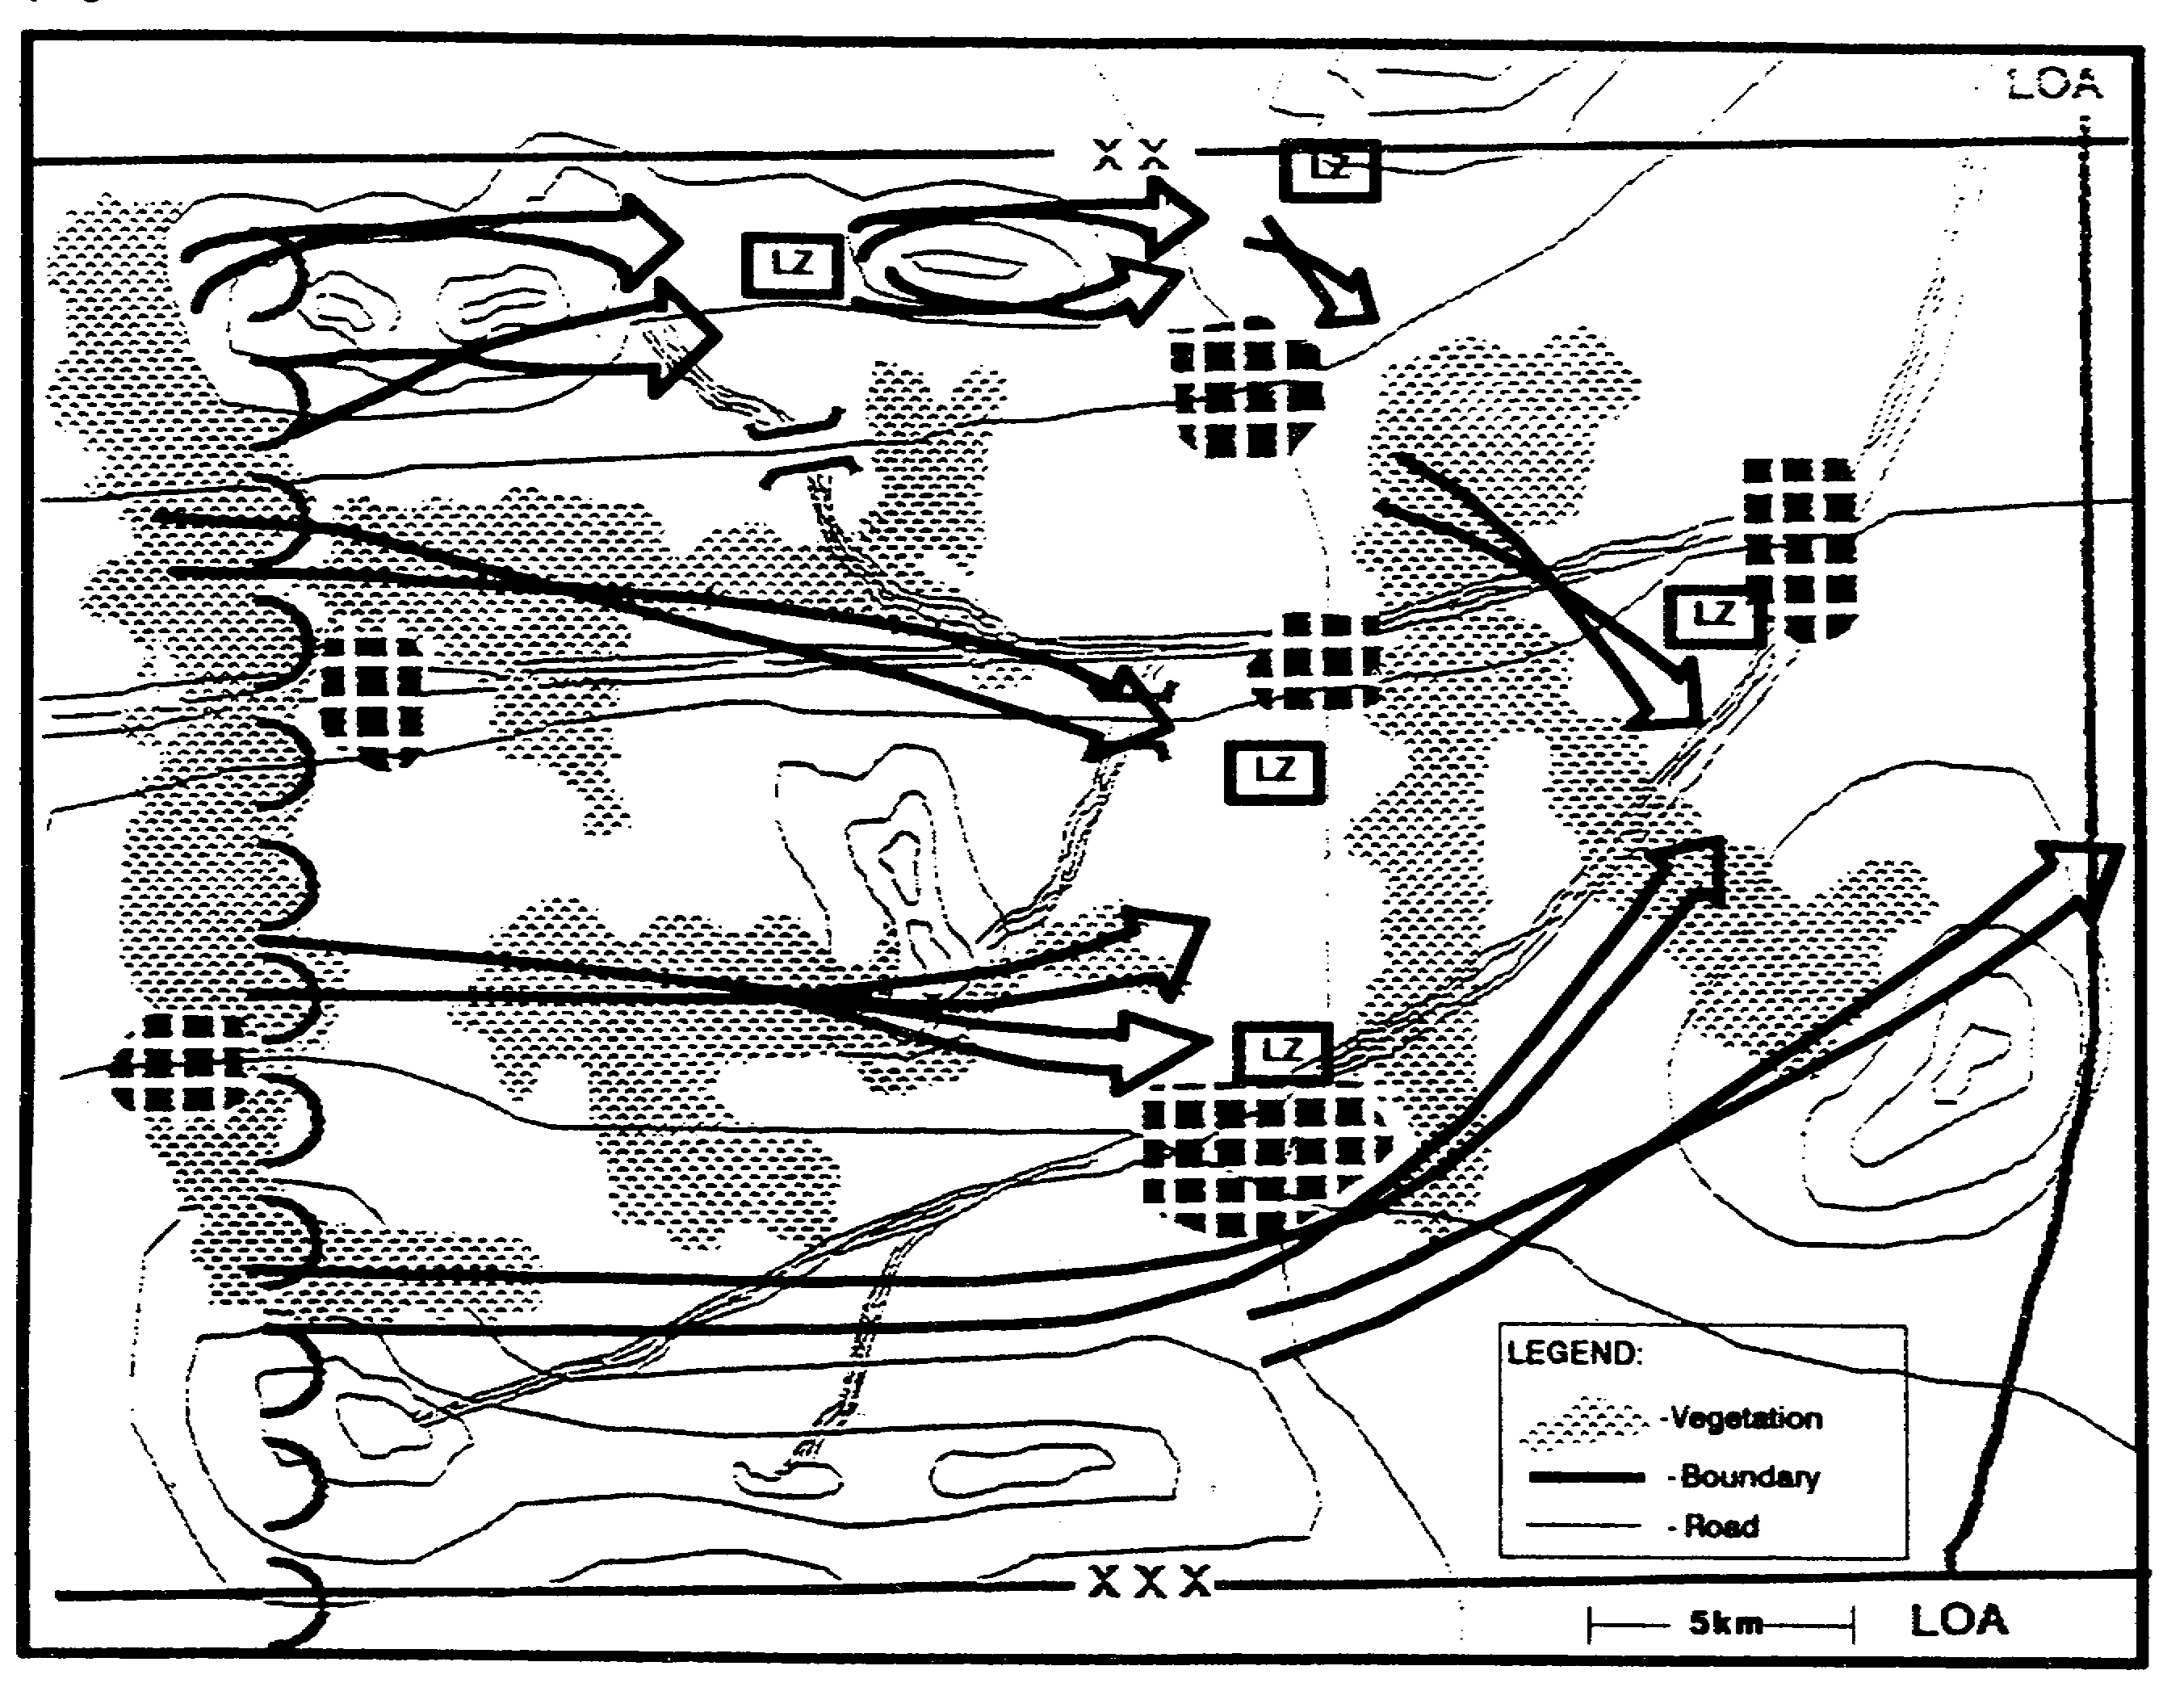

Figure 2-19. Friendly Air AAs.

IT0432 2-32

Even though we expect the enemy to defend, we must consider his avenues of approach as well. These may support counterattacks or the commitment of additional forces into our zone (Figures 2-20 and 2-21).

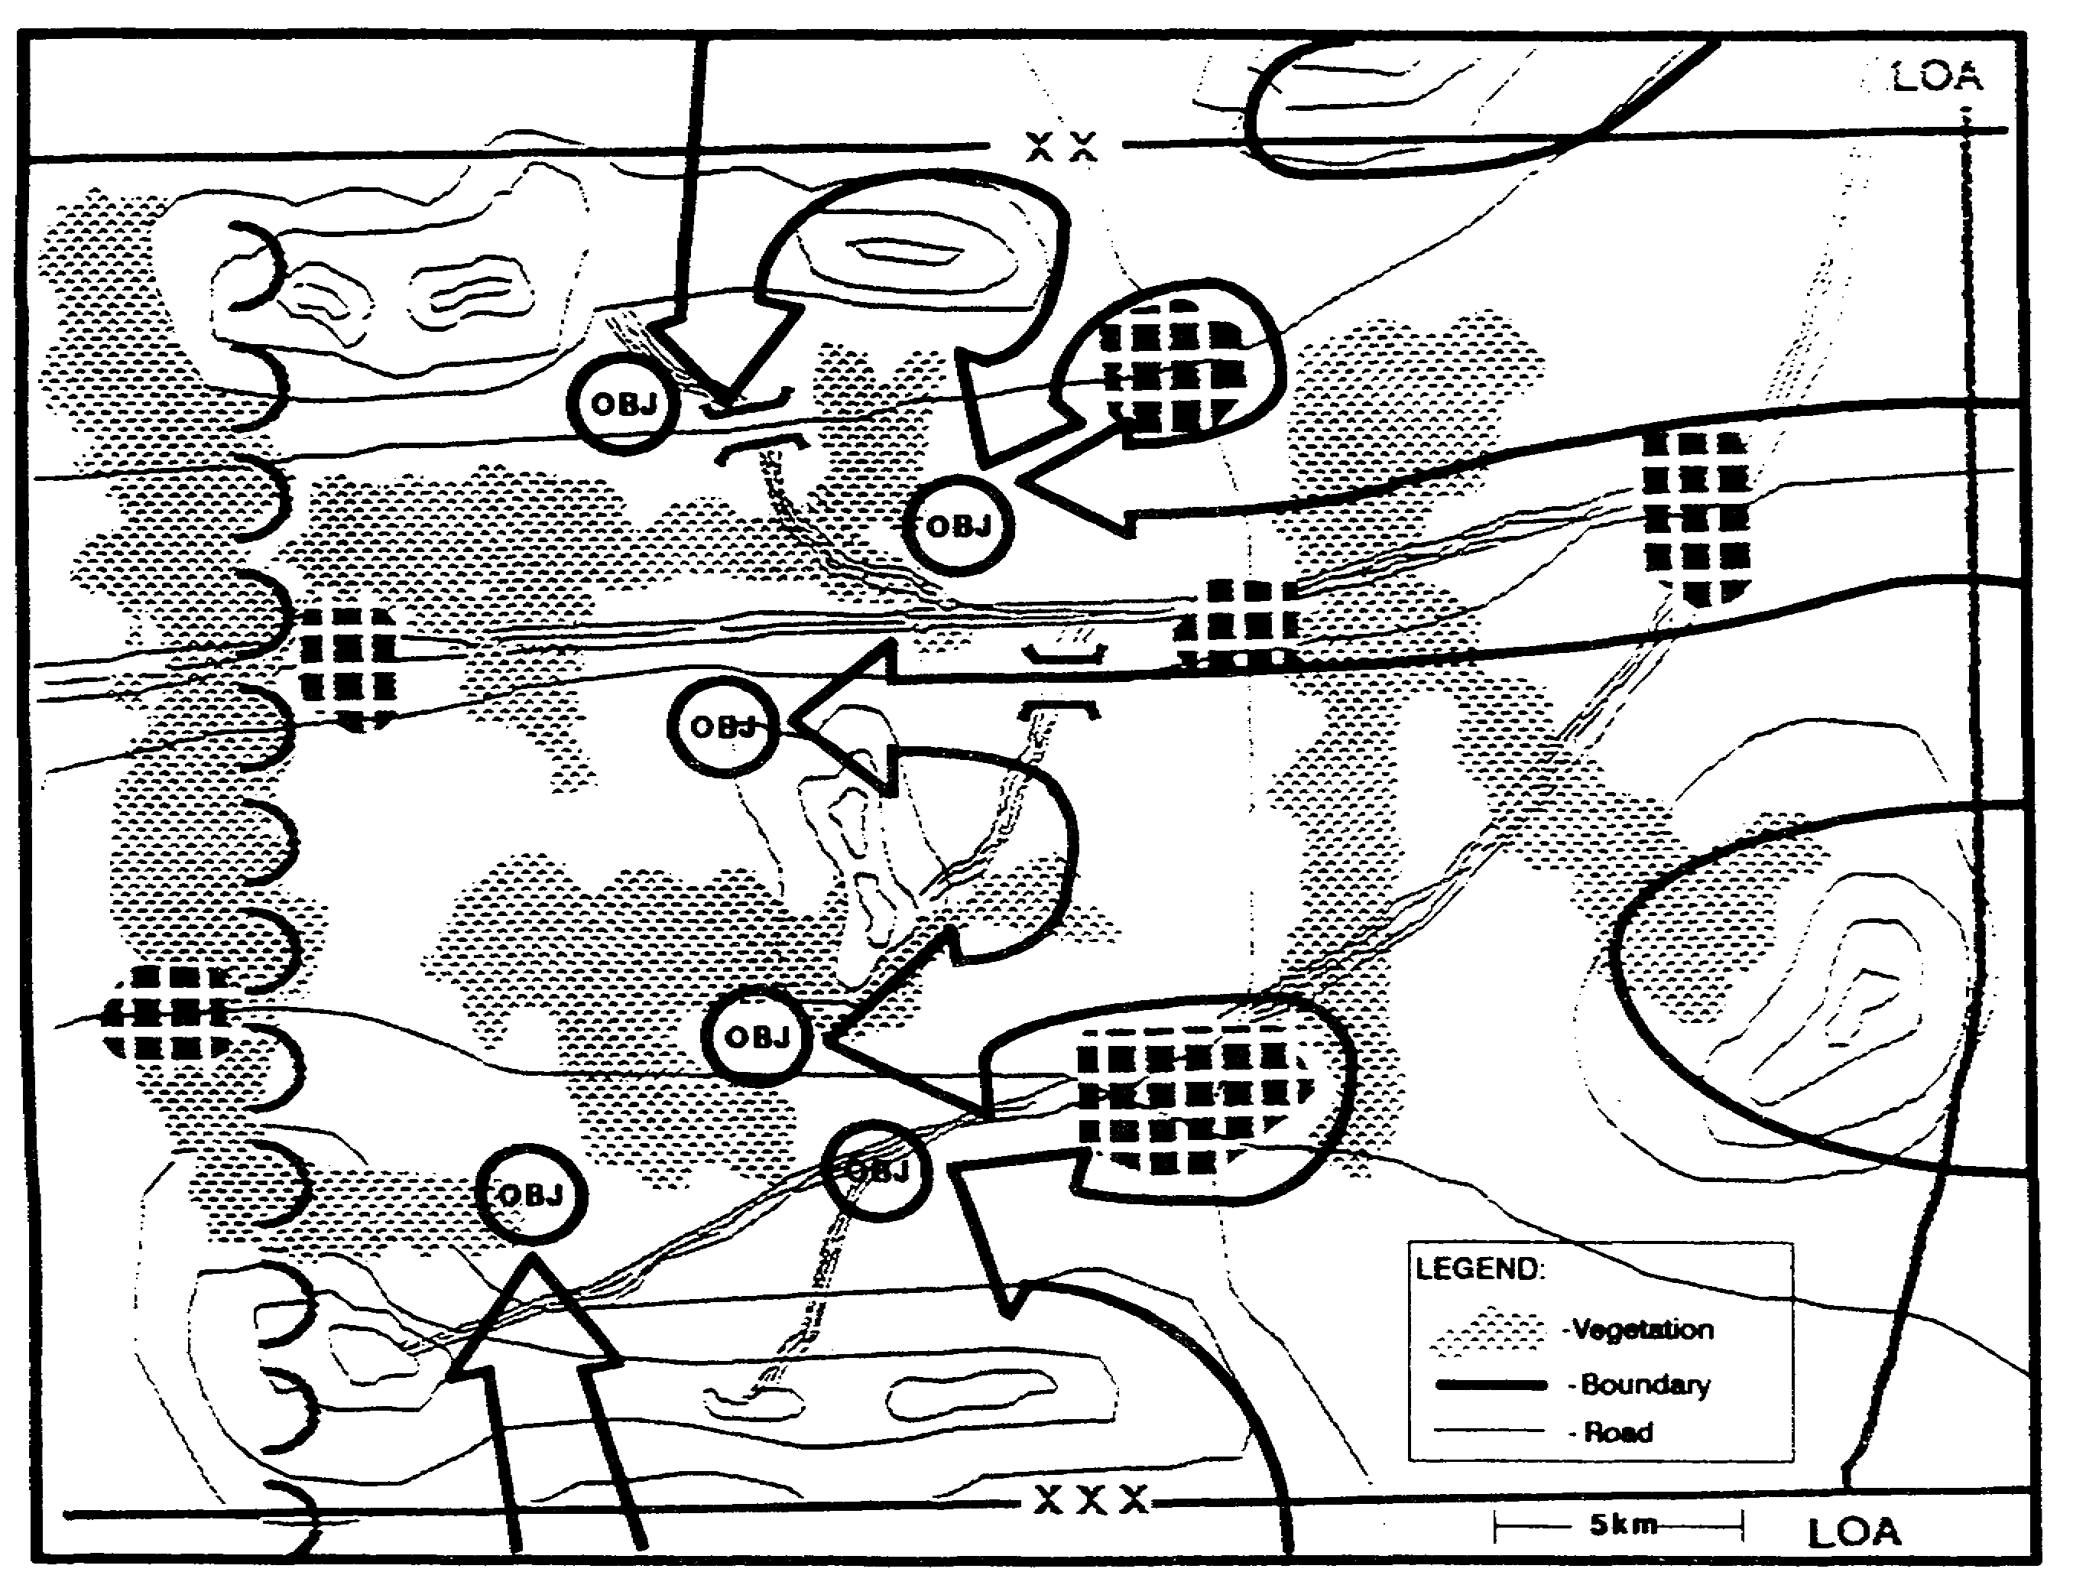

Figure 2-20. Available Enemy AAs.

2-33 IT0432

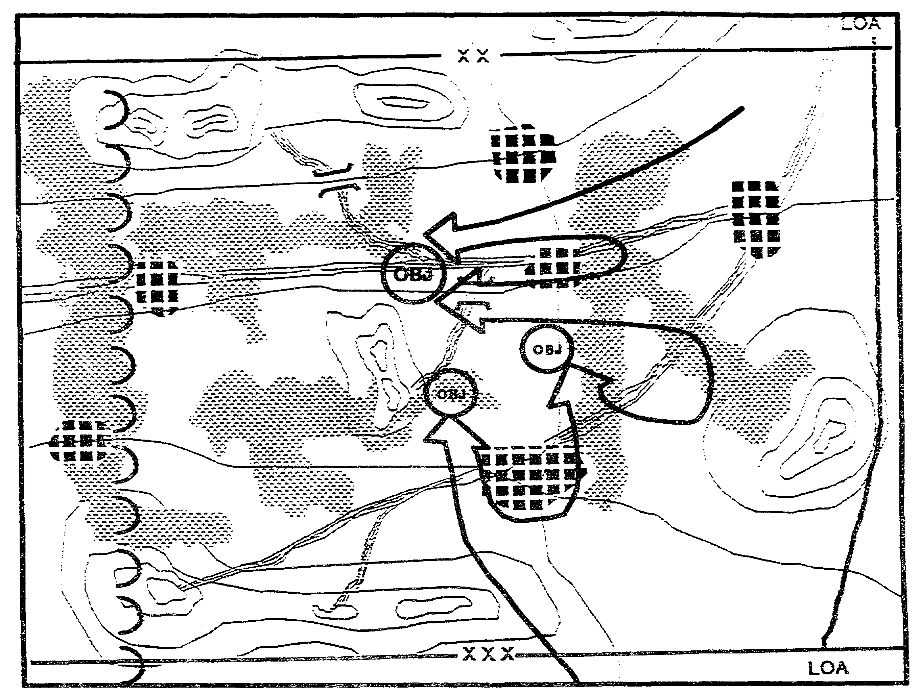

Figure 2-21. Reinforcing and Counterattack AAs.

IT0432 2-34

We also identify the air avenues of approach available to the enemy. These will support their defensive operations and their own deep battle operations in our rear area (Figure 2-22).

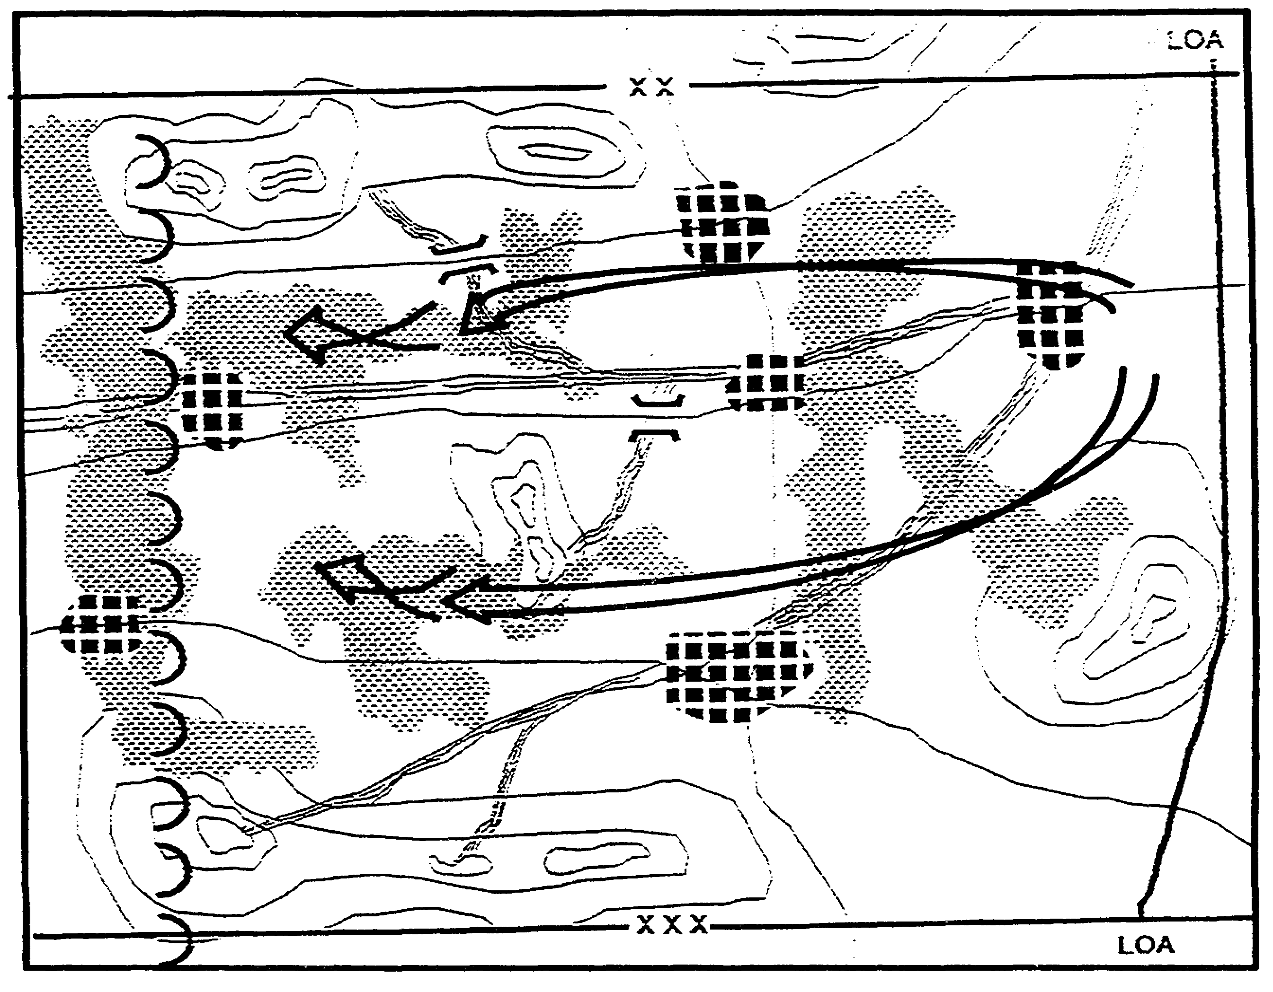

Figure 2-22. Enemy Air AAs.

2-35 IT0432

We have already included the effects of the expected weather in our terrain analysis. To evaluate its other effects on military operations, we start with identifying critical values of relevance to this situation (Figure 2-23).

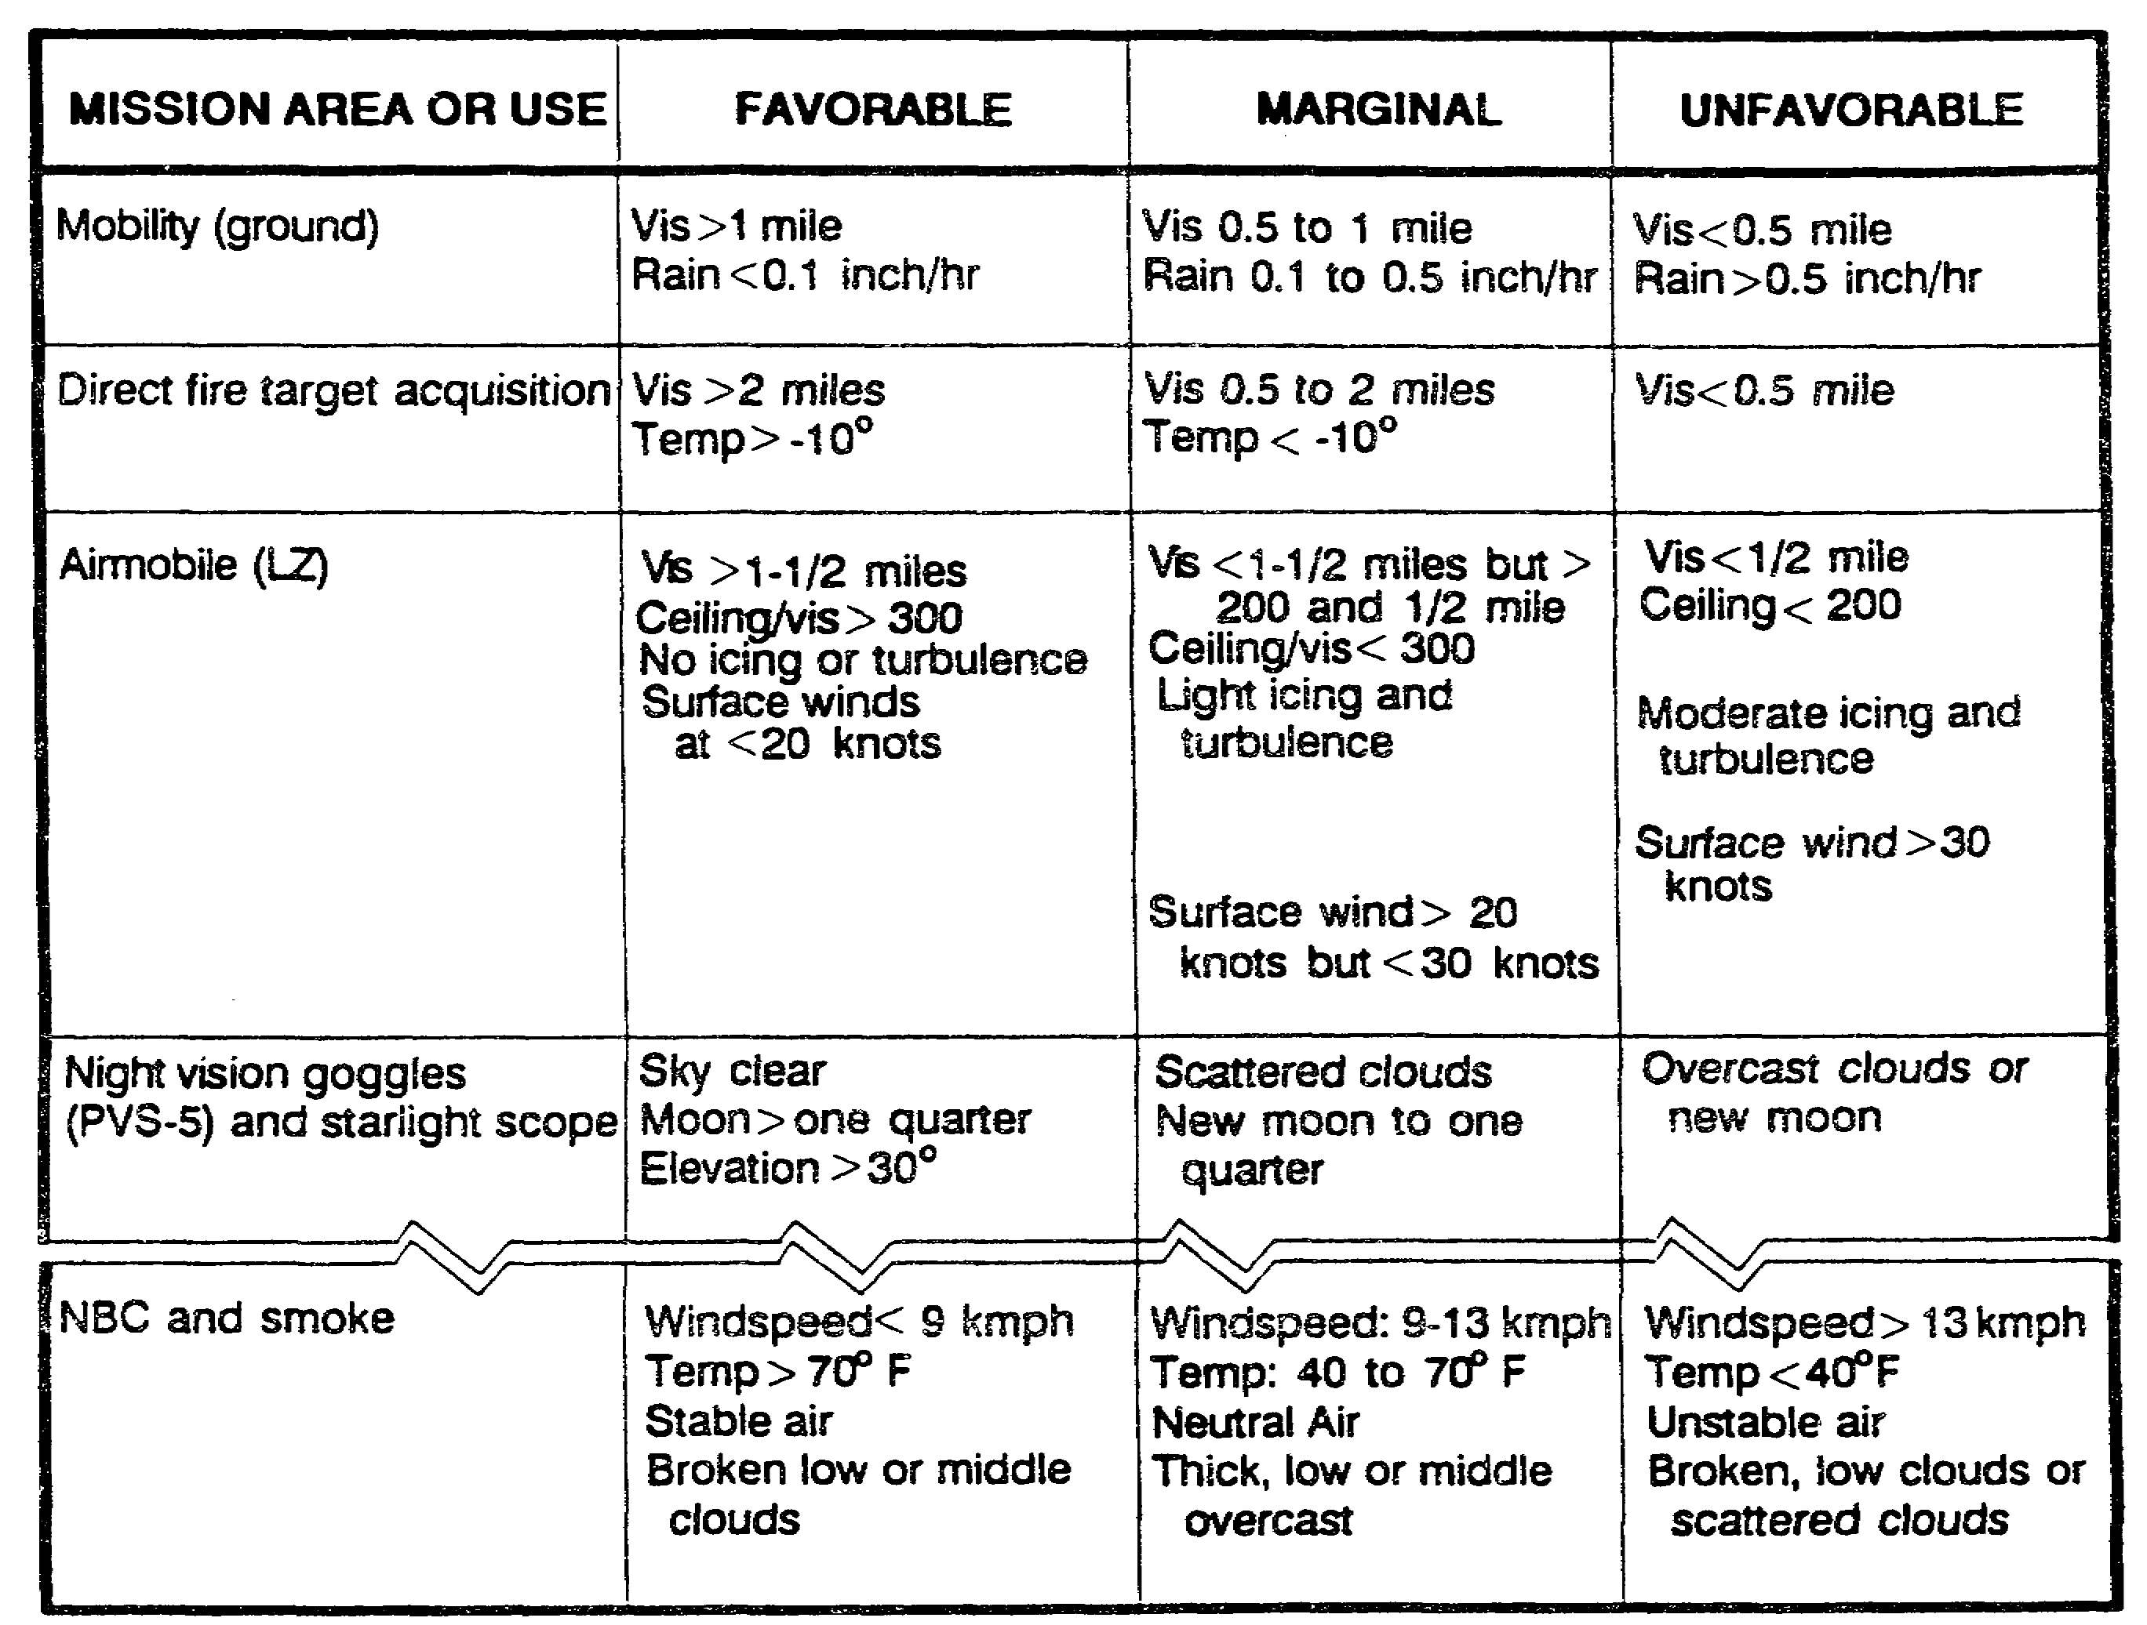

Figure 2-23. Critical Weather Value.

IT0432 2-36

The critical value are compared with the forecasted weather to evaluate its effects on operations. We present the weather's effects on operations in a "forecast style" format that allows the commander, and others, to easily match the weather's predicted effects to their own operations (Figure 2-24).

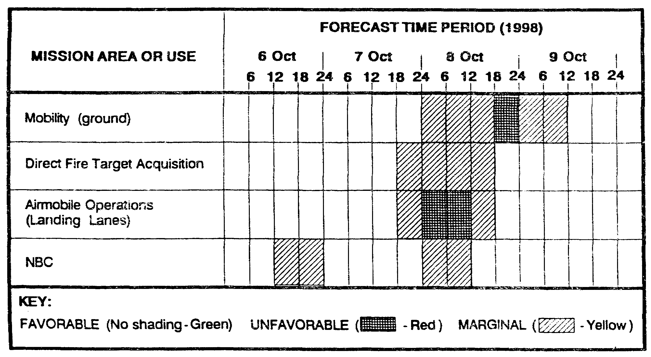

Figure 2-24. Weather Effects Chart/Matrix.

2-37 IT0432

Our commander wants to exploit his technical advantage in limited visibility target acquisition. Accordingly, we evaluate predicted light data and the effects of weather to identify periods that will allow us to optimize this advantage (Figure 2-25).

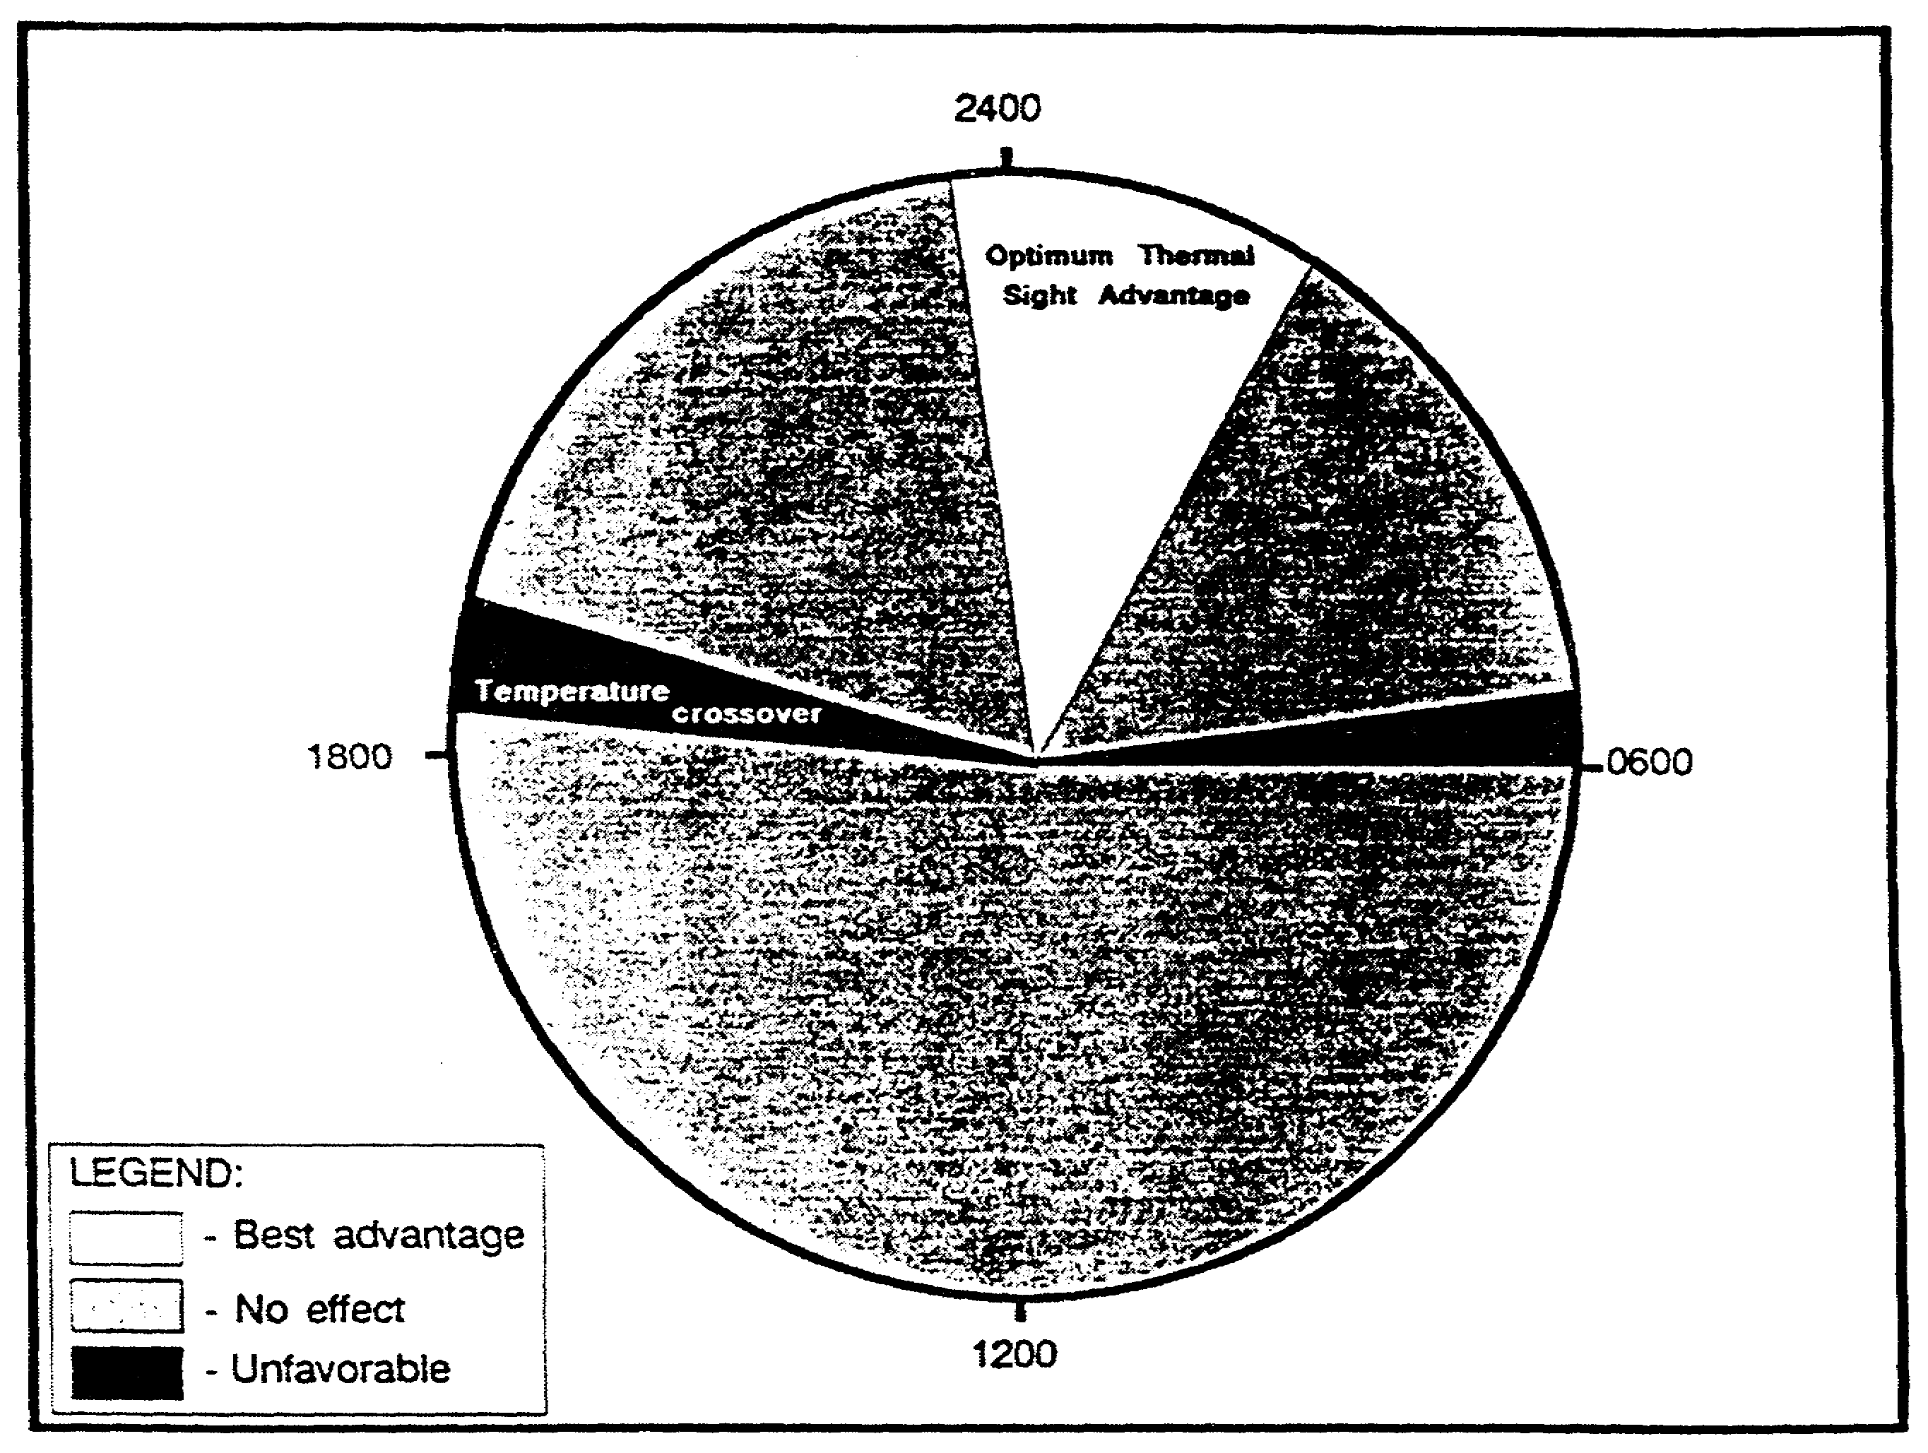

Figure 2-25. Weather Effects on Target Acquisition.

IT0432 2-38

Earlier, we identified the populace's political sympathies as a significant factor of the environment. Here we identify the general political stance of the major population centers on the battlefield (Figure 2-26). We will use it to develop enemy COAs and provide to other elements of the staff for use in developing potential friendly COAs.

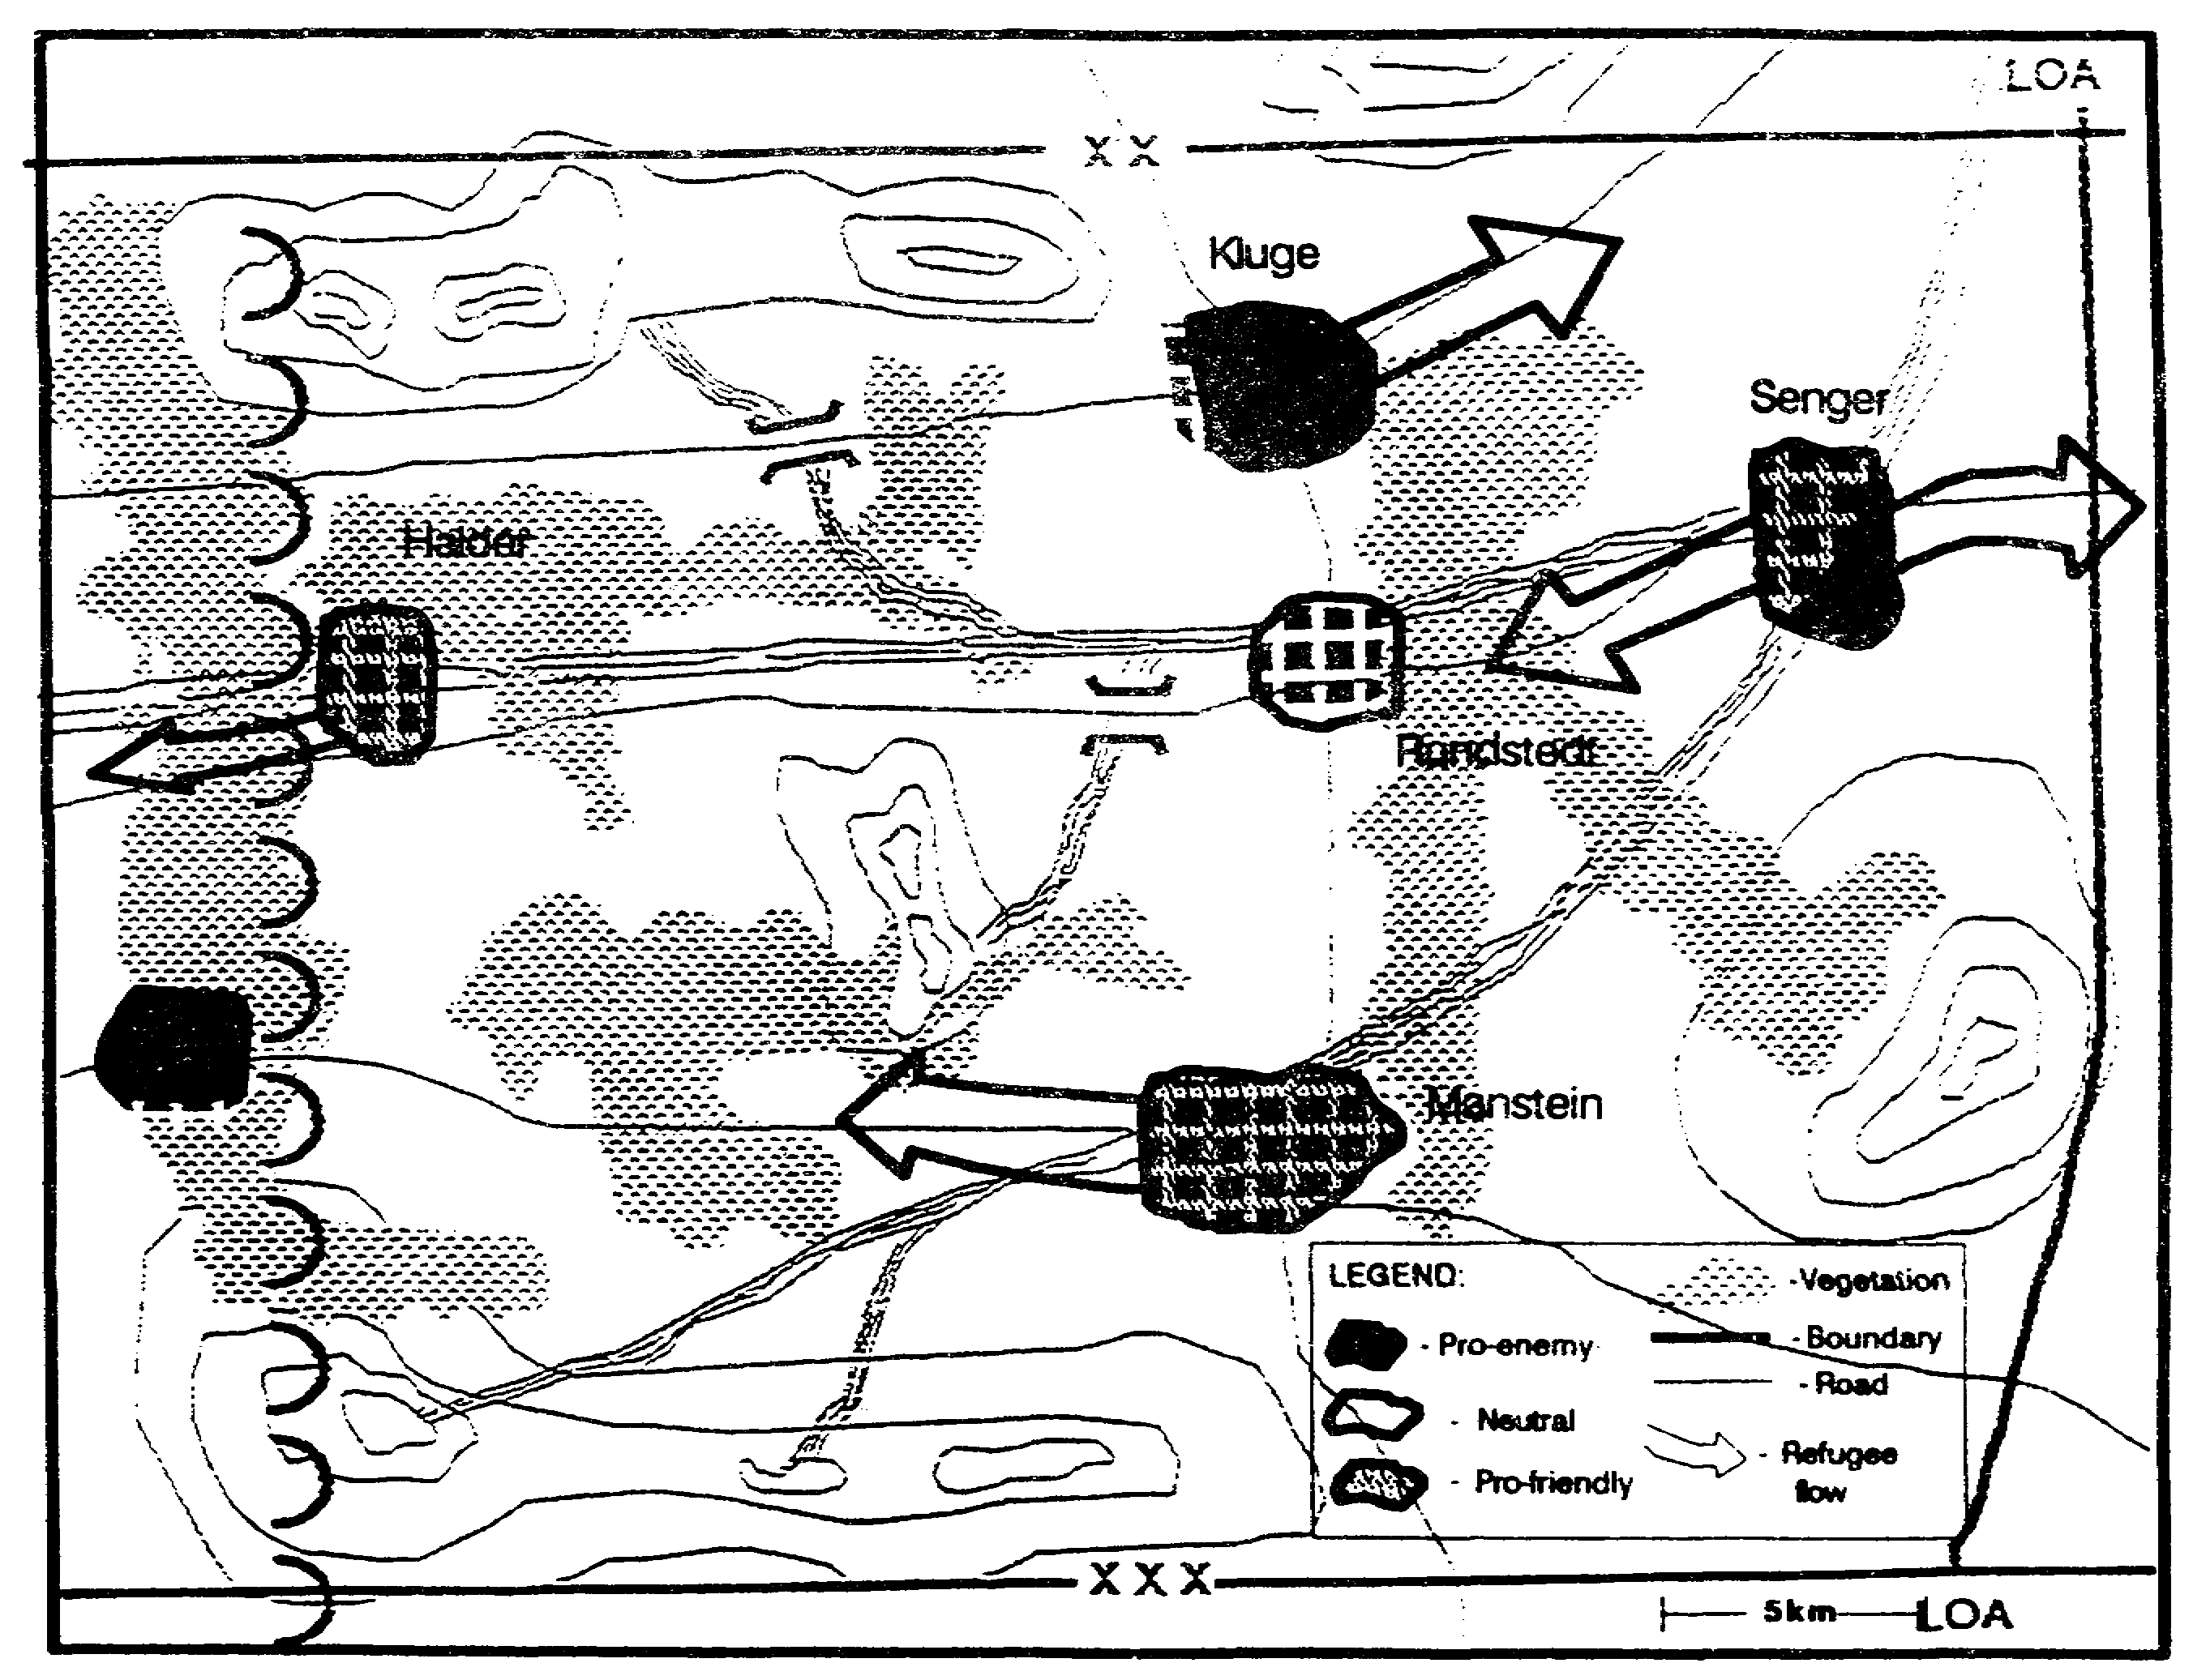

Figure 2-26. Population Status Overlay.

2-39 IT0432

EVALUATE THE THREAT

We start with the common understanding of the battlefield. We have some information on his current dispositions, portrayed on our SITMAP (Figure 2-27). Since the enemy has not completed his shift to a defensive posture, we expect changes.

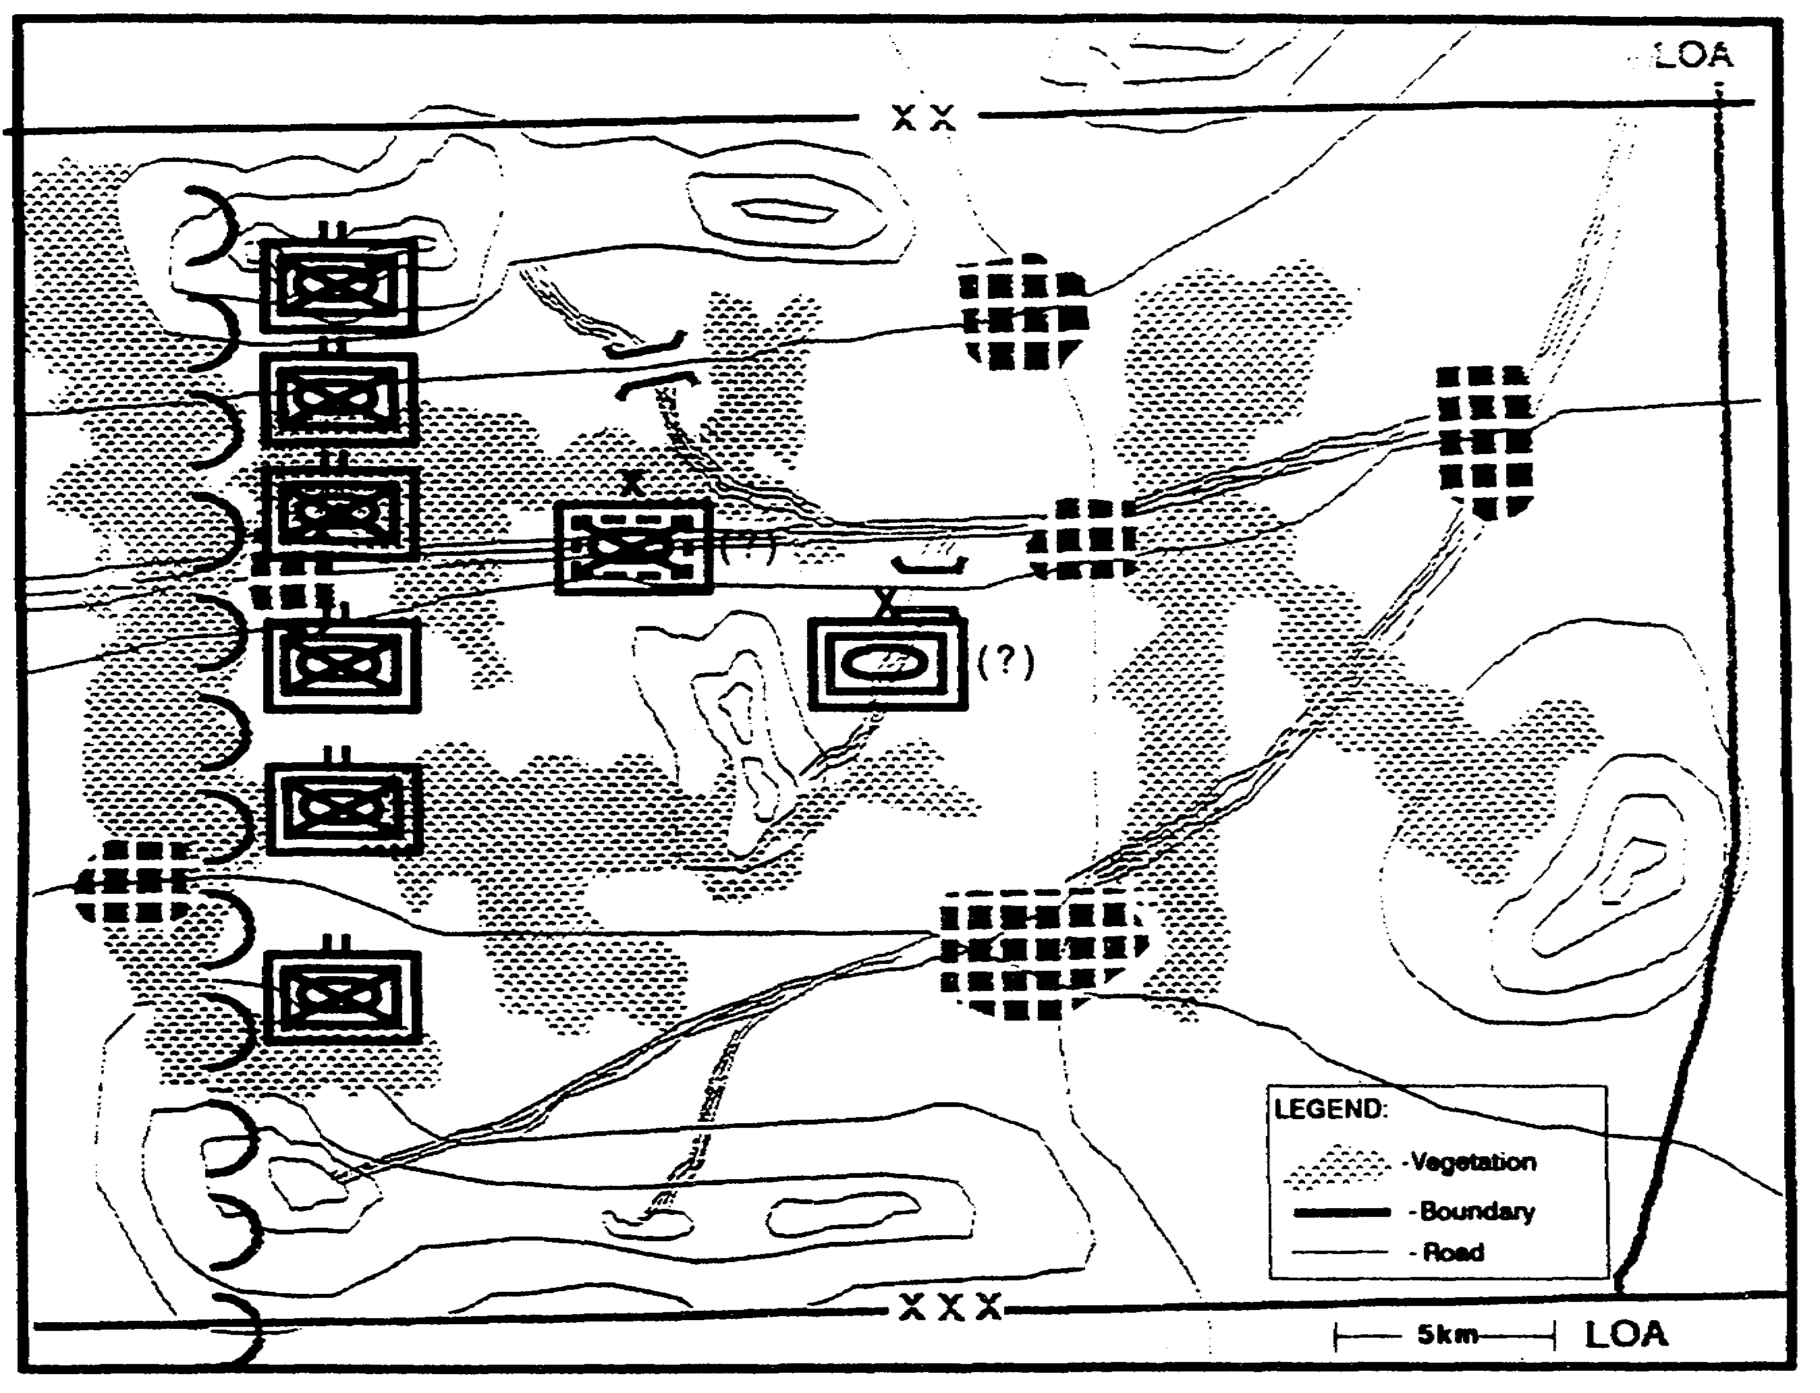

Figure 2-27. Current SITMAP.

IT0432 2-40

To identify the likely changes, we examine our other intelligence holdings to identify how the enemy usually defends. We evaluate his current state to determine his capabilities to execute his normal or preferred defensive tactics. We are careful to include the uncommitted armored divisions and the air assault brigade in our evaluations.

We put together a Threat model to describe the enemy's "typical" defensive operations. Our Threat model includes doctrinal templates that depict enemy dispositions during defense operations. We first look at the typical defending division to get an understanding for the whole (Figure 2-28).

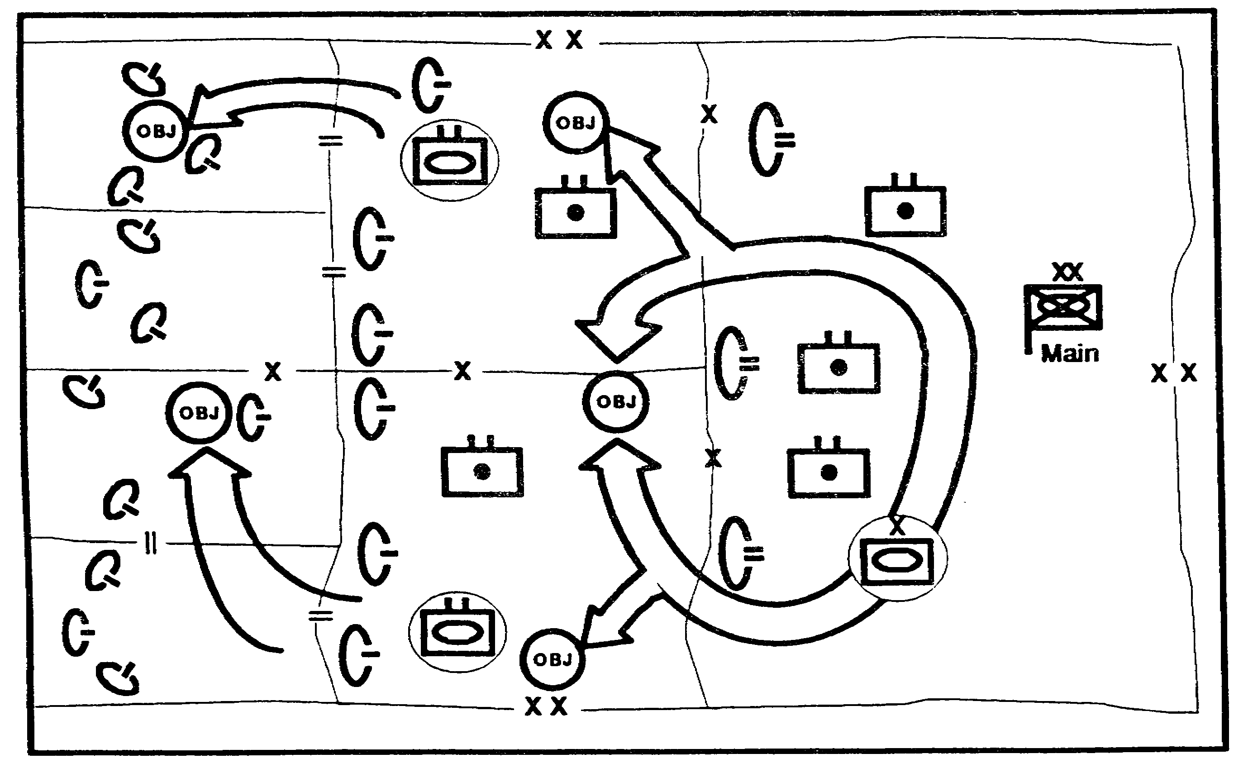

Figure 2-28. Division Doctrinal Template.

2-41 IT0432

We follow this with an examination of the typical defending brigade to add greater detail to our Threat model (Figure 2-29).

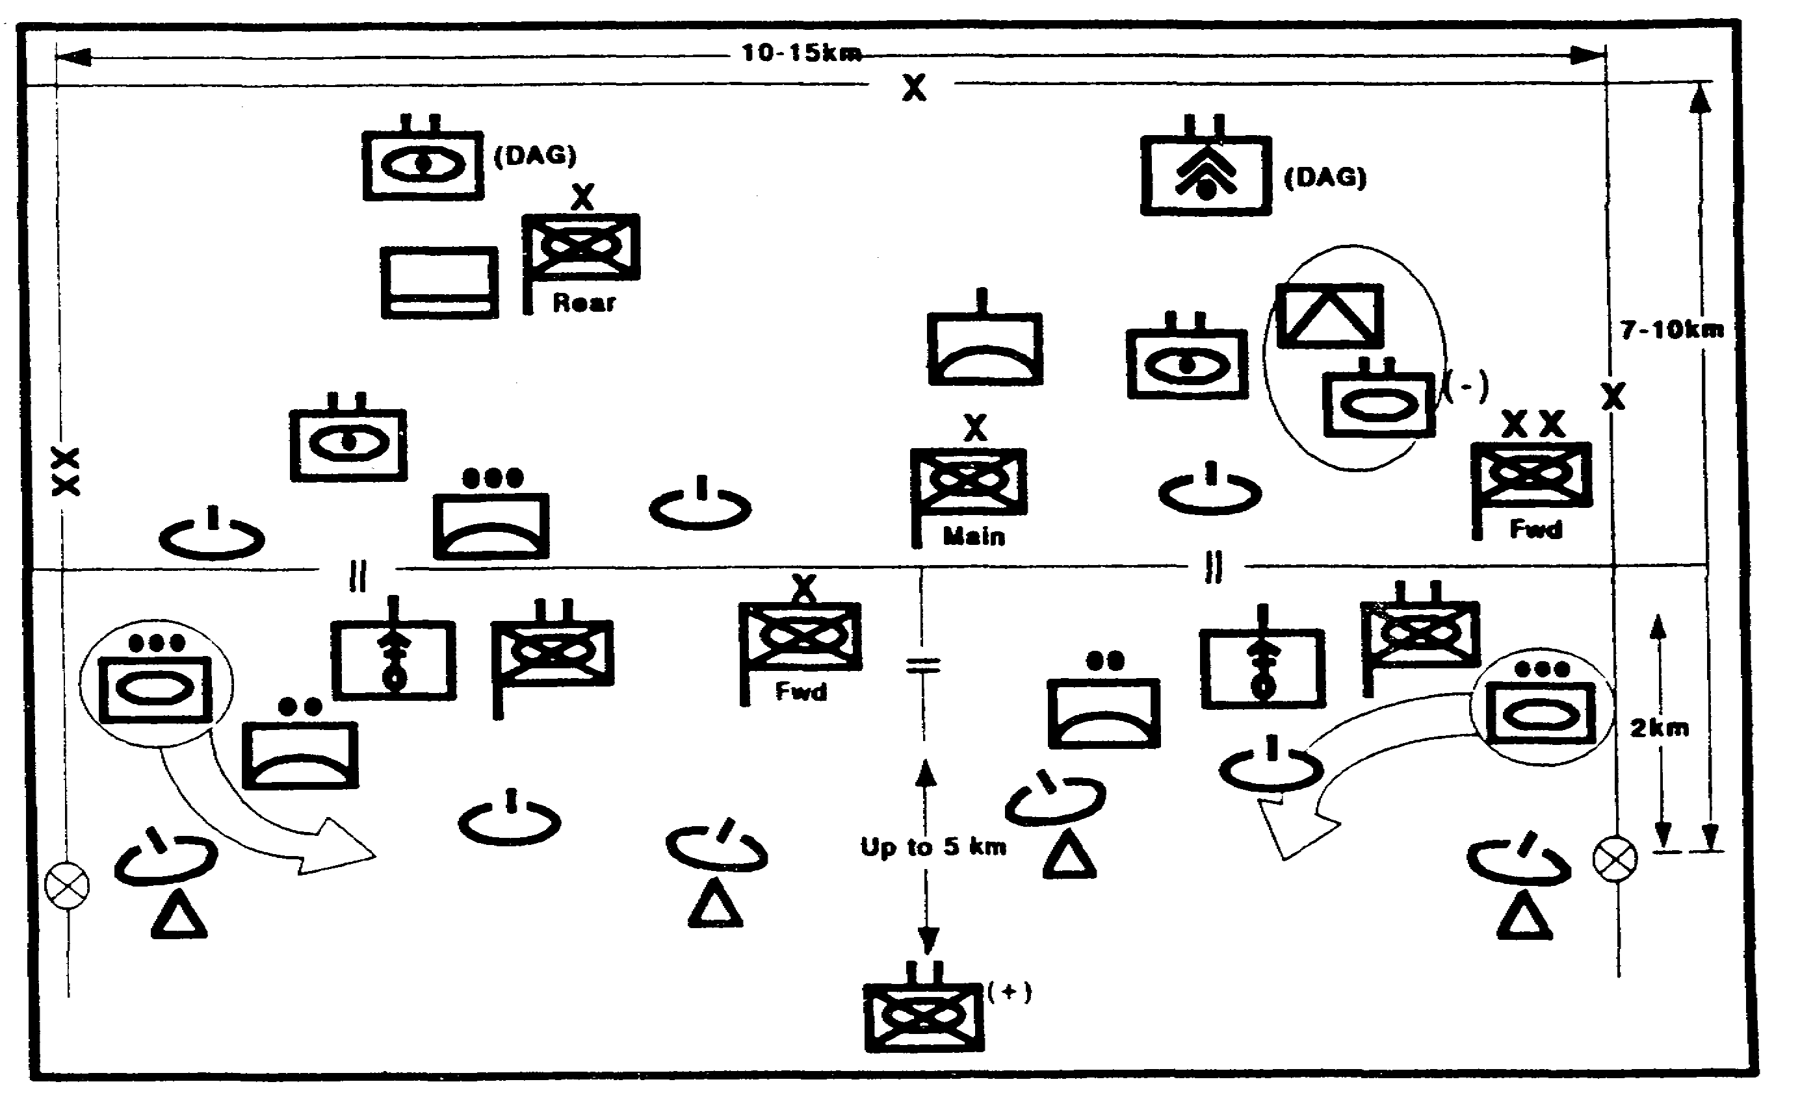

Figure 2-29. Brigade Doctrinal Template.

IT0432 2-42

We develop a description of the "normal" tactics used by the forces depicted on the template. This is very useful in identifying HVTs and for developing potential enemy COAs (Figure 2-30).

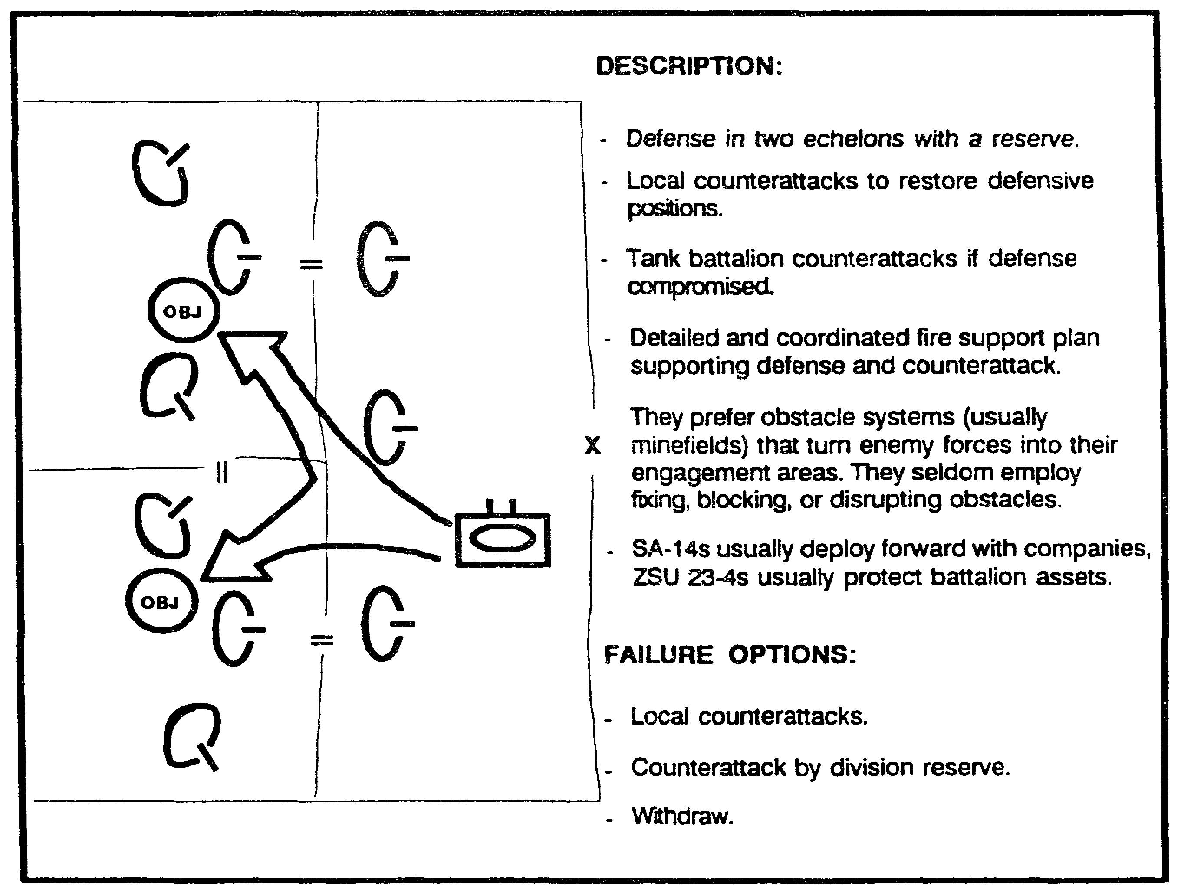

Figure 2-30. Doctrinal Narrative/Matrix.

2-43 IT0432

To complete the Threat model, we evaluate HVTs for defensive operations in conditions unconstrained by friendly actions or the effects of the battlefield environment (Figure 2-31).

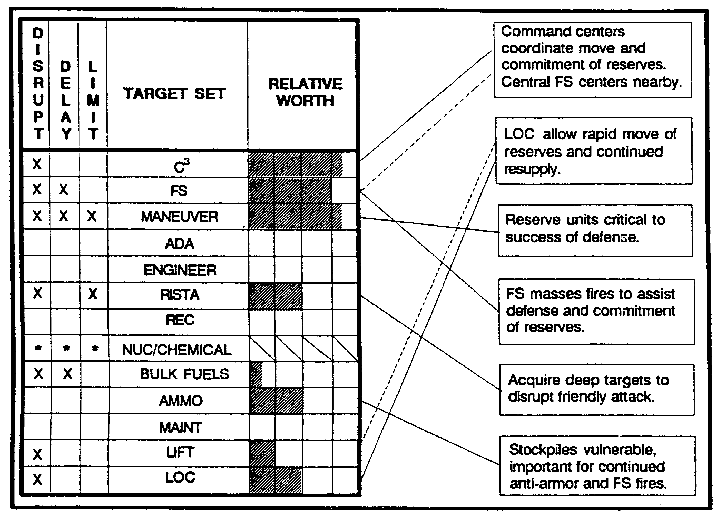

Figure 2-31. Relative Target Values.

IT0432 2-44

Since defensive operations include counterattack options, we construct a similar model depicting the normal deployments and tactics of the division's armored brigade during a counterattack (Figure 2-32).

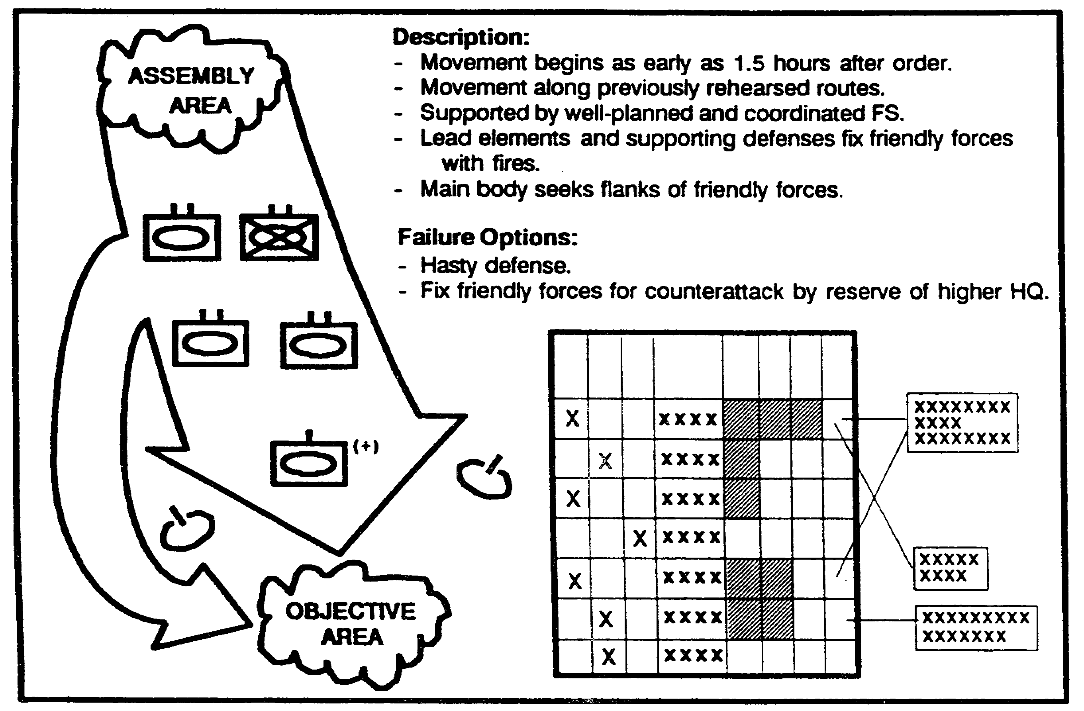

Figure 2-32. Threat Counterattack Options.

We also consider counterattacks by the armored divisions and the operations of the air assault Brigade. We construct similar Threat models to portray these COAs.

2-45 IT0432

DETERMINE THREAT COURSES OF ACTION

We start by comparing the enemy's doctrine for defense with the results of our description of the battlefield. Because the western most set of defensive positions (positions a, b, and c) can be easily bypassed, a defense there will not accomplish the enemy's likely objective (Figure 2-33). We discard this set of positions as infeasible and concentrate on developing defensive COAs on the remaining sets.

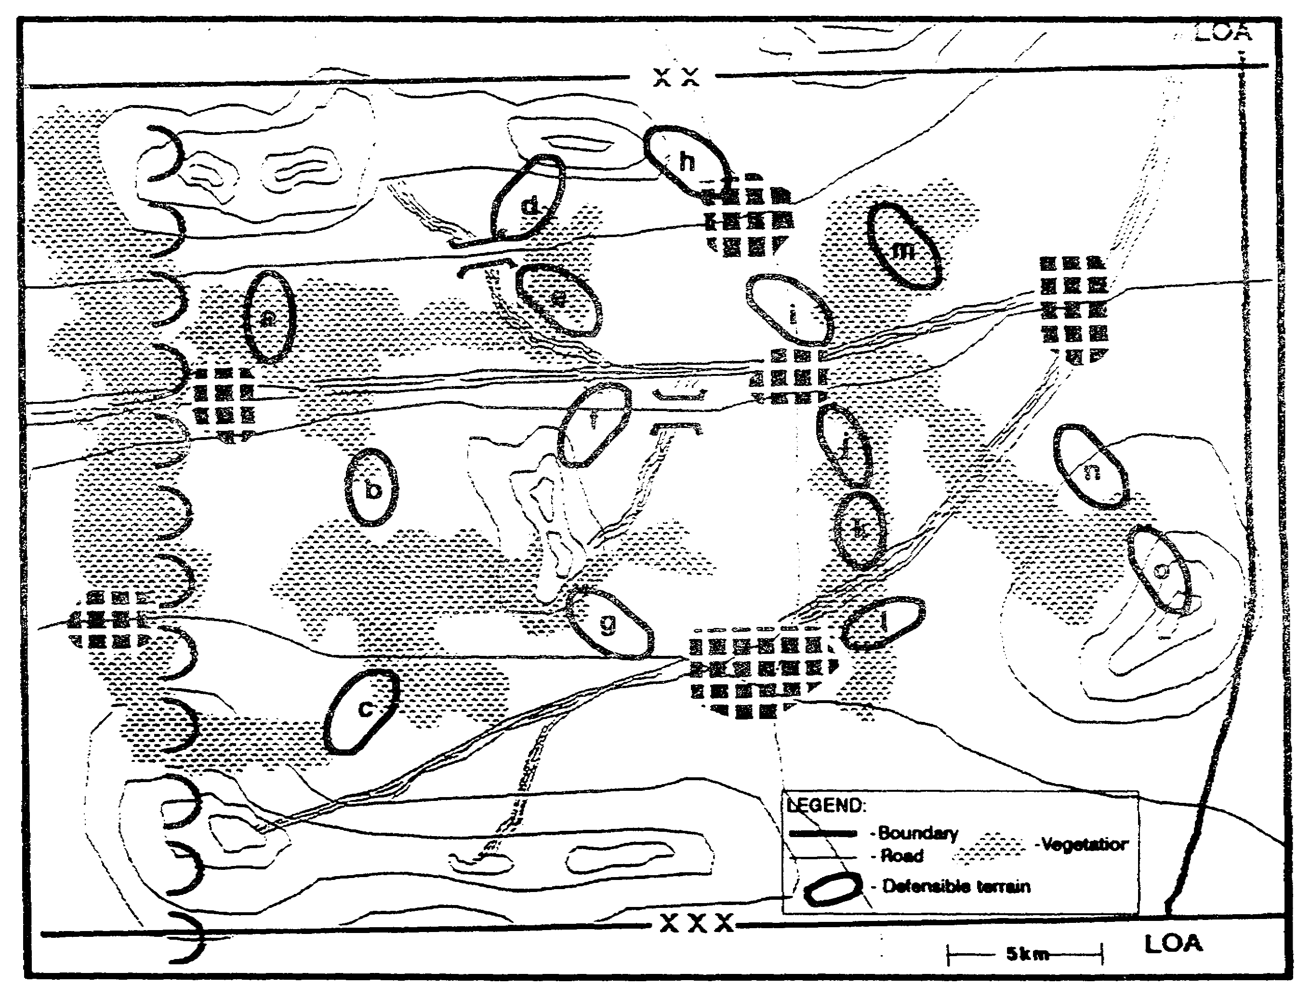

Figure 2-33. Supporting Terrain.

IT0432 2-46

As enemy COA 1, we place the enemy's covering force in the western most set of positions. We array the main defense in the remaining positions by modifying their doctrinal position to account for the effects of the terrain. We identify likely locations of counterattack objectives and include the enemy's counterattack options on the developing situation template (Figure 2-34).

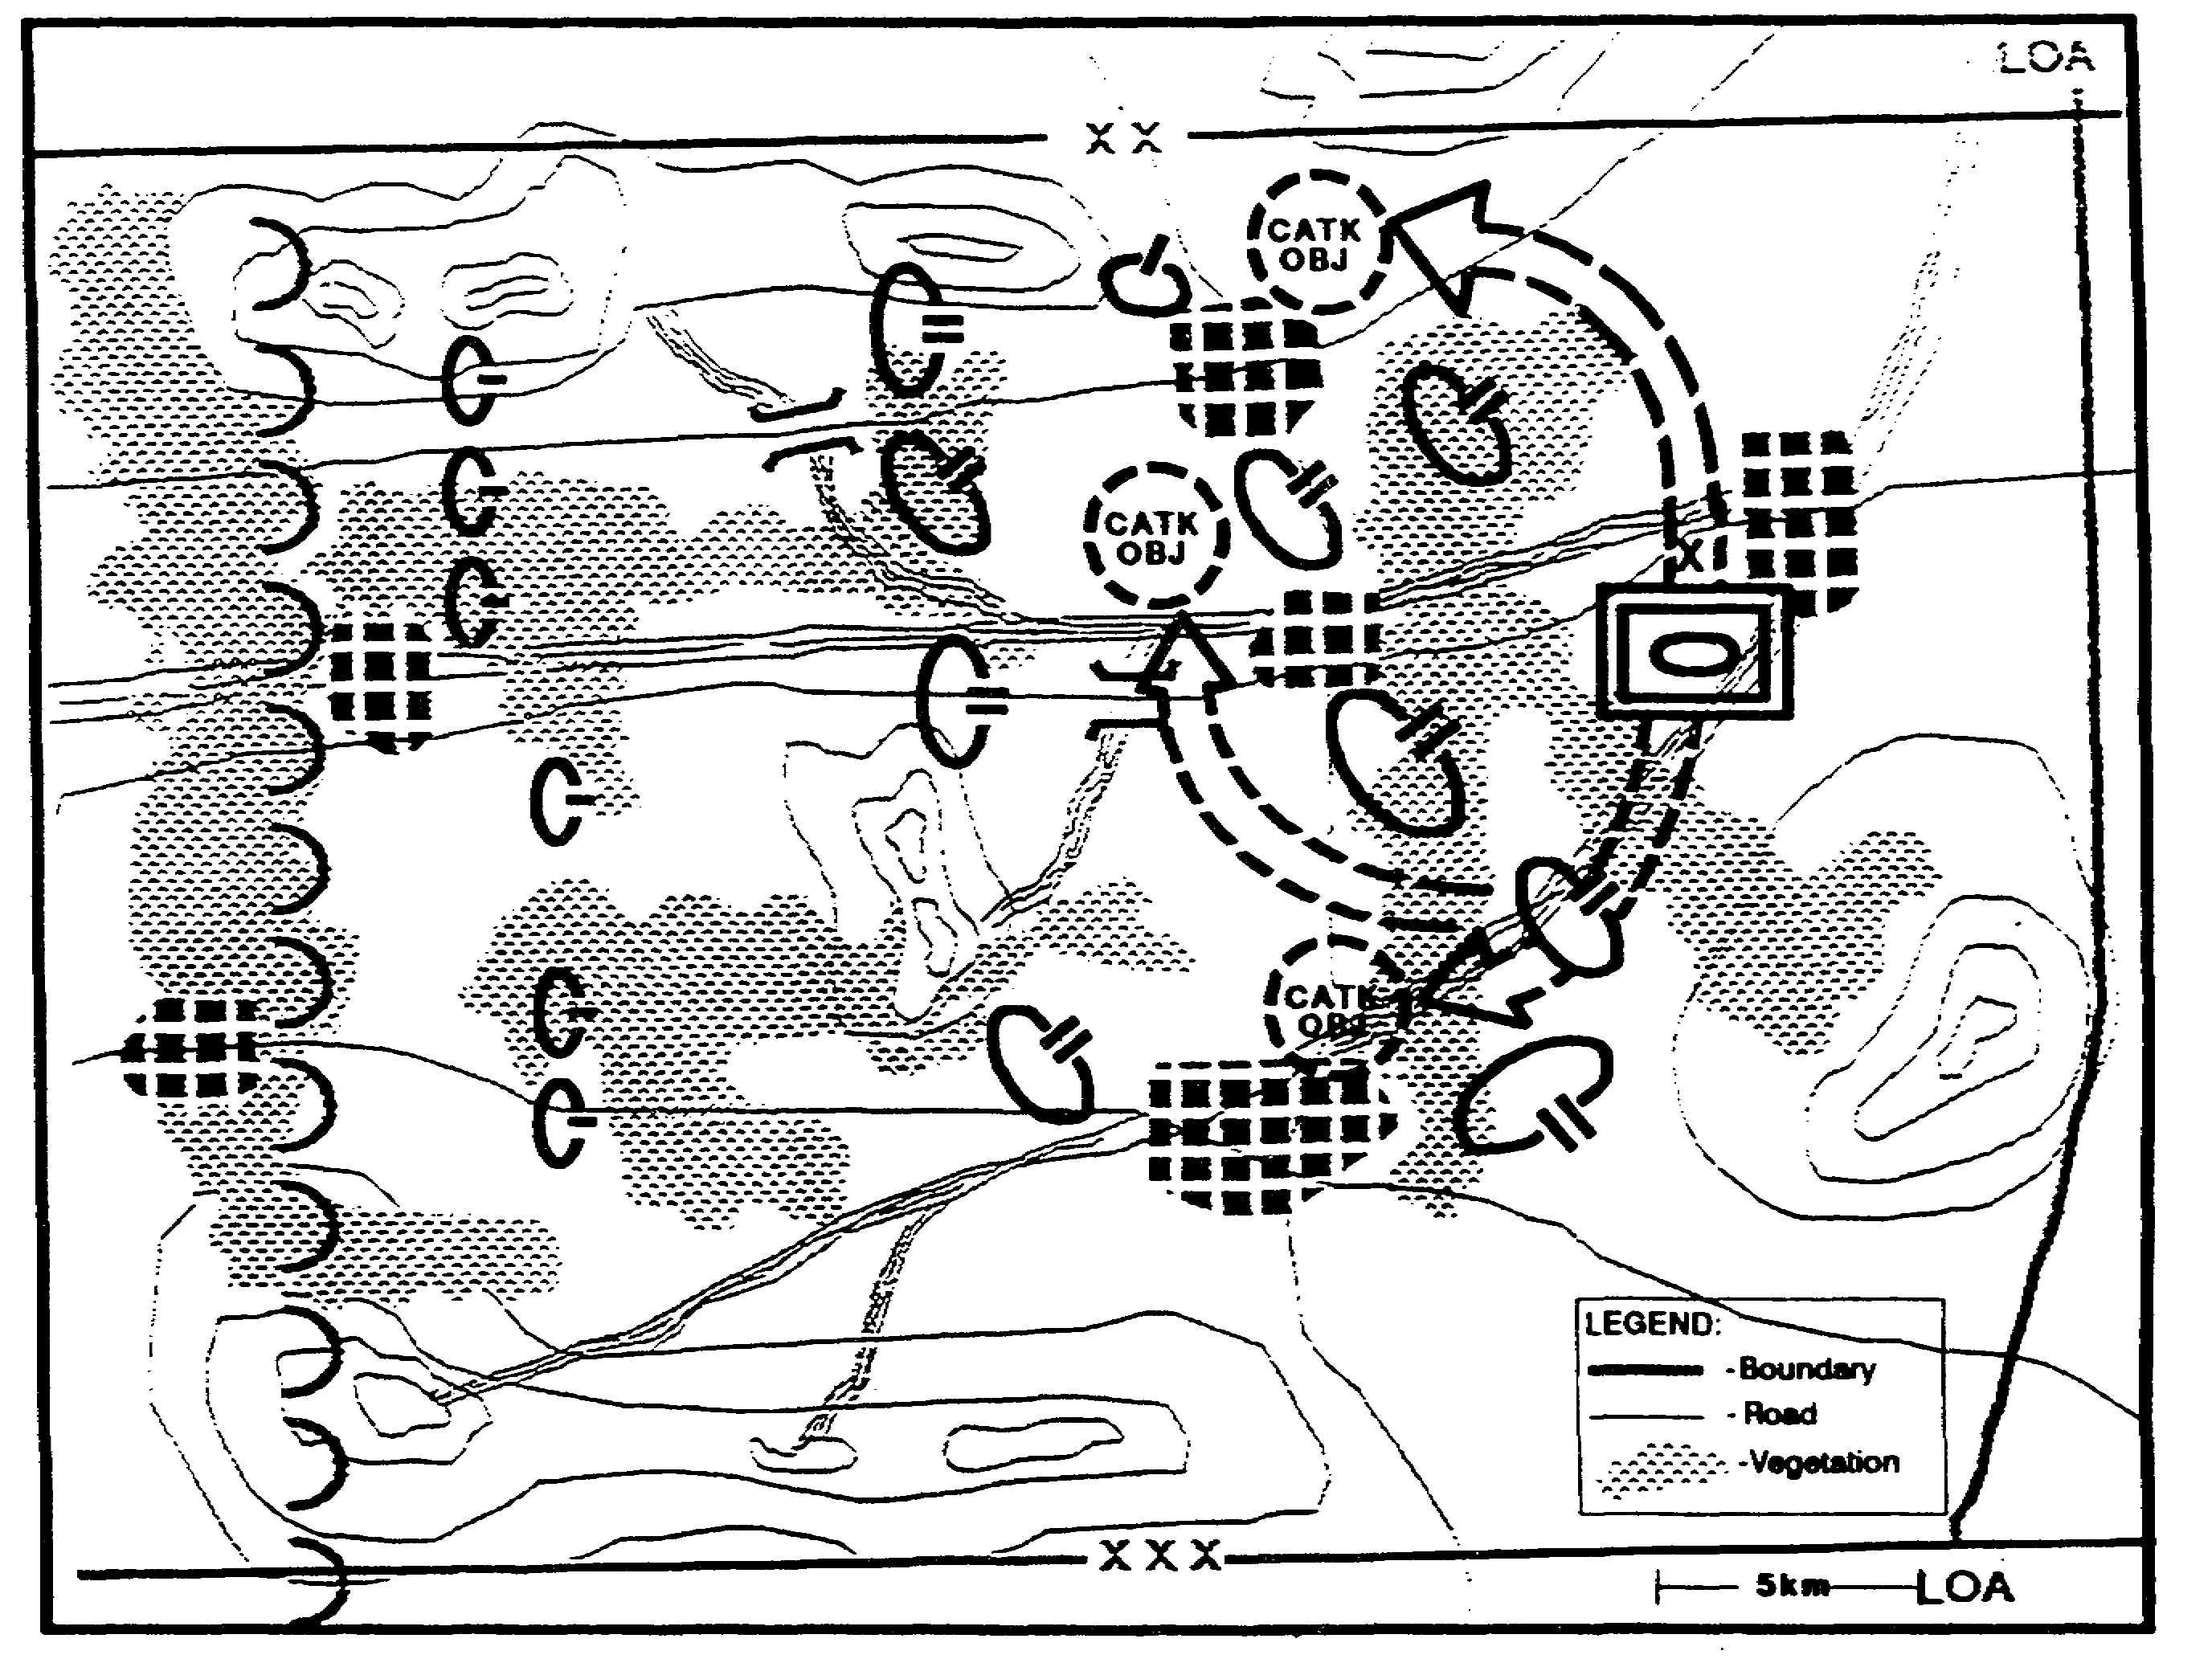

Figure 2-34. Threat COA 1.

2-47 IT0432

We use the same technique to develop COA 2. We place the covering force in the center set of defensive terrain (positions d, e, f, and g identified on Figure 2-33) and place the main defense in the eastern most set. The defense is weighted more heavily in the north than in the south (Figure 2-35).

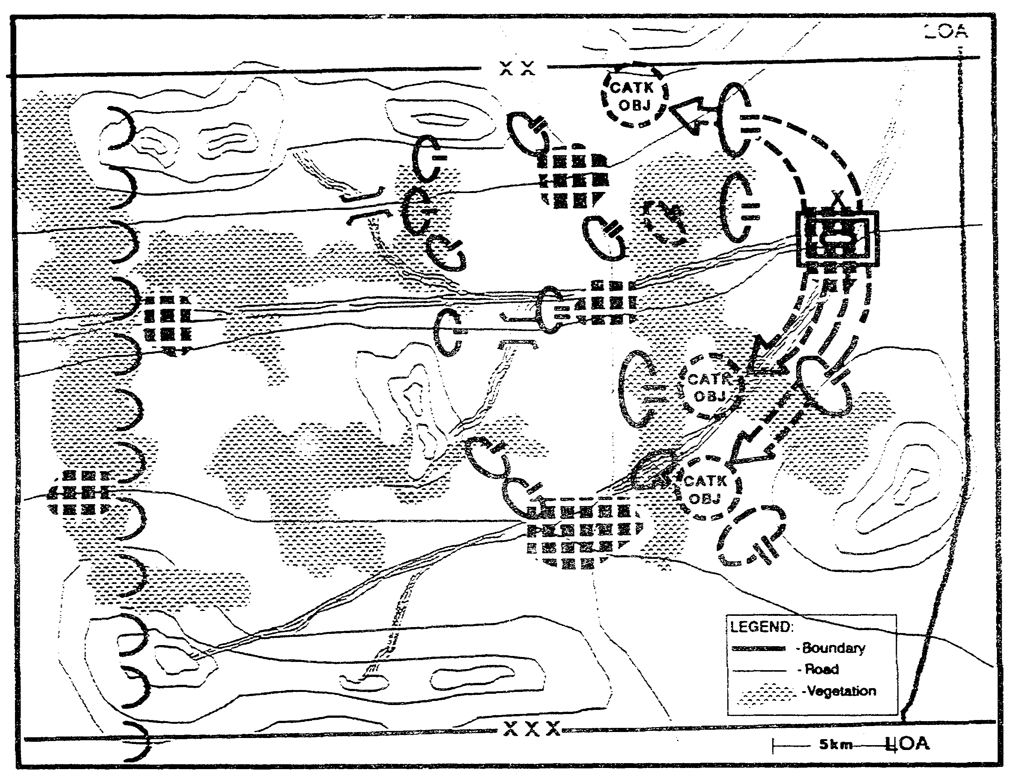

Figure 2-35. Threat COA 2.

IT0432 2-48

Obviously, the enemy has the option to weight the south more heavily than the north. We depict this option as COA 3 (Figure 2-36).

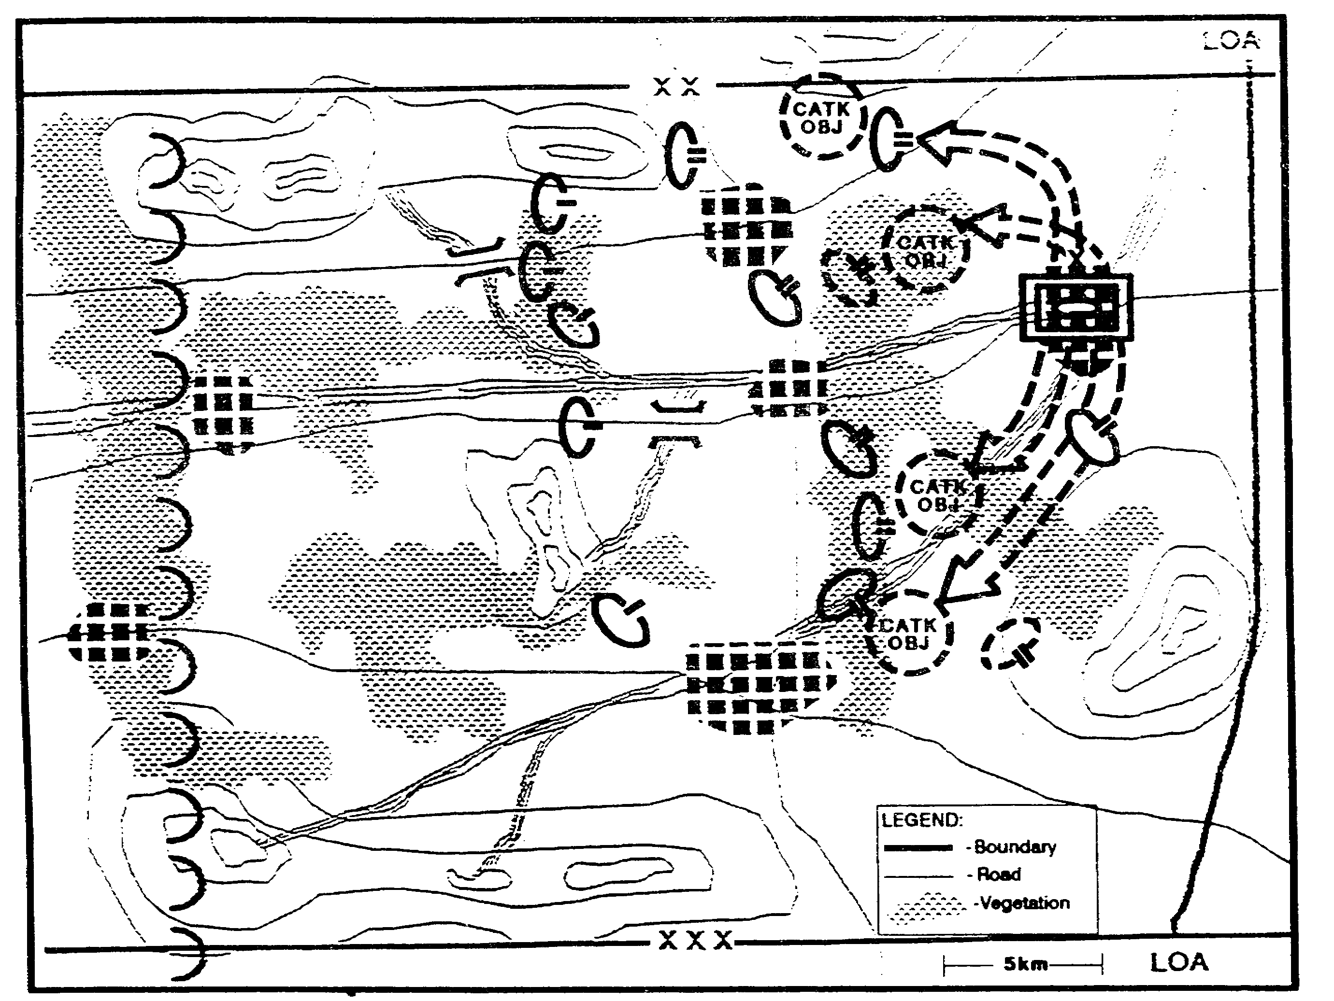

Figure 2-36. Threat COA 3.

2-49 IT0432

We continue to develop each COA by adding more detail. We use the doctrinal templates as a guide and determine the likely locations of HVTs. We evaluate the effects of the battlefield on the enemy's mobility and determine his movement rates along each counterattack avenue of approach. We depict his expected rate of movement on the template using Time Phase Lines (TPLs) (Figure 2-3). For the present, these reflect only the time it will take to form the unit and conduct maneuver. Later, during staff wargaming, the TPLs will be updated to incorporate consideration of events that are likely to initiate movement, such as friendly penetration of the enemy defense.

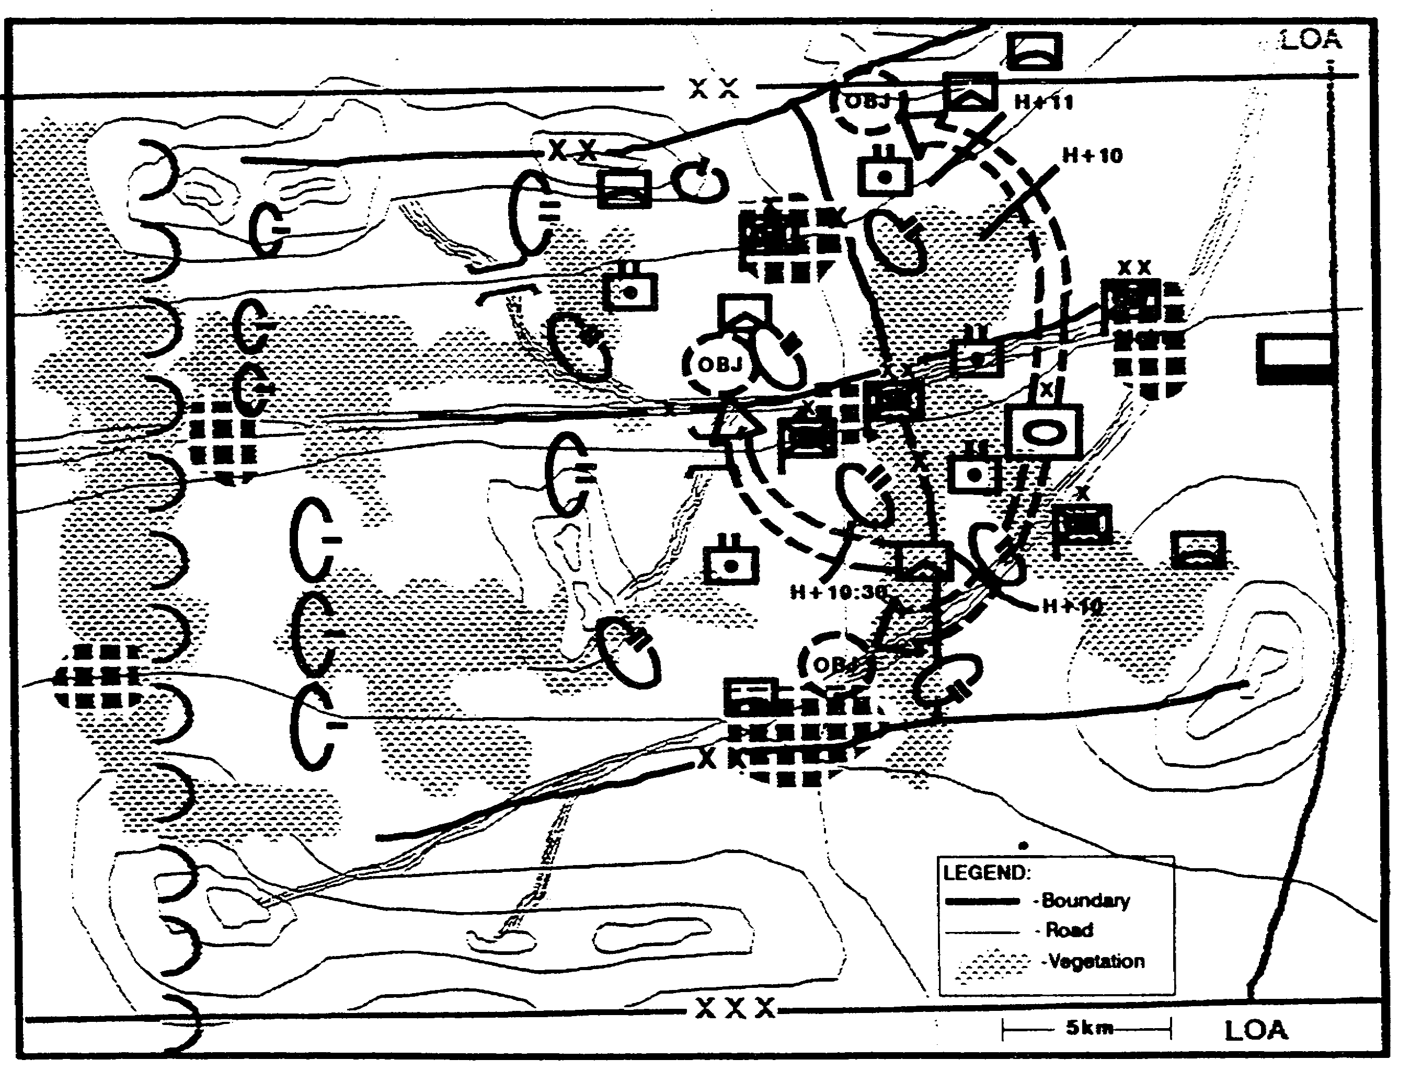

Figure 2-37. Situation Template.

IT0432 2-50

Using the description of tactics that accompanied the doctrinal template as a guide, we mentally wargame each situation template. This allows us to tailor the description of the tactics associated with the COA to this specific situation. We focus on those activities that are associated with the enemy's adoption of the various options open to him or those likely to lead to a friendly decision. In this case, we use a matrix style format (Figure 2-38). Like the situation template, it will be updated and refined during staff wargaming.

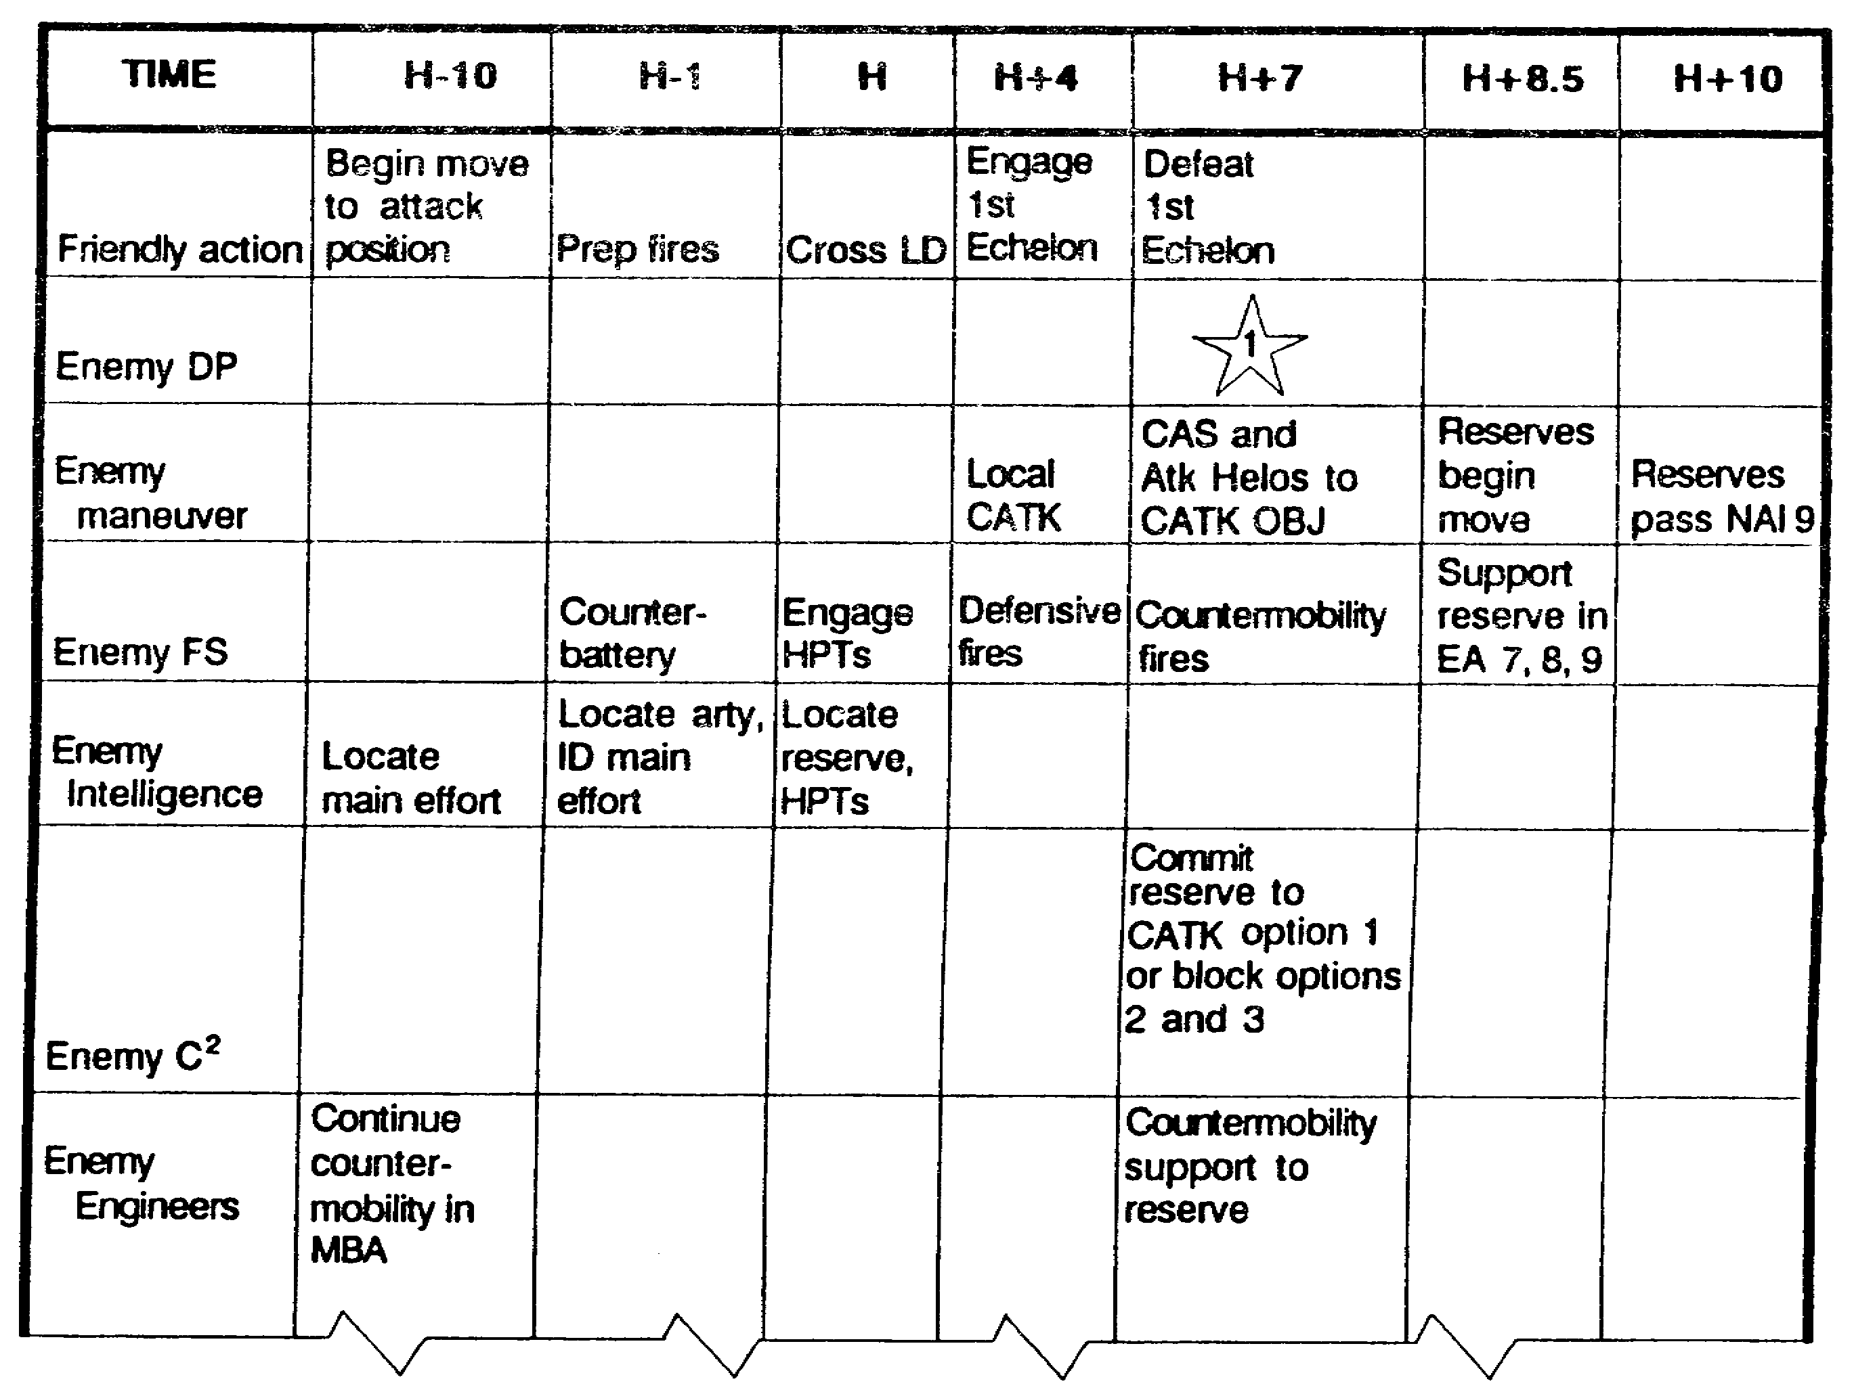

Figure 2-38. COA Description.,

Legend: - When decision maker needs the intelligence.

2-51 IT0432

Similarly, we refine the target relative value matrices to reflect any changes due to the specific situation at hand. This requires an evaluation of the effects of the friendly force as well as the battlefield environment (Figure 2-39).

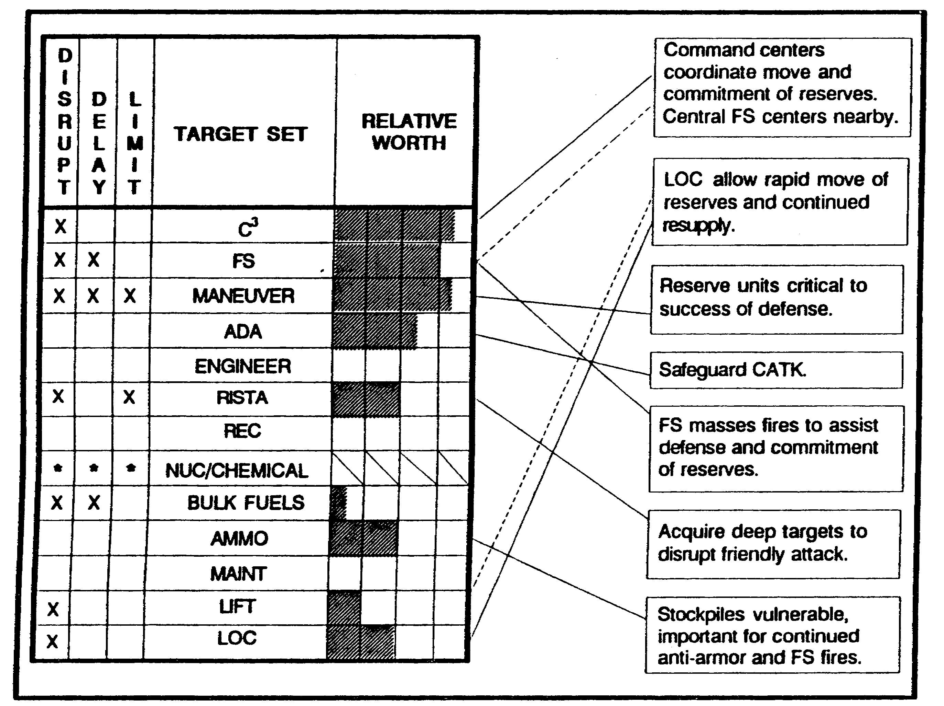

Figure 2-39. Threat COA Doctrinal HVTs.

IT0432 2-52

This leads to NAls that will confirm or deny adopting each enemy COA. We consolidate these NAls onto a single overlay (Figure 2-40). The resulting event template will allow us to focus collection planning on confirming the "set" of the enemy's defenses. This, however, is just the start of the event template.

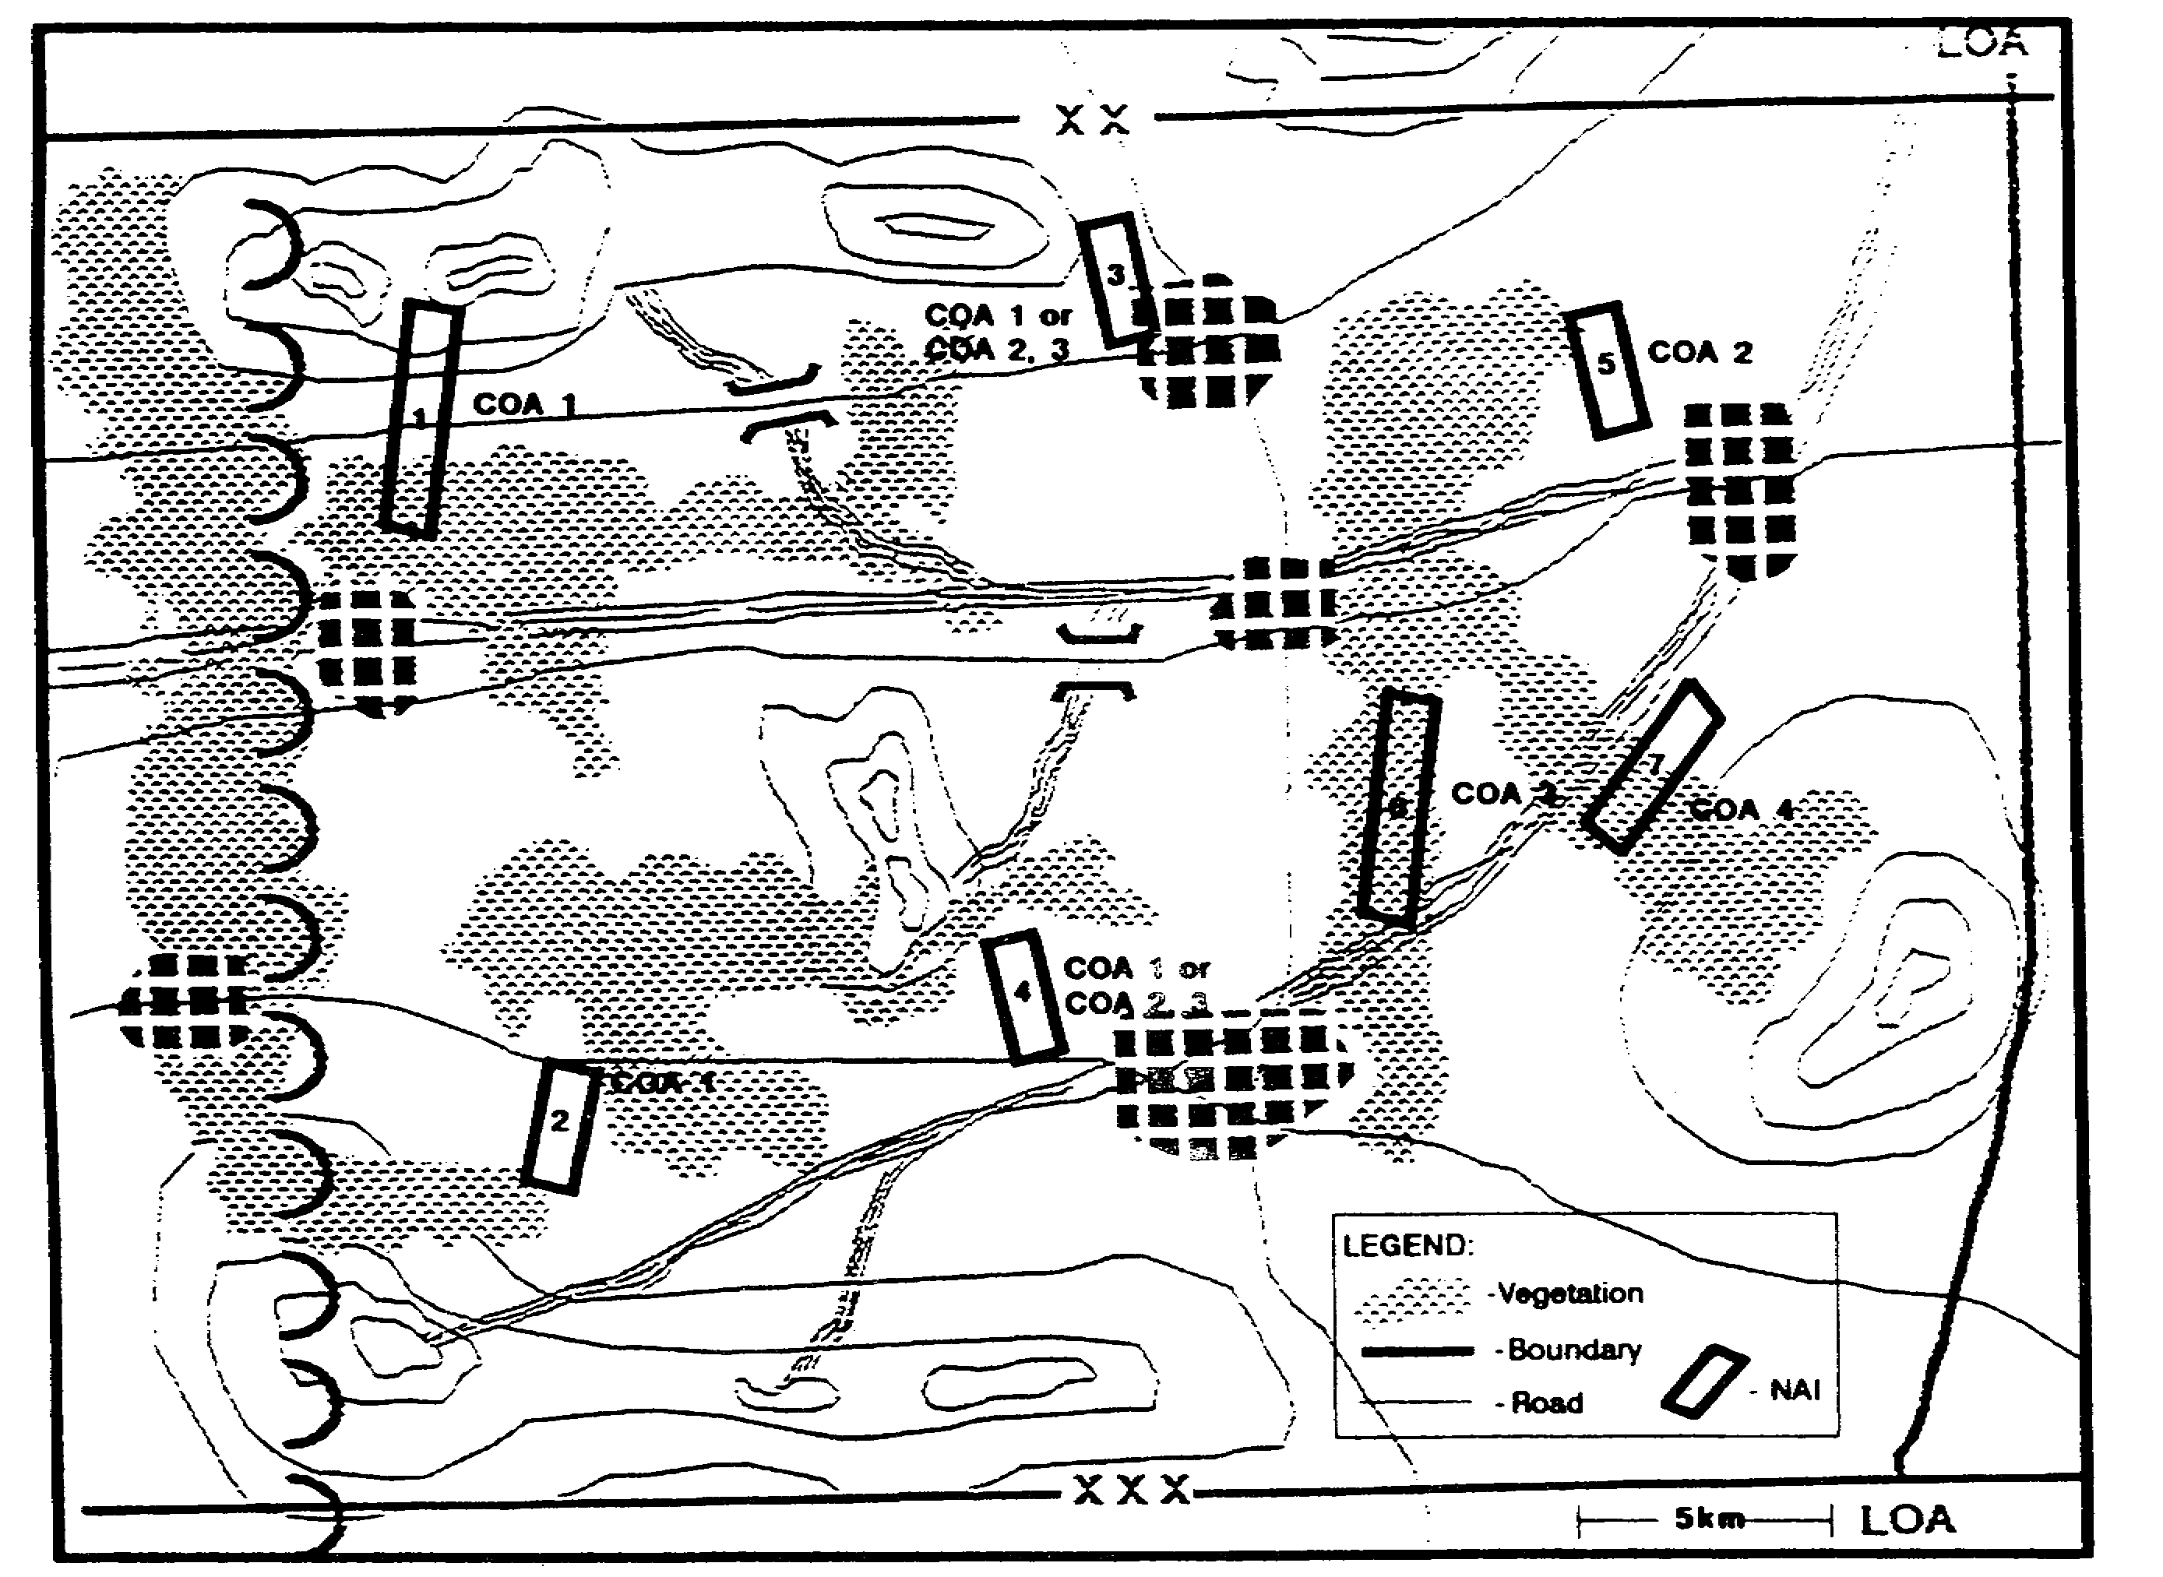

Figure 2-40. Initial Event Template.

2-53 IT0432

We examine the situation templates to identify NAls associated with the various counterattack options of the enemy's armored brigade. We add these onto the event template, along with time lines that reflect the expected arrival time of the counterattacking brigade (Figure 2-41). Some of these NAls may be dropped during staff wargaming, while new ones may be added.

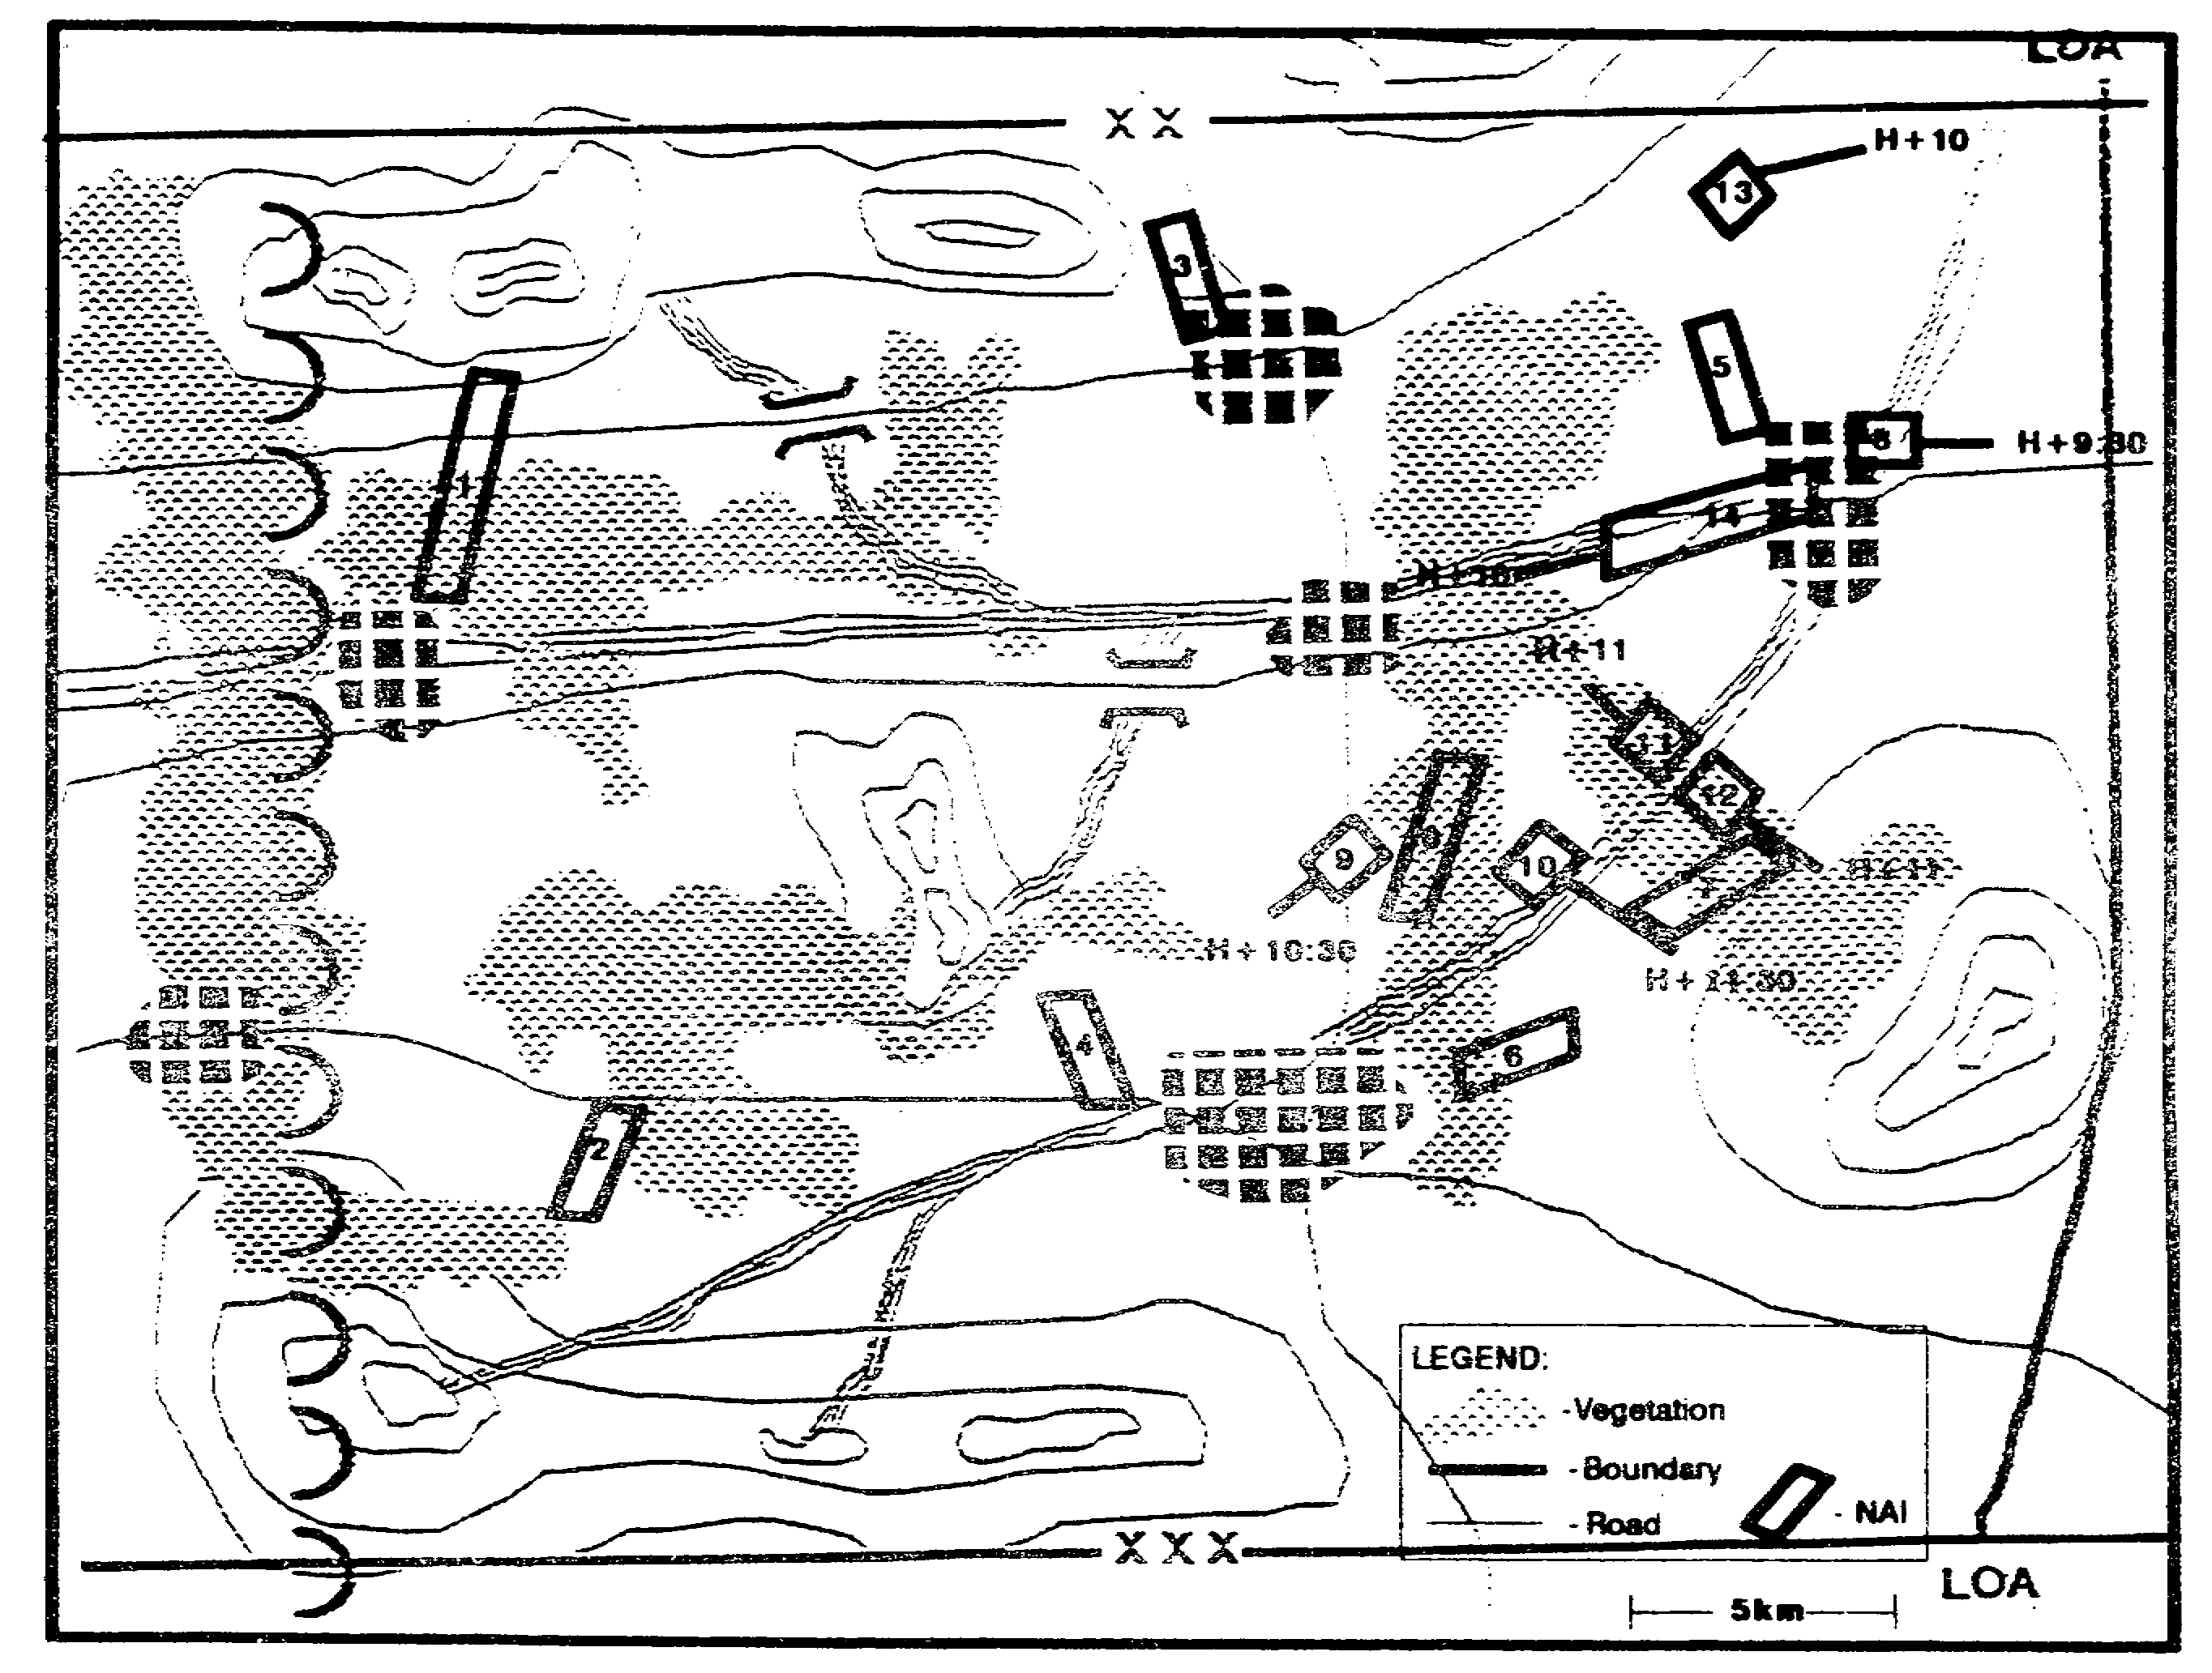

Figure 2-41. Refined Event Template.

IT0432 2-54

We turn next to the COAs available to the two armored divisions. After identifying likely counterattack objectives, in priority order, we identify available avenues of approach. We evaluate each COA for NAls that will provide confirmation or denial of its adoption by the enemy. We include these NAls on the event template, along with the TPLs associated with the armored divisions' movement (Figure 2-42).

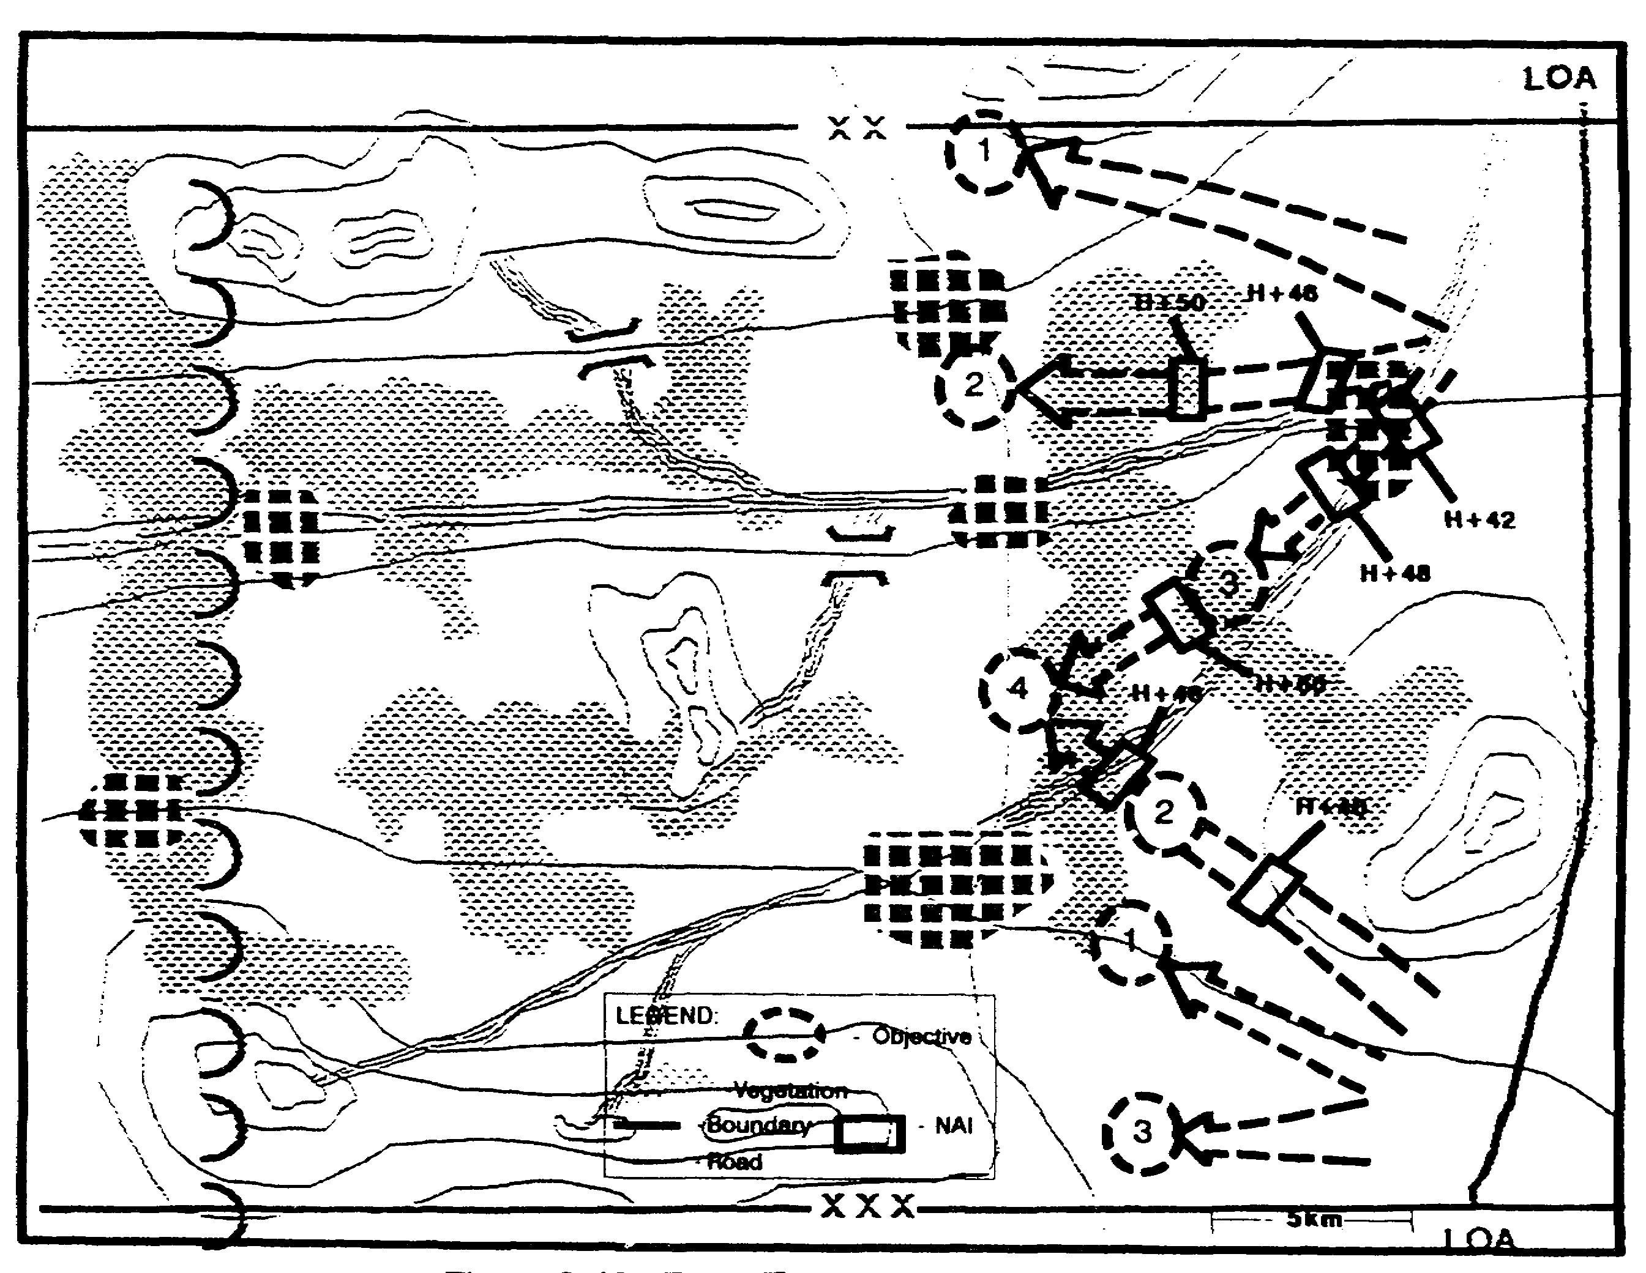

Figure 2-42. Event Template - Counterattack.

2-55 IT0432

We evaluate the COA available to the air assault brigade in the same way. We identify supporting NAls and transfer them to the event template (Figure 2-43).

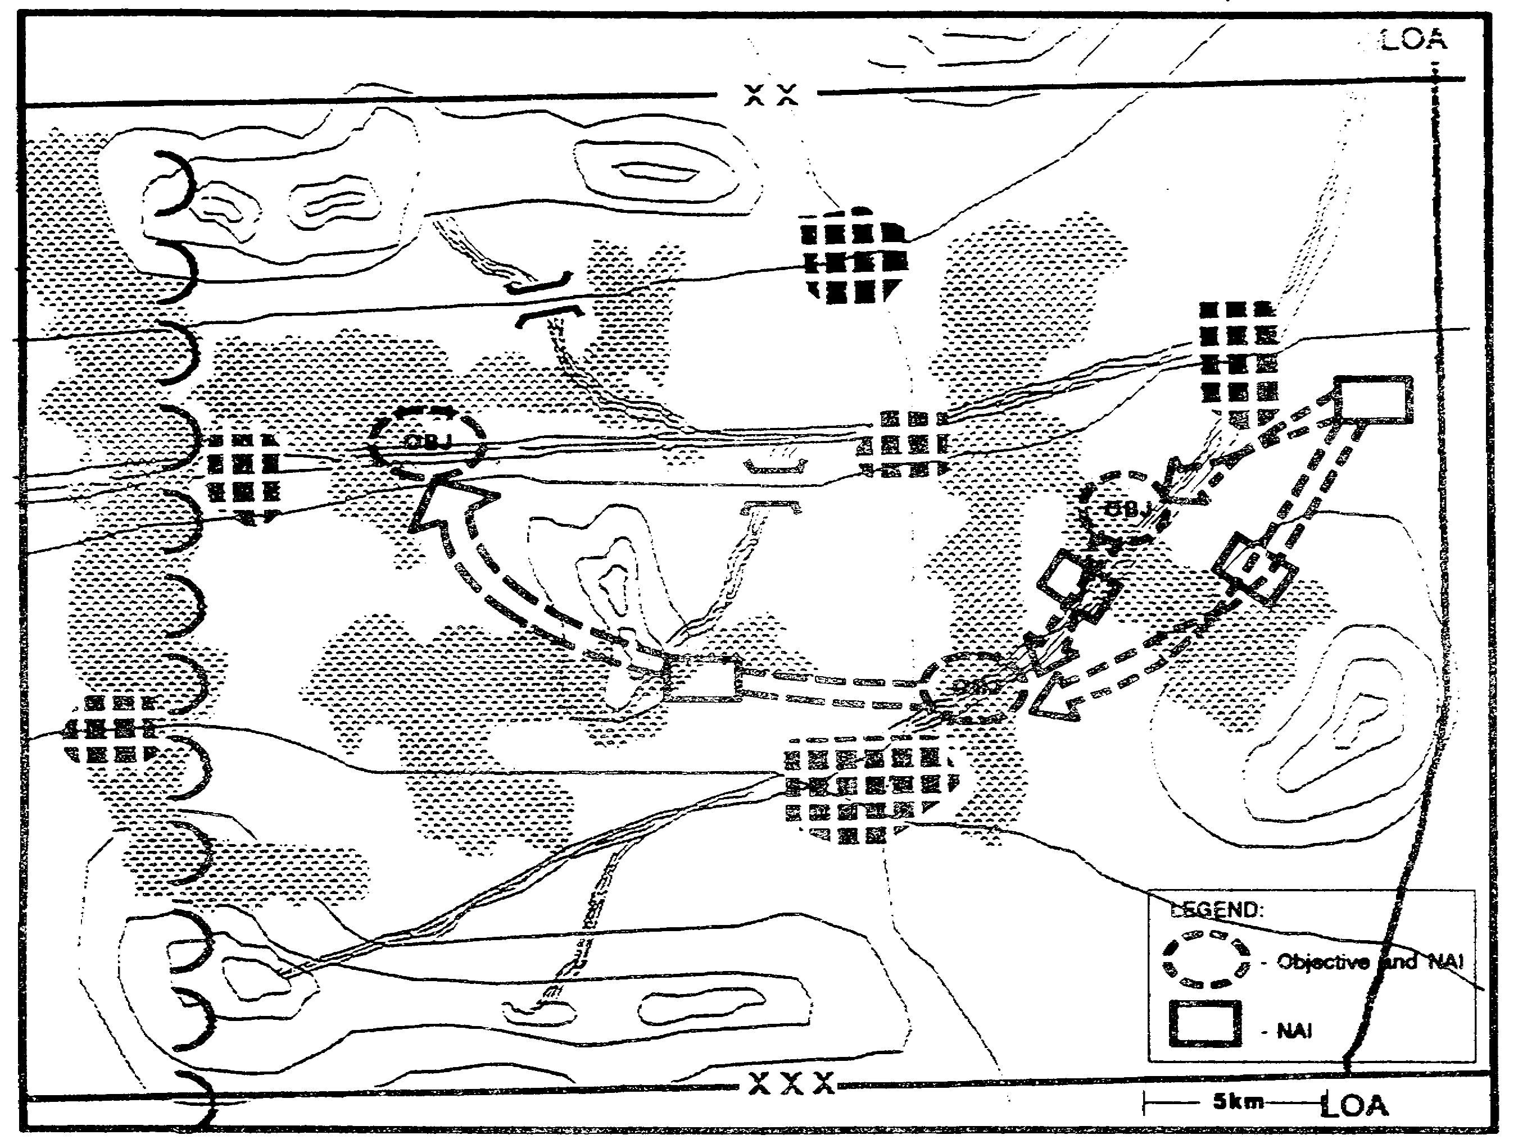

Figure 2-43. NAls - Air Assault Brigade.

IT0432 2-56

We prepare an event matrix to accompany the event template (Figure 2-44). Like the event template, it will be refined during staff wargaming to focus on those NAls that will support the commander's PIR and decision points (DPs).

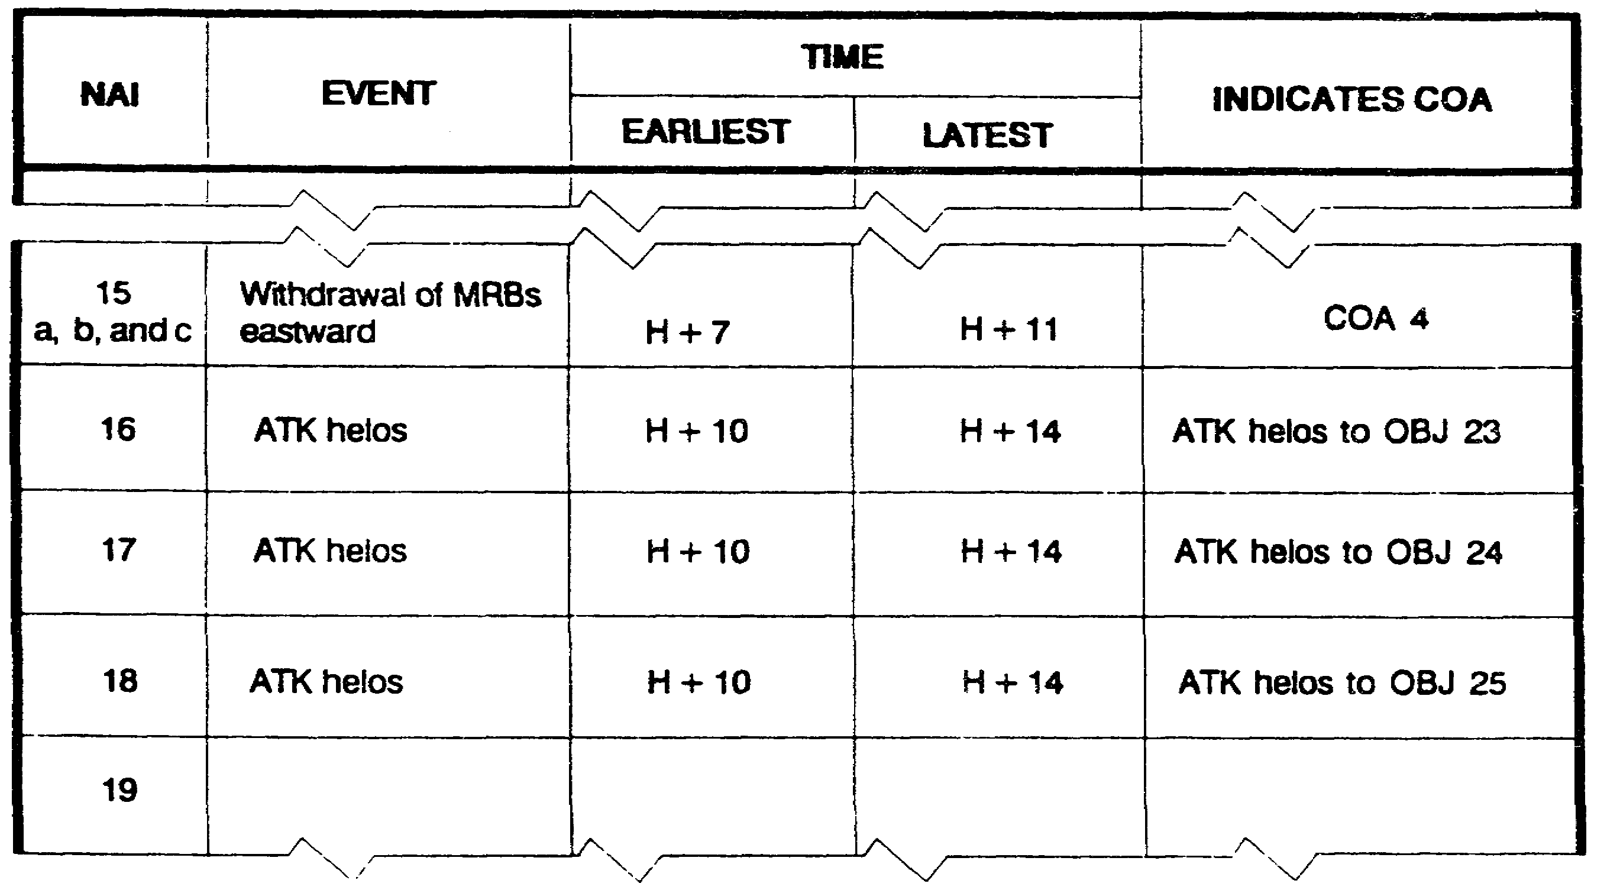

Figure 2-44. Event Matrix.

DISSEMINATE, USE, AND REFINE IPB PRODUCTS

Completing the event template and event matrix does not end the IPB process. As we receive new information and intelligence, it is incorporated into the ongoing IPB effort, refining or creating additional sets of IPB products.

We disseminate the results of our IPB to those who need them to begin their own IPB process.
Subordinate units and other staff sections take the results of our IPB and refine and adapt them to meet their own needs. (See Figures 2-45 thru 2-48.)

The fire support element (FSE) uses the results of our battlefield description to identify areas that are not suited to the large-scale deployment of friendly artillery units. Notice that the FSE has included areas inhabited by a large number of enemy sympathizers in this category.

2-57 IT0432

The FSE will also, use the results of our terrain analysis as a start point for identifying potential locations for friendly and enemy counter-mortar and battery radars or other target acquisition assets (Figure 2-45). He may request that the engineer (terrain) detachment conduct LOS studies for selected sites.

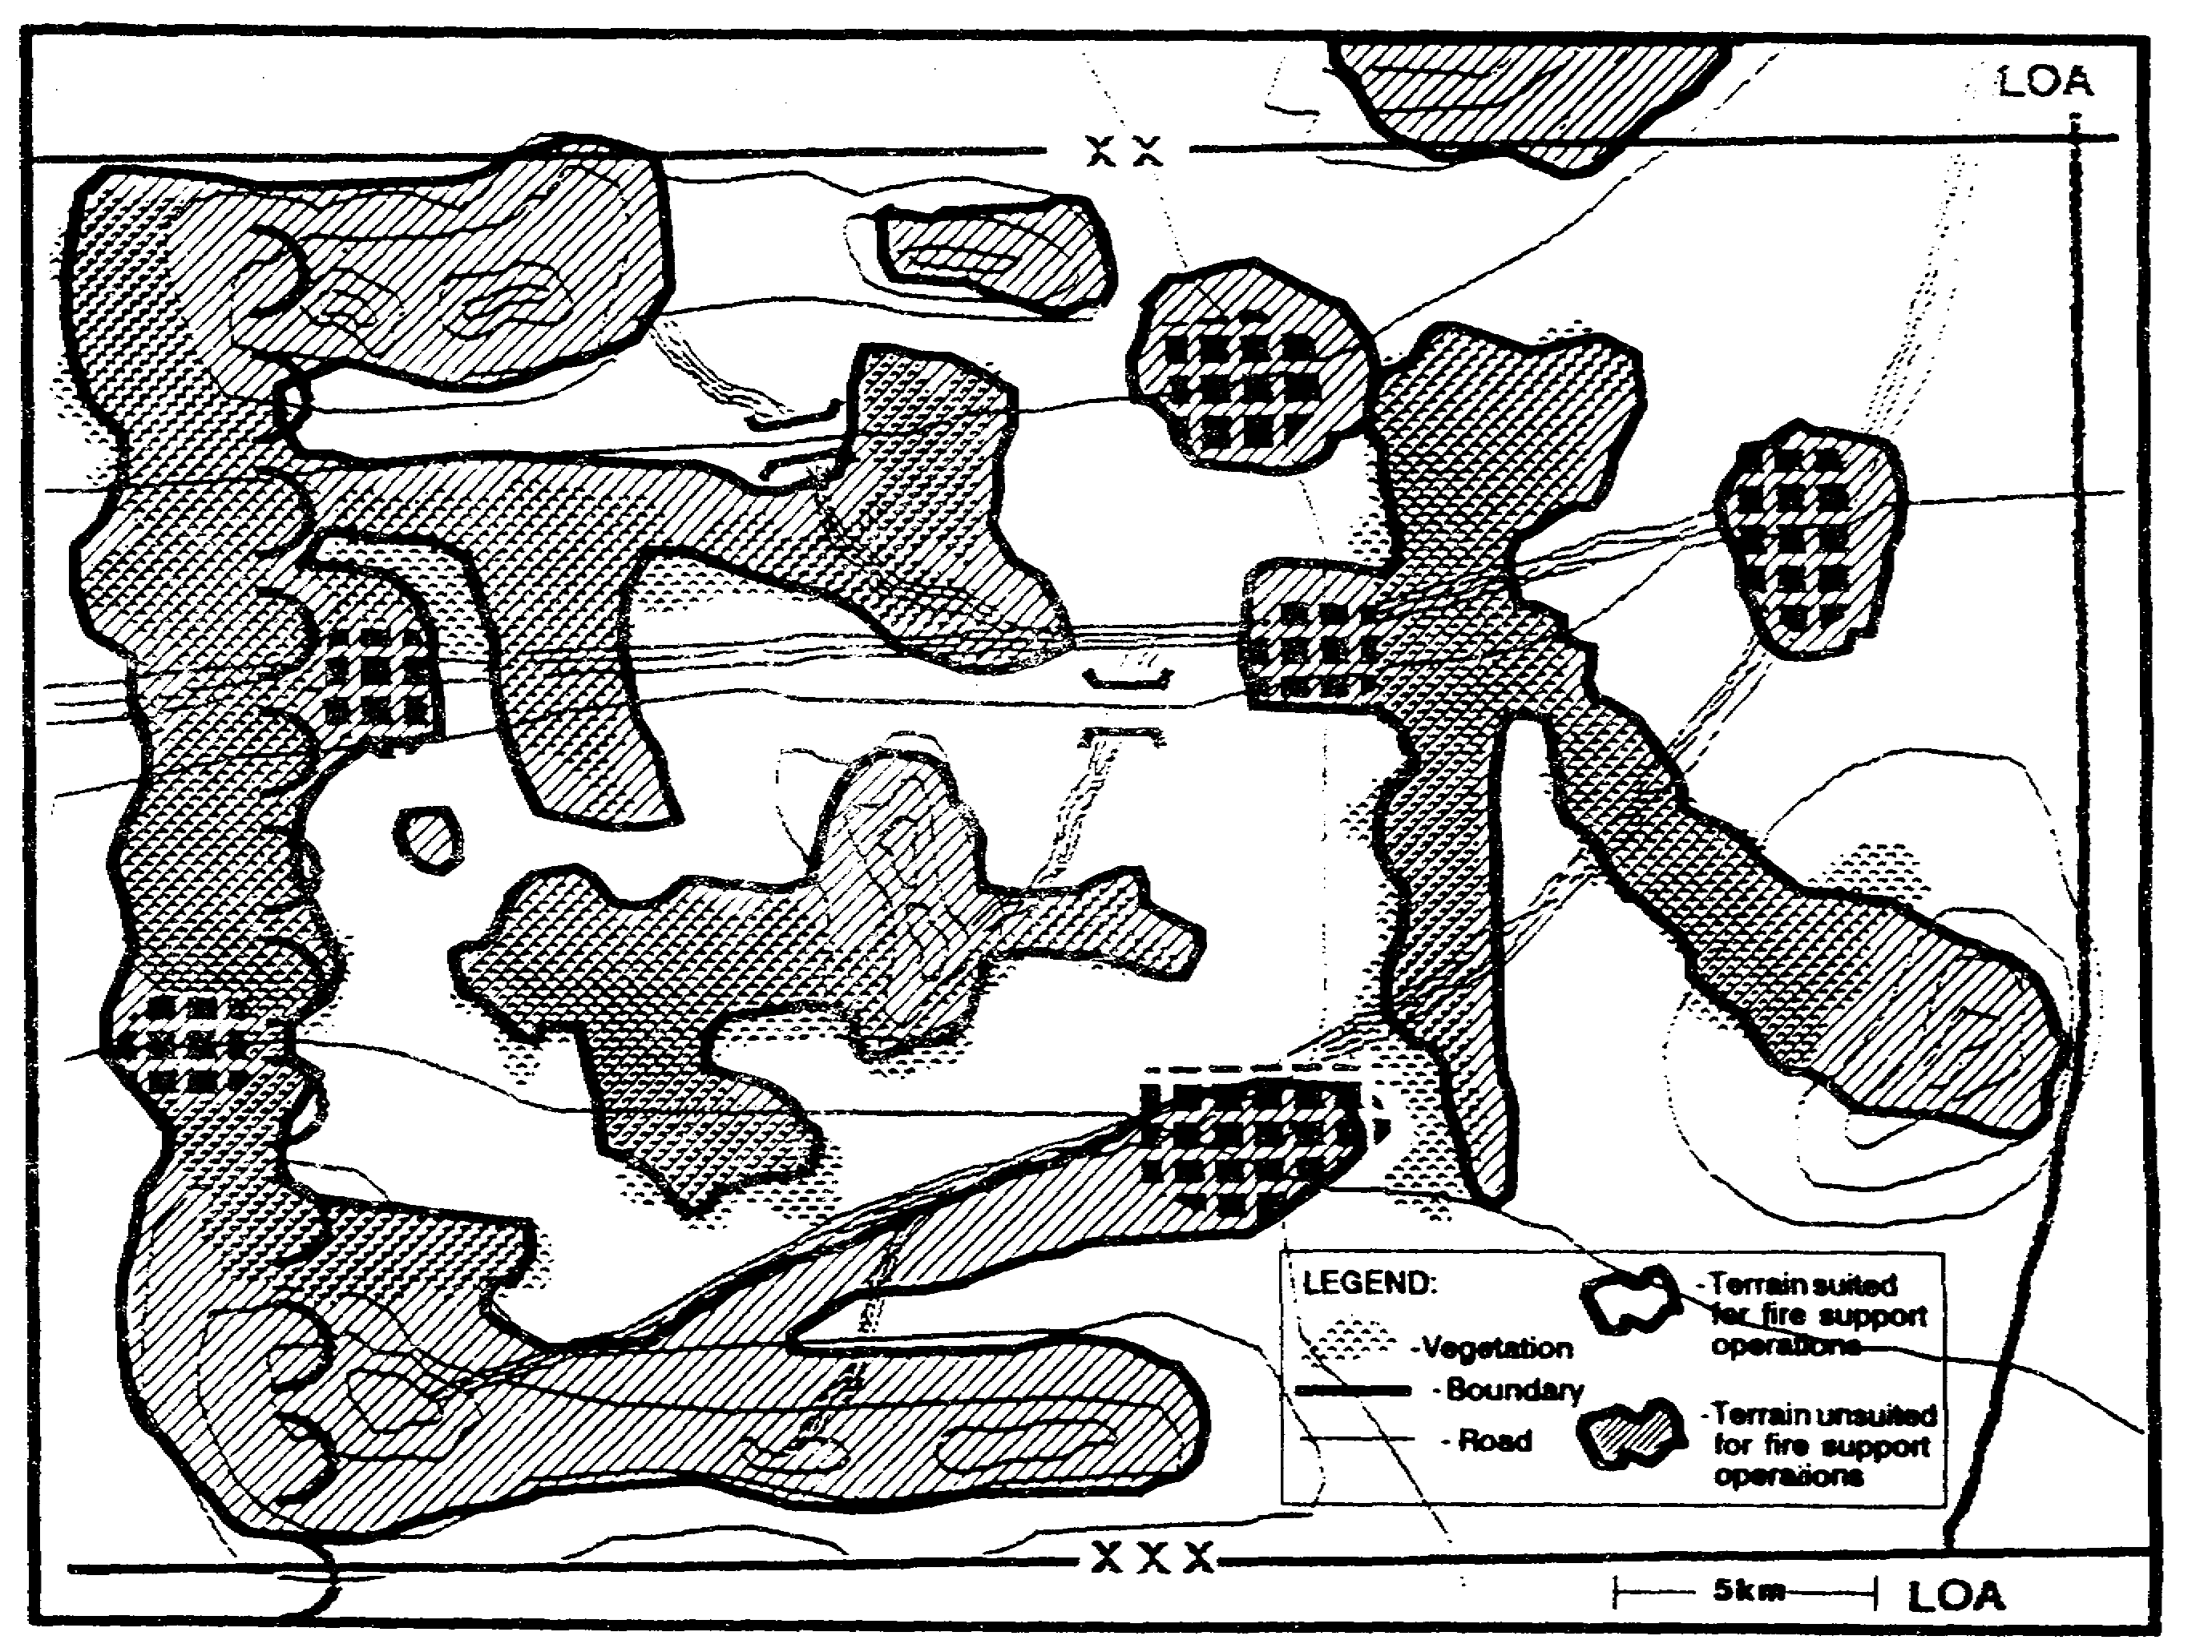

Figure 2-45. Potential Locations FS Assets.

IT0432 2-58

The targeting cell uses our situation templates as the starting point for their own templates that emphasize HVTs (Figure 2-46). Additionally, their description of tactics and target relative value matrices will focus on these same assets.

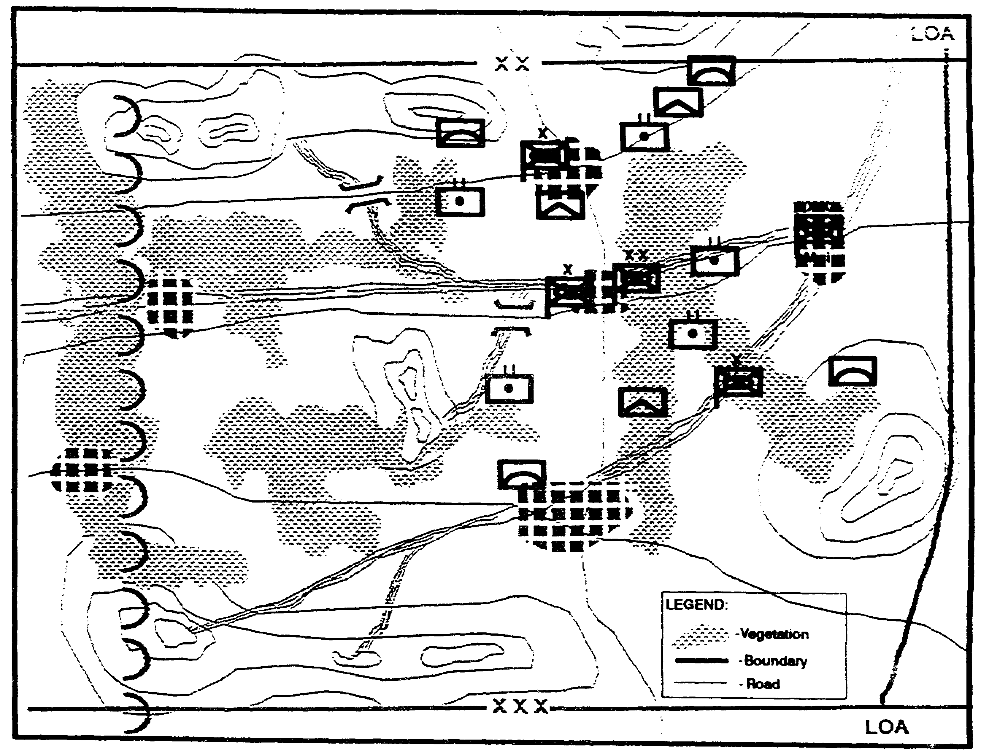

Figure 2-46. HVTs Templated Locations.

2-59 IT0432

The Electronic Warfare Staff Officer (EWSO) uses the situation templates as a starting point for situation templates that depict enemy communication nodes. Here, he uses a segmented wheel to depict the locations of the various communication sites. The letters within each segment correspond to a matrix that further defines the communication systems associated with each node (Figure 2-47).

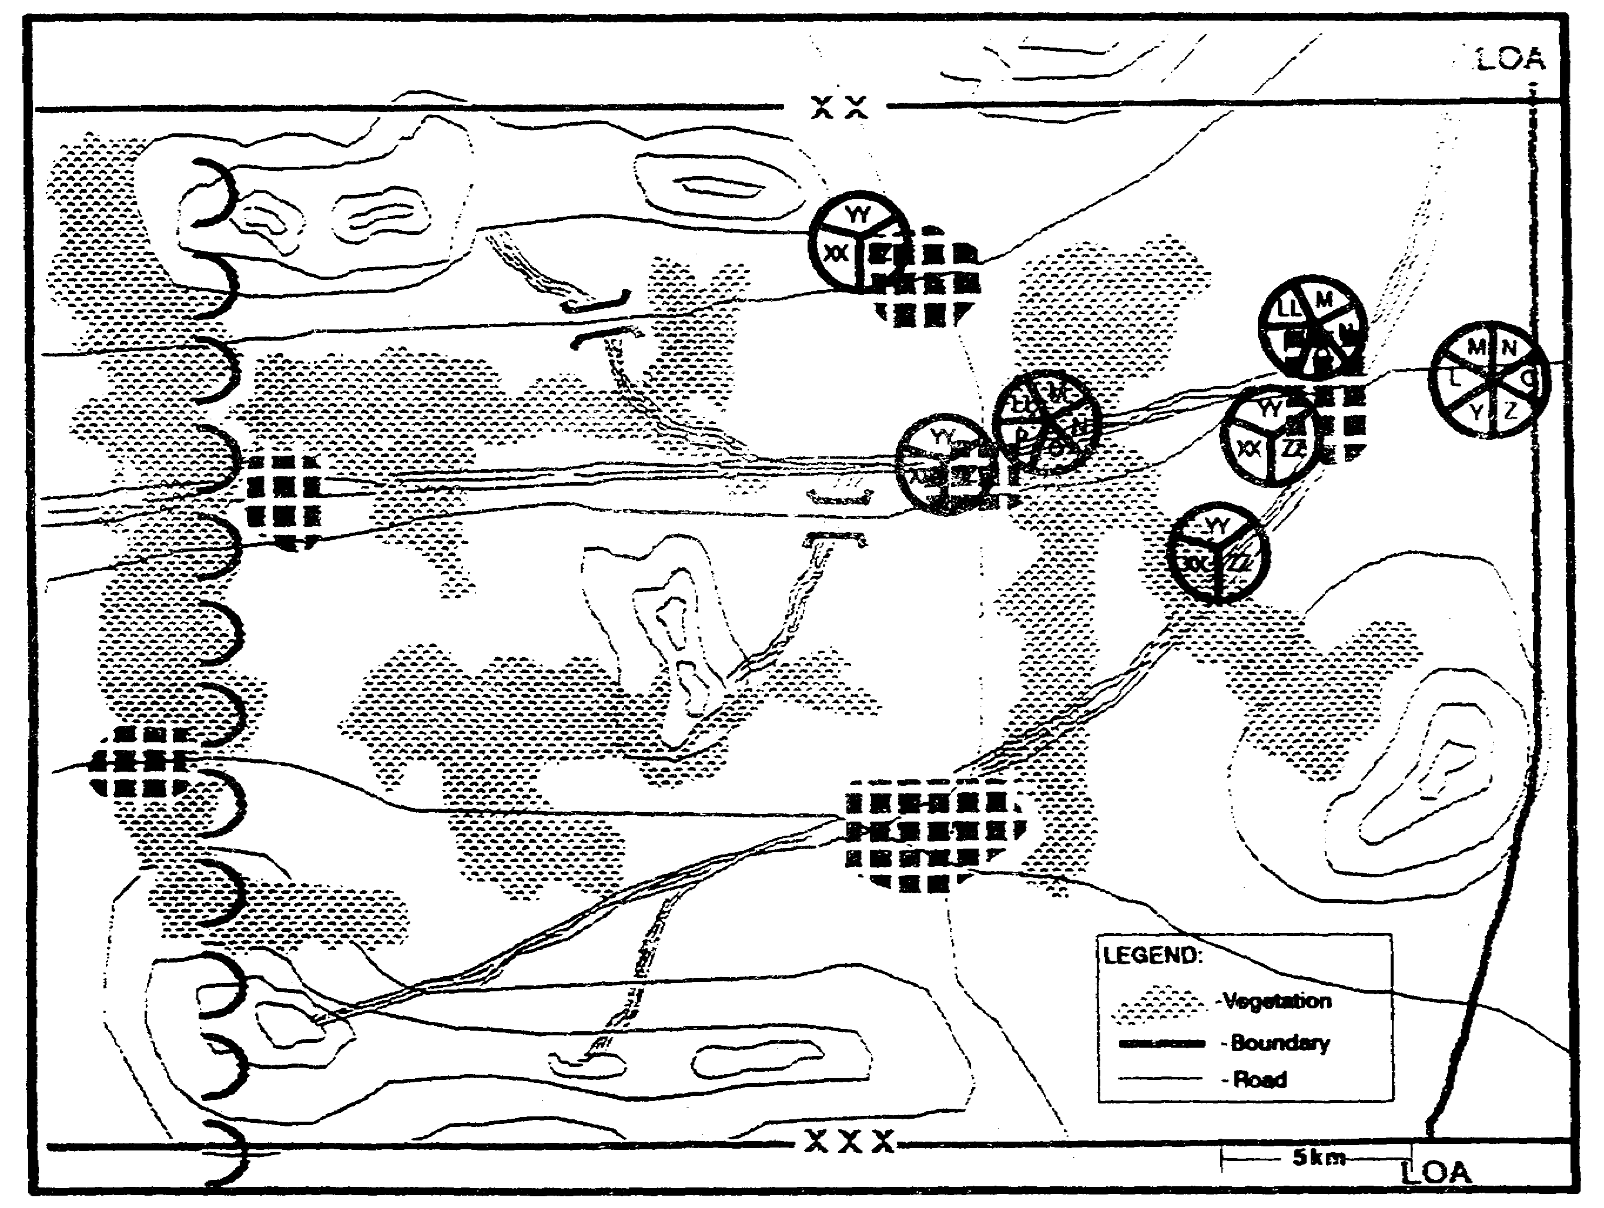

Figure 2-47. Communications Nodes Template.

IT0432 2-60

The Counterintelligence Human Intelligence (HUMINT) Team uses our situation templates as a starting point for its own templates that focus on the enemy's Electronic Attack (EA) and collection assets (Figure 2-48).

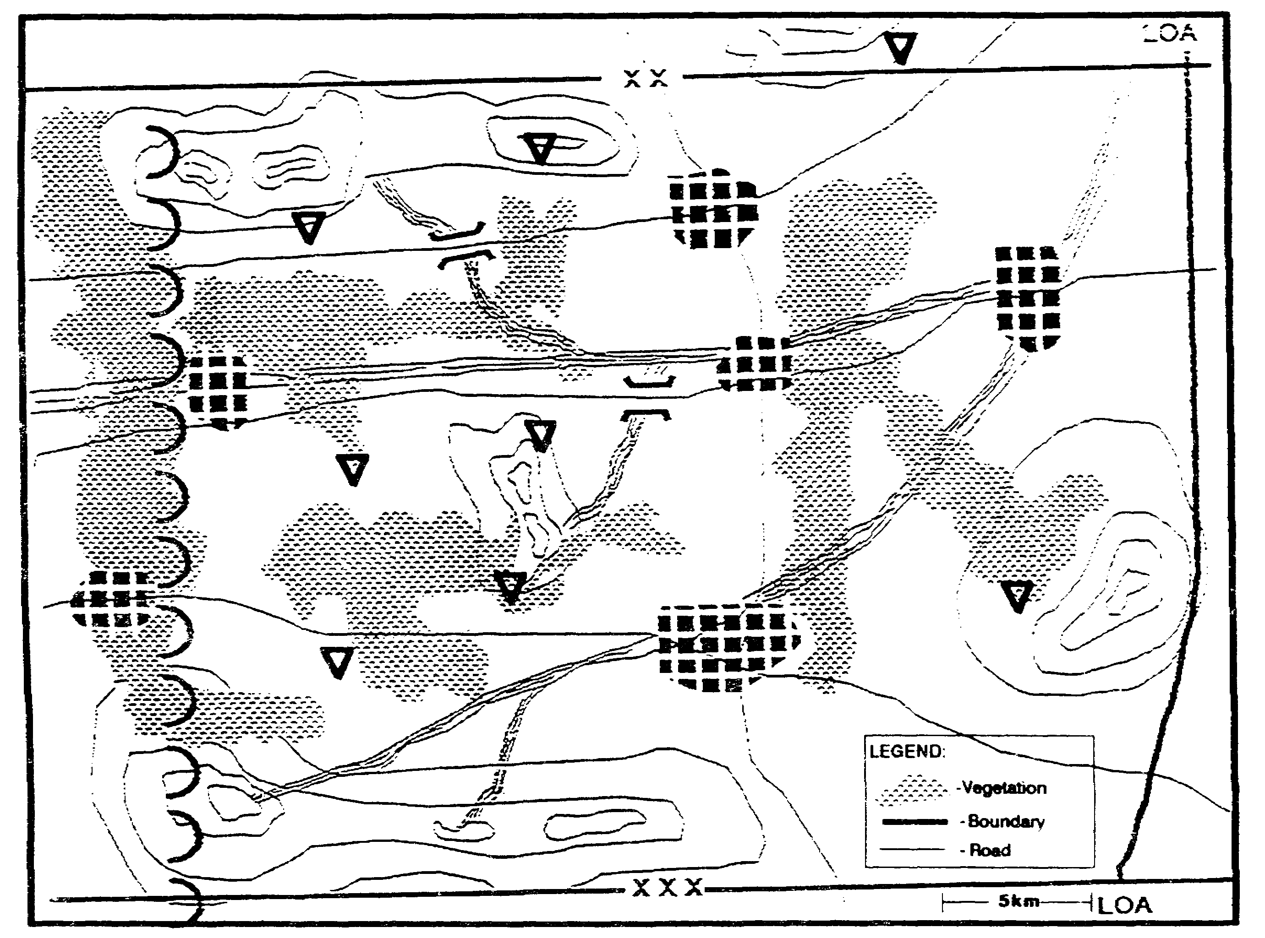

Figure 2-48. Threat IEW Assets Template.

2-61 IT0432

Situation 2 - Defensive Operations.

After a rapid deployment in support of a threatened ally, the division begins to organize its defense. Our brigade is assigned to the center of the division's sector. Due to the relatively close terrain, the brigade has been organized with one armor battalion, one mechanized battalion, and two light infantry battalions.

The enemy directly opposite our sector is one mechanized infantry division. Available as the enemy corps' reserve is an armored division (Figure 2-49).

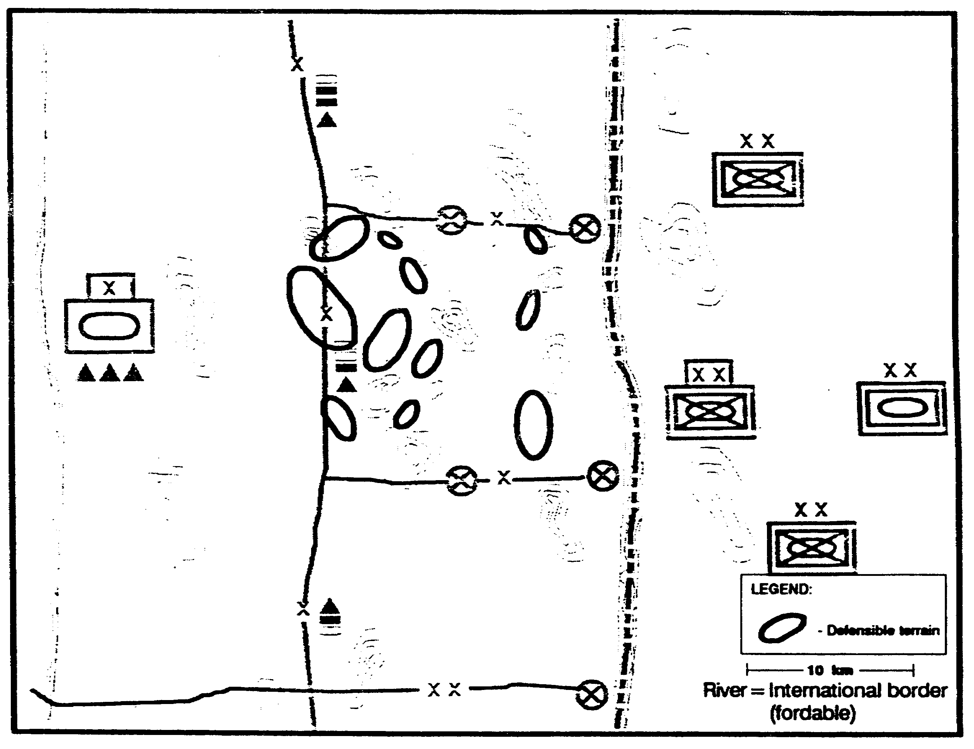

Figure 2-49. General Situation.

IT0432 2-62

Because of the uncertain political situation, with the Threat of imminent hostilities, we must conduct the IPB process as quickly as possible. This is an example of abbreviated IPB.

DEFINE THE BATTLEFIELD ENVIRONMENT

We define our Al to include all probable threats to the brigade's defensive mission. We consider concentration for an attack in our sector as well as the risk of attacks from adjacent sectors (Figure 2-50).

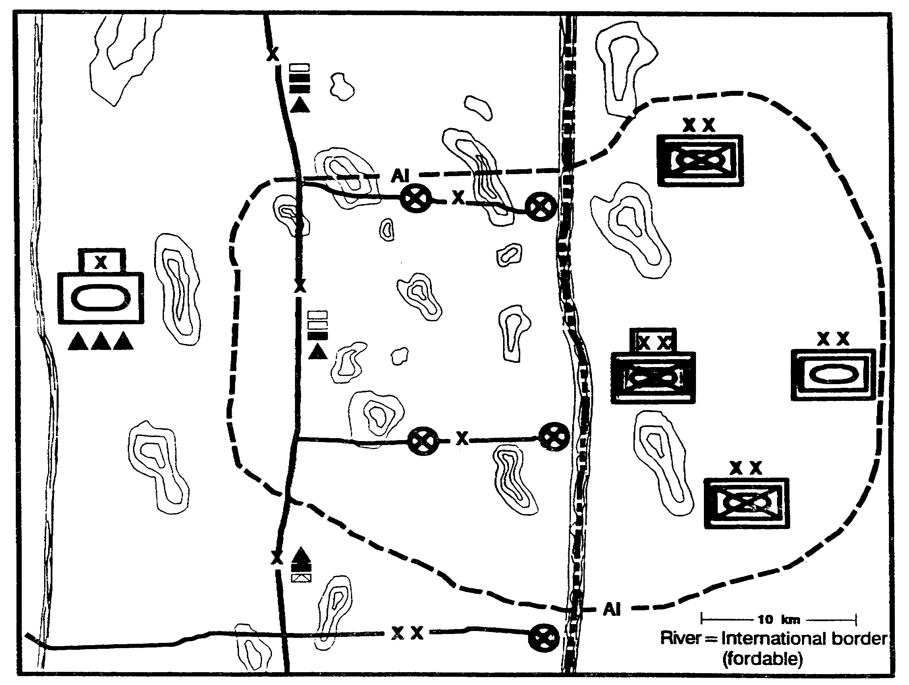

Figure 2-50. Area of Interest.

2-63 IT0432

DESCRIBE THE BATTLEFIELD EFFECT

We examine the map for the various terrain factors that create obstacles to mobility within the Al. Rather than create separate overlays for each factor, we record the end results (mobility corridors and avenues of approach) on a single graphic product (Figure 2-51). To determine avenues of approach, we must first identify likely objectives. To keep the graphic from getting too cluttered, we put air avenues of approach on a separate overlay.

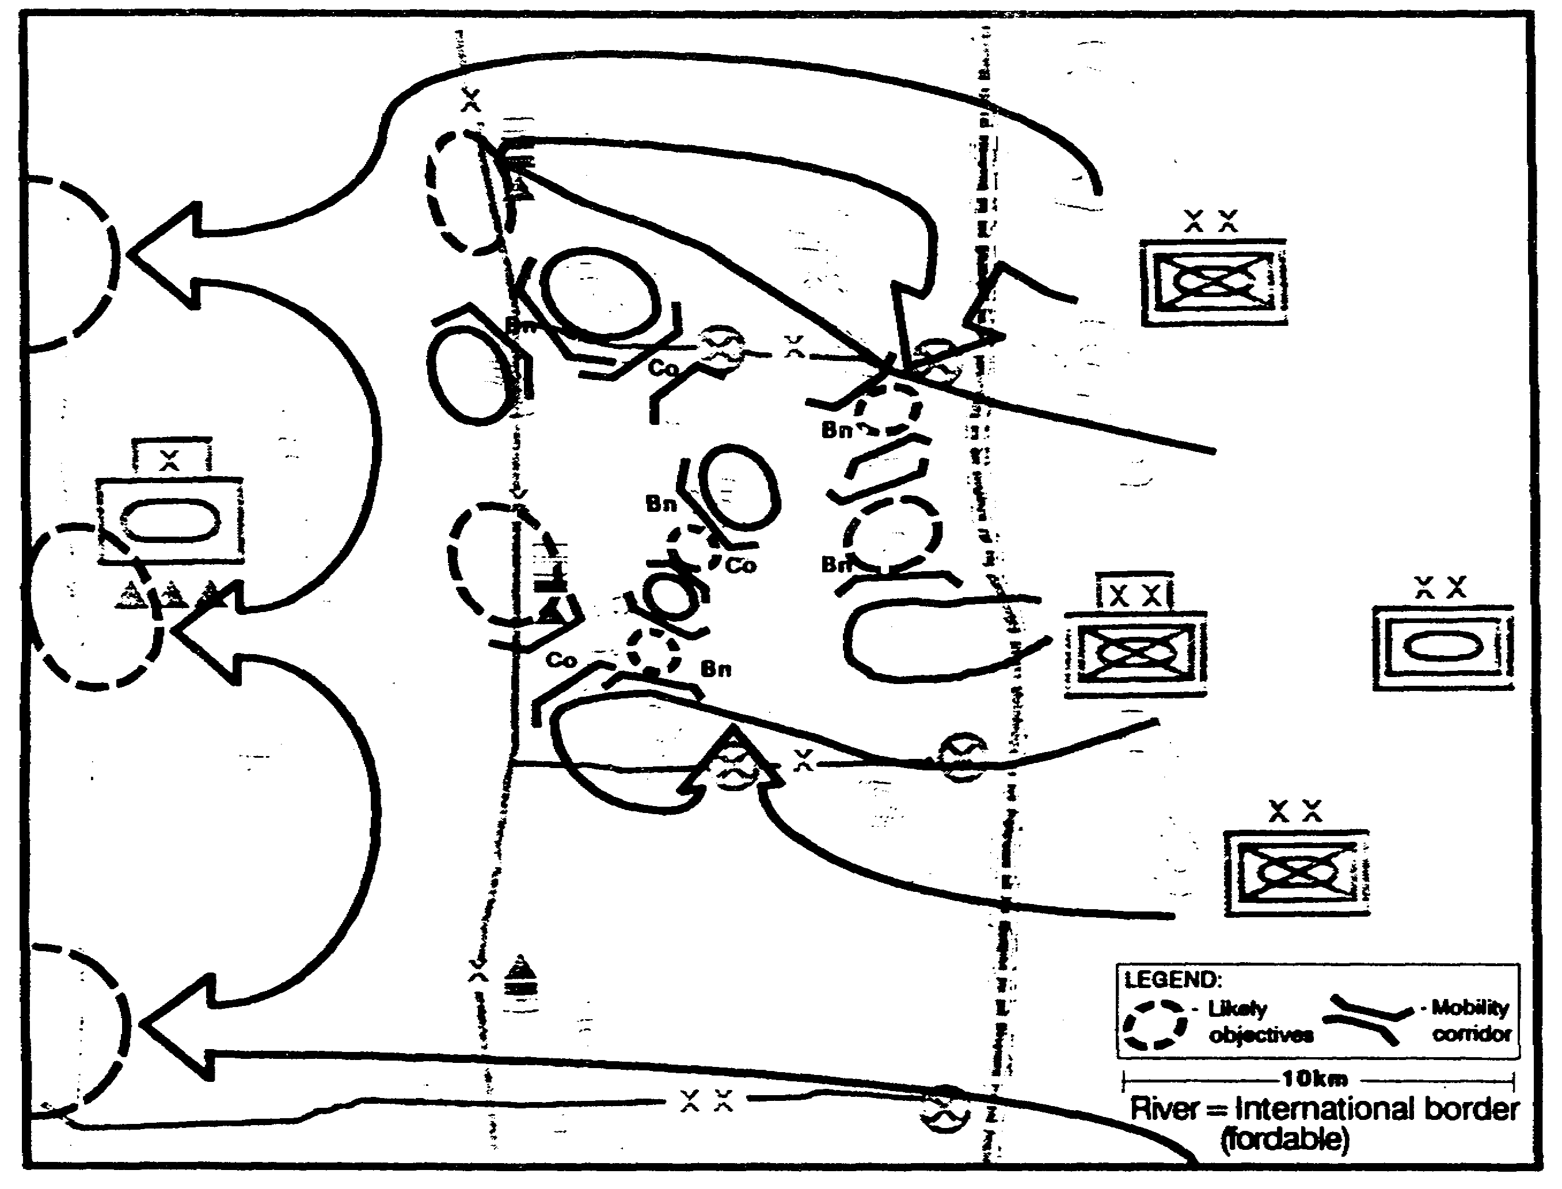

Figure 2-51. MCs and AAs.

IT0432 2-64

There are few obstacles to flight AAs within the Al. Our evaluation of air avenues instead focuses on direct routes that offer some protection to aircraft (Figure 2-52).

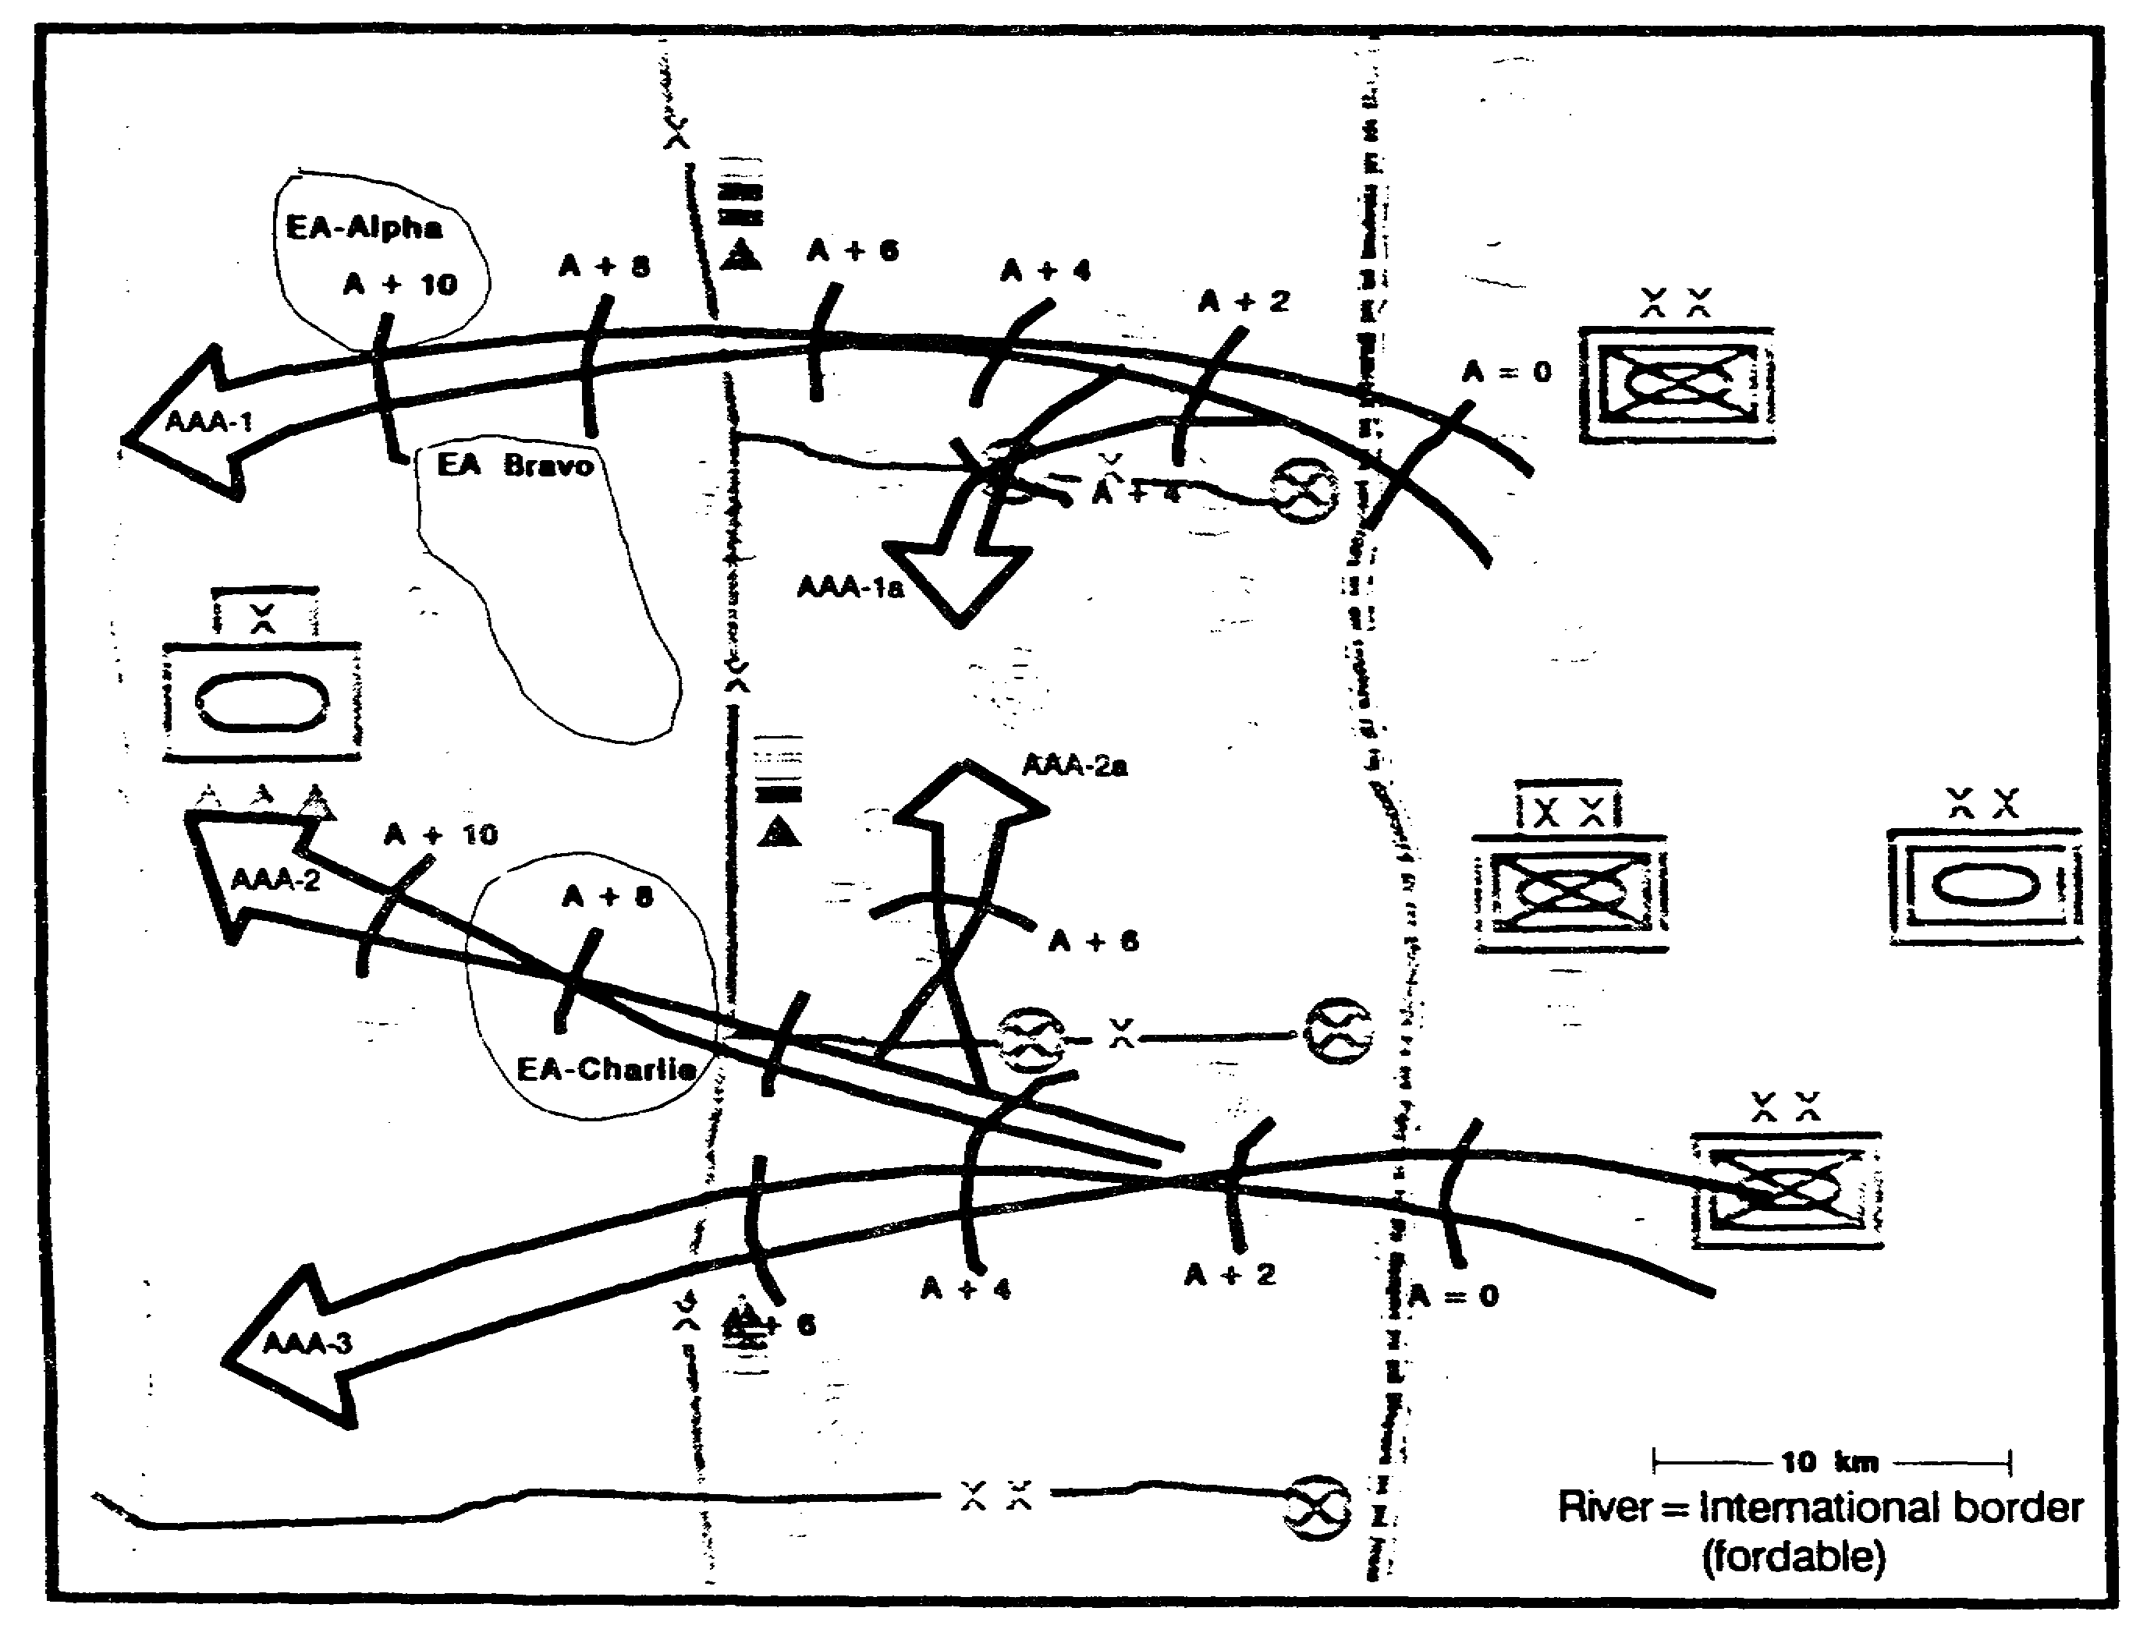

Figure 2-52. Air AAs.

2-65 IT0432

We next identify defensible terrain within the brigade's sector. We identify potential defensive positions for both the heavy and light forces within our brigade, oriented on the enemy's likely avenues of approach (Figure 2-53).

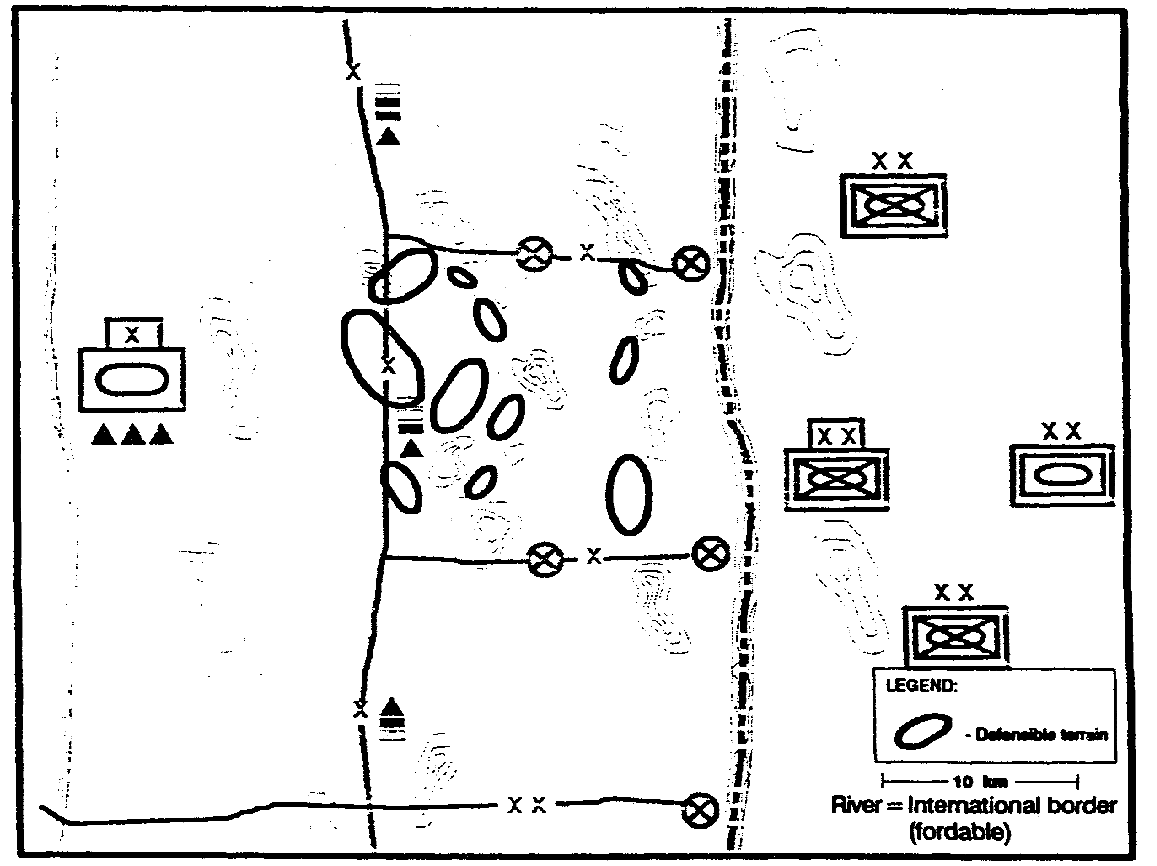

Figure 2-53. Defensible Terrain.

IT0432 2-66

DESCRIBE THE THREAT

Our evaluation of the Threat model reveals the enemy's similarity to our own forces in both doctrine and organization (Figure 2-54). This gives us an advantage in communicating the enemy's capabilities to our commander.

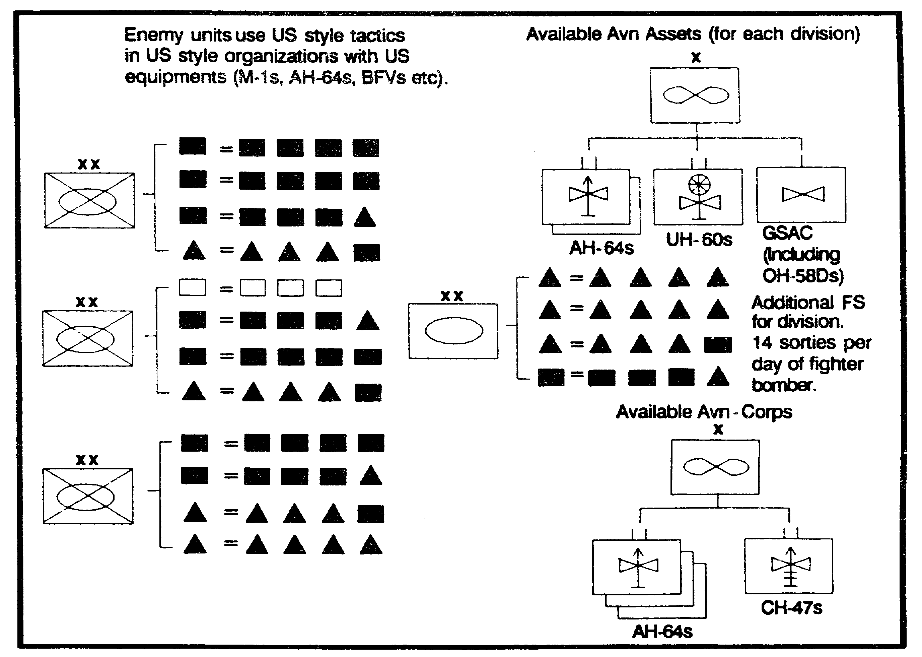

Figure 2-54. Threat Organization.

2-67 IT0432

DETERMINE THREAT COURSES OF ACTION

Overlaying our mental doctrinal templates on our evaluation of the terrain's effects, we create a graphic depiction of the set of enemy's COAs. This serves as our situation template (Figure 2-55). For the moment, we put off developing them in detail.

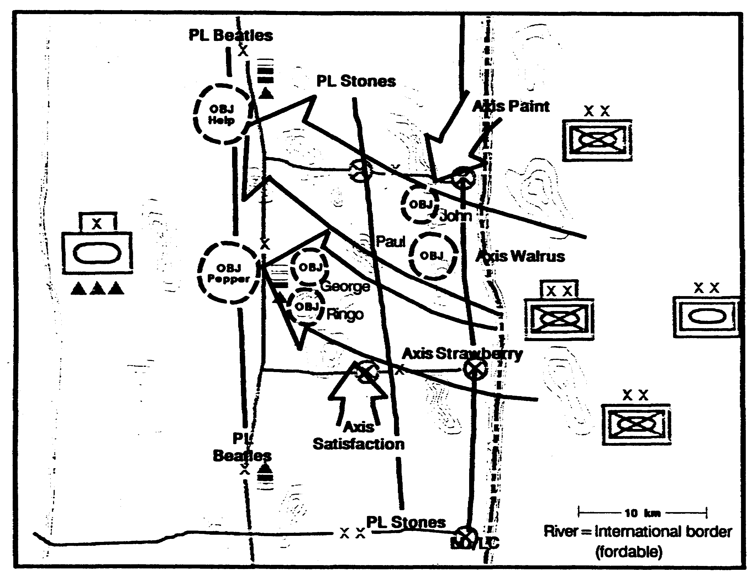

Figure 2-55. Threat COAs.

IT0432 2-68

We create a matrix to describe each COA within the set (Figure 2-56). This helps collection planning and visualizing the conduct of each enemy COA during wargaming.

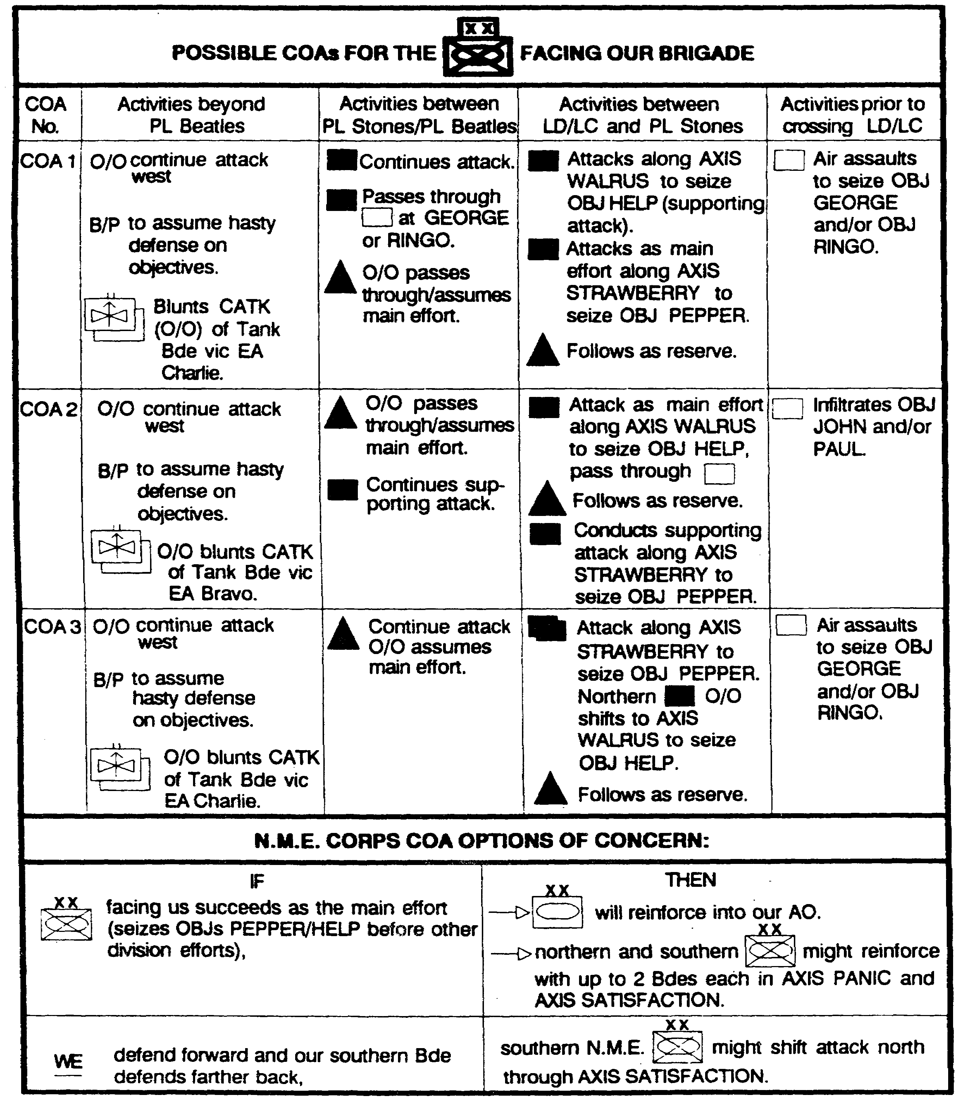

Figure 2-56. Threat COAs Matrix.

2-69 IT0432

Using the situation template and the matrix describing the COA, we prepare an event template. We focus on NAls that will confirm or deny adoption of the COAs within the set. The nature of the terrain causes some of the NAls to take non-traditional shapes (Figure 2-57).

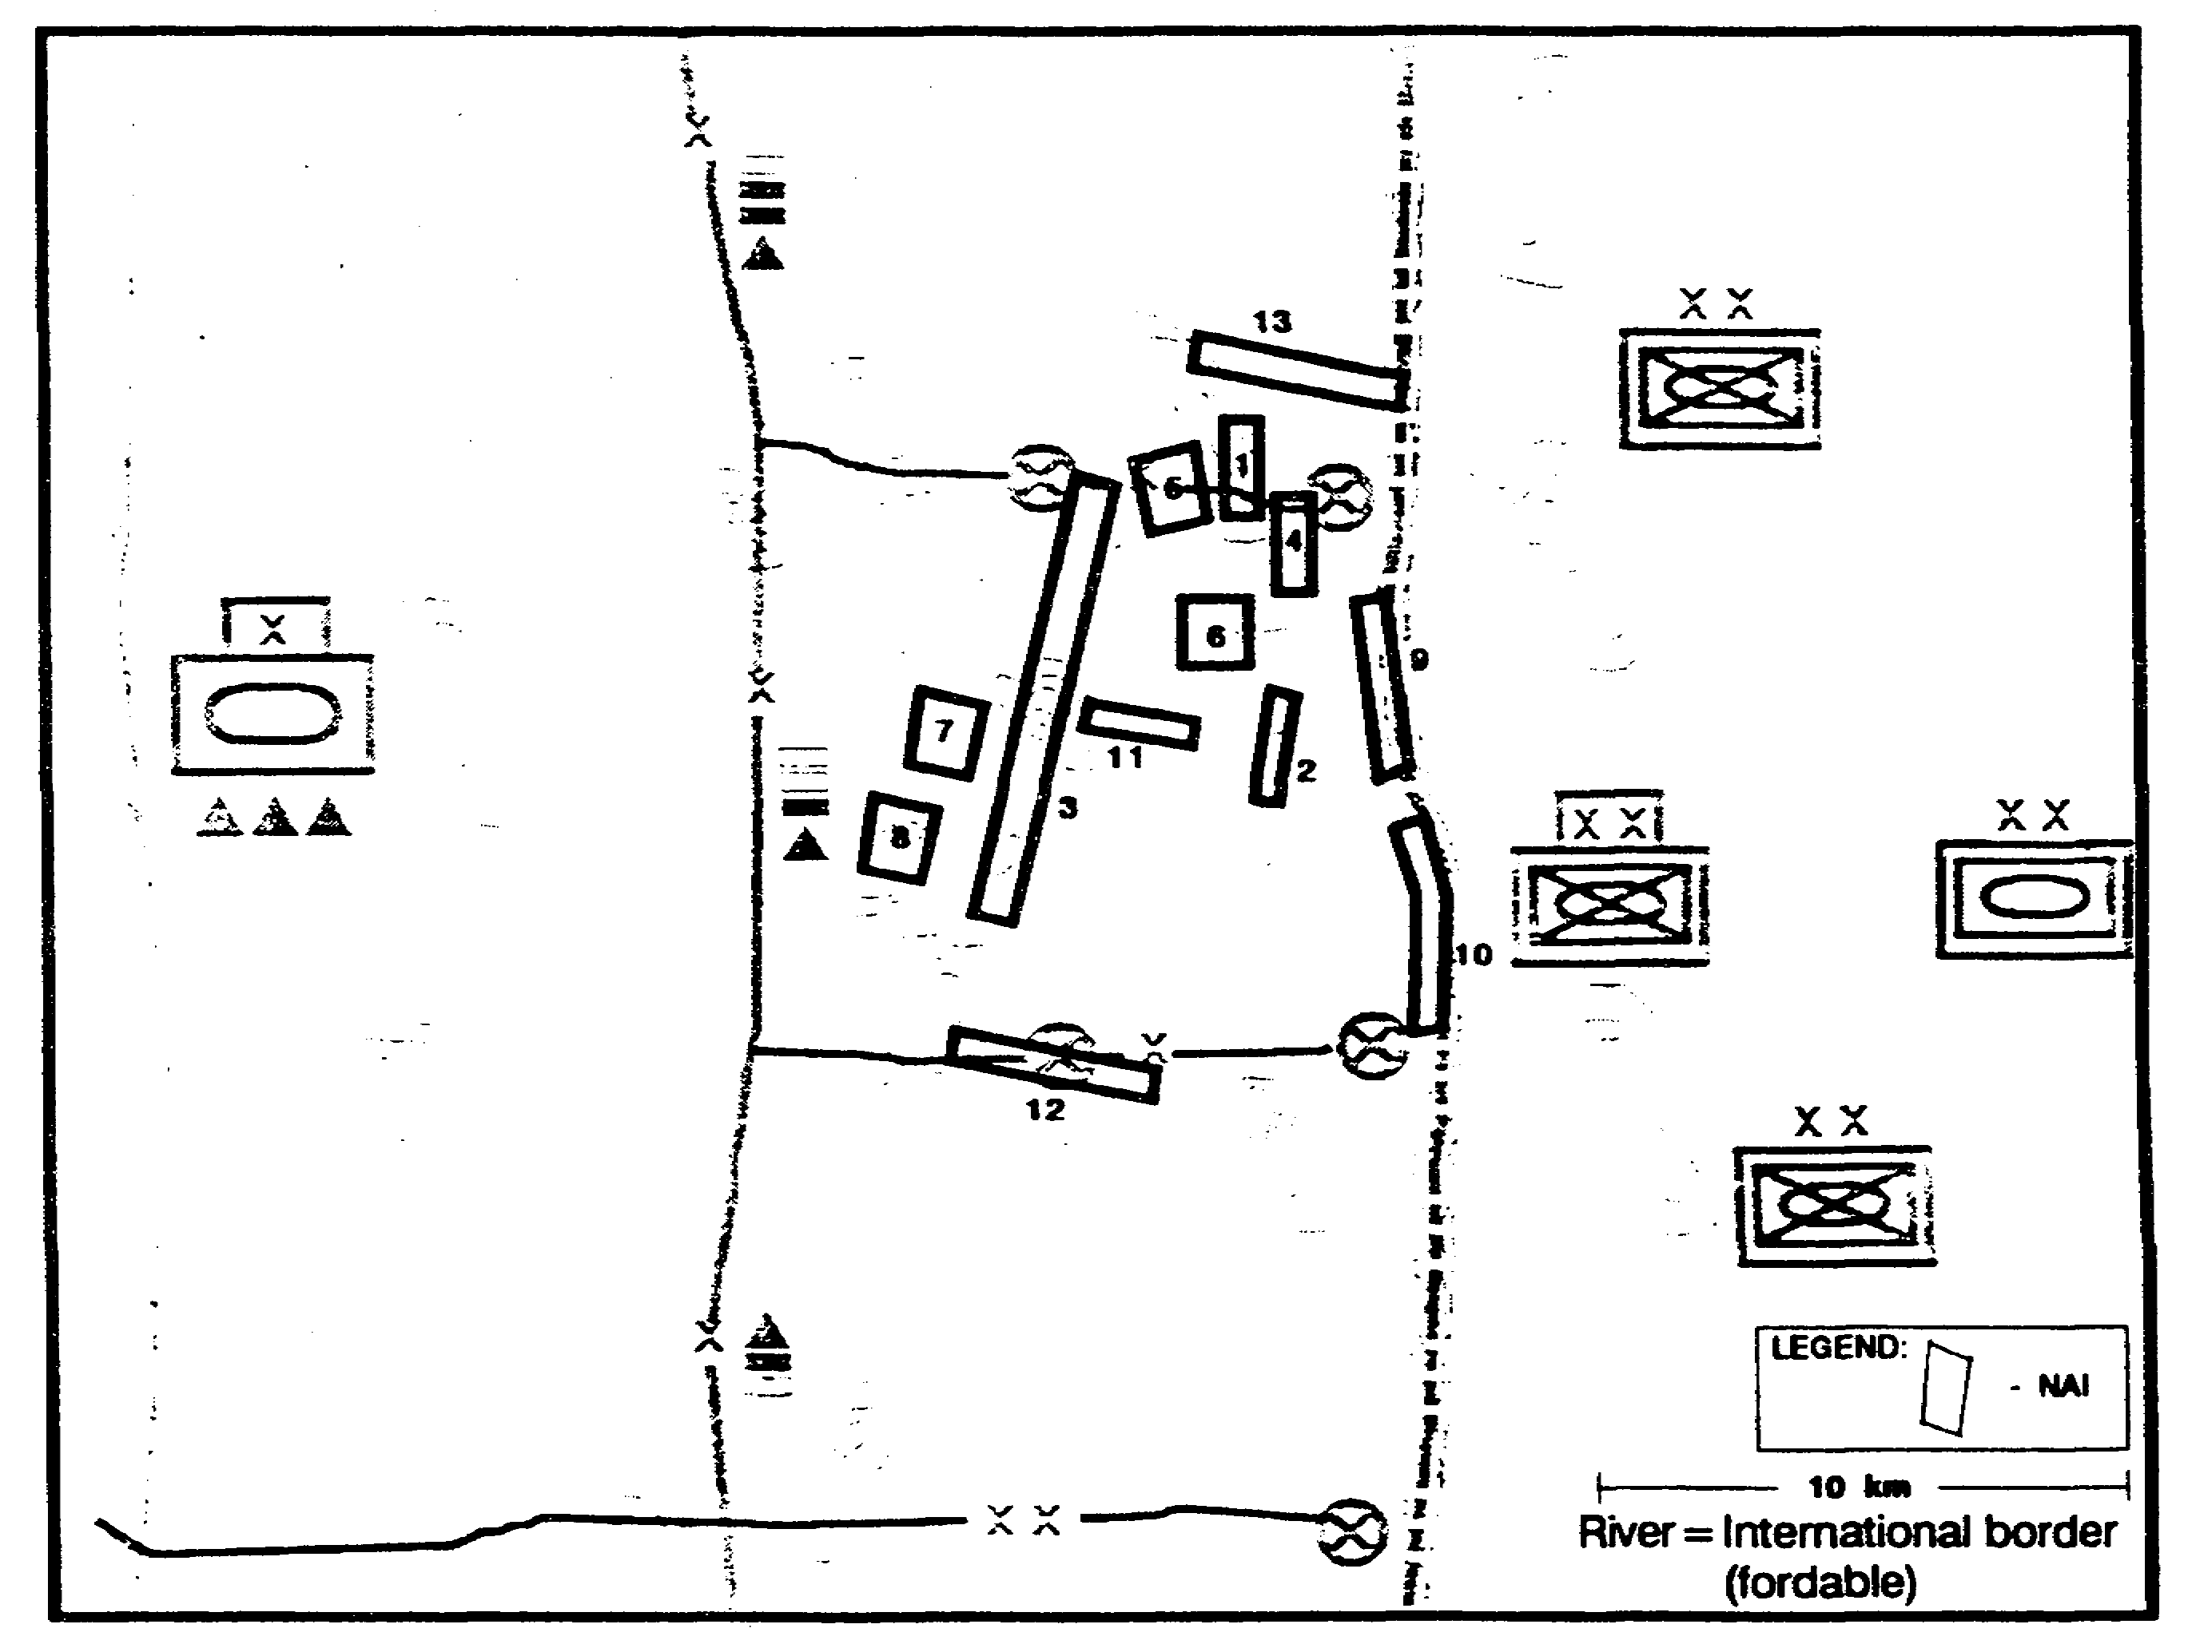

Figure 2-57. Event Template.

IT0432 2-70

We prepare an event matrix that refines the description of the activities we expect to find in each NAI if its associated COA is adopted (Figure 2-58).

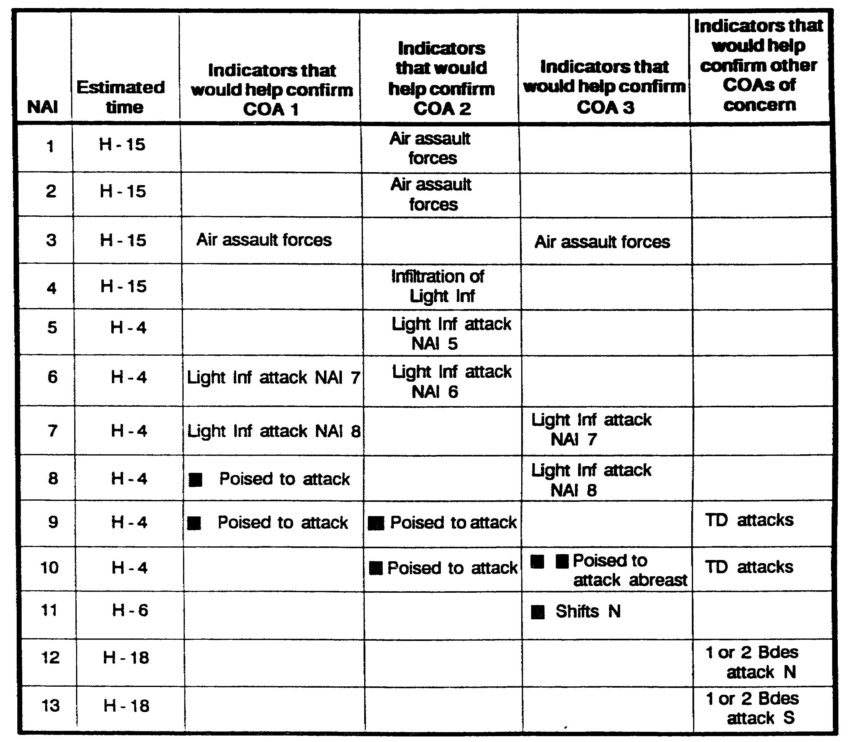

Figure 2-58. Event Matrix.

DISSEMINATE, USE, AND REFINE IPB PRODUCTS

As usual, we disseminate the products of IPB to other staff sections and subordinate units to support their planning efforts. In the time remaining before the onset of hostilities, we refine and improve our basic IPB products. As needed to support planning, we develop our target relative value matrices and develop detailed situation templates. As we receive new information and intelligence, we refine, update, and incorporate it into our initial IPB.

2-71 IT0432

LESSON 2

PRACTICE EXERCISE

The following items will test your grasp of the material covered in this lesson. There is only one correct answer for each item. When you complete the exercise, check your answer with the answer key that follows. If you answer any item incorrectly, study that part of the lesson which contains the portion involved.

1. Which of the following is a component of step 1, Define the Battlefield Environment, of the IPB process?

A. Assess the military aspects of terrain on friendly COAs.

B. Identifies the amount of detail required and feasible within the time limit for IPB.

C. Judges the combined effects of the battlefield environment on Threat courses of action.

D. Identifies initial collection requirements.

2. What step of the IPB process supports the development of paragraph 3, of the Intelligence Estimate?

A. Define the battlefield environment.

B. Describe the battlefield effects.

C. Evaluate the Threat.

D. Determine Threat courses of action.

3. What is a useful technique for updating or constructing Threat models?

A. Link analysis.

B. Activities matrices.

C. Situational templates.

D. Pattern analysis.

IT0432 2-72

LESSON 2

PRACTICE EXERCISE

ANSWER KEY AND FEEDBACK

Item Correct Answer and Feedback

1. B. Identifies the amount of detail required and feasible within the time limit for IPB. Page 2-3.

2. C. Evaluate the Threat. Page 2-22.

3. D. Pattern analysis. Page 2-14.

IT0432 2-74

LESSON 3

INTELLIGENCE SYNCHRONIZATION
AND THE COMMAND ESTIMATE PROCESS

Critical Tasks: 301-372-2152
301-372-3102
301-372-3302

OVERVIEW

LESSON DESCRIPTION:

In this lesson you will learn how intelligence facilitates the Command Estimate Process, and how the intelligence battlefield operating system (BOS) helps synchronize the other friendly BOSs.

TERMINAL LEARNING OBJECTIVE:

ACTIONS: Develop intelligence requirements and participate in the development of the Decision Support Template (DST).

CONDITIONS: You will be given narrative information and illustrations from applicable field manuals.

STANDARDS: Produce recommended input to commander's intelligence and information requirements that focus on the unit's critical intelligence needs. Utilize intelligence preparation of the battlefield (IPB) products to support tactical decision-making and battle management.

REFERENCES: The material contained in this lesson was derived from the following publications:

FM 34-1
FM 34-3
FM 34-8
FM 34-130
FM 101-5

INTRODUCTION

Commanders make decisions. Staffs help commanders make and communicate those decisions and ensure that the decisions are executed. To make accurate decisions, staff officers must have a firm understanding of the decision-making process and the tools used. Commanders and their staffs must use a logical and fast means to evaluate the battlefield and reach decisions. The command estimate process described in FM 101-5, provides the framework within which the commander and staff interact to arrive at and execute a decision. The decision-making cycle is a continuous process.

3-1 IT0432

Tactical decision-making is a multidimensional process that must allow decisions about current operations to occur simultaneously with decisions and planning about future operations. This concept is not new, but technological advances have reduced the available time and increased the possibilities that must be considered. A thorough understanding of the process is essential. This lesson provides you with a framework for understanding the command estimate or tactical decision-making process. It will define the relationship between intelligence and the steps of the command estimate process. The emphasis will be on the intelligence cycle and IPB products.

PART A - MISSION ANALYSIS

Until receipt of a mission, staff members continually conduct situation update in their respective areas of responsibility. The receipt of a new mission provides new direction to this continuous process for that particular operation. A mission originates through an order from a higher headquarters or from the deduction of a mission through the analysis of a current operation.

Mission analysis is the first step of the command estimate process. It consists of command and staff actions related to--

o Gathering facts (current status or conditions).

o Making assumptions (substitute for facts if information is not known).

o Analyzing higher mission and intent (tasks required to accomplish the mission).

o Issuing commander's guidance (focus for subsequent staff planning).

o Issuing a warning order (subordinate commands can begin planning).

Intelligence Support.

In this step IPB products enable the commander to assess facts about the battlefield and make assumptions about how friendly and Threat forces will interact on the battlefield. Mission analysis, supported by IPB, identifies gaps in the command knowledge of Threat forces, the battlefield environment, and its effects on potential courses of action (COAs). Based on commander's guidance, some of these gaps become the initial priorities for intelligence collection. These unanswered requirements form the basis for the development of initial priority intelligence requirements (PIR) and information requirements (IR). These PIR/IR will be modified, changed, or deleted during the wargaming step three -Analysis of Courses of Action, of the command estimate process.

During mission analysis, the IPB process generates a set of Threat courses of action models, which include situation templates. The significant differences between these courses of action are the basis for the development of initial event templates and supporting matrices. These initial event templates and matrices are used to focus collection on identifying which COA will be adopted by the Threat.

IT0432 3-2

The situation templates, and assumptions about Threat COAs, provide a "start point" for the command estimate process. The nature of the battlefield environment, as revealed in the IPB process, and Threat COAs may reveal additional tasks for friendly forces.

Also, during mission analysis, the directing step of the intelligence cycle is implemented and conducted concurrently with the IPB process. Estimates on Threat forces to include committed, reinforcing and support forces are developed for each Threat situation template and COA. Actions are initiated to develop the intelligence estimate. All paragraphs except 5a (Effects of Intelligence on Friendly COAs) and 5b (Effects of Area of Operations on Friendly COAs) can be prepared. These latter paragraphs will be developed during step two of the command estimate process.

PART B - COURSE OF ACTION DEVELOPMENT

A friendly course of action is a possible plan open to the commander that would accomplish the mission. A course of action is usually stated in broad terms with the details determined during wargaming. To develop courses of action, the staff must focus on key information necessary to make decisions and assimilate the data in mission analysis. While developing courses of action, the staff goes through several steps. These steps are--

o Analyze relative force ratios (friendly verses Threat).

o Array initial friendly forces.

o Develop the scheme of maneuver.

o Determine command and control means and maneuver control measures.

o Prepare course of action statements and sketches.

The courses of action may be revised, modified, or changed during wargaming. Courses of action are developed for all staff members to analyze. The number of courses of action developed should be manageable. The ultimate goal is to develop several feasible courses of action for every Threat course of action developed by the G2 or S2. Time available is a key player in developing COAs.

Intelligence Support.

In this step the staff develops friendly courses of action based on facts and assumptions identified during mission analysis and IPB. That is, they ensure that the potential friendly COAs developed do not have an unrealistic reliance on the intelligence system. IPB ensures that each friendly COA is valid in terms of what the environment will allow and against each possible Threat COA. Each Threat COA is analyzed in terms of force ratios, tactics, and common sense.

PART C - ANALYZE AND COMPARE COURSES OF ACTION

Staff analysis identifies the best course of action for recommendation to the commander. Courses of action must be analyzed promptly and efficiently. During this analysis, information identified by any staff member that might affect another's analysis must be shared immediately.

3-3 IT0432

A determination that any course of action is not feasible must be shared so that the staff doesn't waste time analyzing that particular course of action.

Each staff member analyzes the course of action using wargaming technique and compares courses of action to determine which best accomplishes the mission.

PART D - IPB SUPPORT - WARGAMING.

IPB is more than just a mechanical process, It provides commanders and their staffs with a means of synchronizing the intelligence operating system with other battlefield operating systems. They accomplish this by using IPB to support decision-making and battle management (Figure 3-1). This requires a three step approach --

o First. --The commander and staff must integrate IPB and tactical decision-making. They do this during the wargaming step of the tactical decision-making process. the event and decision support templates are products of wargaming a particular friendly course of action.

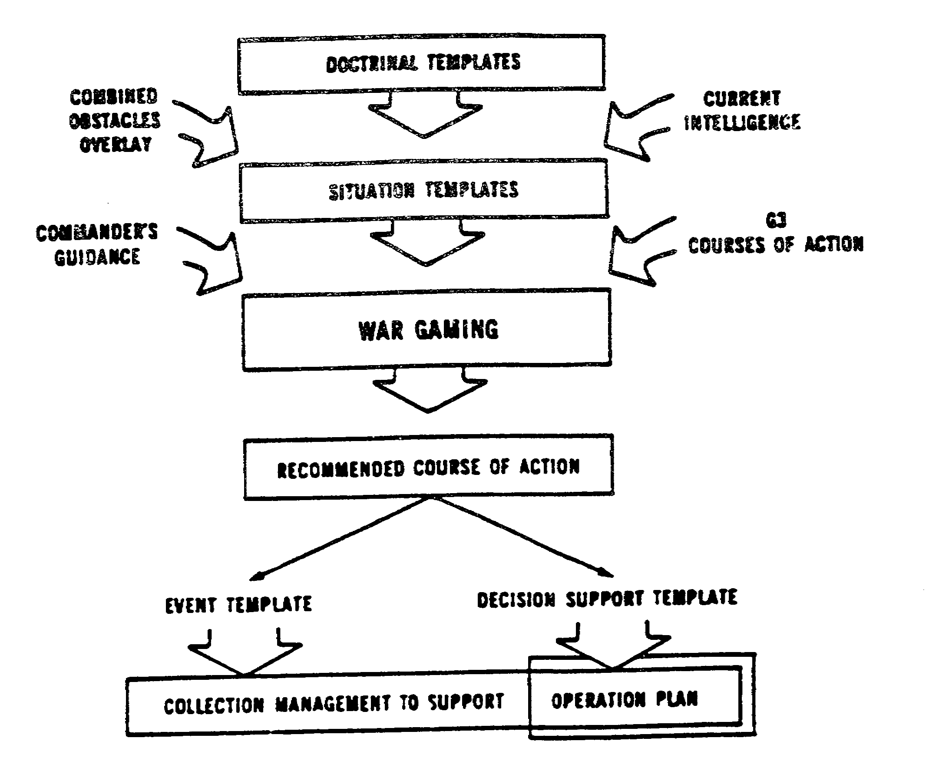

Figure 3-1. IPB and Tactical Decision-Making.

IT0432 3-4

o Second. --The commander and G3 or S3 must take an active role in the later stages of IPB.

o Third. --The G2 or S2 should provide the commander and staff with the full range of possible Threat courses of action, instead of trying to predict Threat COAs. The staff considers these Threat COAs when it wargames each friendly course of action. This procedure ensures that the event and decision support templates support the commander's plan.

Battle staffs wargame operations by visualizing the flow of upcoming battles. The entire staff participates; the G2 or S2 plays a pivotal role in this process by role-playing the Threat commander. If the G2 or S2 accurately portrays a thinking, aggressive, noncooperative Threat, then the battle staff is forced to plan for any eventuality on the battlefield.

The G2 or S2 can accomplish this vital task only if he has used the IPB process to develop situation templates that reflect the full range of options and actual courses of action (COAs) available to the Threat.

During staff wargaming a designated staff officer records the results of wargaming into a DST and BOS synchronization matrix. The results of wargaming and these products enable the battle staff to plan and execute operations that will accomplish the command's mission.

The G2 or S2 uses the results of wargaming to identify IR and recommend PIR. He also uses them to create a strategy for the unit collection effort. The intelligence synchronization matrix is the tool the G2 or S2 uses to link and synchronize this intelligence collection strategy with the expected flow of the operation.

Finally, the G2 or S2 builds a detailed collection plan from this matrix.

The checklist that follows shows common techniques that battle staffs can use to improve wargaming, especially from the intelligence perspective:

Prepare for wargaming

The G2 or S2 must bring situation templates to the wargaming session that accurately reflect the sets of Threat COAs that are available to the Threat.

The G3 or S3 will bring friendly COAs to the wargaming session. During the development of the COAs, the G2 or S2 should identify any friendly COA that will fail to defeat all Threat COAs.

The battle staff will prepare the wargaming location:

o If time is available, the staff should prepare a terrain model or target area replica. Ideally, the terrain model should be large enough for the entire staff to work within (for example, 50 by 50 feet).

o If time is limited, the staff can use a "blown-up" sketch map or cartoon that displays the area of interest (Al).

3-5 IT0432

o If time is severely constrained, the staff can wargame using a standard map.

o The G2 or S2 should ensure that the terrain model includes the current locations of Threat units, and can accommodate all the situation templates he intends to fight as he role-plays the Threat.

o The staff engineer and G3 or S3 should ensure that the model is accurate in terms of the terrain, friendly units, and friendly control measures.

Regardless of the type model or graphic used, it must encompass and display both the area of operation (AO) and Al.

The battle staff will identify a "recorder." This will often be an assistant staff officer, usually from operations or intelligence. As the battle staff wargames, the recorder will enter decisions made onto the BOS synchronization matrix and DST.

A "battle master" should be identified to referee and facilitate the wargaming session. This should either be the commander, a deputy commander, chief of staff, or XO. The battle master will identify the "rules" for wargaming. As a minimum, these should include--

o Echelons to be discussed. Usually this will be limited to the maneuver of units directly subordinate to the friendly and Threat commanders (two levels down).

o BOS to be discussed. The G2 or S2 will usually confine his discussion to the primary Threat BOS under consideration for each engagement. If time permits the rest of the battle staff may coordinate the effects of each friendly BOS throughout the battle.

o Method of wargaming. Common techniques are avenue-in-depth, belt, and box:

- Avenue-in-depth. -- This technique focuses on one avenue at a time starting with main effort. It is a good technique to use for offensive courses of action or in the defense where canalizing terrain exits.

- Belt. -- This technique divides the battlefield into areas that run the width of the sector. It analyzes the sub-component battles sequentially across the width of the sector. This is the preferred method as it ensures simultaneous consideration of all forces that could affect a particular event.

- Box. -- This technique is a microanalysis of a few critical areas, such as an engagement area, a river crossing site, or a flank avenue of approach into the sector. The area is isolated and the battle is focused in that terrain area. This technique is less time consuming and is used when time is extremely limited, such as in a hasty attack.

These techniques can be used separately or in combination. See FM 101-5 for a detailed discussion of these wargaming methods.

IT0432 3-6

o Recording technique. The most common technique used is the BOS synchronization matrix and the DST. A narrative visualization of the operation in sentence form or sketch note technique (wargame work sheet) can also be used.

o Criteria for discussion:

- As a minimum, the staff should agree to explore and pre-plan the decisions that their headquarters might have to make during battle. The staff should avoid the temptation to wargame decisions for subordinate or higher headquarters.

- If time permits, the staff may identify tasks to subordinate units which require synchronization that do not depend upon a decision during battle. These tasks will be executed regardless of the evolving situation but their nature may dictate their inclusion in the synchronization matrix.

o Time limits wargaming for each part of the battle. If time limits are not established, staffs often find that they plan one part of the battle in extraordinary detail at the expense of other areas.

The battle master might even consider limiting the amount of time each participant has to speak. In any event the staff should discipline itself to avoid long discussions.

Conduct Wargaming.

Whichever side (G2/S2 or G3/S3) has the initiative will begin the discussion by articulating the appropriate COA. For example, if a staff is planning a defense, the G2 or S2 will begin the wargaming session by talking through one of the Threat COAs for attack. He should start with either the most likely or most dangerous COA.

As the side with initiative describes his COA, the other side will interrupt, as appropriate, to describe reactions. The first priority for discussion should be to identify friendly responses and preemptions of Threat COAs. These are actions whose execution during battle depend upon a decision that will be made either by the commander or battle staff.

The G2 or S2 should ensure that the battle staff considers all Threat COAs and other options available to the Threat. In addition to the basic set of situation templates, the G2 or S2 should also describe the Threat actions that might prompt the execution of the following friendly decisions:

o Commit the reserve.

o Use attack helicopters or close air support (CAS).

o Artillery barrages against target area of interest (TAls).

o Family of scatterable mines (FASCAM) delivery.

o Shift the main effort.

3-7 IT0432

o Advance to the next phase of the operation.

o Change in overall mission.

o Request for higher headquarters assistance.

o Branches and sequels.

The G2 or S2 also describes the location and activities of Threat high value targets (HVTs). He highlights those points during the battle where these assets are of importance to the Threat's COA. This may prompt the staff to nominate these HVTs as high payoff targets (HPTs), making their engagement an integral part of the friendly COA.

The G2 or S2 should also look to the current set of PIR and IR as he determines which Threat actions to nominate for wargaming discussion. Sometimes the PIR and IR include important parts of the battle that the battle staff has temporarily forgotten. This is an especially important function since the PIR and IR that evolve from wargaming usually replace the old set in its entirety.

The battle master should ensure that all decisions identified are ones that his staff or commander will make during battle. Do not waste time wargaming the decisions of a higher or subordinate unit.

Record the Results of Wargaming

As each decision is identified, the recorder will enter it onto the DST and the BOS synchronization matrix. The priority elements that must be identified and recorded are:

o Decision criteria. Often this is the Threat action which will prompt the commander or battle staff to make the decision to engage a target or to execute a branch plan. Sometimes it is related to friendly force activity.

o Friendly action or response. This is the activity which the decision causes. It might be an engagement of HPTs in a deep strike or the execution of an on-order or be prepared mission by subordinate units.

o Decision Point (DP). This is the location where collection assets will look for indicators to verify or deny that the decision criteria (Threat action) has occurred. During wargaming, locations for DPs are selected that ensure that the decision to execute an operations or to engage a particular target occurs at the proper time. When placing DPs, consider time for:

- Intelligence collection.

- Processing and disseminating the intelligence to the commander or other decision-maker.

IT0432 3-8

- Preparation and movement time of friendly forces or assets that will execute the mission.

- Activities or movement of the target or Threat during the time elapsed between decision and execution.

o TAI. This is the location where the effects of friendly actions will be synchronized. This will often be an engagement area or a set of targets. The battle staff needs to ensure that the physical distance between a DP and its associated TAI allows for the time delays involved in collecting, processing, and communicating intelligence; the movement of Threat forces; and the time lines associated with friendly activities.

o HPT list. This is a list of Threat assets that are attacked as part of the friendly COA. The basis for HPTs is the list of HVTs that are included in each description of an Threat COA.

If time permits, the battle staff may discuss and record the synchronization of those friendly actions which will occur regardless of events on the battlefield. Examples of such events are--

o Cross the line of departure (LD) or line of contact (LC).

o Initiate preparatory fires.

o Shift preparatory fires.

If the interaction of anticipated friendly and Threat events is particularly complicated the staff might prepare a two-sided time line. This is a time line of Threat events matched against friendly events. An example of this is shown at Figure 3-2. This tool serves as a quick reference for planning the synchronization of effects in fluid and dynamic situations.

After the primary wargaming session distinct members of the battle staff may initiate specialized sessions for their functional areas. For example, the G4 or S4 may want to wargame logistics activities throughout the battle.

Conduct the Targeting Conference.

The fire support officer (FSO) almost always convenes a targeting session after the base wargaming session. The targeting conference further refines HPTs nominated during wargaming and the plans to engage them. During the targeting conference:

o The staff develops recommendations on how each HPT should be engaged.

o Using situation templates and other IPB products, the staff assesses the risk to friendly attacking assets.

o The G3 or S3 and FSO develop the attack guidance matrix (Figure 3-3).

3-9 IT0432

o The G2 or S2 identifies NAls that will locate and track HPTs and includes them on the event template (Figure 3-4).

o The G3 or S3 and FSO determine target damage assessment needs. The G2 or S2 includes these as IR to support the friendly COA and develops NAls that support them. These NAls, are often the TAI where the target is engaged.

Compare Friendly Courses of Action.

Following wargaming, the staff compares friendly COAs to identify the one that has the highest probability of success against the set of Threat COAs. Each staff officer uses his own criteria for comparing the friendly COAs in his own staff area of responsibility. The G2 or S2 compares them based on their ability to defeat the Threat's COA and their ability to support the command with the intelligence required to execute each friendly COA.

Led by the G3 or S3, each staff officer presents his findings to the remainder of the staff. Together they determine which friendly COA they will recommend to the commander. In the event they cannot reach a conclusion, the chief of staff or executive officer will determine which COA to recommend to the commander.

IT0432 3-10

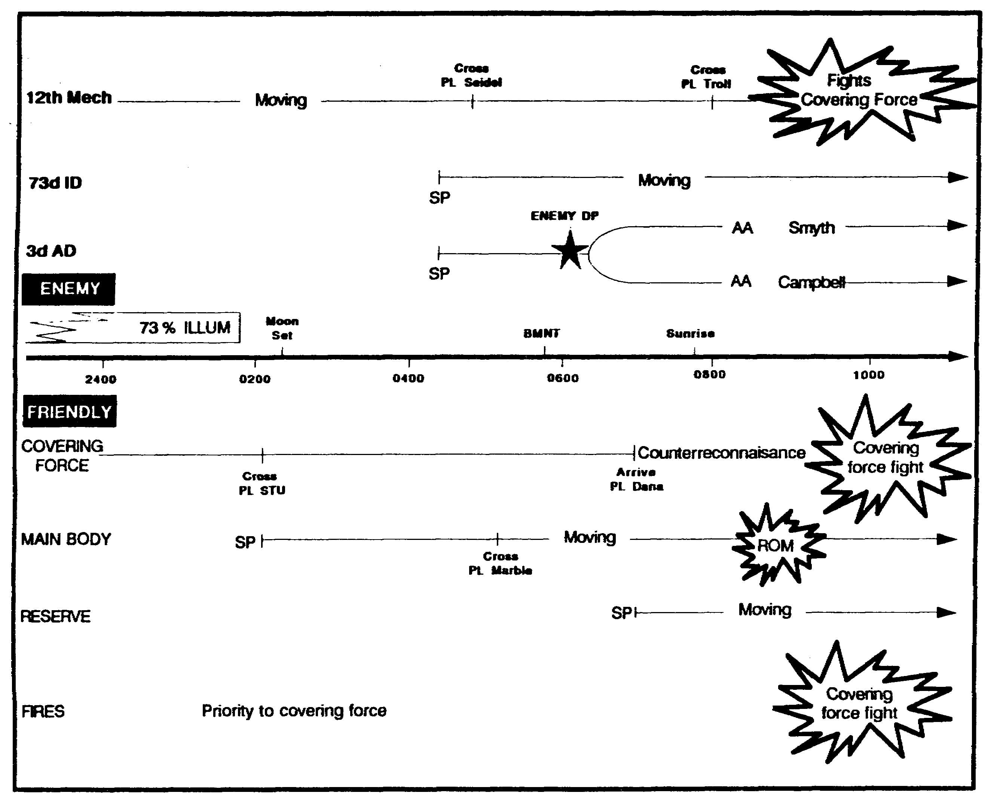

Figure 3-2. The two-sided time line.

3-11 IT0432

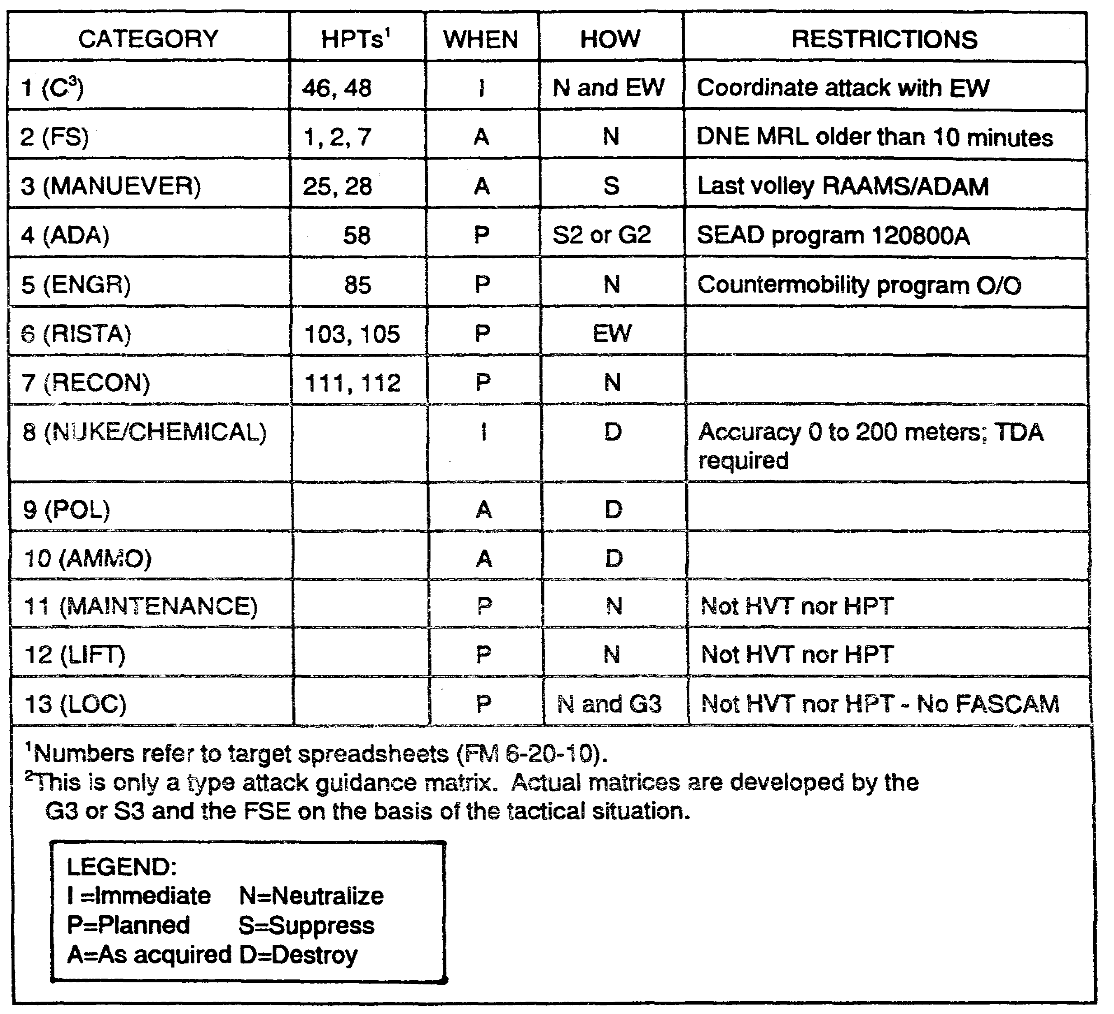

Figure 3-3. Attack Guidance Matrix.

IT0432 3-12

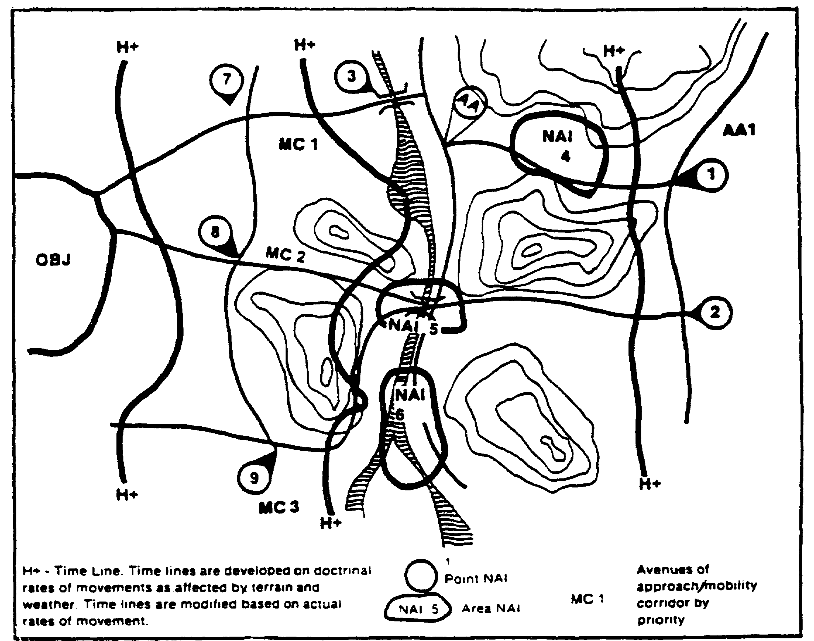

Figure 3-4. Event Template.

3-13 IT0432

PART E - DECISION AND EXECUTION

The staff presents its recommendation to the commander. The G3 or S3 briefs each COA, including its branches and sequels, using the results and records of wargaming such as the DST and BOS synchronization matrix. He highlights the advantages and disadvantages of each COA.

The commander decides upon a COA and announces his concept of the operation. Using the results of wargaming associated with the selected COA, the staff prepares plans and orders that implement the commander's decision.

Decisions made during wargaming form the basis for the "Be Prepared" and "On Order" tasks specified in OPORDs and FRAGOs. The decision criteria associated with each DP accompanies the task as it is written into paragraph 3 of the OPORD. For example: "ON ORDER TF Honabach will attack to destroy enemy forces vicinity OBJ HEAD. This order will be given if the 32d Division turns southwest onto HWY 34."

PART F -- PRIORITIZING INTELLIGENCE REQUIREMENTS.

The G2 or S2 normally discards the initial set of PIR and IR, replacing them with those developed during wargaming. Chances are that they will not be much different than the initial set unless some have been satisfied.

The G2 or S2 should designate the decision criteria for each DP as an IR. The IR should not be larger than the decision criteria. In other words, the G2 or S2 should resist the temptation of combining two decision criteria into one IR. He should also avoid adding additional requirements onto the IR. If the battle staff fully considered the G2 or S2s prompting during wargaming, additional information is unnecessary for the successful execution of the unit mission.

The G2 or S2 should prioritize the list of IR to reflect his recommended PIR and present it to the commander. The commander will designate several of the most important IR to become PIR. The remainder will remain as a prioritized list of IR.

The Intelligence Synchronization Matrix.

The intelligence synchronization matrix is the expanded intelligence portion of the BOS synchronization matrix. (Figure 3-5)

IT0432 3-14

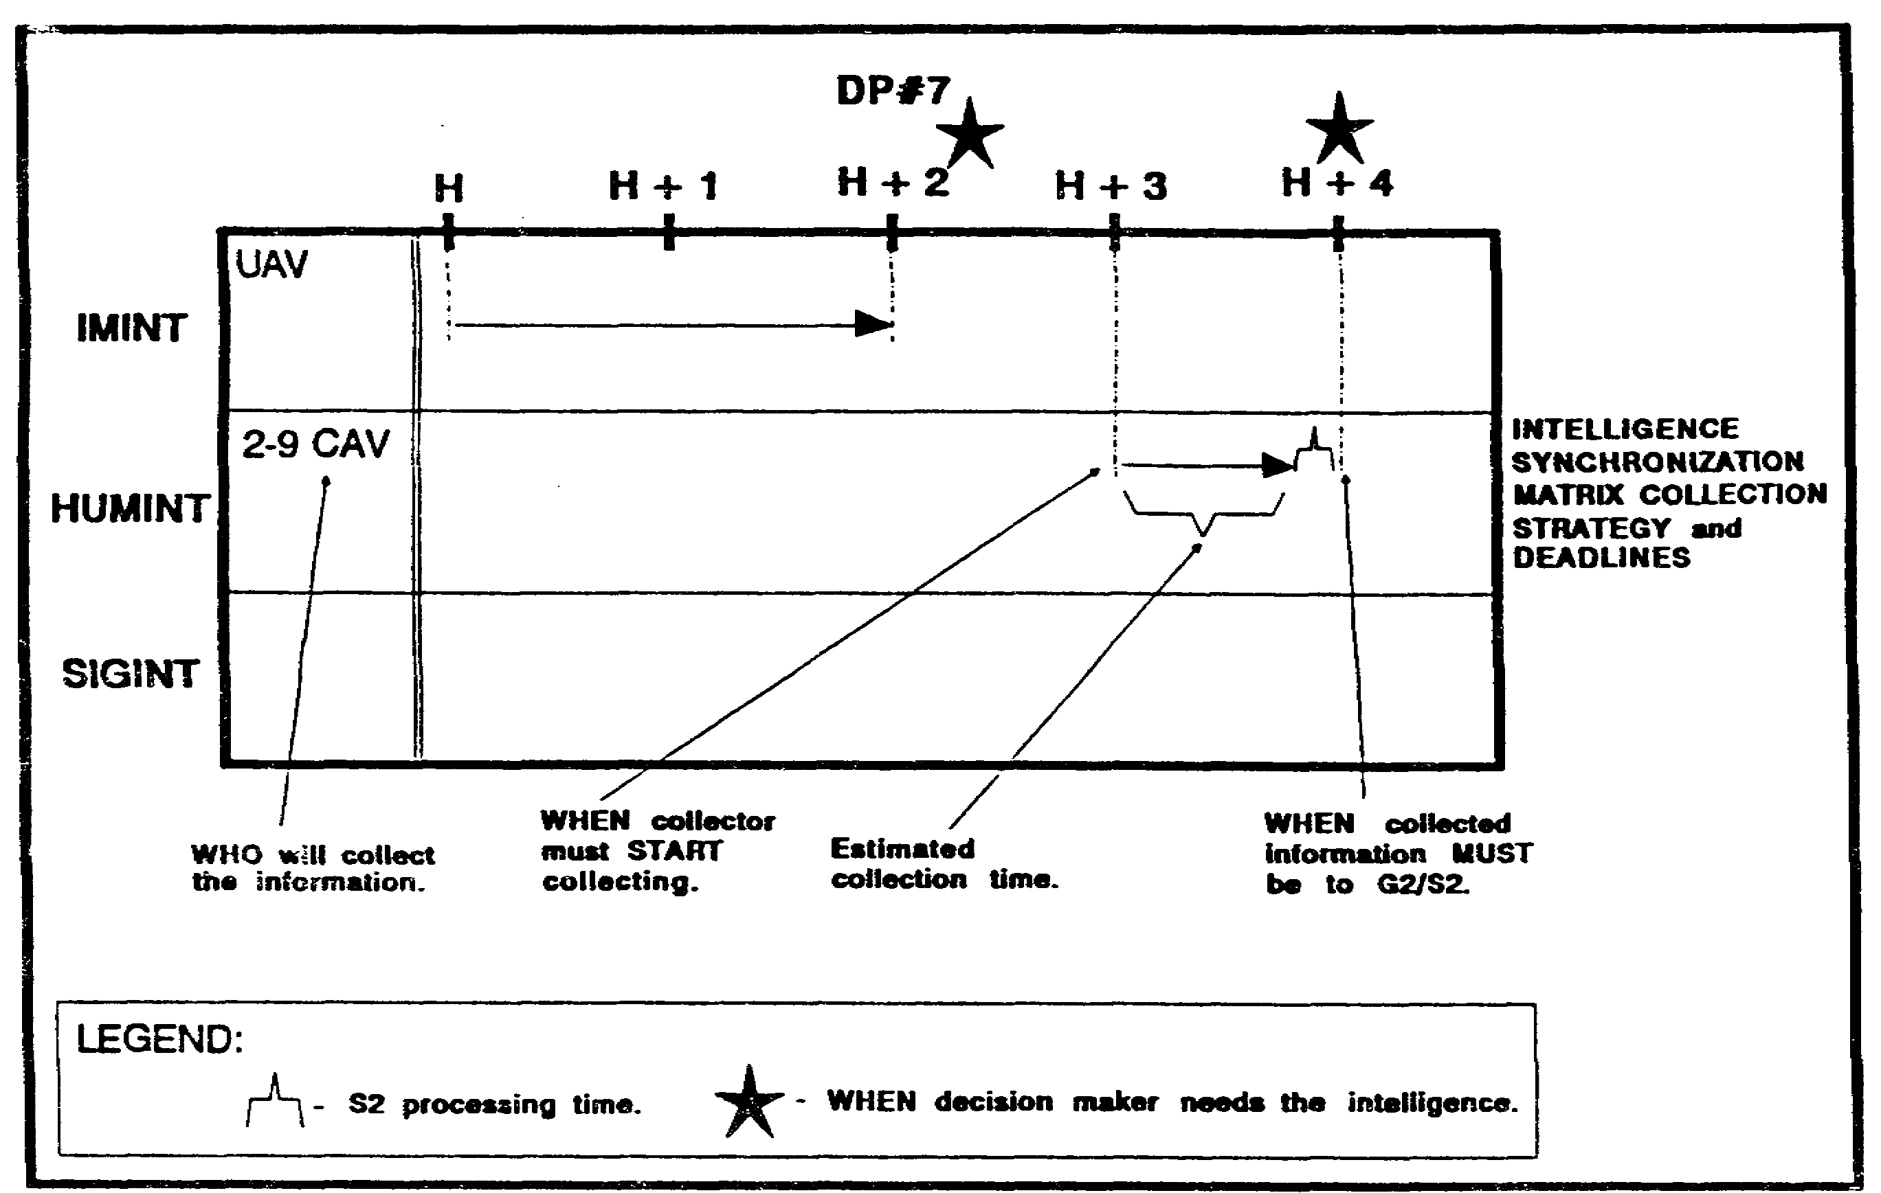

Figure 3-5. Intelligence Synchronization Matrix.

The G2 or S2 begins the intelligence synchronization matrix by establishing blank time lines for each collection asset that match the time lines on the BOS synchronization matrix.

The G2 or S2 then establishes the "deadlines" for each PIR and IR. This is easy to determine since each PIR or IR is exactly matched to the criteria to execute a decision identified in wargaming. They are recorded on the DST as decision points and will have at least an estimated time line associated with each one.

The S2 or collection manager then develops a collection strategy for each PIR and IR that will ensure it is answered on time. He considers--

o Tasking time lines associated with each collection system or discipline.

o Collection and processing time lines.

o Dissemination time lines.

o Type of target or activity collected against.

o Location of the NAI collected against.

o Time lines associated with the expected Threat activity.

3-15 IT0432

These strategies, which are designed not only to collect the intelligence but to deliver it on time, are then entered onto the intelligence synchronization matrix. The S2 or collection manager then develops a detailed collection plan using the intelligence synchronization matrix as the basic structure.

Execute the Battle.

As the G2 or S2 tracks the battle, he refers to the DST and BOS synchronization matrix to determine which decisions are becoming due.

He then looks at the intelligence synchronization matrix to determine which collection agencies owe combat information and intelligence which will enable that decision to be made in a timely manner. The G2 or S2 may have to re-prompt the collection asset to the upcoming PIR or IR. This is especially true if the course of the battle is occurring faster than anticipated.

As the collection assets report, the all source intelligence section (ASIS) conducts analysis to determine if decision criteria have been met. If not, the collection manger must retask the collector or the ASIS must make an educated guess based upon available information.

During dissemination, the collection manager refers to the DST and BOS synchronization matrix to identify all decision-makers which require the intelligence. See Lesson 4, for a detailed discussion on collection management operations.

PART G -- MINI-WARGAMING SESSIONS

Usually the battle does not flow the exact way the battle staff visualizes during wargaming. The staff compensates for this by conducting "mini-wargaming."

When any member of the staff identifies conditions which require revalidation or refinement of the plan, he initiates a mini-wargame. The G2 or S2 prompts mini-wargame sessions whenever he develops intelligence that runs counter to planning assumptions.

The G2 or S2 usually begins by discussing the current state of the common understanding of the battlefield:

o He reviews those IPB predictions that have been confirmed, denied, and are yet to be confirmed. These are usually Threat COAs but might also be assumptions about the terrain or other factors.

o He follows this with a full report of the unanticipated intelligence. This brief should emphasize the significance of the intelligence in terms of the Threat COAs that it indicates or fails to indicate.

The G2 or S2 should then present an informal, revised set of Threat COAs that allow for the new intelligence. This will often be the result of an abbreviated IPB process that may have been executed in a few minutes.

IT0432 3-16

If the new intelligence is too contrary to the original IPB, the commander may want to initiate a completely new planning session. Otherwise the personnel present at the mini-wargame will modify the current plan based upon the revised IPB. Battle staff personnel should follow an abbreviated form of the wargaming and intelligence synchronization techniques presented above.

The G3 or S3 will usually prepare a FRAGO to incorporate the new tasks to subordinate units. The G2 or S2 should use this opportunity to retask collection assets in accordance with the revised collection plan.

The staff should conduct numerous mini-wargame sessions during the course of an operation. A good technique is to pre-schedule mini-wargame sessions every 2 to 6 hours. The battle staff would then review he current situation and the "health" of its plan.

PART H -- EXAMPLE APPLICATION - IPB/WARGAMING

The following example shows how a G2 or S2 can use products from IPB and wargaming to synchronize intelligence as described above. It shows the process for two decisions only, but the same fundamentals apply for all decisions that arise from wargaming.

The same basic procedure applies equally well to the use of IPB and wargaming at all echelons.

Scenario.

The 2d Battalion, 9th Infantry (L), is conducting counterinsurgency operations in the country of Daemonia. The battalion has a large area of operations. From the brigade intelligence estimate, the S2 has learned that an insurgent company of regular infantry is expected to enter the battalion AO within 72 hours.

The S2 section initiates an abbreviated IPB process. Figure 3-6 shows a sketch map of the AO. The battalion situation templates highlight the following:

o Key facilities and targets overlay (potential targets for the insurgents).

o Infiltration and exfiltration routes.

o Likely base camps within the AO.

o Probable logistics, intelligence, and security activities within the AO.

To expedite the command estimate process, the commander selected a friendly COA immediately after mission analysis. The friendly plan includes two phases:

o Phase I: Establish platoon-sized ambushes along the 5 likely infiltration routes while conducting reconnaissance of the 1 i possible base camp areas.

o Phase II: Destroy the insurgent company in its base camp.

3-17 IT0432

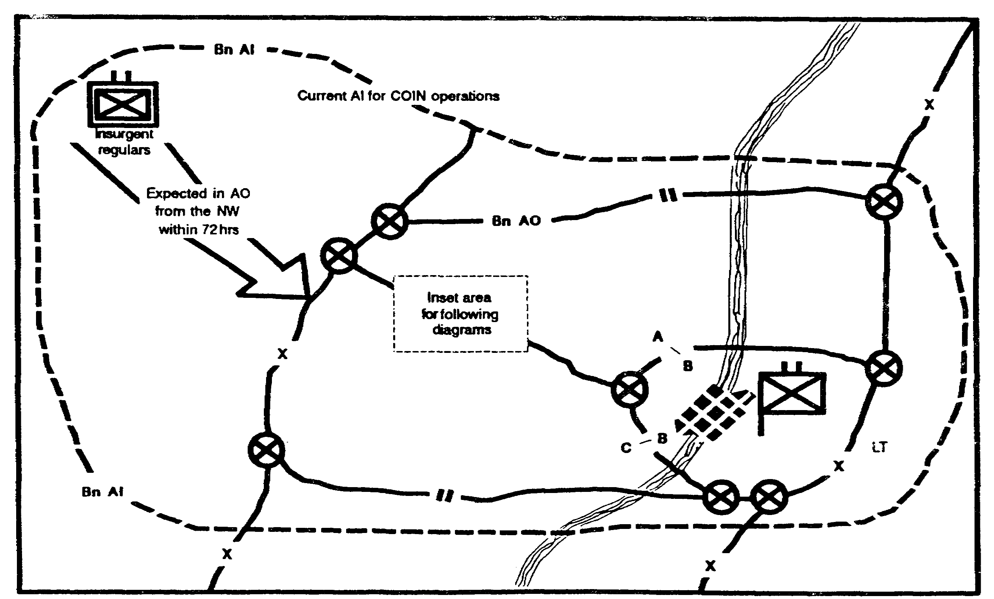

Figure 3-6. Area of Operations.

During both phases the battalion will accept risk at insurgent target areas identified on the trap map. The battalion will also retain a company (-) as a mobile reserve for the entire mission. The division has given (operational control [OPCON]) the battalion enough air assault assets to conduct immediate lift of one platoon for the duration of this mission.

The S2 has verified that this plan should succeed against all his situation templates.

Wargaming.

The examples shown below reflect only two of the decisions identified during the wargaming session. The actual DST and BOS synchronization matrix would show even more decisions.

Due to the large size of the AO and the limited number of critical areas, the S2 and S3 have decided to use the box technique of wargaming.

The wargaming begins with the S2s describing the situation templates for NAls 1, 2, and 3. These are three possible base camps that are located reasonably close. The S2 describes how each base camp would be physically arranged to include--

o Their warning system for attacks.

IT0432 3-18

o Defense and security system.

o Their evacuation and exfiltration procedures. Figure 3-7 shows a sketch map with NAIs and control features.

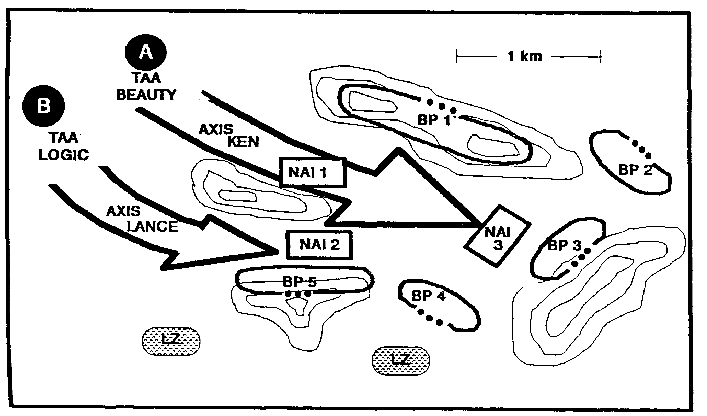

Figure 3-7. Named Areas of Interest.

Due to the proximity of the three base camps and other common features identified during IPB, the S3 decides to attack these base camps using the same set of control measures.

The staff synchronizes the following plan for this area of the phase II battlefield:

o When the insurgent company is located in any of these three NAls, A Company will immediately occupy TAA BEAUTY while B Company will immediately occupy TAA LOGIC.

o If the insurgents are in base camp 1 or 3:

- A Co receives 3d platoon of B Company.

- On Order C Company will conduct air assaults to occupy battle positions 3, 4, and 5 in order to block the southern and eastern evacuation routes.

- On Order B Company (-) will conduct air assault to occupy battle positions (BP) 1 and 2 in order to block the northern evacuation routes.

3-19 IT0432

- On Order A Company will conduct movement to contact along AXIS KEN as the battalion main effort to destroy insurgents vicinity OBJs NAI 1 or NAI 3.

o If the insurgents are in base camp 2:

- C Company receives 3d platoon of B Company.

- On Order A Company will occupy battle positions 1, 2, and 3 in order to block the northern and eastern evacuation routes.

- On Order B Company (-) will conduct air assault to occupy battle positions 4 and 5 in order to block the southern evacuation routes.

- On Order C Company will conduct movement to contact along AXIS LANCE as the battalion main effort to destroy insurgents vicinity OBJs NAI 2.

The battle staff then plans appropriate BOS support to each of these schemes of maneuver. While the staff synchronizes the concept of operations for this part of the battlefield, the recorder enters information into the DST and BOS synchronization matrix. For purposes of clarity he decides to combine the operations graphics and the DST. Figure 3-8 shows a diagram of terrain, DST, and control measures.

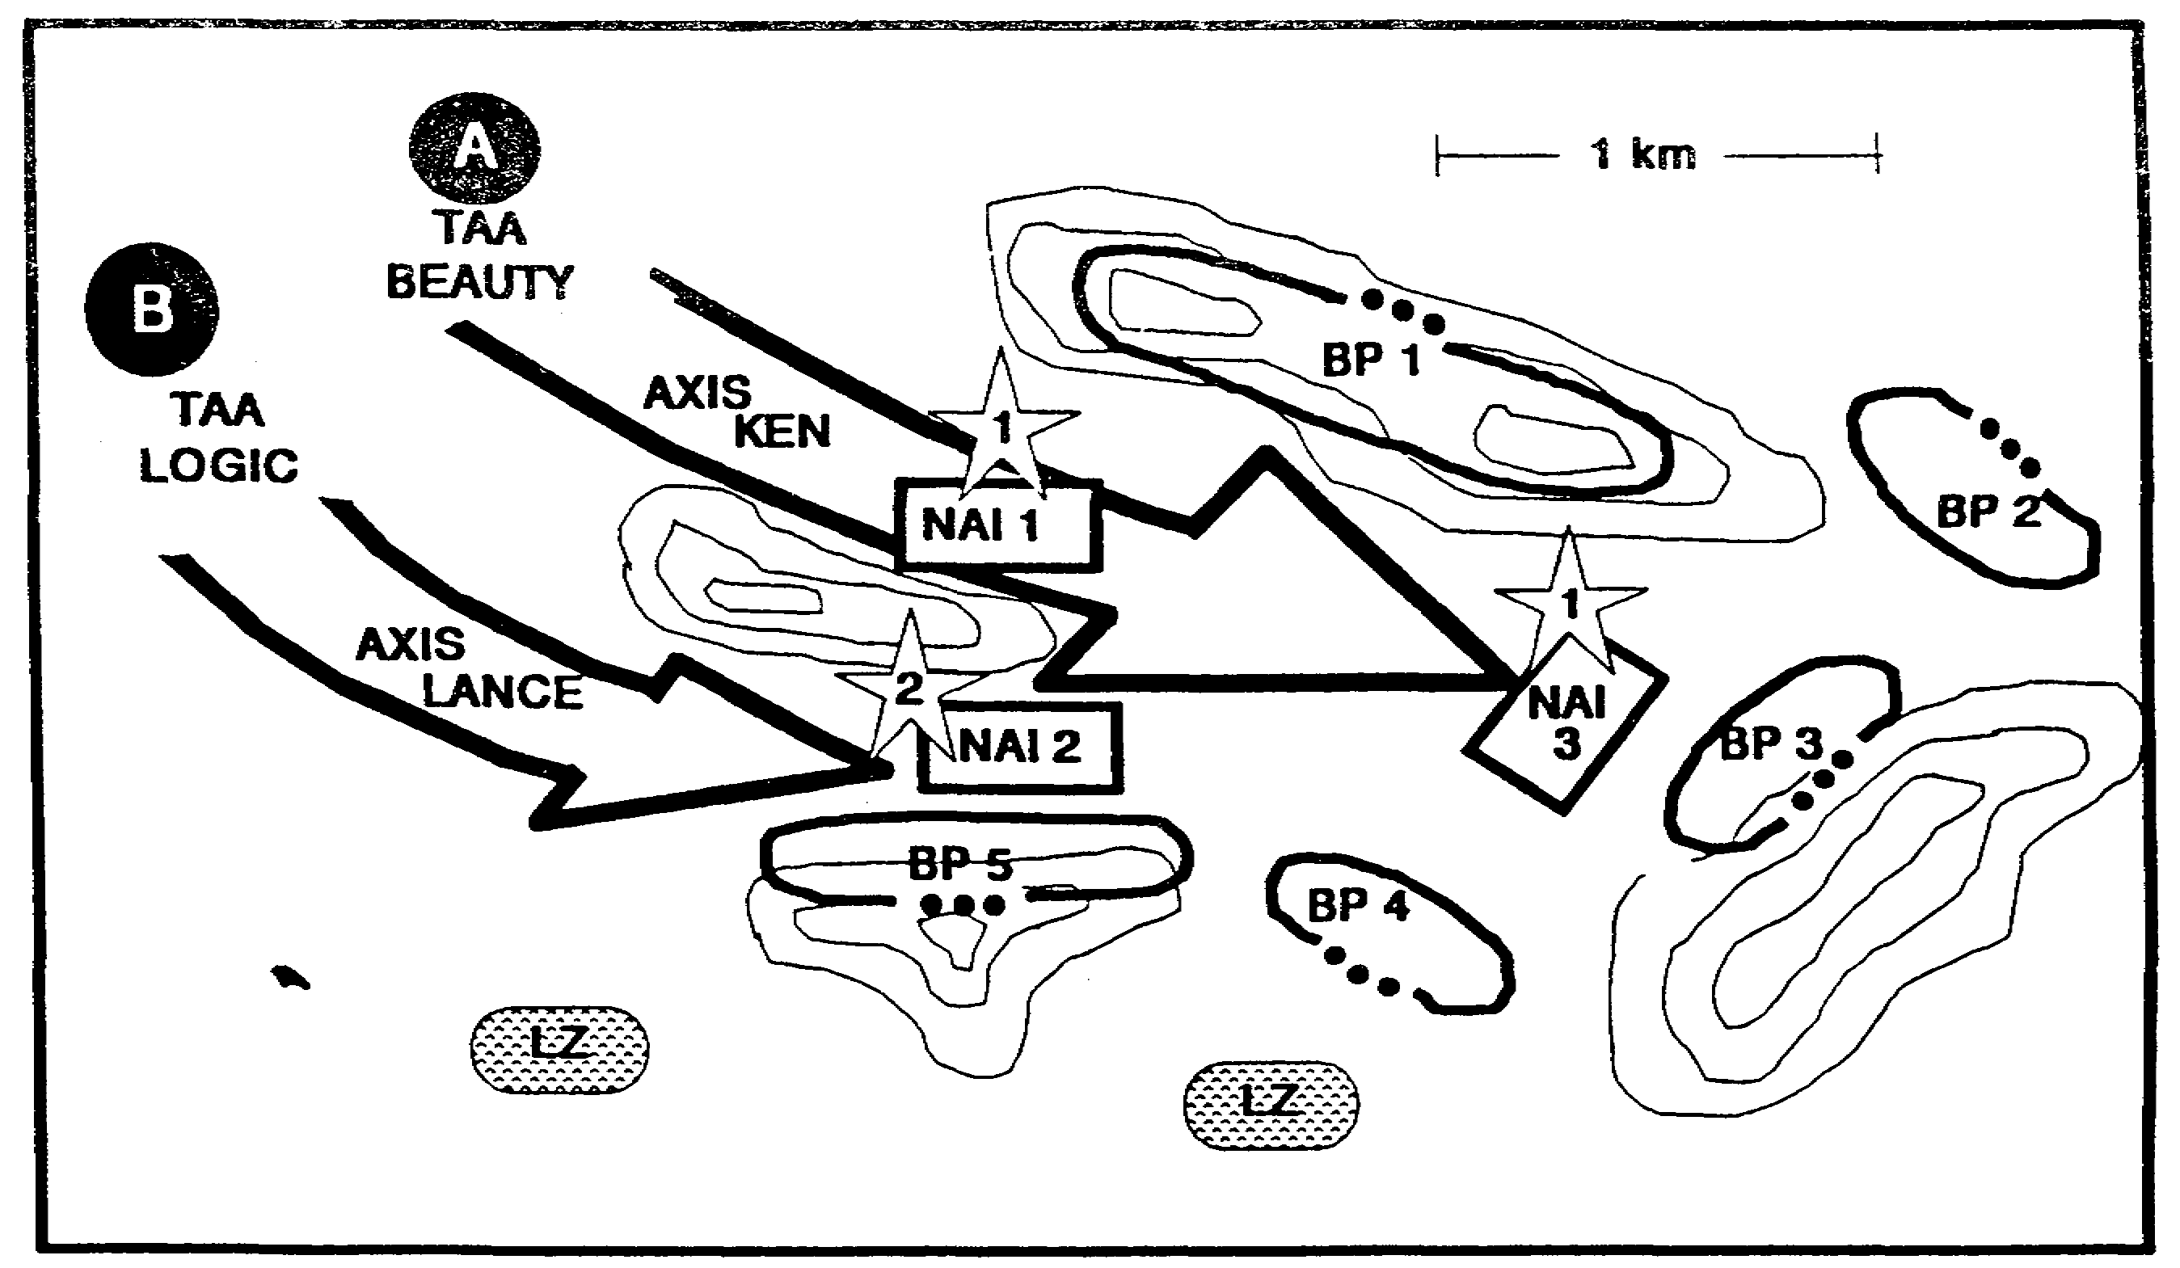

Figure 3-8. Decision Support Template.

After wargaming, the S2 translates all the decision criteria from the BOS synchronization matrix into IR. Figure 3-9 shows this matrix. As he prioritizes the list, he places IR numbers 1 and 2 at

IT0432 3-20

the top of the list as his recommended PIR. The commander agrees and the new PIR are--

o PIR 1: Has the insurgent company established a base camp in NAls 1 or 3?

o PIR 2: Has the insurgent company established a base camp in NAI 2?

While developing the collection strategy, the S2 decides to use the battalion scouts to answer PIR 1 and a patrol from B Company to answer PIR 2. The insurgent company is expected to occupy the base camp only for a limited time. Maneuver and operation security (OPSEC) constraints narrow the window even further. The S2 records all this information into his intelligence synchronization matrix shown at Figure 3-10.

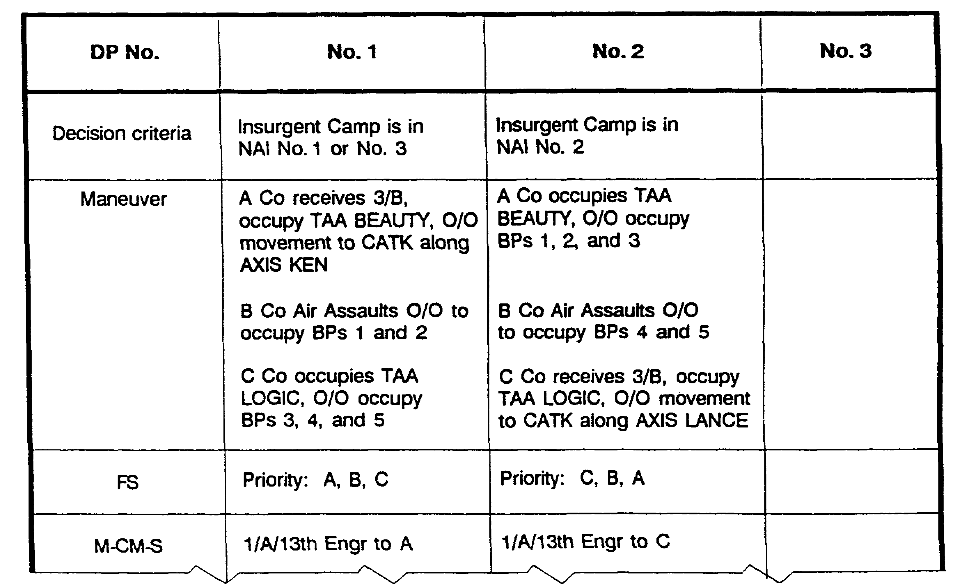

Figure 3-9. BOS Synchronization Matrix.

3-21 IT0432

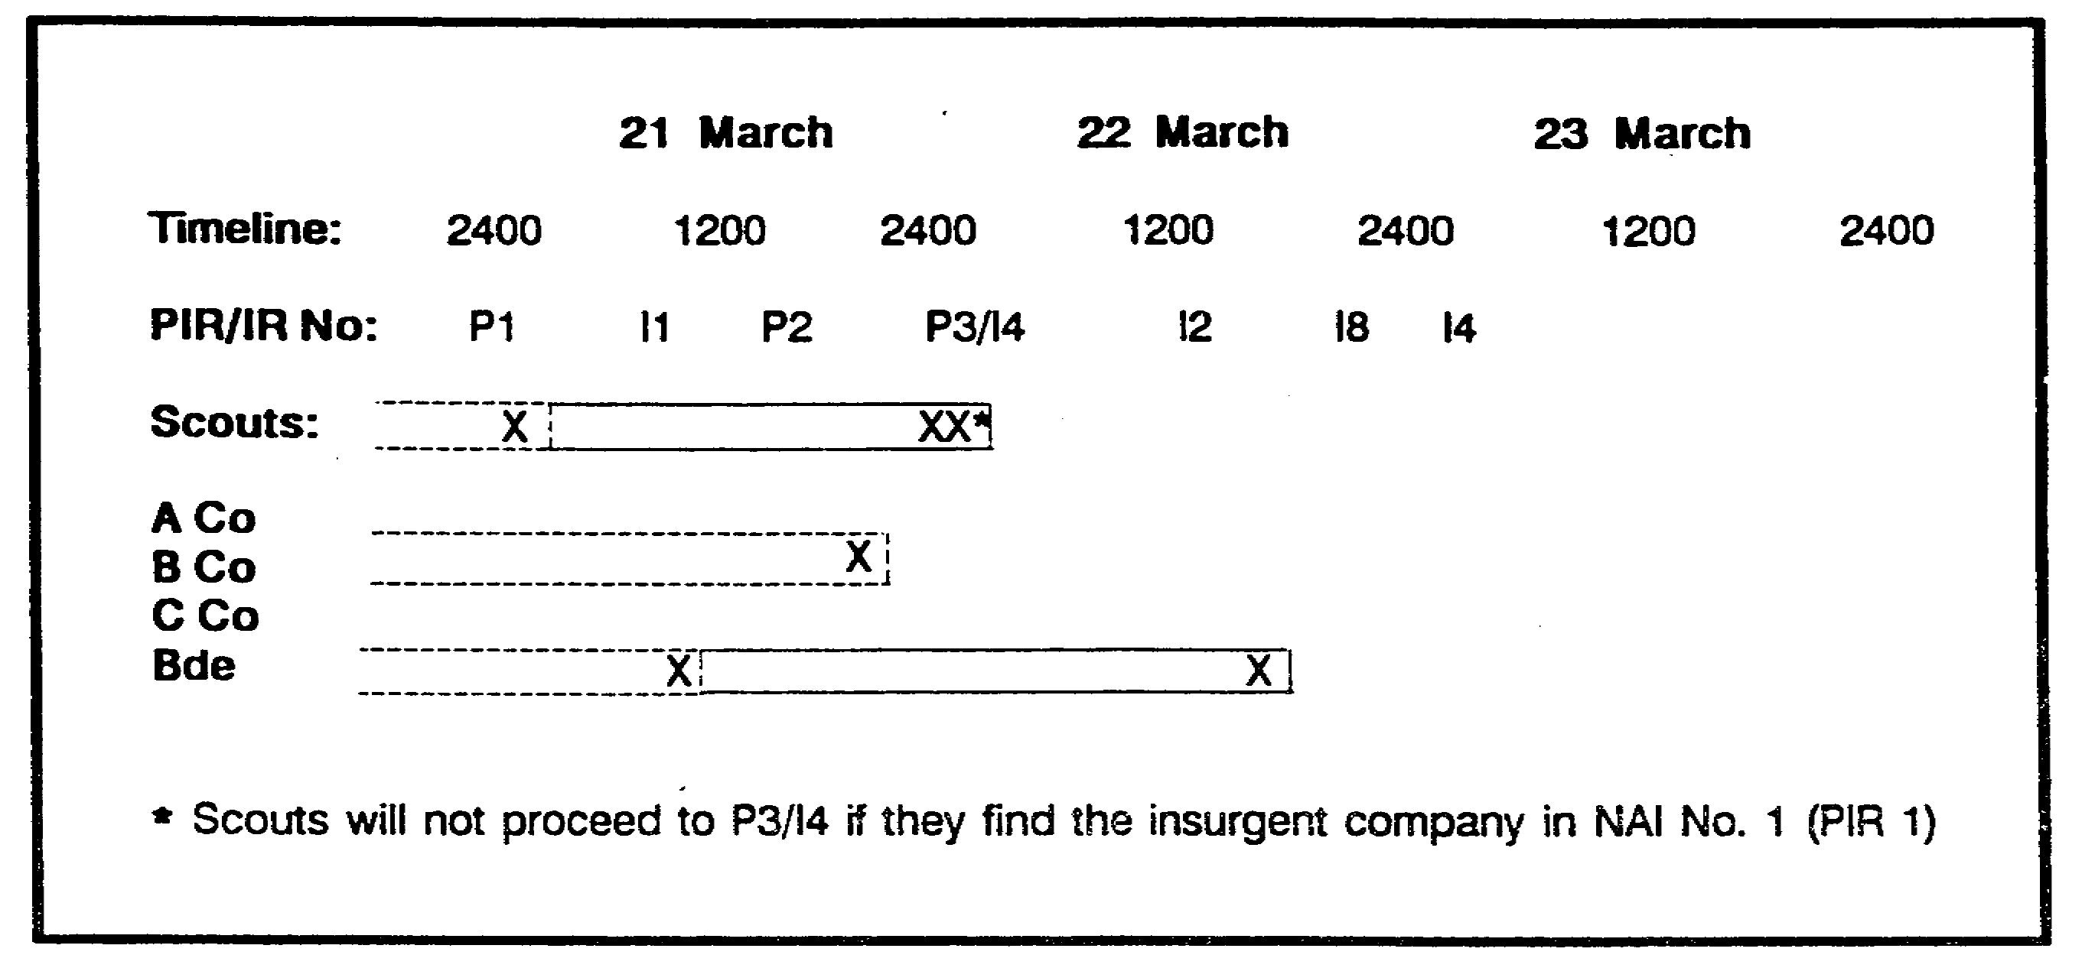

Figure 3-10. Intelligence Synchronization Matrix.

Execution.

Eleven hours after the battalion issued the OPORD, the scouts report significant insurgent activity in NAI 3, with no activity in NAls 1 or 2. Additionally, the scout platoon leader, who sat in on the wargaming session, reports that the hill selected for use as BP I is actually a cliff that would not support exfiltration lanes for insurgents. However, the gap vicinity BP 4 supports more escape lanes than one infantry platoon can block.

The S2 prompts a mini-wargame session where he presents the new intelligence. The commander and S3 decide to modify the original plan as follows:

- B Company will occupy BPs 1,2, and 3.

- C Company will occupy BPs 4 and 5 only.

The S3 issues the appropriate FRAGO, and the S2 retasks the scout platoon to better identify the guerrillas' early warning and defense system.

The synchronization that occurs during battle staff wargaming drastically multiplies the combat effectiveness of a unit. To make wargaming work, the G2 or S2 needs to force the staff to consider the full set of COAs available to the Threat. The G2 or S2 develops these Threat COAs during the IPB process.

During wargaming the staff plans responses or preemptive actions to deal with Threat actions. The G2 or S2 uses the records and products of wargaming, such as the DST and BOS synchronization matrix, to structure the unit collection effort to deliver the intelligence that the decision-makers need at the times they need it. He does this through the use of PIR, IR, and the synchronization of intelligence.

IT0432 3-22

As collection assets report, the G2 or S2 prompts mini-wargame sessions so that the staff can react quickly to the evolving situation.

As intelligence confirms or denies planning assumptions, a continuous IPB process identifies new PIR. As the battle progresses, IPB is used to reevaluate the situation facing the command; it continues to drive the command estimate process and the directing step of the intelligence cycle.

3-23 IT0432

LESSON 3

PRACTICE EXERCISE

The following items will test your grasp of the material covered in this lesson. There is only one correct answer for each item. When you complete the exercise, check your answer with the answer key that follows. If you answer any item incorrectly, study that part of the lesson which contains the portion involved.

1. What step of the command estimate process requires an analysis of relative force ratios?

A. Analyze Courses of Action.

B. Decision.

C. Course of Action Development.

D. Mission Analysis.

2. Which of the following should be used as the criteria for developing the Information Requirements (IR) ?

A. Time Phase Line.

B. Named Area of Interest.

C. Target Area of Interest.

D. Decision Point.

3. Which of the following describes the Belt wargaming method?

A. Focusing on one avenue of approach starting with the main effort.

B. Analyzing the sub-component battles sequentially across the width of the sector.

C. Microanalysis of a few critical areas.

D. Synchronization of friendly forces or assets.

IT0432 3-24

LESSON 3

PRACTICE EXERCISE

ANSWER KEY AND FEEDBACK

Item Correct Answer and Feedback

1. C. Course of Action Development. Page 3-3.

2. D. Decision Point. Page 3-18.

3. B. Analyzing the sub-component battles sequentially across the width of the sector. - Page 3-6.

IT0432 3-26

LESSON 4

DIRECT COLLECTION MANAGEMENT OPERATIONS

Critical Tasks: 301-372-2150
301-372-3005
301-372-3018
301-372-3101
301-372-3208
301-372-3651

OVERVIEW

LESSON DESCRIPTION:

In this lesson you will learn how to direct collection management operations.

TERMINAL LEARNING OBJECTIVE:

ACTIONS: Develop a collection plan. Identify unit intelligence gaps, update the collection plan and initiate taskings.

CONDITIONS: You will be given narrative information and illustrations from FM 34-2, FM 34-8, FM 34-10, and FM 34-130.

STANDARDS: Direct collection management operations in accordance with FM 34-2.

REFERENCES: The material contained in this lesson was derived from the following publications:

FM 34-2
FM 34-8
FM 34-10
FM 34-130

INTRODUCTION

The primary purpose of collection management is to answer the commander's intelligence requirements. The secondary purpose is to answer intelligence requirements of other intelligence users.

These requirements generally focus on intelligence required to prevent surprise, support. planning, support decisions during execution of a friendly course of action, and engage high payoff targets in support of that course of action. They are products of the command estimate and targeting process.

Collection management satisfies these requirements by synchronizing the activities of intelligence collectors and processors with the command's operations. Collection management

4-1 IT0432

is the Intelligence System of Systems (ISOS) procedure that orchestrates organizations and systems to focus the intelligence effort in support of war fighting and stability and support operations.

As an intelligence officer, you will have the opportunity to work as a unit's S2 or collection management officer. This lesson plan provides you with the knowledge of the basic fundamentals of collection management functions, principles and procedures. This will aid you in understanding the complexities of intelligence collection management and assist in directing collection management operations.

PART A - COLLECTION MANAGEMENT FUNCTIONS

Collection management (CM) is accomplished through the execution of three distinct functions:

o Requirements Management (RM).
o Mission Management (MM).
o Asset Management (AM).

These subfunctions are used to distinguish between internal and external relationships among managers, requestors, and collectors during CM operations. Requestor-manager interface occurs during requirements management when intelligence questions are first asked and eventually answered. Mission management assigns the intelligence question to the best available collection unit or agency. Direct manager-collector interface occurs during asset management, the result of which is the actual answer to a question.

Requirements Management.

Requirements management defines what, when, and where to collect. During the staff wargaming process initial intelligence requirements are developed. This includes both priority intelligence requirements (PIR) and information requirements (IR). These intelligence requirements are continuously update based upon collection results and changes to the operational concept.

RM involves a deliberate review process which screens requests for intelligence information (RII) and intelligence acquisition tasks (IAT) for pertinence, feasibility, and completeness. The established data base is searched for available answers before issuing a new collection requirement. RM prioritizes valid intelligence requirements for collection and refines them into specific information requirements (SIR). Effective RM results in a "what" that is clear, concise, and collectable.

Correlating intelligence reporting to the original requirement and evaluating that reporting are key subfunctions of RM. This is the quality control effort that helps ensure timely satisfaction of PIR/IR. RM includes dissemination of reporting and related information to original requestors and other users. Creation and update of the collection plan is a shared responsibility between the function of requirements management and mission management.

IT0432 4-2

Mission Management.

Mission management defines how to employ collection resources to satisfy requirements. The suitability of systems, units, and agencies are evaluated based upon capability and availability.

MM maps out the collection strategy, synchronizing collection schedules to PIR and deriving specific orders and requests (SOR) from SIR. This strategy is captured in the collection plan. MM generates the actual task/request media and continually monitors resource readiness and performance.

The proliferation of intelligence processing equipment at echelons corps and below (ECB) affords the combat commander access to deep collection capabilities owned and operated at theater and national levels. The existence of these sophisticated "receivers" adds another dimension to MM: exploitation management. We now have the capability to capitalize on existing collection strategies, hoping to satisfy our intelligence requirements without employing another resource. Our ability to effectively manage exploitation implements the ISOS concept of "push/pull echelonment".

Asset Management.

Asset management executes collection and/or exploitation in accordance with collection plan requirements and tasking. For example, AM involves the resource-specific planning required to launch an aerial exploitation battalion (AEB) mission or emplace Long Range Surveillance (LRS) teams. Unit commanders conduct asset management of assigned resources; therefore, the doctrine governing this CM function and its process is resident in the various echelon operations manuals. Some examples include FM 34-10, FM 34-25, FM 34-37, and FM 34-80.

PART B - COLLECTION MANAGEMENT AND
INTELLIGENCE SYNCHRONIZATION

Intelligence synchronization is the process that ensures the intelligence system provides answers to PIR and IR in time to influence the decision they support. Synchronization begins with the command estimate and targeting processes. Taken together these processes identify the decisions that accompany a course of action and its branches and sequels. These decisions drive the command's intelligence requirements. Every identified decision should be supported by an intelligence requirement.

Other commands as well as subordinate units develop their intelligence requirements through the same process. They communicate these to the collection manager in the form of intelligence acquisition tasks or requests for intelligence (RI). Hence, the collection manager should be able to link every intelligence requirement he receives to a decision.

Synchronization continues during the collection management process. The collection manager uses the products of intelligence preparation of the battlefield (IPB), the command estimate process, and the targeting process to develop SOR sets. These sets synchronize the activities of collectors with the command's decision points. The collection manager ensures that all requirements are fully supported by a set of SOR and that the collection and reporting time lines will delivers intelligence in time to influence each decision.

4-3 IT0432

During execution, the collection manager follow up and monitors the collection effort and reporting to ensure synchronization. As needed, he prompts collectors to meet time lines, cross cueing and retasking as necessary to keep intelligence synchronized with the command's operations.

Collection Manager's Role.

As the link between the command's intelligence requirements and the collectors that satisfy them, the collection manager is the key to intelligence synchronization. The collection manager checks to ensure that all decisions identified during course of action (COA) development are supported one for one by intelligence requirements. This usually involves coordination with the planning staff or the All Source Intelligence Section (ASIS).

The collection manager uses the tools developed during wargaming to develop and evaluate collection strategies against each identified information requirement. He ensures that intelligence collection is capable of supporting each friendly course of action. He develops and depicts these strategies for each potential friendly COA using his own synchronization tools -the intelligence synchronization matrix and the collection plan. He then manages the CM process to ensure:

o collection supports all PIR and IR.

o all SOR support some PIR or IR.

o collection strategies are properly "backwards planned."

o collectors execute the strategies within the time lines each PIR and IR requires.

Successful synchronization results in the command's mission accomplishment. Failure to synchronize results in:

o decisions made without the benefit of intelligence.

o collection against PIR or IR that are no longer valid.

o collection of intelligence that will not influence the course of action.

o under or over used collection systems.

PART C - COLLECTION MANAGEMENT PROCESS

The CM process is cyclic in nature. In other words, as the collection manager uses the process to satisfy some intelligence requirements, he will simultaneously use it to generate new requirements or reprioritize existing ones. The overall process basically consists of five steps:

o Receives and Analyze Requirements (Develop Requirements).

o Determine Resource Availability and Capability (Develop Collection Plan).

IT0432 4-4

o Task or Request Tasking of Resources.

o Evaluate Reporting.

o Update Collection Planning.

Each step of the CM process consists of a series of judgement decisions. Taken together they form the "how to" of collection management. In outline form these judgement decisions are:

Develop Requirements:

o Participate in Staff Wargaming.
o Analyze Requirements:
- record.
- validate.
- consolidate.
- prioritize.
o Develop SIR sets.

Develop Collection Plan:

o Evaluate resources.
o Develop collection strategy:
- select resources.
- synchronize collection to requirements.
o Develop SOR sets.
o Prioritize SORs for collection assets.

Task or Request Tasking of Resources:

o Determined tasking/request mechanism.
o Execute/implement.
o Collect and exploit.

Evaluate Reporting:

o Determine perishability.
o Correlate reports to requirements.
o Screen reports.
o Provide feedback to collectors and exploiters.

Update Collection Plan:

o Eliminate satisfied requirements.
o Redirect assets to unsatisfied requirements.
o Cue assets to collection opportunities.
o Maintain synchronization.
o Add new requirements.

4-5 IT0432

Doctrinal Procedure:

This procedural thought process is used regardless of echelon, type operation, or time available. However, circumstances will dictate the nature and amount of detail that will be developed. For example, a collection management section at the corps level might take several days to execute all of the procedures to produce:

o An intelligence synchronization matrix.
o A number of asset evaluation work sheets.
o A detailed collection plan reflecting several hundred specific orders or requests (SORs).

During an accelerated staff planning process an experienced Bn S2 may take five minutes to execute the exact same set of procedures. He then hands the event template and a simple R&S tasking matrix to his scout platoon leader. He also asks for a copy of the platoon leader's plan to incorporate into the battalion R&S overlay.

PART D - DEVELOP REQUIREMENTS

Developing requirements is the identification, prioritization, and refinement of uncertainties concerning the Threat and the battlefield environment that a command must resolve to accomplish its mission. The desired end result is a prioritized list of exactly WHAT needs to be collected, precisely WHERE it needs to be collected, and WHEN it needs to be collected and reported. This prioritized list of intelligence requirements is crucial to a unit's capability to conduct operations as planned.

Participate in Staff Wargaming:

A CM representative (normally the requirements manager) should participate in wargaming sessions. The CM representative determines whether the normally available collection assets can acquire the appropriate intelligence in a timely manner. If not, wargamers must plan contingencies around the predicted lack of intelligence.

By sitting in on the wargaming the CM will better be able to evaluate the relevance of incoming reports later in the CM process. The CM will also be able to develop collection strategies with higher reliability. The CM will also better understand the commander's intent and concept of operation. This will enable the CM to respond faster to changes in operational priorities during battle.

Participating in staff wargaming allows the collection manager to fully integrate the CM process into the command estimate process. As a result, he is better able to synchronize the command's collection operations with the remainder of its operations.

Analyze Requirements:

To ensure the most effective use of collection assets, the RM first analyzes each requirement he receives to determine how best to satisfy it. Sometimes this does not require collection activity. Often, a newly received requirement can be satisfied by intelligence in he database or

IT0432 4-6

it duplicates one that has already been processed. The RM uses the following steps to ensure that each requirement is satisfied in the most efficient manner:

o Record Requirements: In addition to the set of intelligence requirements produced during wargaming the RM will receive intelligence requirements from:

- higher headquarters, in the form of specific orders.

- subordinate and adjacent units, in the form of specific requests for intelligence.

In order to track these requirements, along with those of his own command, the RM records each requirement as he receives it. He uses this record to trace each requirement from its receipt to its eventual satisfaction.

o Validate Requirements: After beginning an audit trail by recording each requirement, the RM validates requirements by considering feasibility. When a request is not feasible the RM returns it with an explanation of why the request cannot be satisfied. He also coordinates with the requestor to establish possible alternatives that might satisfy the requestor's needs.

- Check for Completeness: All requirements should specify:

WHAT (activity or indicator))
WHERE (named area of interest)
WHEN (time that the indicator is expected to occur and latest time information of value)
WHY (justification)
WHO (who needs the results)

o Consolidate Requirements: Since the RM receives requirements from several different commands, he will often receive requirements which are similar to those previously received. In particular, the specific request for intelligence from subordinate units often duplicate the intelligence requirements of their parent command. The RM simplifies the collection effort by merging similar requirements. He will usually replace the more poorly written requirement with the wording of the better justified or more specific requirement.

However, the RM must exercise caution to ensure that in merging requirements he does not lose the intent of either of the original requirements. The RM must also ensure that when merging requirements he does not lose accountability of the replaced requirement. In other words, the RM's audit trail must allow him to match the satisfied requirement against all requests for that intelligence; ensuring dissemination to every requesting headquarters when the requirement is satisfied.

o Prioritize Requirements: After consolidation the RM will have a composite list of IRs, RIIs, and IATs. Some of these requirements are more important to mission success than others. Therefore, the RM prioritizes the list. This prioritization enables the MM

4-7 IT0432

to focus assets on the most important requirements, while economizing assets for less significant areas.

After the RM prioritizes this list, the commander designates some of the most important requirements as priority intelligence requirements, or PIRs. By doing so the commander declares that the answer to the PIR is mission essential. In other words, failure to answer the PIR endangers the command's mission accomplishment. The PIR are themselves also arranged in priority order. For maximum effectiveness the commander and CM should refine the PIRs to very specific questions that are linked to operational decisions.

Develop SIR Sets.

A specific information requirement (SIR) describes what information is required, where it is to be obtained, and when it is to be-obtained and reported in as much detail as possible. To support mission management and the development of SORs the RM develops sets of SIRs for each requirement.

Ideally, each intelligence requirement will contain all the information the RM needs to develop supporting SIR. In such cases, the intelligence requirement states the "where" and "when" to collect; the RM need only refine the "what to collect" into specific items of information.

For those requirements that still require SIR refinement, acquire the supporting IPB products from the requesting agency. This should include situation template, the event template, and the event matrix.

The event matrix shows the Threat activities, or indicators to look for in each NAI. The event template shows the actual location of each NAI as well as the time phase lines which give an idea of the times that the NAls should be observed for indicators. Identify the NAls, indicators, and time associated with each requirement.

Coordinate with the MM to get a "feel" for the types of SIRs and exact specificity required to support his planning. A technique is to develop SIR sets while the MM is developing the collection strategy for each requirement.

Identify indicators that complement and reinforce the primary indicators you are working with. Ensure that all indicators either confirm or deny the enemy courses of action you're interested in. A useful analogy from IPB is to consider indicators as doctrinal templates, and SIRs as situation templates. In other words, the indicators describe the generic activity, while the SIR shows that indicator applied to the current situation. An example of a final SIR might be "SIR 2.12.7: Are there QUASIT data signals active in NAI 12 between 041200 and 060200 March? Latest Time Information of Value (LTIOV): 060400 March."

Indicators and SIRs are analytical tools. Ensure that when the collector satisfies the SIR, the analyst will have information that truly does indicate enemy actions that will solve the original requirement.

IT0432 4-8

PART E - DEVELOP COLLECTION PLAN

A collection plan is the integrated and synchronized end product of selecting the most capable organic or supporting collectors to cover clearly stated and prioritized requirements. It is also the graphic representation of your collection strategy. This is the first step in the CM process that involves Mission Management. The desired end effect is a collection strategy and employment scheme that will effectively answer the command's PIR and IR.

Evaluate Resources.

Mission management takes prioritized requirements and begins matching them with suitable collection and exploitation assets using the following criteria:

o Availability: Knowing the collectors and processors you own or can access is an important first step during collection planning. You determine higher echelon and other service asset availability by reviewing various scheduling mechanisms. Human Intelligence (HUMINT) assets are not tied to traditional "schedules"; their availability is linked to geographic access, support relationships, work load, etc.

o Capability: This criteria is fairly straight forward with electronic collection and exploitation systems. Capability includes range (both actual distance and electromagnetic spectrum), day/night effectiveness, technical characteristics, reporting timeliness, geolocational accuracy, etc. Determining HUMINT collector capability is often a very subjective process. Access to the target and reporting timeliness may be key qualifiers. A tool that can help work through the capability evaluation is the asset evaluation work sheet at Figure 4-1.

o Performance History: An experienced collection manager knows the "work horses" upon which he relies to meet the commander's intelligence requirements. Readiness rates, responsiveness, and accuracy over time may raise one collector's reliability quotient. Certain sensors require confirmation, especially if targeting is an issue. If experience shows that a system is often unavailable because of local weather patterns, the experienced collection manager considers this in evaluating the system's performance history; perhaps leading to the selection of an alternate system.

A viable HUMINT resource are the Long Range Surveillance (LRS) Teams organic to the Tactical Exploitation Battalion at corps (these teams are also assigned to the MI Battalion of airborne and air assault divisions). These LRS teams collect combat information through the surveillance of specified Named Area of Interest (NAls). LRS units provide the capability to gather accurate and timely information that does not require lengthy processing and analysis. In addition to surveillance on NAls, the teams can support Battle Damage Assessment and determining the locations of high payoff targets.

When evaluating LRS teams capability to answer intelligence requirements, the following factors should be considered--

4-9 IT0432

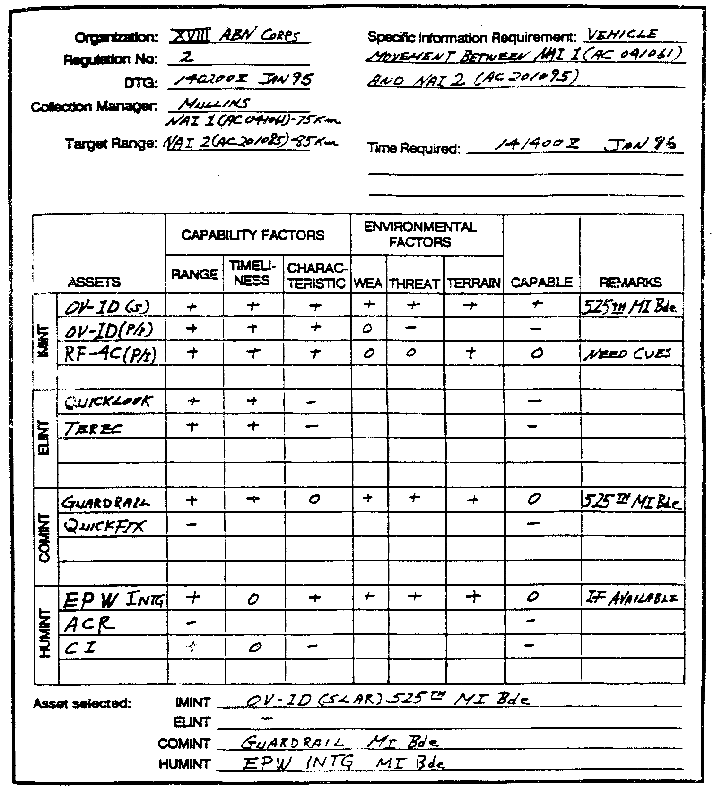

Figure 4-1. Sample Asset Evaluation Work Sheet.

IT0432 4-10

o Insertion capability of the division and corps. LRS Teams are inserted by airborne, air landing, helicopter rappel, ground infiltration, or small boat operations. Teams can also be inserted by remaining stationary and allowing Threat forces to roll over and bypass their positions.

o Timeliness required. LRS teams require an absolute minimum of 24 hours for planning, insertion, and movement. Depending on the insertion method this time might be increased considerably.

o Survivability. Enemy threat in the area of projected LRS operations, suitable surveillance/hide site locations, target standoff, and concealed routes of infiltration impact on team survivability.

o Technical proficiency. Are the surveillance teams are capable of answering the intelligence requirements?

o Communications. Whether current conditions and locations support the propagation of HF signals with the proposed site. If not, whether moving the Detachment Operations Base (DOB) or Forward Operations Base (FOB) will cut off communications with presently deployed teams. DOB capability to monitor frequency to ensure communications windows are available to the teams every six hours.

o Extraction capability. Team extraction can occur under several circumstances ---Following mission accomplishment, in accordance with (IAW) the mission folder extraction plan.

- From the No Communications Pickup Zone (NCPZ) after loss of communications with the DOB or FOB.

- As a result of Escape and Evasion from a designated area of recovery or passage of lines.

- When the team leader determines that the team is incapable of completing its assigned mission.

Develop Collection Strategy.

After thorough study of availability, capability and performance history, the collection manager selects the resources he plans to use. You plan to task organic assets, request support from higher, and recommend tasking to subordinate echelons. Organic assets are usually more responsive and you may directly influence their availability. However, avoid relying solely on your own resources if other systems are, based upon your evaluation, more capable.

The fact that each echelon has unique, organic intelligence capabilities and the resultant hierarchy of task/request/recommend relates directly to the ISOS "push/pull" concept "seamlessness." EAC asset reporting "pushes" intelligence down to corps. Corps collectors support the intelligence requirements of division, brigade, and battalion. As we continue to

4-11 IT0432

develop multiple subscriber processors that complement the unique collectors, lower echelon units are increasingly capable of "pulling" the information they need from higher. Maximizing the "take" from those processors and the collection systems that feed them results from effective exploitation management.

In some cases, new collection tasking is not the most efficient approach to PIR resolution. Exploitation management allows you to "piggyback" on existing collection by tasking your processors to "pull" in the appropriate image or signals. For example: A brigade S2 who knows that the division is conducting Unmanned Aerial Vehicle (UAV) flights within his area of interest may tap into the downlink on his own ground station module (GSM) at those times it operates over his NAls.

Key to collection strategy development are the considerations of cueing, redundancy, mix, and integration.

o Cueing involves the use of one or more sensor systems to provided data that directs collection by other systems. For example, sweeping the battlefield electronically with wide-area surveillance systems reveals activity that triggers direct collection by a more accurate, pin-point sensor system. Cueing maximizes the efficient use of finite collection assets in support of multiple, often competing, intelligence collection priorities.

o Redundancy planning as part of collection strategy development involves the use of several same-discipline assets to cover the same target. You use redundant tasking against high priority targets when the probability of success by any one system is low. For example, if you focus several SIGINT collectors on a designated emitter at different times, the probability of intercept improves -even if the emitter operates intermittently.

o Mix means planning for complementary coverage by a combination of assets from multiple disciplines. Sensor mix increases the probability of collection, reduces the risk of successful enemy deception, can facilitate cueing, and provides more complete reporting. For example, scouts report resupply activity within a known assembly area; SIGINT intercept of the associated logistics net provides unit identity, subordination, and indications of future activity.

o Integration is the resource management aspect of collection strategy development. Barring a decision to use next step in the strategy.

Synchronize Collection to Requirements: The RM function develops SIR sets from the consolidated, validated, and prioritized PIR and IR. The MM function uses SIRs to complete his collection strategy by associating each requirement and its corresponding decision point(s) and time lines. He matches each SIR against the PIR or IR that it supports to ensure that he fully understands the requirement. Starting at the point in time that the commander requires intelligence to effect a decision, the Collection Manager backward plans to account for dissemination, analysis, processing, collection, and tasking time.

IT0432 4-12

An effective tool used to link and synchronize the collection strategy with the expected flow of the operation it supports is the intelligence synchronization matrix (see figure 4-2). In addition to the "latest time information of value" (LTIOV), determined by the prioritized requirements and associated decision criteria, the matrix records NAI from the event template and reflects time lines of expected enemy activity from the event template and the event matrix. The intelligence synchronization matrix provides the basic structure for the more detailed collection plan, which reflects the specific orders or requests assigned to selected collectors for each PIR and IR.

Develop SOR Sets.

The development of detailed SIR during the RM function facilitates the MM process of developing SOR sets. You can easily translate a well written SIR into an effective SOR or SOR set by making a directive vice inquisitive statement and tailoring the reporting criteria to the collection capabilities of the asset tasked. For example:

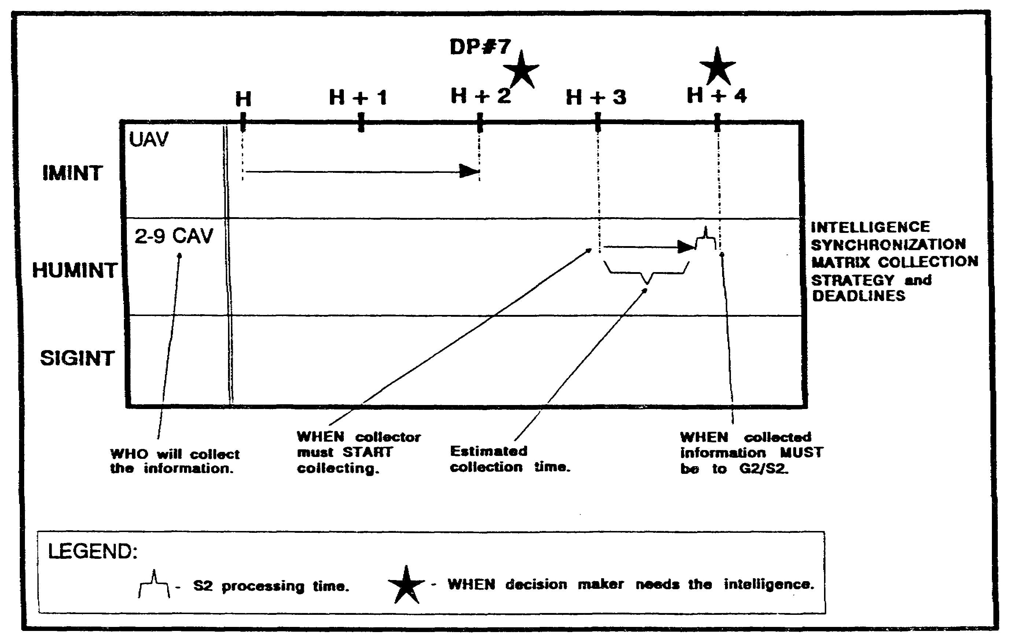

Figure 4-2. Intelligence Synchronization Matrix.

SIR 1: Will more than 17 reconnaissance vehicles subordinate to the 3rd TD or its regiments pass through NAI 8 or NAI 9 between 041800 and 052000 March?

SOR 1A: Report the presence of reconnaissance vehicles in NAI 8 and NAI 9 between 041800 and 052000 March. Specify direction of movement and numbers and types of vehicles. LTIOV: 060400 March.

4-13 IT0432

SOR 1 B: Report the presence of communications nodes associated with reconnaissance elements of the 3rd TD or its subordinate regiments in NAI 8 or NAI 9 between 041800 and 052000 March. LTIOV: 060400 March.

Specificity is important; however, avoid overly restrictive reporting guidelines. Allow your collectors the latitude to provide information you and the analysts had not anticipated. Emphasis or amplification tasking supplies the specifics required without artificially restricting collector capability.

Tailor the SOR to the selected collection system or organization. For example, some imaging systems require a Basic Encyclopedia (BE) number rather than a geographic or universal transverse mercator (UTM) coordinate for target location. Most USAF airborne collection platforms recognize geographic coordinates only. HUMINT collectors need to have specific timelines, reporting, and dissemination guidance. If your SOR are specific enough, they can roll over into the actual tasking/request mechanism/format.

Prioritize SORs for Collection Assets.

Collection Plans at higher echelons are complex, with multiple requirements and collection assets. Each asset may have several SOR to which it must respond. For example, Corps requests TRACKWOLF support to target HF communications associated with three deployed Army headquarters. You require DF locational data for each HQ. You need to prioritize which HQ is most important (perhaps a center of gravity?) according to the Corps operational concept.

Prioritization affects reporting as well as collection procedures. To avoid the "first in, first out" approach to reporting, especially if communications paths are limited, specify which answers need to be transmitted first regardless of when they were received.

Collection Plan Format.

One of the tools the CM uses to determine the most appropriate asset to task against a particular PIR or IR is a collection plan. Figure 4-3 shows examples of collection plan formats. The collection plan does not have a set format, unless it is prescribed by the unit's standing operating procedure (SOP). It can be a --

o Simple fragmentary work sheet.

o Matrix.

o Visual card file.

o Detailed formal plan.

o Mental process.

IT0432 4-14

Experienced CMs formulate a mental collection plan. However, fewer errors occur when they use the written form of the plan.

The selection of a format at any particular headquarters is based on the requirements of that headquarters and the resources available for collection management. However, regardless of the format selected, it must follow the logical sequence of collection management. In addition, the plan must be easily adjustable to changing requirements, situations, and missions.

4-15 IT0432

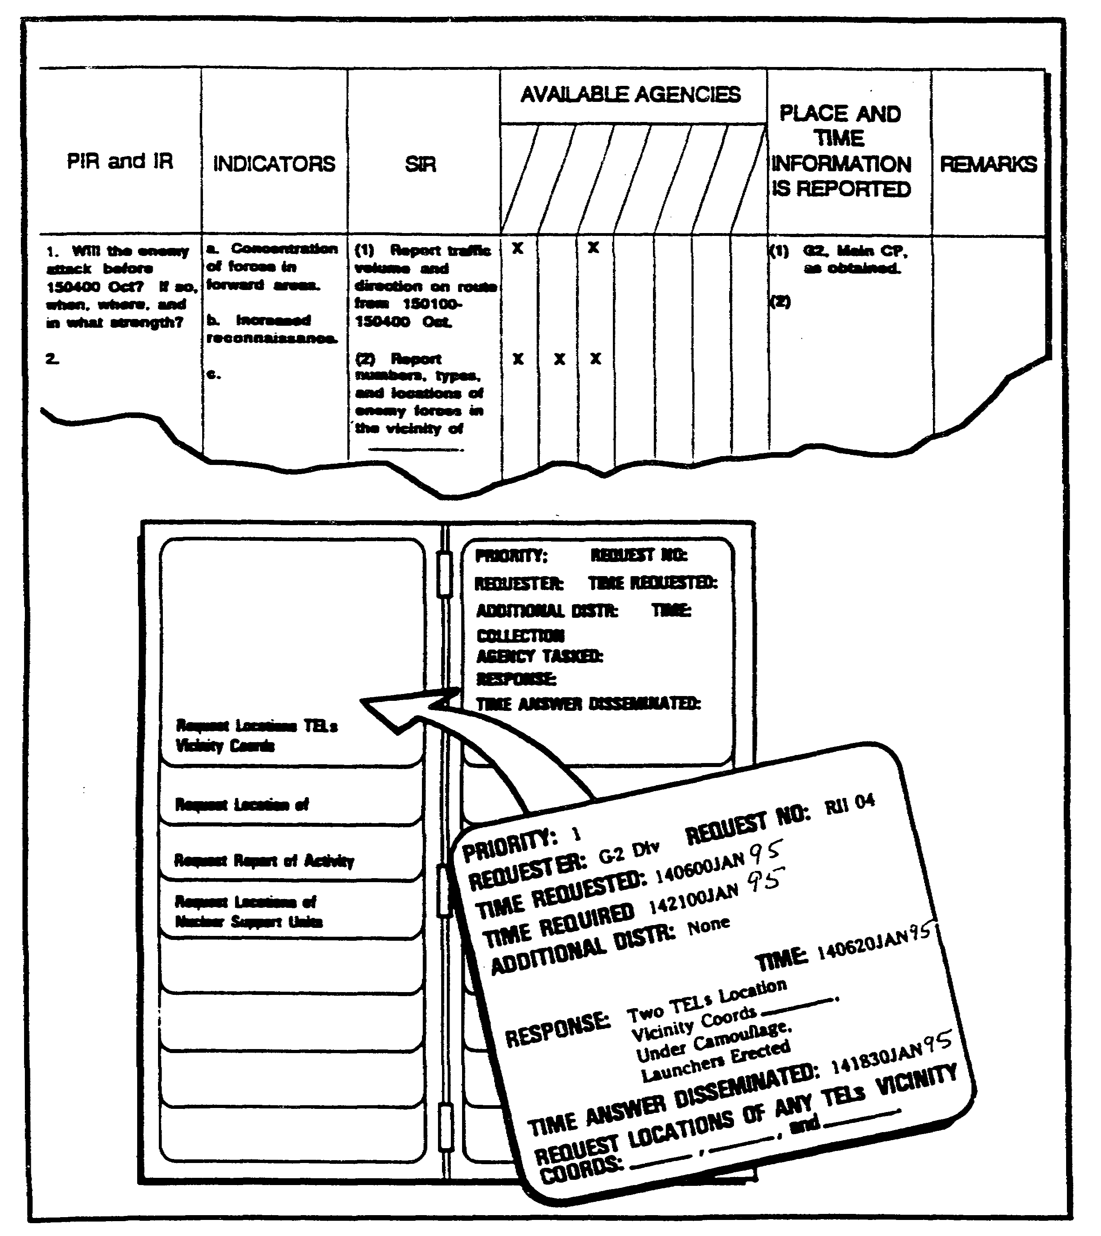

Figure 4-3. Collection plan formats.

IT0432 4-16

Collection plan work sheet.

The intelligence collection plan work sheet is a valuable tool in planning and directing the collection effort. At battalion and brigade, the collection plan work sheet is very informal. It may consist of a list of available collection means plus brief notes or reminders on current intelligence requirements an specific information to collect. At corps and division collection planning is more complex. Consequently, written collection work sheets at these echelons are detailed. Figure 4-4 shows a collection plan work sheet suitable for division and corps. Brigades and battalions can modify this format to fit their requirements. Figure 4-5 provides an example of a completed collection plan using fictitious data.

Visual file index.

Another method for maintaining a collection plan is in the form of a visual file index using 5 by 8 inch cards (see Figures 4-6 and 4-7). In this method, a collection requirement is displayed across the bottom of the card. The remainder of the card may contain:

o Priority.

o Request or request number.

o Time requested and LTIOV.

o Additional distribution of results.

o Collection agencies tasked and time.

o Time the answer was received.

o Answer.

o Time the answer was disseminated to the requester.

Priorities can be shown by using different colored cards or index tabs. For example, a red card or index tab could indicate a highly time sensitive request to the CM, no matter how many shift changes take place. The CM can group the cards in a number of ways: OB factors, NAI, requester, or collector. In each operation the file may start out one way and, by necessity, change as the situation changes. This can be done quickly since the cards are easy to manipulate.

4-17 IT0432

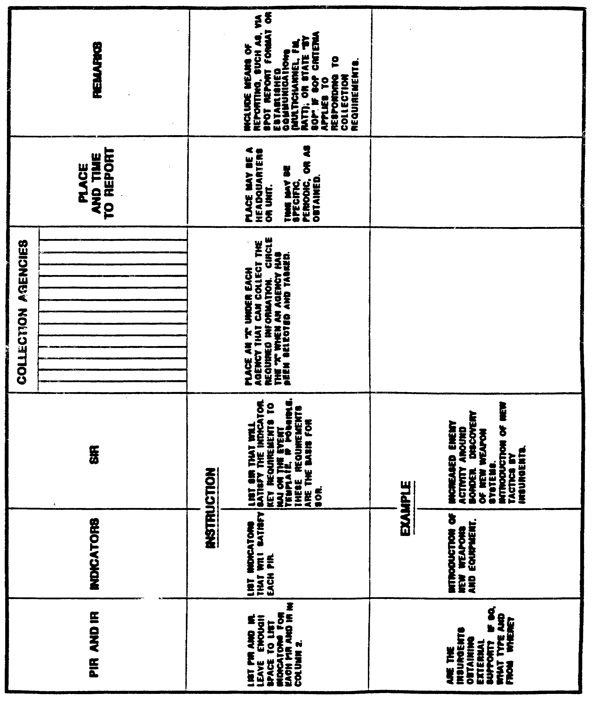

Figure 4-4. Collection work sheet.

IT0432 4-18

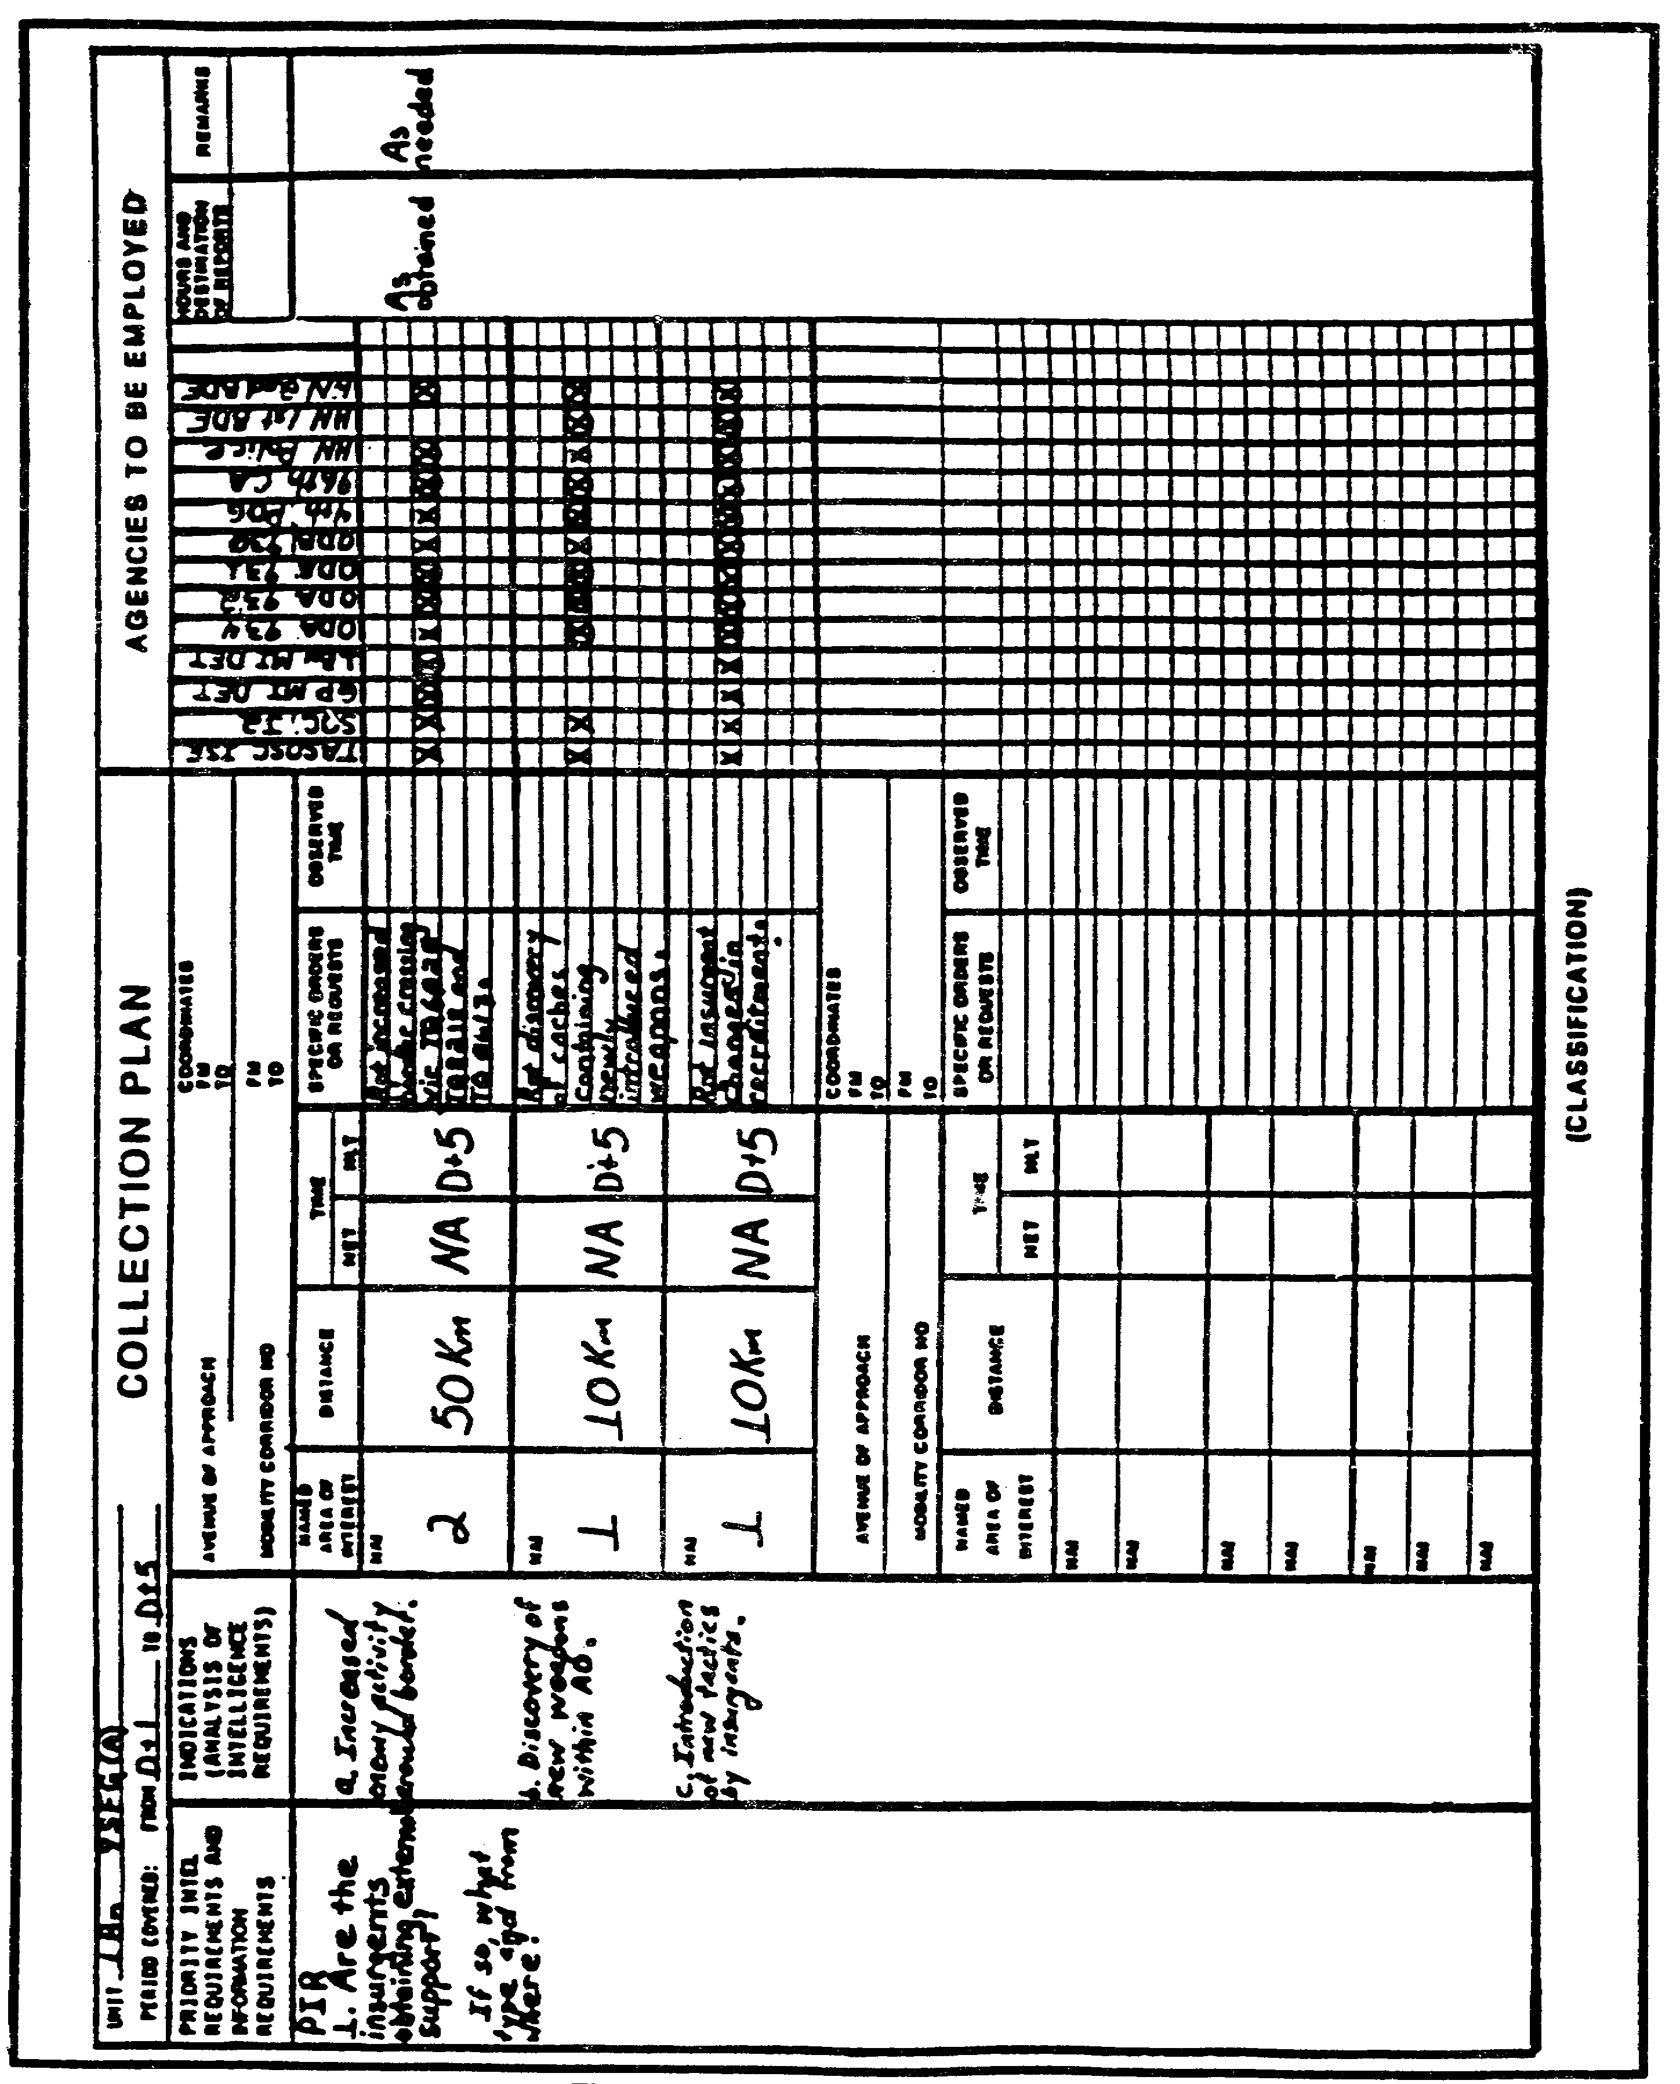

Figure 4-5. Collection plan format.

4-19 IT0432

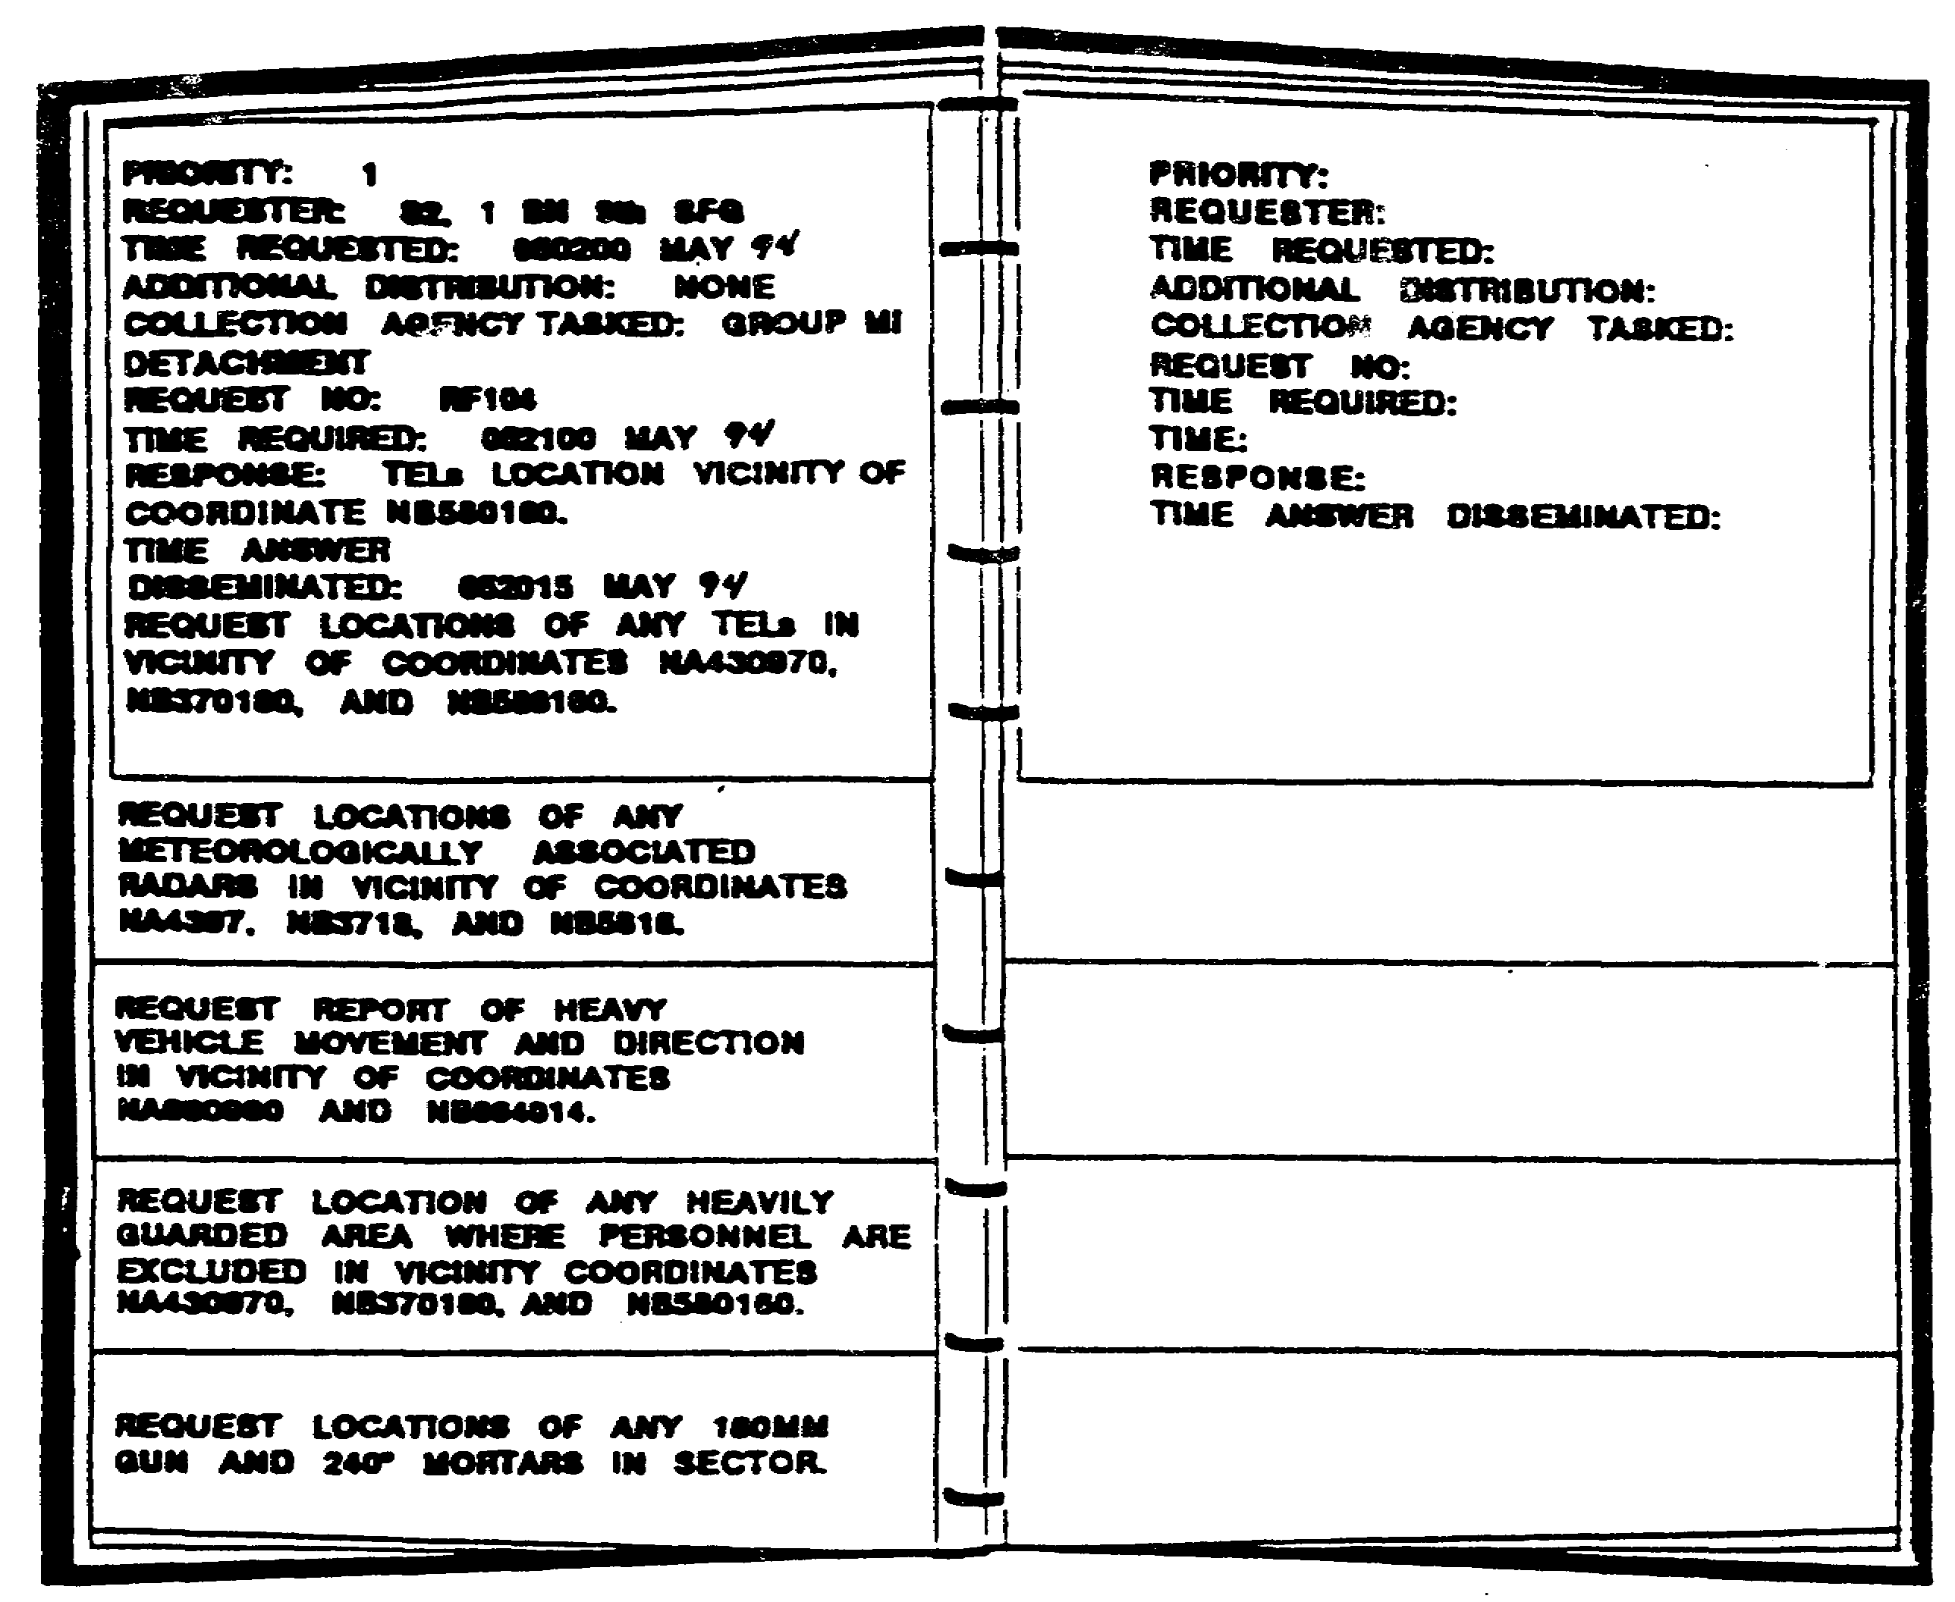

Figure 4-6. Collection coordination visual file folder.

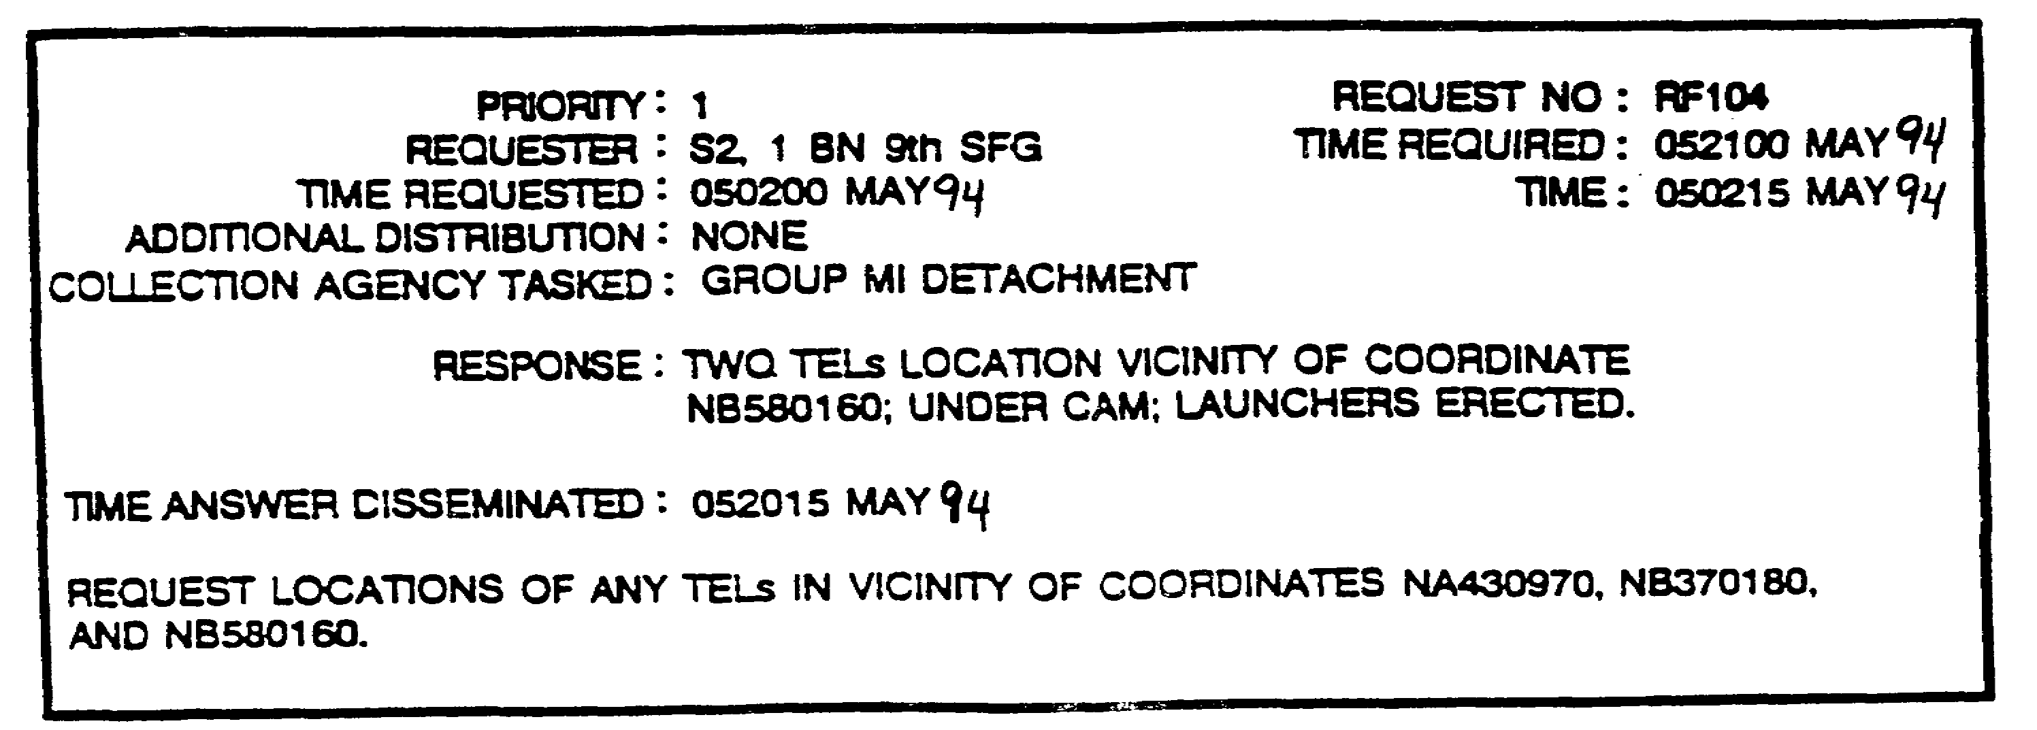

Figure 4-7. Collection coordination visual file card.

IT0432 4-20

When the collection requirement is satisfied, the card is removed from the visual files. The remainder of the cards are not disrupted. The CM can then place the 5 by 8 inch card in a small file organized by geographic areas. This enables the CM to build a database on the responsiveness of the collection agencies within specific geographical areas. If the visual file method is used, the CM must maintain two charts. One is used to depict the collection effort. The other lists the available units and agencies and those tasked with each requirement. This chart is needed to prevent overloading or overlooking a-single available collector. These two charts are shown in Figure 4-8.

Reconnaissance and Surveillance Matrix.

The reconnaissance and surveillance (R&S) matrix is used at the maneuver battalion and task force level. Figure 4-9 is an example of a modified matrix. Each column has a letter designator. For example, the Priority column is "A," the NAI column is "B," and so on. The lettering makes it very easy to quickly assign a new R&S mission, or modify an existing mission. Just transmit pertinent information within the column. For example:

o Column B - 4.

o Column C - 1800-2000.

o Column D - BRDM, BMP, platoon-size (3 vehicles) with possible tanks.

o Column E through O - Action.

o Column P - Coordinate with Echo.

o Column Q - Report by type (light/heavy wheeled and tracked) number of vehicles, location, speed, and direction of movement.

The CM told the attached GSR team to monitor NAI 4 from 1800-2000. They could expect to see BRDM or BMP vehicles (possibly reinforced with tanks) up to platoon size (3 vehicles). You've also told the GSR team they must coordinate with A company, and should report targets by type (light, heavy wheeled; light, heavy tracked) and number of vehicles, location, speed, and direction of movement.

4-21 IT0432

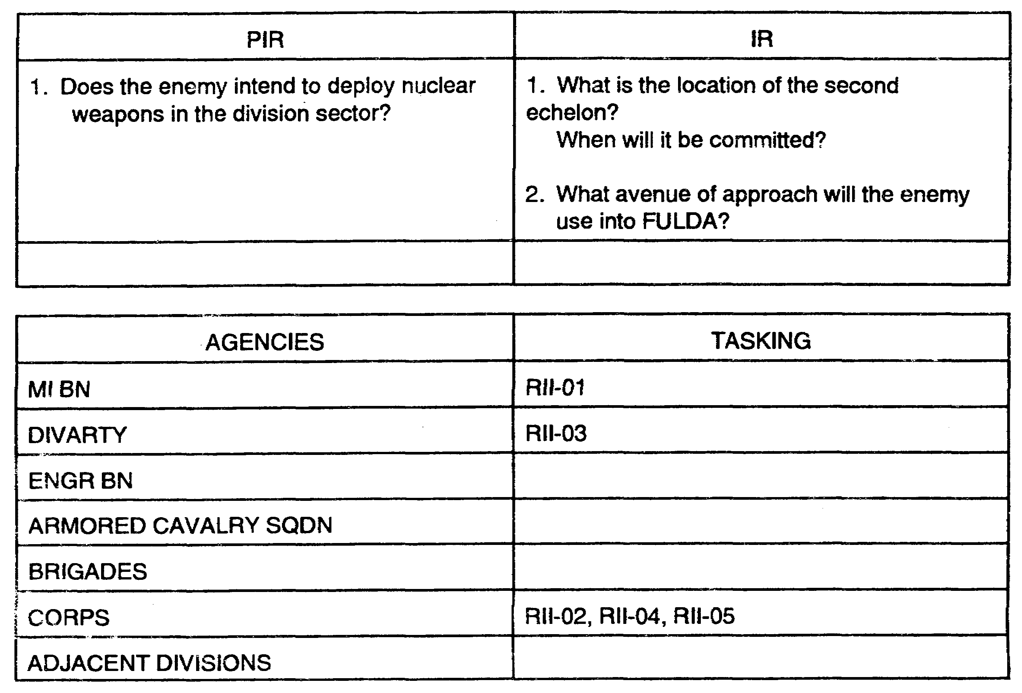

Figure 4-8. Charts used in determining commander's PIR and IR and
available agencies and tasking.

IT0432 4-22

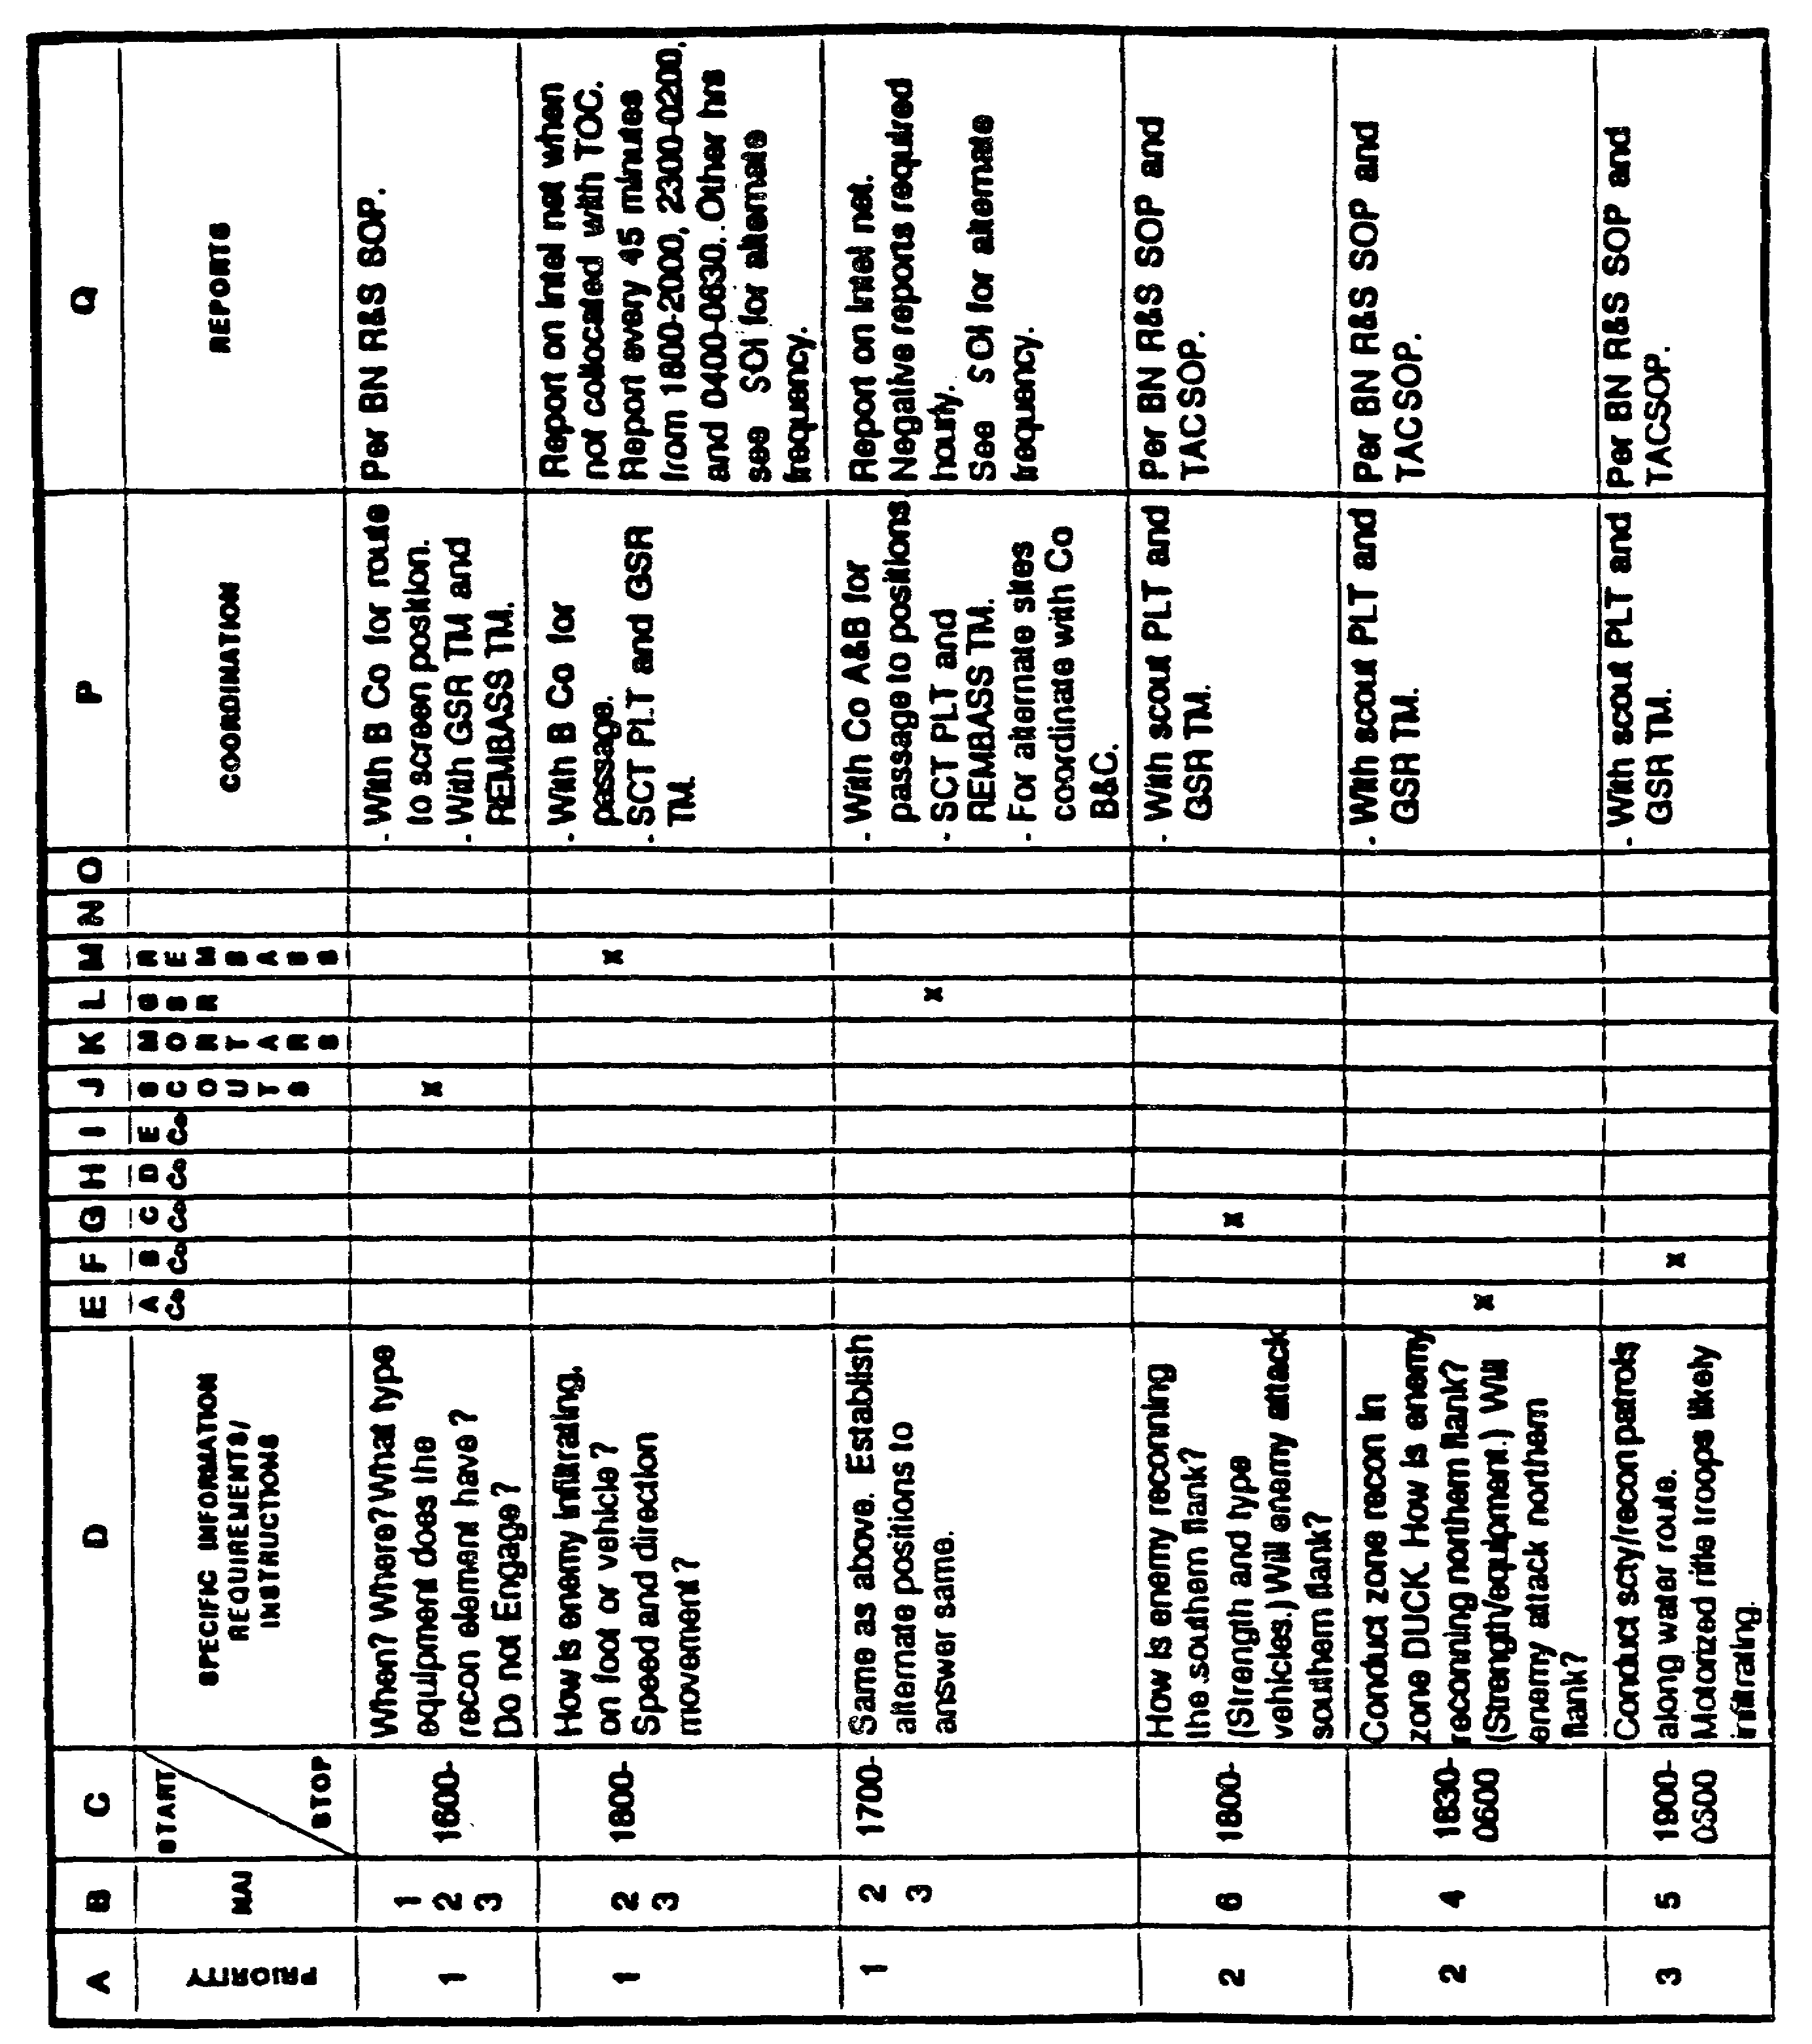

Figure 4-9. Example of modified matrix.

4-23 IT0432

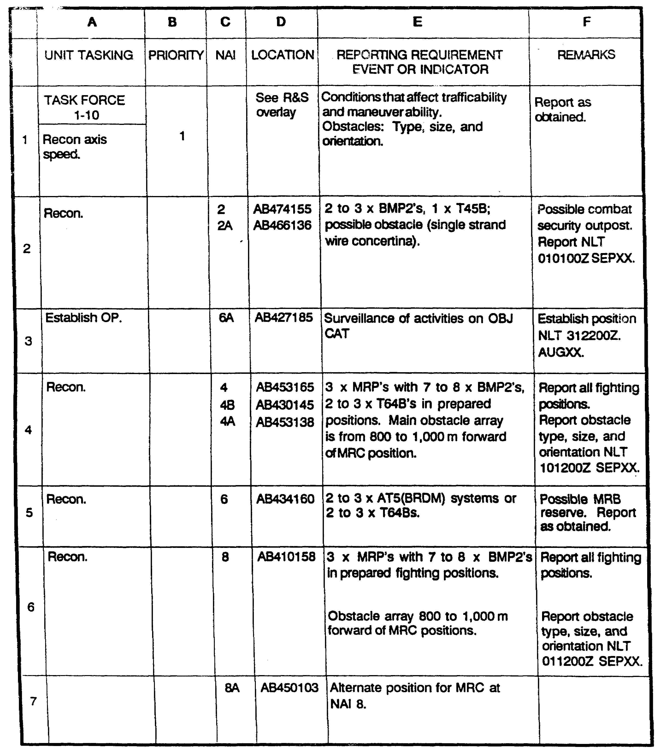

Figure 4-10. Modifying an R&S matrix.

IT0432 4-24

Figure 4-10 is a similar R&S tasking matrix whose horizontal lines are identified by number, and whose vertical columns are identified by letter. Use this system to modify a specific element of the matrix. For example:

o Line 3C - 8.

o Line 3D - AB 434160.

o Line 3E - Refer to 7E.

In this example, the CM told TF 1-10 to establish an observation post at an NAI. The observation post is to observe an alternate position for a motorized rifle company at NAI 8.

These are just two examples of technique the CM can use to quickly re-task deployed R&S assets. There are many more techniques. The key is to establish a standard way to quickly and easily modify the R&S plan based on the commanders changing needs.

PART F - TASK OR REQUEST TASKING OF RESOURCES.

Task or request tasking of resources is the implementation of the Collection Plan through the execution of system-specific tasking or request mechanisms. The desired end result is that the collector receives properly formatted tasking with all necessary data fields to execute the mission.

Determine task/request mechanism.

There are various tasking documents used to levy intelligence requirements on collection agencies. Some tasking mechanisms are theater or system unique. The J-TENS and various DIA manuals specify procedures and formats for requesting support from EAC and national systems or agencies.

The IEW Character-Oriented Message Catalog (IEWCOMCAT) contains the Multiple Asset Tasking Message (MATAM) and Exploitation Requirement (ER) among other standard formats.

The Intelligence Annex to the OPORD is a standardized tasking vehicle at ECB. Paragraph 3 of the Intelligence Annex, Intelligence Acquisition Tasks, implements the collection plan. It contains a complete list of current orders and requests for information. Use an appendix to the annex to relay lengthy intelligence tasking orders and requests. At brigade or battalion levels this appendix often takes the form of R&S overlays and plans.

Another effective technique is to coordinate with the G3/S3 to list specific orders for the collection of intelligence in paragraph 3, Execution, of the command's operations order. Supporting details are then included in the Intelligence Annex and additional appendices, as required.

Determination of the most efficient task or request mechanism depends upon system or agency requirements. For example, fragmentary orders (FRAGOs) over the radio often redirect the scout platoon to new or changed missions.

4-25 IT0432

Execute tasking.

At the Joint level, in addition to system or agency specific tasking (an SOR developed for a specific collector), the theater J-2 issues a statement of intelligence interest (SlI) for all theater units. The SII provides the "collection intent" for a specified period of time, ensuring collective comprehension of collection priorities in support of theater operations. SIl update is the first function of joint-level collection requirements management.

A similar tool for division and corps collection managers is the collection emphasis message (see Figure 4-11). It is the IEW synchronization matrix in narrative format. You can broadcast your collection strategy to higher, lower, and adjacent units; collectors; and exploiters in addition to providing specific tasking or requests.

The primary benefit of communicating "collection intent" is the "big picture" perspective it provides organizations which may be otherwise isolated from your planning process. An informed collector can often amplify reporting to provide an answer that goes beyond the immediate question. While the report stops short of analysis, it refines raw information and may facilitate cueing.

Collect and Exploit.

This final subfunction belongs to the asset manager for planning purposes and to the collection and exploitation systems themselves for execution. The final result is the production of information and intelligence that leads to the satisfaction of the initial intelligence requirements.

In addition to providing reports on the results of their collection operations, asset managers report on the status and availability of their collection systems. This ensures that the collection manager is able to make efficient use of the command's intelligence collection capabilities and continually update and refine his collection plan.

The echelon manuals (FM 34-80, 34-10, 34-25, etc.) address Ml operations in detail. Systems handbooks and Tactics, Techniques and Procedures (TTPs) cover the "how to" aspect of collection and exploitation.

PART G - EVALUATE REPORTING

Reporting evaluation is the determination and publication of the value of the collected information relative to the established intelligence requirements. The desired end effect is that all SORs are fully satisfied in a timely manner, keeping the intelligence system fully synchronized.

Determine Perishability of each Report.

This is the step that enables the RM to determine if normal routing procedures will forward necessary combat information to war fighters in a timely manner. When the RM receives a report he determines how "perishable" the report is or how long the intelligence should be of value. If normal routing procedures are too slow, and the information is a critical HPT, the RM arranges for perishable combat information to go straight to the attack system. He still routes

IT0432 4-26

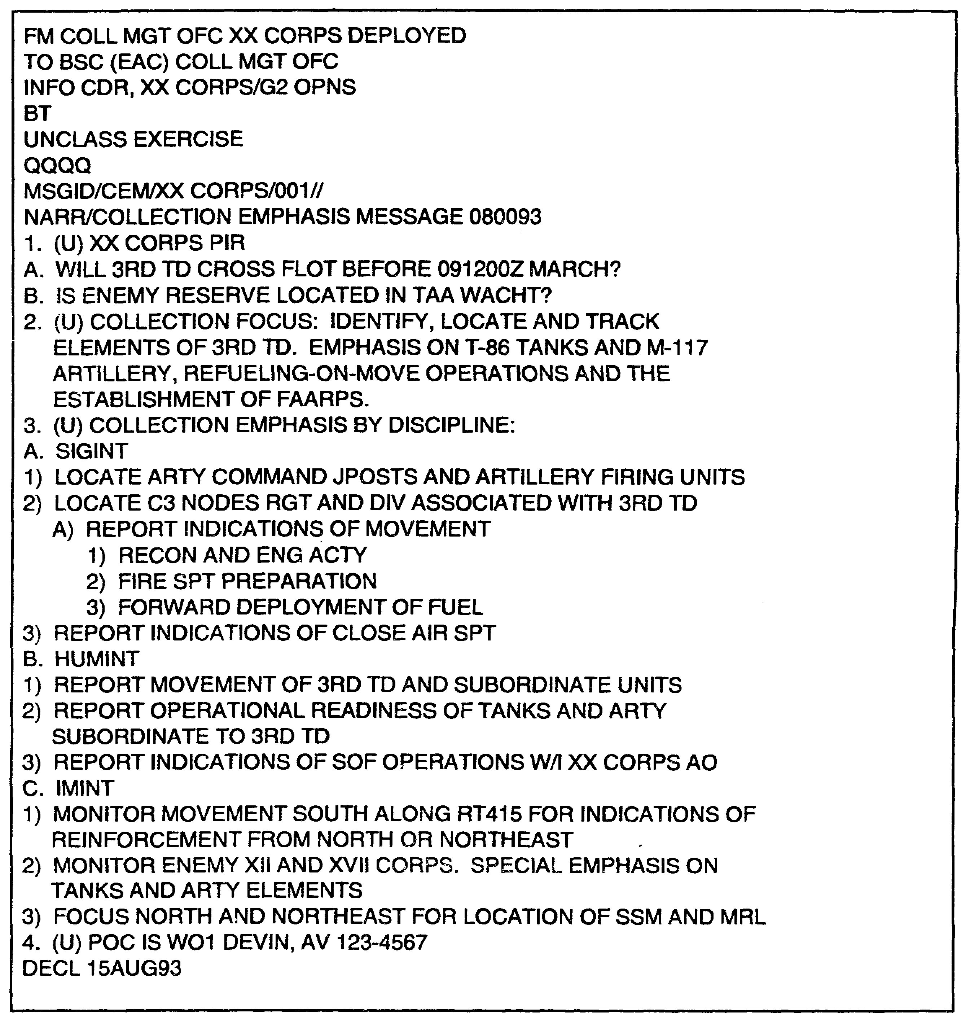

Figure 4-11. Collection Emphasis Message.

4-27 IT0432

the information through normal channels with the remarks that show the information has already been forwarded to the attack system.

Some Examples:

"8 x BMPs and 3 x T-72s dug in at NAI-11 b ... "will probably still bear an accurate report after the 15-20 minutes the ASPS requires to integrate this information into their understanding of the battlefield. The RM routes it normally.

"Transporter Erector Launcher (TEL) just moved into NAI-341 ..." may or may not be perishable. If the TEL takes 45 minutes to prepare for launching, and the most available attack system requires only 5 minutes lead time, the RM should forward the report through normal channels (assuming it will still get to the attack system in a timely manner). If this is a HPT, it should be routed to the targeting cell immediately.

"35 x BMPs and 8 x T-80s moving south at FQ12345678 at 1317 Hrs ..." is highly perishable - at 1327 Hrs the MRB could be several miles south of the reported grid. Therefore, the RM retasks the asset to maintain surveillance of the MRB and to continue reporting updates on its location. If the original asset is unable to maintain surveillance the RM cues another system, arranging for the Near Real Time information to go straight into the targeting cell.

Correlate Reports to Requirements.

In this step the RM identifies the original SOR and requirement that the reported information satisfies. By doing this he will later be able to determine which SORs have been satisfied and which require more collection. To accomplish this step he simply tags the SOR and requirement number onto the report.

During the development of requirements, develop a numbering system that enables the RM to conduct quick audit trails linking requirements to SORs. For example, "SOR 8-h-2" might be the second SOR developed for "SIR-h" of "IR-8." Remember that all PIRs and IRs should already be linked one-for-one to operational decisions. Insist that asset managers tag all their reports with the number of the SOR(s) they satisfy.

Screen Reports.

After reports have been correlated and tagged to the appropriate SOR, the RM must determine whether the SOR has been satisfied. He does this by screening each report for:

o Pertinence: Does the information actually address the tasked SOR? If not, can the RM use this information to answer requirements anyway?

o Completeness: Is essential information missing? (refer to the original SOR).

o Timeliness: Has the collector reported by the LTIOV established in the original SOR?

IT0432 4-28

o Opportunities for Cueing: Can this system or another system take advantage of the new information to increase the effectiveness and efficiency of the overall collection effort?

If the report fully satisfies the SOR the RM makes the appropriate entry in his audit trail or register of intelligence requirements and disseminates the final intelligence to the requestor. He must coordinate with the requestor to ensure that the requester also considers the requirement satisfied.

If the report only partially satisfies the report, the RM annotates what has been accomplished and what remains to be done in his audit trail or registers.

If the report suggests an opportunity to cue other assets the RM should take immediate action to do so, recording any new requirements into his collection plan and audit trail.

Provide Feedback to Collectors and Exploiters.

After the RM determines how well reported information satisfies SORs he informs the concerned collectors and exploiters.

For fully satisfied SORs he relieves the AMs of further responsibility to collect against the SOR. For partially satisfied SORs he notifies the AMs that the SORs remain outstanding. He also explains what remains to be done. AMs are notified of new SORs designed to exploit cueing opportunities.

PART H - UPDATE COLLECTION PLAN

Redirecting and updating is the adjustment of the overall collection plan to optimize collection and exploitation capability on remaining requirements. The desired end effect is that collectors and exploiters only work on SORs for unsatisfied requirements.

Eliminate Satisfied Requirements.

During the "Evaluate Reporting" step of the CM process the RM eliminates SORs that have been satisfied. In this step the RM also eliminates SORs that are overtaken by events, even if unsatisfied. The RM does this by continuous coordination with the agency that generated the original requirement. For example, a division RM would coordinate with:

o The ASIS and G2 Plans for PIRs and IRs,

o Senior, subordinate, and adjacent commands for their SORs.

When the originating agency declares an SOR satisfied, the RM eliminates the requirement from the collection plan and updates his other logs and records.

4-29 IT0432

Redirect Assets to Unsatisfied Requirements.

Requirements can be satisfied by the collector to which they were tasked or as a result of collection success elsewhere on the battlefield. Hence, for limited periods of time an asset manager may have collection capability in excess of his taskings. The purpose of this step is to make best use of this "excess" capability. After the RM eliminates satisfied requirements from the collection plan, the MM re-evaluates each collection asset for excess capability.

The MM then focuses the excess collection capability on the most important of the remaining unsatisfied requirements. This enables him to compensate for:

o Second and third priority requirements that the MM designated for economy of force efforts when he developed the original collection strategies and plan;

o Requirements that require more collection effort than the MM originally planned for; and

o Assets that are not performing to the capability that the MM originally evaluated them for (e.g., the enemy destroys a system).

Cue Assets to Collection Opportunities.

This is where the RM and MM redirected an asset not because of excess capability, but as the result of cross-cueing or because of the opportunity that an intelligence report might generate.

The RM and MM execute the same procedure at this stage in the process. The primary difference is that the RM and MM are now responding to results of analysis, rather than combat information.

When the RM receives the results of analysis he consults the MM. The MM re-evaluates his original collection strategy based upon the new intelligence. In particular he looks for opportunities to improve collection strategies. Once identified the MM retasks collection assets appropriately. For example,

o A division ASPS informs the ACE that they have unexpectedly deduced the location of a second echelon regiment's command post (to within 1000 meters) through analysis of JSTARs, MTI and SAR data.

o The MM's original strategy for locating this headquarters was to use Guardrail Common Sensor (GRCS).

o Since this CP is a critical HPT, the MM focuses on refining the locational accuracy to meet target selection standards. He evaluates the likelihood of the GRCS providing more accurate locational data against the capabilities of other systems.

o He decides to divert an ongoing Unmanned Aerial Vehicle (UAV) mission from a lower priority requirement to conduct reconnaissance on the 1000 meter circle that the ASIS identified. He issues the necessary orders to the asset manager and then helps coordinate the changed flight track with the division's airspace manager.

IT0432 4-30

o After the UAV identifies the precise location of the CP the MM withdraws the corresponding SOR from the corps RM. The corps MM then relieves the AEB of that SOR, making them available for additional taskings.

In summary, cueing opportunities, whether prompted through combat information or analysis, allow the MM to satisfy requirements more efficiently than previously planned through collection strategies.

As planning or execution of a course of action evolve, and as the Threat situation develops, commanders will generate new intelligence requirements. This prompts the re-initiation of the collection management process.

The RM should ensure that he carefully prioritizes the new requirements against the old rather than simply add them to the existing list. Similarly, he must not simply discount the previous requirements; some may still be valid.

Re-initiate the collection management process, consolidating the new requirements with those existing requirements which remain valid.

4-31 IT0432

LESSON 4

PRACTICE EXERCISE

The following items will test your grasp of the material covered in this lesson. There is only one correct answer for each item. When you complete the exercise, check your answer with the answer key that follows. If you answer any item incorrectly, study that part of the lesson which contains the portion involved.

1. Correlating and evaluating intelligence reporting to collection requirements is the responsibility of which of the following?

A. Mission Management.

B. Asset Management.

C. Requirements Management.

D. Collection Management.

2. Developing collection strategy is a substep of what phase of the collection management process?

A. Update Collection Planning.

B. Evaluate Reporting.

C. Determine Requirements.

D. Develop Collection Plan.

3. Which of the following is responsible for collection and exploitation?

A. Collection Manager.

B. Asset Manager.

C. Mission Manager.

D. Resource Manager.

IT0432 4-32

LESSON 4

PRACTICE EXERCISE

ANSWER KEY AND FEEDBACK

Item Correct Answer and Feedback

1. C. Requirements Management. Page 4-2.

2. D. Develop Collection Plan. Page 4-9.

3. B. Asset Manager. Page 4-3.

IT0432 4-34

LESSON 5

DEVELOP AN INTELLIGENCE AND ELECTRONIC
WARFARE SCHEME OF MANEUVER

Critical Tasks: 301-372-2005
301-372-3012

OVERVIEW

LESSON DESCRIPTION:

In this lesson you will learn the intelligence and electronic warfare (IEW) structure at division, to include organization, associated equipment, mission, operations, and communications.

TERMINAL LEARNING OBJECTIVE:

ACTIONS: Describe the functions, task organization and deployment considerations for IEW assets at division. Develop an IEW scheme of maneuver to support the commander's intent and concept of operations.

CONDITIONS: You will be given narrative information and illustrations from applicable field manuals.

STANDARDS: Develop an IEW scheme of maneuver and initial IEW task organization. Prepare paragraph 3a (concept of operations) of an operations order (OPORD) in accordance with FM 101-5.

REFERENCES: The material contained in this lesson was derived from the following publications:

FM 34-1
FM 34-8
FM 34-10
FM 34-25
FM 34-35
FM 34-80
FM 101-5

INTRODUCTION

In lesson 3, you learned the principles of the command estimate process and intelligence synchronization. In this lesson, you will learn the basic fundamentals for developing an IEW scheme of maneuver at the Military Intelligence (Ml) battalion level. This will include developing an initial IEW task organization, to support the scheme of maneuver, and the preparation of paragraph 3a of the battalion OPORD. The primary emphasis will be on the IEW company team. Additionally, you will be provided information on MI battalion organization, associated IEW equipment, standard tactical mission (STM), operations, and communications. This

5-1 IT0432

knowledge will assist in the development of task organization, scheme of maneuver, and concept of operations to provide IEW support to the command.

NOTE: The emphasis in this lesson will be on IEW support to the heavy division. The IEW structure at corps; light, airborne, and air assault divisions; armored cavalry regiments, and separate brigades are outlined in Appendix A.

PART A - Ml BATTALION ORGANIZATION

Mission and structure: The Ml battalion (Figure 5-1) of a heavy division has the mission to provide IEW support to divisional operations. It is organized into four companies and a long-range surveillance detachment. Additionally a Quickfix flight platoon is under operational control (OPCON) of the battalion. The platoon is assigned to the division's combat aviation brigade. The Ml companies of the battalion will not deploy as companies. Instead, they are task-organized into IEW company teams. There is no standard tactical mix of assets within the separate company teams. They are organized under the concept of mission, enemy, terrain, troops, and time available (METT-T) to provide the best possible mix of IEW assets to support the mission. The IEW company teams will be discussed later in this lesson.

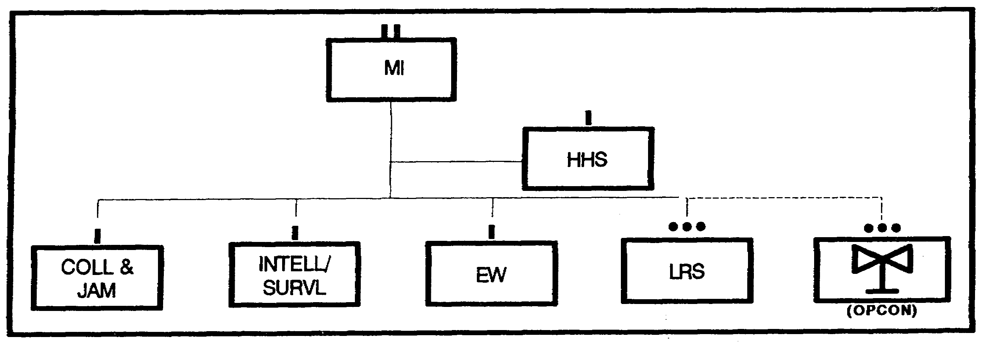

Figure 5-1. Ml Battalion.

Headquarters. Headquarters and Service Company (HHSC) contains command and control, analysis, deception, and service elements. The structure of the HHSC is shown in Figure 5-2.

The key element of the deployed MI battalion is the Tactical Operations Center (TOC). The Ml Battalion TOC provides centralized management of organic, attached, and supporting Ml resources. It provides the battalion commander with the centralized management necessary to ensure rapid, efficient response to mission requirements. The TOC tasks battalion assets in response to mission requirements. The TOC tasks battalion assets in response to mission taskings received from the Analysis and Control Element (ACE). The battalion TOC consists of the Battalion Commander, S2 and S3 sections and the ACE. The S3 supervises all TOC operations. The functions of the MI BN TOC are to --

IT0432 5-2

o Control MI BN assets.

o Control subordinate company teams.

o Control Corps Ml assets attached or OPCON to the division MI Battalion.

o Signals intelligence (SIGINT) /EW tasking to both general support (GS) and direct support (DS) assets.

o Asset management and tasking for subordinate counterintelligence (CI) and interrogation elements when deployed in GS.

MI BN S3: The S3, as the battalion operations officer, has staff responsibility for operations, plans, and training in the battalion. He has staff responsibility for asset management for Ml BN resources to include supporting or reinforcing Ml assets and supervising battalion TOC operations. The Ml Battalion S3 has three deployable intelligence support element (DISE) which perform three tasks:

o Liaison to the Brigade Commander.

o Coordination with the Brigade S3 for locations of Ml assets in the brigade AO.

o Provides combat information to the brigade S2 by monitoring the communications net between the Collection and Jamming (C&J), Platoon Operations Center (POC), and the ACE.

Ml BN S2: The S2 monitors the division operations and intelligence (O&l) net and maintains a current intelligence situation map (SITMAP). The S2 also assists the S3 in assessing Cl and enemy prisoner of war (EPW) interrogation priorities received from the ACE section.

ACE: The ACE manages SIGINT/EW assets for the commander and S3 by providing technical control and tasking in accordance with established SIGINT/EW priorities. It also recommends task organization and tactical employment of SIGINT/EW assets.

Battlefield Deception (BAT-D) Section. The Battlefield Deception Element (BDE), is OPCON to the G3 section and normally collocates with the Division TOC. The signature teams: commo, physical, and electronic will normally be task organized to perform the division's deception plan. The communications signature team replicates low-level friendly communication nodes/signatures. The physical signature team replicates low-level friendly physical signatures. The electronic signature team replicates low-level friendly noncommunications signatures.

The communications signature team replicates low-level friendly communication nodes/signatures. The physical signature team replicates low-level friendly physical signatures. The electronic signature team replicates low-level friendly noncommunications signature.

5-3 IT0432

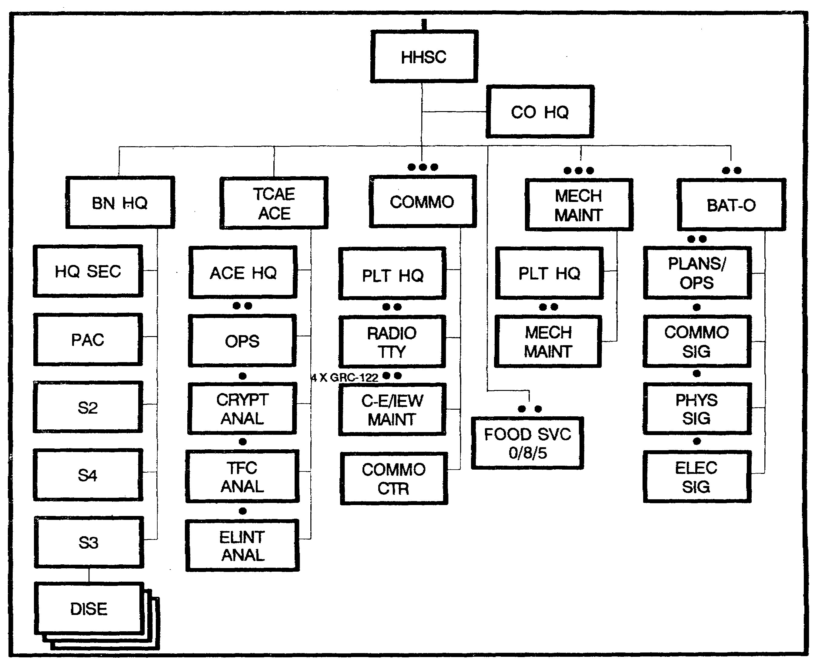

Figure 5-2. Headquarters, Headquarters Service Company.

Service Support: The service support elements provide communications, Communications-Electronics (C-E) and mechanical maintenance, and food service support to the battalion. As the battalion task organizes into IEW company teams, assets of the IEW maintenance section and mechanical maintenance platoon are organized into teams attached to each company.

Collection and Jamming (C&J) Company (Figure 5-3).

The C&J company pro vides SIGINT/EW support to the division. The unit is equipped to provide communications collection, low-level analysis, and communications jamming. It also has an organic radio teletype communications section and C-E/mechanical maintenance assets. The company may be task-organized to support the battalion mission. The platoon HQ and the Transcription and Analysis (T&A) team form the controlling element for the deployed assets.

IT0432 5-4

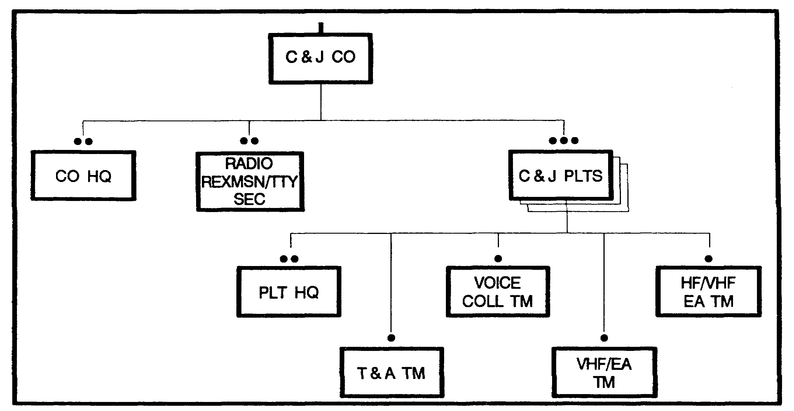

Figure 5-3. Collection and Jamming Company.

The voice collection team deploys with the Platoon Operations Center, if possible. The voice collection team performs high frequency (HF), very high frequency (VHF), and ultra high frequency (UHF) voice intercept with the AN/TRQ-30(V) and the AN/TRQ-32(V) 2, (TEAMMATE).

The HF/VHF Electronic Attack (EA) team performs jamming missions using the AN/TLQ-1A(V) 3 (TRAFFICJAM) communications jammer. The team also performs electronic warfare support (ES) when not tasked for EA operations.

The VHF EA team performs ES and EA (jamming), missions using the AN/MLQ-34 (TACJAM) communications jammer.

Intelligence and Surveillance (I&S) Company (Figure 5-4).

The Intelligence and Surveillance company provides the division with human intelligence (HUMINT), Cl, and ground surveillance assets. It is organized with an operations support section and a ground surveillance platoon.

5-5 IT0432

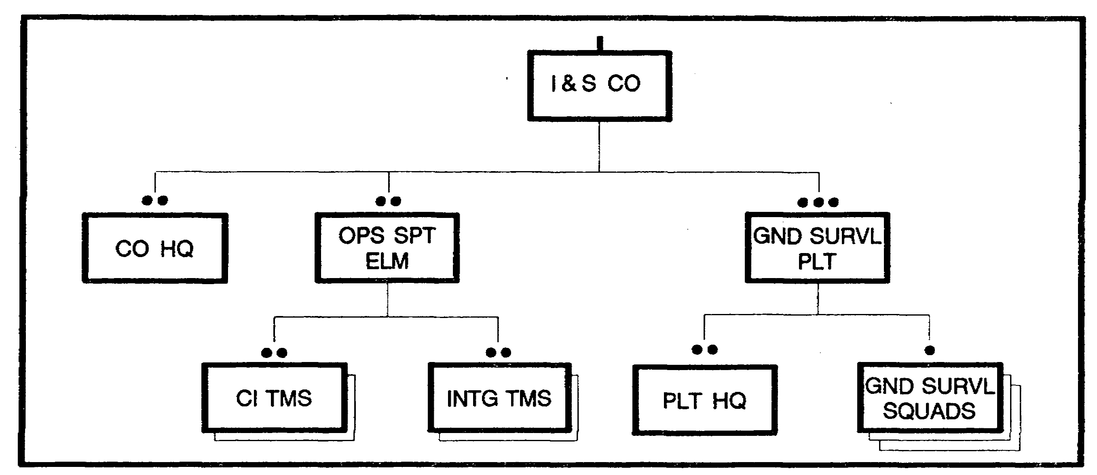

Figure 5-4. Intelligence and Surveillance Company.

The Operations Support Section has two Cl and interrogation teams. Cl teams provide division level GS support. With corps augmentation, Cl teams can provide DS support to a brigade as part of an IEW company team. Cl teams counter the foreign intelligence collection Threat, subversion, sabotage, and terrorism. The interrogation teams usually operate from the division's enemy prisoner of war (EPW) collection point. With corps augmentation interrogation teams can provide DS support to a brigade. Interrogation teams interrogate EPWs and translate captured enemy documents.

The Ground Surveillance Radar (GSR) platoon is organized into three GSR squads, each with four AN/PPS-5B radar teams. The GSR squads provide Moving Target Indicator (MTI) locations. The AN/PPS-5B radar is the only organic division imagery asset. Ground surveillance assets may be attached to a brigade and further attached to the battalion task force (BTF) and maneuver company teams. GSR teams provide a 24-hour battlefield surveillance capability. They can be used near the forward line of own troops (FLOT), forward of the FLOT, or on the flanks in a screening role. They can be used in surveillance of gaps between units or in rear areas at possible drop zones or landing sites. All support for GSR teams is provided by the unit to which attached, less radar-unique maintenance, which is provided by the Ml battalion.

Electronic Warfare (EW) Company (Figure 5-5).

The EW company provides SIGINT/ES support to the division and subordinate elements. It is capable of communications collection and direction finding (DF). It also has noncommunications collection and DF capabilities. EW company assets provide ground-based DF results on enemy communications and noncommunications emitters. The mission is accomplished with the SIGINT processing platoon's assets.

IT0432 5-6

The SIGINT processing platoon includes the TRAILBLAZER system (AN/TSQ-138) which sets up in a generally "Lazy W" shaped baseline across the division frontage to intercept and DF enemy VHF communications emitters.

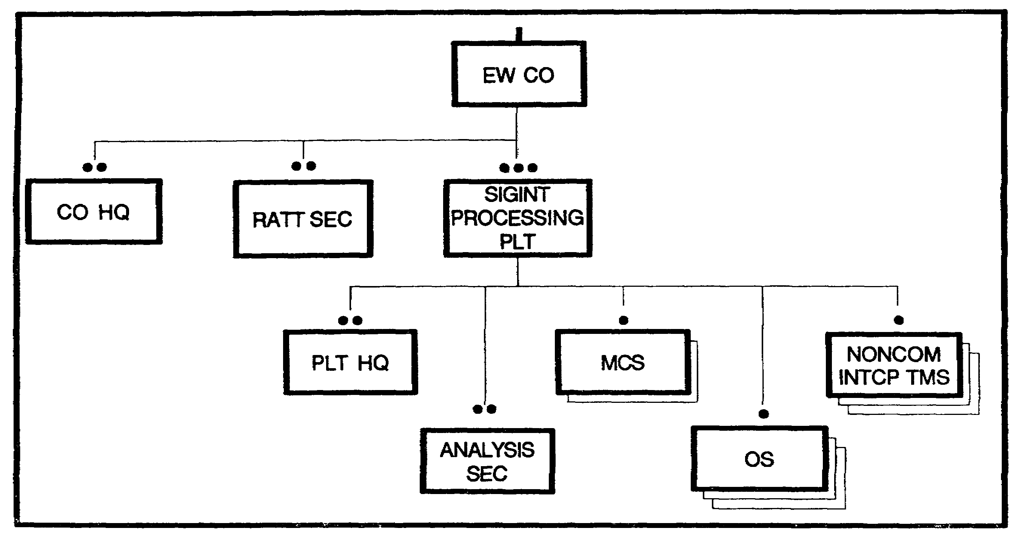

Figure 5-5. Electronic Warfare Company.

Long Range Surveillance Detachment (Figure 5-6).

The LRS Detachment (LRSD) at Division level is organic to the Ml Battalion in Division, but operationally, receives its tasking and assignments from the Division Commander (via Div G2 and G3). The teams deploy for up to 6 days, 15 to 80 Kms forward of the FLOT to observe and report on enemy activity at Division named Areas of Interest (NAIs). Each team consist of 6 persons, armed with surveillance equipment (Night Vision Goggles-NVG, Infrared Viewers, Scopes and Binoculars), NBC detection and warning equipment (IM-93 Radiacmeter), personal weapons (AR-15 or M16A2), and secure radio equipment (Improved HF radio w/data burst transmission device). During crisis action (H hour sequence), the teams go into isolation, receive and review their mission packets, and prepare for insertion. The teams report to base stations strategically deployed on the battlefield to receive the data burst transmission (normally one collocates with division tactical operations center support element (DTOCSE). The teams reporting criteria, thresholds and time lines are established by division ACE.

5-7 IT0432

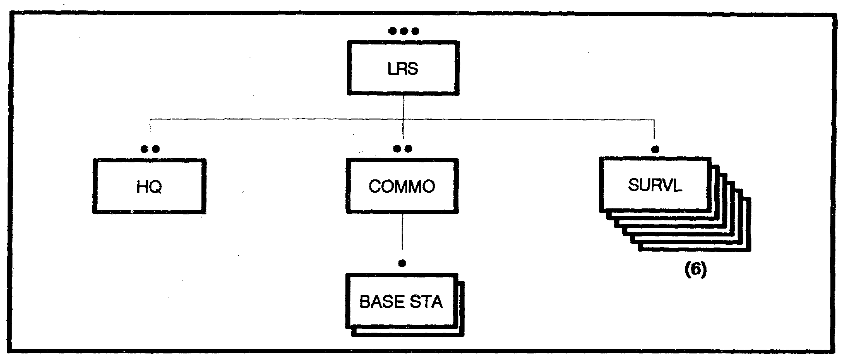

Figure 5-6. Long Range Surveillance Detachment.

Aviation (Quickfix IIB) Flight Platoon.

The Quickfix IIB flight platoon provides three airborne Communication Intelligence (COMINT) and EW systems to provide aerial communication intercept, locating, and jamming support. Deployed OPCON to the MI battalion, it is normally used as a GS resource to complement ground-based system capabilities with tasking and control coming from the ACE.

PART B - IEW EQUIPMENT DATA

The following information provides the characteristics and capabilities of the IEW equipment organic to the Ml battalion of the heavy division. NOTE: Appendix C, provide an extract from FM 34-8 on present tactical IEW equipment for the other echelon corps and below (ECB) military intelligence organizations. It also provides information on emerging tactical IEW equipment and systems.

AN/TRQ-32(V) 2 (TEAMMATE): is used to receive (intercept), record and determine the approximate direction of arrival of transmitted radio signals (voice and morse). All systems provide intercepts in the HF, VHF and UHF ranges. A single system can provide a Line of Bearing (LOB) in the VHF range only. When netted with three other systems via UHF data link, it can perform DF fix operations (VHF only). A maximum of four systems can be netted together. Upgraded versions of the TRQ-32 will allow it to also data link/net with the Quickfix, ALQ-151 .

The system has the following components: 2 x Operator Terminals; H-Adcock DF Antenna; 2 x Receivers per terminal; a Direction Finder; an Audio Recorder per terminal; a Data Processor per terminal; and communications equipment. The communications package provides secure radio (FM voice), a non-secure field telephone, and a secure UHF data link.

This system's shelter is air-conditioned, has a hydraulic generator to raise and lower the antenna, and is powered by the vehicle's engine. Two operators run the TRQ-32 per shift and

IT0432 5-8

can work independently of each other. The system doctrinally deploys 5-10 Kms from the FLOT, and should be within 8 Kms Radio Line-of-Sight (RLOS) of other systems for the UHF Data Link. A Voice Collection Team consists of 6 persons. Set up/ear down time without camouflage is less than 15 minutes each.

AN/TRQ-30(V): is a communications intercept (HF/VHF/UHF) and Line-of-Bearing (LOB for VHF only) system used for tactical support and will normally deploy 1-3 Km from the FLOT. The system consist of a HF and/or VHF Radio Receiver(s), Tape Recorder/Reproducer, and 4xDF Loop Antennas (the smaller the antenna, the higher the frequency). The system is battery powered using BA-30s; a set (32) of BA-30s will power all three components for approximately 24-28 hours continuous operations, and 72 hours non-continuous operations. The system can also be powered by 24 volts DC vehicular source, or 110/230 volts AC. The system weighs approximately 76 lbs without the batteries. Information gathered by the AN/TRQ-30 (V) is transmitted via secure radio (FM voice). Two persons are required to set up and transport the system between sites. Set up and tear down takes 5 minutes without camouflage and 15 minutes with camouflage. The system primarily serves as back-up for the TRQ-32 in the Voice Collection Team.

AN/TLQ-17 series (TRAFFICJAM): is an Electronic Attack (EA) set designed for surveillance (intercept) and jamming of hostile voice communications in the HF and VHF range (intercept 1.5-80MHz/Jam 20-80MHz). NOTE: A special ground antenna is required to jam in HF (1.5-20MHz) range. It is a low power jammer capable of generating up to 550 watts of power on a single frequency using a whip antenna or (directional) Log Periodic Antenna (LPA). The system operates in five modes: scan, search, manual, monitor and priority. It can jam manually and automatically in the monitor and priority modes. It deploys 3-5 KM (ground-based) from the FLOT. This system will be replaced with the jamming capable Ground Based Common Sensor (GBCS). There are four versions of this system:

The AN/TLQ-1 7(V) 1 is mounted on a jeep and trailer and in an equipment rack that allows mounted or dismounted operation of the system. Omni-directional antennas for this version are trailer mounted (this system has been phased out of active duty forces).

The AN/TLQ-1 7(V) 2 is mounted in an EH-60 helicopter and is part of the QuickFix mission equipment. Antennas are helicopter mounted.

The AN/TLQ-1 7A(V) 3 components are mounted in an S-250 shelter-and powered by the vehicle engine. A mount for a Log-Periodic Antenna (LPA) is on the driver's side of the shelter. The antenna is permanently directed to the rear of the shelter, requiring the vehicle to be parked with the rear toward the enemy. An omni-directional whip antenna can be mounted on the rear of the shelter for intercept or for quicker EA operations with less effective radiated power. The system can store up to 255 protected or targeted frequencies in active memory. Secure voice is the primary communications means used. It is organic to the HF/VHF EA team, which consist of a 4 person team capable of set up within 15 minutes without camouflage.

The AN/TLQ-1 7A(V) 4 is similar to the (V) 3 but is mounted on a High Mobility MultipurposeWheeled Vehicle (HMMWV).

5-9 IT0432

AN/MLO-34 (TACJAM): is a Special Purpose Countermeasures Set capable of jamming single-channel tactical enemy communication links. It incorporates a variety of signal modulation types to effectively harass and jam enemy' communications. It is a high power jammer capable of generating 6500 watts of power on a single frequency or 2000 watts of power on multiple frequencies simultaneously using the Log Periodic Antenna. It will normally deploy 3 -5 KM from the FLOT. The system is mounted on an M1015 tracked vehicle which has an on-board 60 kilowatt (Kw) generator for power. This limits the system to very slow movement (20-25 MPH on hardball). Systems currently fielded are being remounted on 5-ton vehicles. The system uses a quick erection pneumatic antenna mast with a folding LPA. This antenna covers the frequency band of 20-150 MHz. The antenna mast is a pneumatic system which can be raised to a height of approximately 40 feet. Primary communications are secure VHF/FM voice. A VHF EA team consists of 4 persons. Set up/tear down time is 15 minutes without camouflage. This system is being replaced with the jam capable Ground Based Common Sensor (GBCS).

AN/PPS-5B Radar set: is a portable radar set that is powered by either battery, generator or vehicle (this requires a power converter). It is used to identify and track moving ground targets. The PPS-5B can track moving personnel up to 6,000 meters and moving vehicles at ranges up to 10,000 meters. This radar consists of two assemblies; a control indicator (Cl) and the tripod mounted components. Tripod components include a receiver/transmitter, antenna, battery box and telescope. The two assemblies are connected by a remote cable. During operation, the Cl receives output from receiver/transmitter and presents them both visually and audibly. The Cl also controls the movement of the antenna. Power for this system is received from a battery through a remote cable. The system can be set up or torn down within 10 minutes.

AN/TSQ-138 (TRAILBLAZER): is a special purpose detecting system used as a ground-based tactical intercept and automated DF support system. It is found only in the heavy division. The Trailblazer has 5 Master Control Stations (MCSs) with two intercept positions inside each shelter. These five systems will normally deploy across the entire division front about 5 to 10 KM from the FLOT, and in general support to the division. Communications between the systems is accomplished by a secure UHF data link. The system's shelter is mounted on an M1015 tracked vehicle and has a self erecting pneumatic H-Adcock antenna (extends 60 feet). (The M1015 is being replaced by a 5 ton truck.) Though the chassis has an on-board 60Kw generator, a towed 30Kw generator on a trailer is the primary power source. The communications sub-system consists of an UHF data link (internal); an external tasking and reporting data link (also provided by a UHF radio) and a secure VHF voice radio for communications and control. The system can operate with UHF data link to other TSQ-138s or the QuickFix. The system is organic to the SIGINT Processing Platoon, EW Company, HVY Div with a 6 person team. They can be operational approximately 7-10 minutes after arriving at the site.

AN/ALQ-151 (V) 2 (Quickfix IIB) sub-system: is part of the heliborne (EH-60A) system. The mission equipment includes both ES and EA equipment. The ES equipment is used to detect a communications target signal of interest, and locate it by radio direction finding (RDF). The ES/DF equipment is the same as the AN/TASQ-138 with HF/VHF/UHF intercept and VHF DF.

The equipment is used to jam communication target signals and is identical to the TLQ-17 system with VHF EA only. This system can operate by itself or, through UHF data link, with the

IT0432 5-10

AN/TSQ-138 Trailblazer (ground-based) to provide better DF accuracy. The Quickfix IIB contains a computer system that is used to process Airborne Radio Direction Finding (ARDF) data and provide an automatic reference point for the location of the aircraft. The ES and EA systems operate independently of each other, however, collection and jamming operations cannot be accomplished simultaneously. The system has flight endurance of 2.5 -3 hours which includes travel time to and from the airfield and the planned collection track. The system has secure communications gear that allows communications with other Quickfix IlBs or the AN/TSQ-138 (via data link) and with ground control (UHF secure voice). Upgrades of the system will allow the Quickfix to also data link with the AN/TRQ-32 Teammate. The future QF called Advanced Quickfix will data link with the GBCS.

PART C - IEW TACTICAL MISSION

During IEW operations, Ml assets are assigned standard tactical missions. Standard tactical missions describe the IEW support responsibilities for an Ml unit. They also establish an Ml unit's relationship to a supported force or another Ml unit. Standard tactical missions do not affect the organizational structure or the command relationship that results from that structure. The four standard tactical missions are: Direct Support, General Support, Reinforcing, and General Support-Reinforcing (GS-R).

o Direct Support: An MI element in direct support of a specific unit is required to respond to the IEW requirements of that unit. The supported unit will identify its requirements through liaison elements, which will route them to the Ml element for execution. The MI unit's first priority is to the specified unit, and a second priority to the force as a whole. A unit in DS has no command relationship with the supported unit, and remains under the command of its MI chain of command.

o General Support: An MI element in general support (GS) will provide support to the force as a whole and not any particular subordinate unit. It responds to the requirements of the force commander, as tasked by the Ml unit TOC.

o Reinforcing: The IEW capabilities of MI units or staff sections are extended by Ml units reinforcing other Ml units. Reinforcing MI units remain under the command of the Ml commander assigning the reinforcing mission, while operational control is retained by the Ml unit or staff sections being reinforced. The reinforcing mission permits increased support to specific maneuver units without giving up complete control of Ml assets to the supported elements.

o General Support-Reinforcing (GS-R). An MI element assigned a GS-R missions is required to first respond to the IEW requirements of the force as a whole and then to reinforce the activities of another specified MI element as a second priority. The GS-R mission gives the force commander flexibility needed to meet the changing tactical situation.

There are inherent responsibilities within each of the four standard missions. The matrix at Figure 5-7 illustrates these responsibilities as applied to the four standard IEW missions.

5-11 IT0432

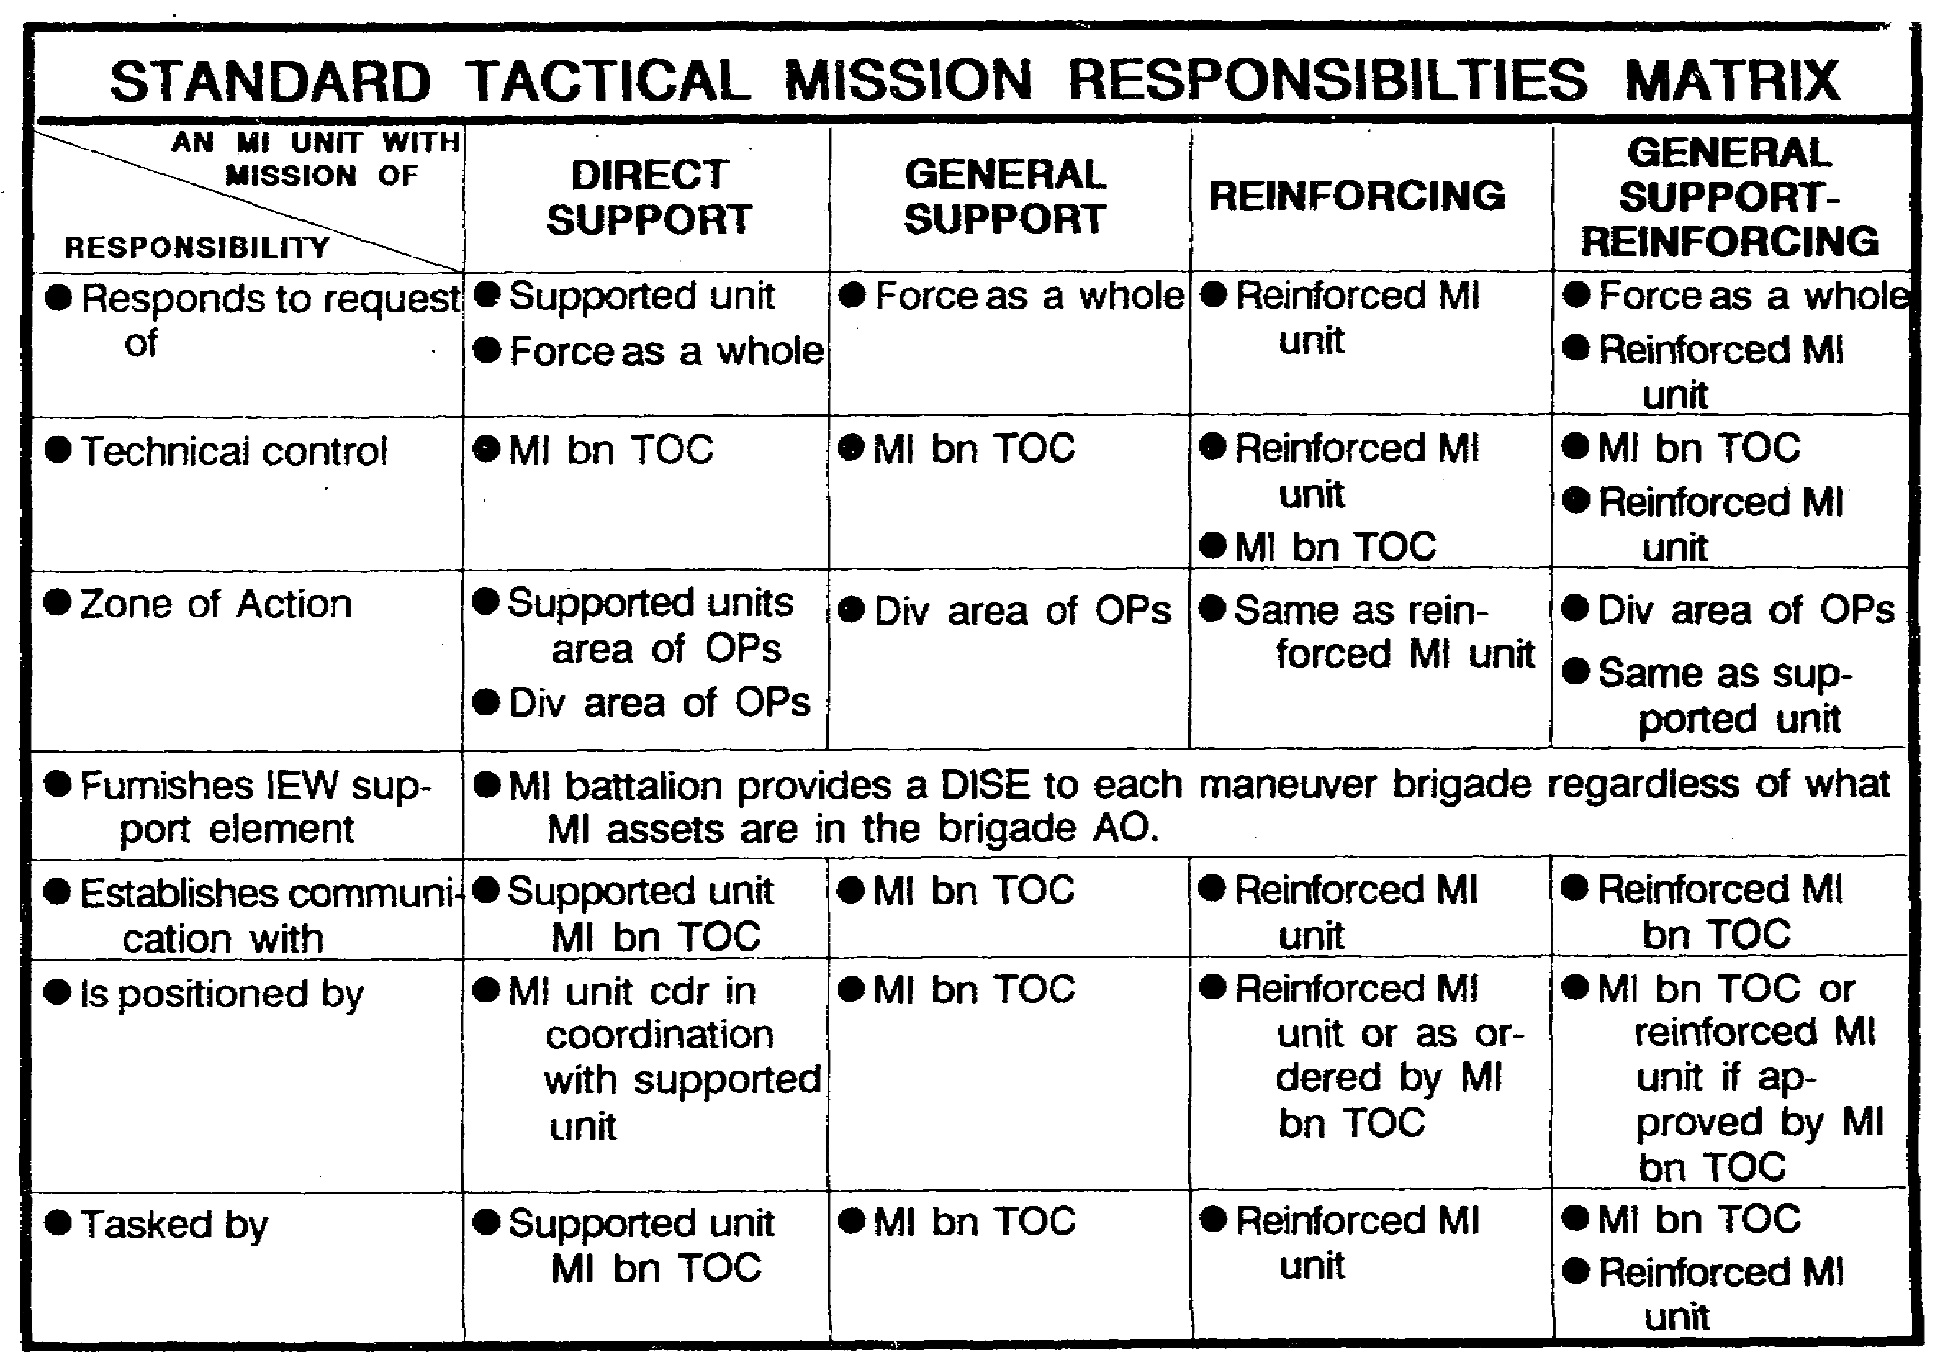

Figure 5-7. STM Responsibilities Matrix.

Standard tactical missions are not command relationships. They clearly define the priorities of support, but in all cases, command and control is exercised through the MI chain. A company team may be assigned any of the four standard tactical missions. The assets and mission assigned to company teams will be determined by the Ml battalion commander. He will make his decision based on the division concept of operation and the guidance of the division commander, G2, and G3.

PART D - IEW OPERATIONS

IEW operations support combat operations. Given a mission by the force commander, the Ml commander, subordinate commanders, and staff must quickly determine the--

o mission to be accomplished.

o unit(s) to be supported.

o Ml assets available.

o organization of Ml assets to provide the required support.

IT0432 5-12

Principles of Organization. All actions in the Battlefield Operations doctrine are based on the nine principles of war. These principles are fundamental, interrelated concepts that vary with the situation. In organizing for combat, four of the nine principles take precedence for consideration by Ml commanders. They include--objective, economy of force, unity of command, and simplicity.

Objective. Ml commanders must understand clearly the overall mission of the force commander, the Ml unit mission, and how the MI unit will be organized to support the force commander's objective. They select objectives for MI assets that will directly and indirectly contribute to the ultimate objective.

Economy of Force. The principle of economy of force requires that MI commanders organize limited available MI resources with emphasis in the area where the main effort of the force will take place. However, MI commanders must also allocate resources that will adequately support secondary efforts.

Unity of Command. Ml commanders ensure unity of command by coordinating the actions and organization of all MI assets toward the common goal through mission orders. Ml commanders control their subordinates, yet extend them the freedom to exercise their initiative.

Simplicity. Ml commanders accomplish the mission in the simplest way possible. Direct, simple plans and clear, concise orders reduce misunderstanding and confusion. Simplicity generates flexibility and results in responsive IEW support.

Command Relationships. The MI commander provides the direction to subordinate elements to accomplish the IEW mission generated by the force commanders concept of the operation. MI commanders command and control MI resources assigned to support the combat force. The command relationships which direct Ml commanders are: Organic, assigned, attached, and operational control (OPCON).

Organic. Those assets which form an integral part of a military organization. These assets are listed in a tables of organization and equipment (TO&E) and specify the personnel, material, and structuring of a unit.

Assigned. A unit which is placed in an organization on a RELATIVELY PERMANENT basic and is controlled and administered for its primary function, or a greater part of its function, by the organization to which it is assigned.

Attached. This command relationship places a unit under the TEMPORARY command and control of another unit, e.g., GSRs. The directive establishes specific terms of attachment, such as the provision of combat service support (CSS).

Operational Control (OPCON). This relationship places one unit under the control of another for its direction and employment. OPCON basically has the same intent as attachment, but the controlling unit does not have responsibility for logistical and administrative support. OPCON does not permit the gaining commander to tailor the unit placed in support.

5-13 IT0432

Organizing for Combat. In organizing for combat, MI commanders must assign resources to support the force commander's battle. In allocating Mi assets for DS and reinforcing missions, consideration must be given to retaining sufficient assets in GS and GS-R roles to provide the flexibility to influence the battle at critical times and places. Consideration which the Ml commander must make when organizing for combat are: degree of control, sufficient support to accomplish the assigned mission, and future operations.

Degree of Control. Ml units require a sufficient degree of centralized control to maximized their capabilities to influence the close-in and deep battles. Each tactical mission requires a different degree of centralized control which will affect MI responsiveness to supported force.

Sufficient Support. Sufficient support is provided to the force command by assigning standard IEW missions. Ml units are most responsive to a supported commander in the DS role. Additional support is provided with other Ml units in reinforcing or general support reinforcing roles.

Future Operations. MI commanders must assure unit uninterrupted IEW support by organizing their units in such a way as to ensure the smooth transition from current to future operations. The MI commander does not hold assets in reserve. Immediate responsiveness to the force commander's priorities demands the MI commander organize MI elements with a mix of assets that provide complete support to the maneuver force. Future operations are facilitated by:

o Using on-order missions.

o Providing a comprehensive CSS package.

o Dispersion of units to provide survivability from nuclear, biological, and chemical (NBC) attack.

o Detailed standing operating procedures (SOPs) that provide flexibility.

Task Organization. Through asset distribution, the MI commander rapidly organizes for combat and readjusts the organization as the tactical situation changes. Shifting assets between command structures creates a mix of IEW assets immediately responsive to the force commander's scheme of maneuver. The Ml commander must retain flexibility by organizing the unit to quickly adjust to the unexpected. Flexibility is achieved by planning for each possible contingency.

When task organizing an Ml battalion, there are comparable parts as with task organizing maneuver units. Figure 5-8 shows the relationships.

Although Task Organization is dependent on many considerations to include METT-T, there are some norms. Under BN Control the following are usually listed: Flight Pit, LRSD and the OPS SPT Sec of the I&S CO. Under Bn Trains is usually HHS(-). Under Attachments/Detachments are the elements/teams attached to the maneuver Bdes such as GSRs, Remotely Monitored Battlefield Sensor System (REMBASS), and the DISE. NOTE: No standard mix of an IEW Company Team exists as they are structured to meet the needs of a specific situation/mission and are also based on the factors of METT-T.

IT0432 5-14

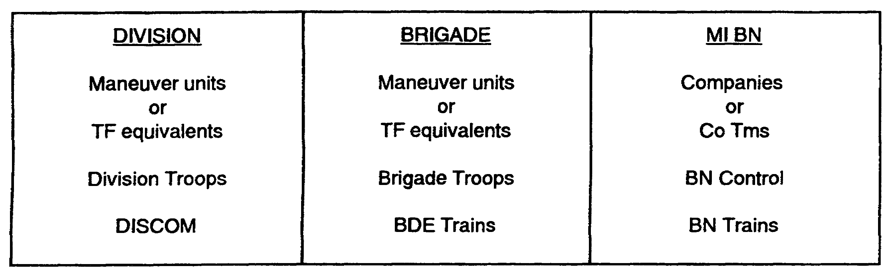

Figure 5-8. Maneuver/MI Comparison Chart

PART E - IEW COMPANY TEAMS

As the assets of the MI battalion are task organized, IEW company teams are created. These contain the mix of assets selected by the Ml battalion commander and his S3 to perform a specific mission. When sufficient assets are operating in the same area, and to enhance MI battalion internal command and control of operational elements, a company team will be created to command them. These company teams will be in DS of a maneuver brigade or in GS of the division. The designation of standard tactical missions will be determined by the battalion

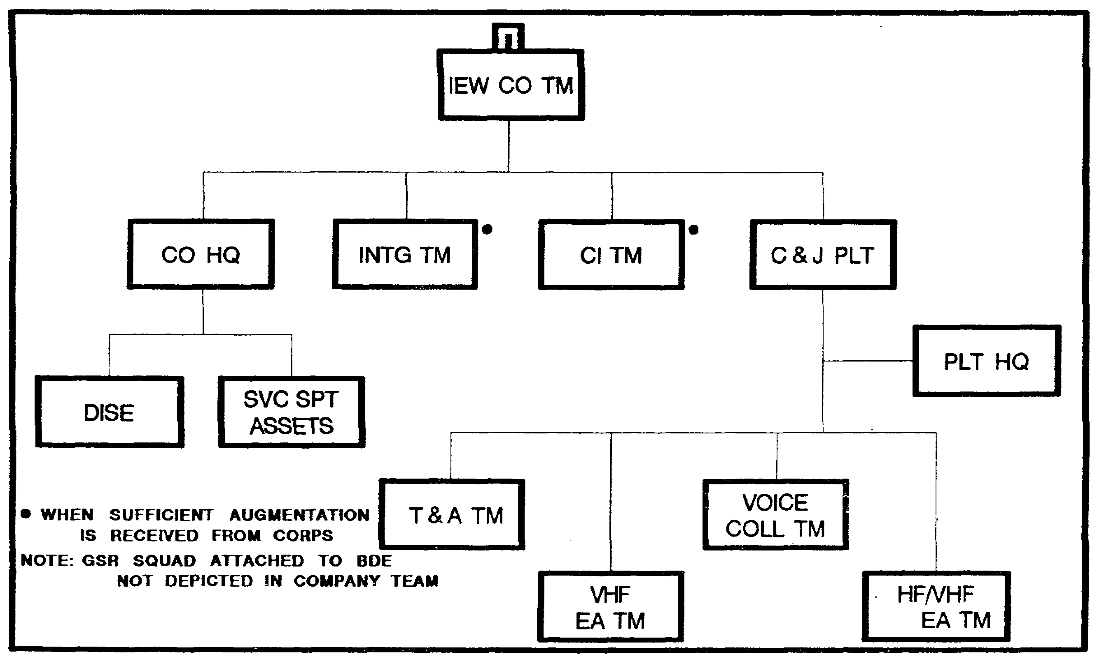

Figure 5-9. IEW Company Team (DS).

5-15 IT0432

commander in coordination with the division commander and recommendation of the G2 and G3. The means of stating standard tactical mission for IEW elements is through the Ml battalion OPORD as well as annex A of the division or brigade OPORD. As stated earlier, there is no standard mix for an IEW company team. They are structured to meet the needs of a specific situation and are based on the factors of METT-T.

IEW Company Team (DS). Figure 5-9 depicts a typical structure of an IEW company team in direct support of a maneuver brigade.

The first priority of the IEW Company team assets is to the IEW requirements of the brigade that it supports. Its second priority is to overall divisional requirements. The Ml battalion TOC will manage brigade and division priorities and provide direct tasking to SIGINT/EW assets placed in DS of the force. The C&J platoon receives technical taskings from the ACE. The DISE coordinates brigade SIGINT/EW requirements with the MI battalion TOC, while non-SIGINT assets are tasked directly by the DISE or brigade. The DISE receives combat information directly from the assets of the company team.

The maintenance assets task organized and attached to the company team would include communication, vehicular, and IEW system maintenance personnel. In addition to its own assets, a DS company team is responsible for providing and coordinating administrative and logistical support to any IEW elements operating GS in the brigade area. If there are no direct support IEW company teams, the GS assets operating in the brigade areas receive support from their parent company team or brigade support elements.

When the brigade is held in reserve the IEW company team may be placed in a divisional GS role or OPCON to another brigade. It is preferable to deploy the company team in the general area that the brigade will be committed. When the brigade is committed, the battalion S3 changes the mission of the company team to provide DS to the brigade.

IEW Company Team (GS). Figure 5-10 depicts a typical structure of an IEW company team in general support of the division. The main priority of the GS company team is the IEW requirements of the division. Its tasking comes from the Ml battalion TOC with technical tasking for SIGINT/EW from the ACE. Combat information from company assets will be reported to the brigade DISE by the Ml battalion TOC/ACE. Assets of this company team may be deployed in more than one brigade area. The company team headquarters is responsible for administrative and logistical support to company assets. Logistics support from brigade CSS elements will be provided based on prior coordination between the MI battalion S4 and the brigade staff.

IT0432 5-16

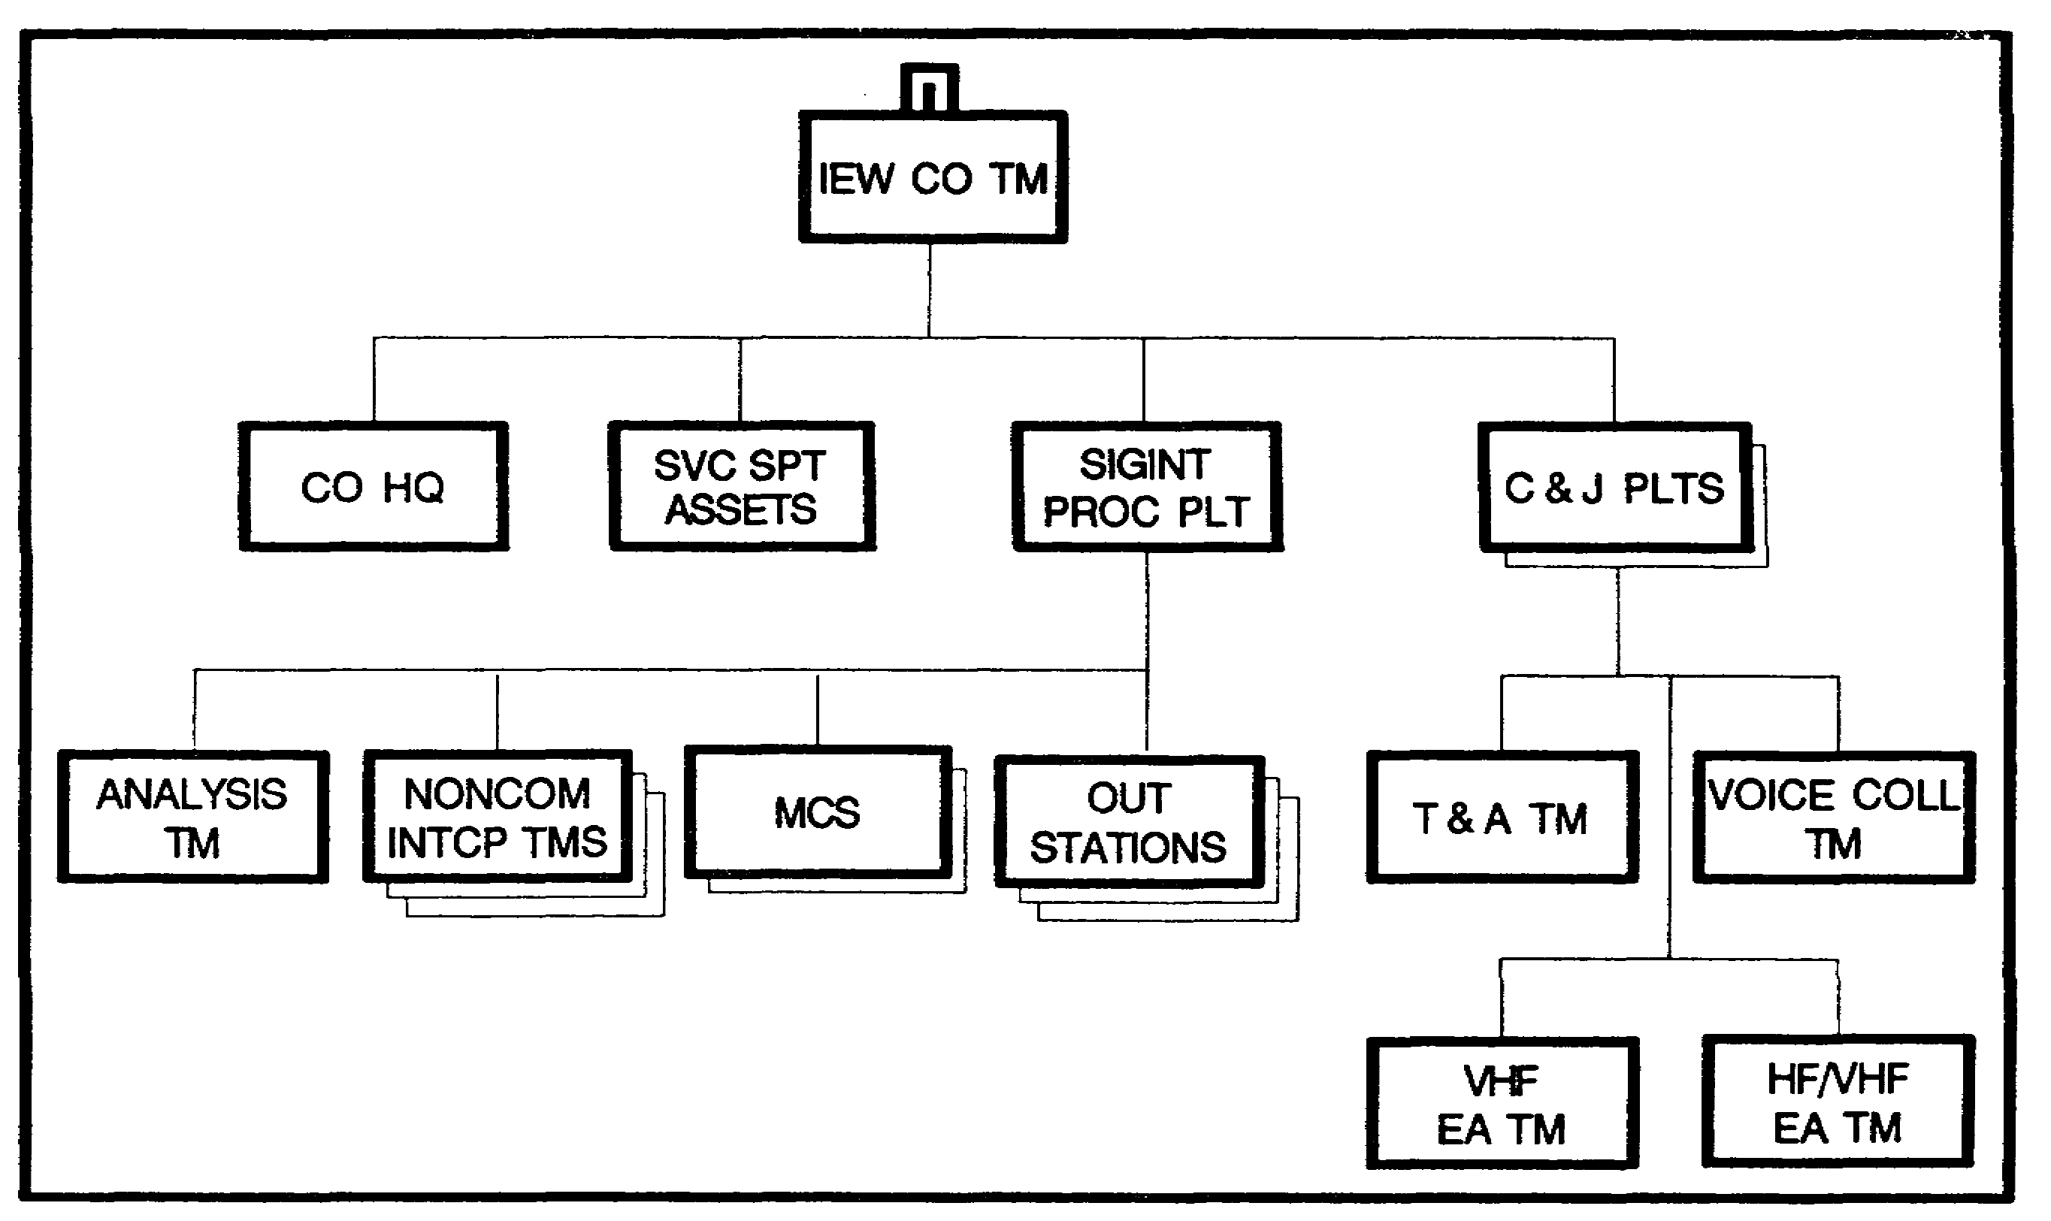

Figure 5-10. IEW Company Team (GS) of the division.

PART F - IEW COMMUNICATIONS

Ml Battalion Communications. There are three types of communications used in the Ml battalion: multichannel, radio teletypewriter (RATT), and radio (FM).

Multichannel. The Ml battalion employs multichannel communications for command and control, coordination, and reporting purposes. In support of command and control functions, multichannel based voice, facsimile, and tactical commander's terminal (TCT) between the Ml battalion TOC, DISE sections at brigade CPs, the G2 or G3, and DTOC allow for coordination of mission tasking, and clarification of priorities for MI battalion operations. It also allows for the tactical control and coordination needed by the MI battalion commander and S3 in planning for subsequent Ml battalion operations or the displacement of IEW company teams within the division and brigade area of operations.

Radio Teletypewriter. In the Ml battalion, RATT is used for record traffic communications to SIGINT and EW assets. These nets pass formatted tasking messages and reports of intercepted information. RATT systems of the Ml battalion deploy to the battalion TOC and well forward with each of the three C&J platoons and SIGINT processing platoon.

Radio (FM). FM voice communications are critical to the command and control within the Ml battalion. They link the battalion TOC with IEW company teams and to the IEW assets on the

5-17 IT0432

battlefield. FM nets in the Ml battalion also connect the DISE at the brigades to the MI battalion to ensure it receives the IEW requirements of the brigades in a timely manner.

Ml Battalion Communications Nets.

The MI battalion Command (or Operations) net is used by the MI battalion commander for command, control, and coordination purposes. The MI battalion Operations net (FM) is the principal operations net internal to the MI battalion used for asset tasking, coordination, and tactical control of deployed IEW elements.

The Mi battalion Administrative and Logistics net is used to coordinate combat service support requirements internal to the Ml battalion. Its primary subscribers are the maintenance teams of the battalion's HHSC and service support platoons or elements found in each of the operating companies of the Ml Battalion.

C&J Tasking and Reporting net. The Ml battalion C&J tasking and reporting nets (1st, 2nd, and 3rd C&J platoons) are used for SIGINT and EW tasking and reporting and for passing technical data to the deployed C&J platoons.

C&J Internal Net. Upon receipt of missions from the ACE, via FM or RATT tasking and reporting nets, the T&A team will task subordinate teams of the platoon via the C&J platoon's internal tasking and reporting net. Each of the three C&J platoons operates such a net.

SIGINT Tasking and Reporting Net. SIGINT tasking and reporting nets (RATT and FM) connect ACE to the SIGINT processing platoon analysis section for record traffic and operational tasking and reporting.

QUICKFIX Flight Platoon Tasking and Reporting Net. The flight platoon operations section is tasked by the ACE for QUICKFIX missions. Mission tasking and technical data to support this tasking is provided to the platoon operations center over the MI BN flight platoon tasking and reporting net prior to mission execution to allow maximum operational time by SIGINT and EW operations.

Retransmission Station. Communications between deployed teams, platoon headquarters, company team headquarters, brigade DISE, and the Ml battalion TOC is vital to maintain continuous support to the division and brigades. Because of the distance and terrain features between elements, retransmission of communications may be necessary. Three VHF FM retransmission stations are provided within the MI battalion so that battalion elements can communicate at extended ranges or avoid terrain obstructions.

Division Operations and Intelligence (O&I) Net. The O&I net (FM) provides the division with a means of receiving and disseminating O&I information. The division G2 uses this net to receive information and intelligence developed by the brigades and to receive requirements and requests for additional IEW support. The MI battalion S2 is a subscriber on this net; he reports information to and receives intelligence from the division G2 and other stations on this network.

The MI battalion TOC uses this net to monitor reported information and to receive intelligence

IT0432 5-18

disseminated from the division TOC and tactical command post.

CORPS SIGINT/EW RATT. The ACE at the Ml battalion TOC is a subscriber in the corps SIGINT/EW net. This sensitive compartmented information (SCI) net allows for the exchange of technical data between the division ACE, corps ACE, and the ACE of adjacent division. The Ml brigade provides the equipment and operators for this net.

PART G - IEW SCHEME OF MANEUVER

The scheme of maneuver answers the "how" element of a friendly course of action. It is the narrative description of how IEW assets will accomplish the commander's intent. The scheme must describe how the battalion will arrive at the end state the commander articulates. It provides a means for actually employing IEW assets and is the basis for analysis. It is expressed in terms of defeating the enemy or accomplishing the IEW mission through maneuver. The battalion addresses how its forces will accomplish the mission. This step of the command estimate process allows the battalion to determine how to accomplish the mission within the limitations of available assets. A scheme of maneuver is the outline for determining the final course of action (COA). Several schemes of maneuver should be prepared, addressing all friendly COAs, for any mission.

Developing a scheme of maneuver takes the initial array of forces/assets developed during step 2 of developing a friendly COA and refines them. The refinement encompasses the actions deemed appropriate to address the five elements of the battlefield (deep operations, covering force/security, close operations, rear operations, and reserves). This is accomplished by--

o Reevaluating the terrain and enemy.

o Reevaluating the force ratio and accepting risks. Number and type of friendly IEW assets in comparison to Threat IEW assets and targeting capabilities, limitations, and weaknesses. Risks can be defined as shortages of IEW equipment and assets.

o Considering the impact of shortages and/or use for forces (possibly) uncommitted during the array of initial forces. Consider IEW general support and direct support capabilities for potential economy of force operations and missions.

o Evaluating type(s) of operations identified as possible during the relative combat power analysis. Consider mix of IEW standard tactical missions, collection and targeting operations to support friendly maneuver COAs.

o Determining the defeat mechanism including locating objectives and identifying specific targets. A defeat mechanism has four basic components:

- Attack means. Specific units/assets with direct and indirect fires and EW capabilities.

- Location. A place where the attack will occur: an engagement area, target are of interest (TAI), artillery target, EW target, and objective(s).

5-19 IT0432

- Time. When the attack will occur, so as to impact on friendly operations and missions.

- High payoff target (HPT). A previously selected high value target (HVT) that has been selected for attack. It is the specific HPT(s) and the means to defeat the enemy.

o Determining the location of objectives and counterattack objectives. Wargaming and force ratios can be used to determine IEW capabilities to support friendly offensive and counterattack operations.

o Determining the location of the main effort and supporting effort(s). A given to the Ml battalion based on maneuver commander's intent and scheme of maneuver. Determine IEW priorities in supporting main and secondary efforts.

During the next substep in developing a scheme of maneuver the battalion planner must address the following:

o Arraying Additional Forces. If any IEW assets, either organic, assigned, or attached, remain from the initial array they should be used during the development of the scheme of maneuver. This could be a Corps IEW asset not available during initial array. These assets could provide depth to the battlefield.

o Converting Generic Forces. Converting generic IEW forces arrayed during step 2 to specific IEW company teams is a conscious decision by the battalion planner. He needs to identify which mix of IEW assets will be allocated to support the identified missions. To accomplish this conversion, the planner considers the terrain (line of sight characteristics/capabilities), the enemy, and the IEW mission. This conversion is the initial step in identifying the battalion task organization. Final decisions and refinement will be made during wargaming the COAs.

The selection of the final battalion COA and supporting scheme of maneuver forms the basis for the IEW task organization and preparation of paragraph 3a of the battalion OPORD. The concept of the IEW operation includes a clear, concise narrative and an operations overlay or graphics. The IEW scheme of maneuver needs to articulate the concept of operations from beginning to successful conclusion. The scheme of maneuver should agree with the operations graphics and add to the clarity of the operation overlay rather than duplicate or contradict it. Also, it should not duplicate information that will be listed in later subparagraphs or in the coordinating instructions.

IT0432 5-20

LESSON 5

PRACTICE EXERCISE

The following items will test your grasp of the material covered in this lesson. There is only one correct answer for each item. When you complete the exercise, check your answer with the answer key that follows. If you answer any item incorrectly, study that part of the lesson which contains the portion involved.

1. What are the four terms essential to the concept of organization for combat?

A. Organic, assigned, attached, reinforcing.

B. Organic, attached, general support, operational control.

C. Organic, direct support, attached, general support.

D. Organic, assigned, attached, operational control.

2. What Ml battalion (division) level asset is provided to each maneuver brigade regardless of what MI assets are deployed in the brigade AO?

A. IEW company team (DS).

B. DISE.

C. IEW company team (GS).

D. IEW support officer.

5-21 IT0432

LESSON 5

PRACTICE EXERCISE

ANSWER KEY AND FEEDBACK

Item Correct Answer and Feedback

1. D. Organic, assigned, attached, operational control. (Page 5-13).

2. B. DISE. (Page 5-16).

5-23 IT0432

